All you Need to Know About Bajaj Finserv Personal Loans
Personal Loans are a great way to facilitate for your urgent monetary requirements. If you are facing any kind of economic emergencies, these are a great way to help you turn your situation around.
Sometimes, applying for a Personal Loan can be confusing because of the varied eligibility criteria lenders take into consideration. Before you apply for a Personal Loan, you’ll need to check if you are eligible.
How to Apply for Personal Loan
In order to successfully apply for a Personal Loan, you need to have all your documentation in place. Also, you’ll need to follow certain guidelines which are made by the bank in your interest. This Personal Loan FAQ, is designed specially for you so that the whole process of taking a loan is significantly simplified.
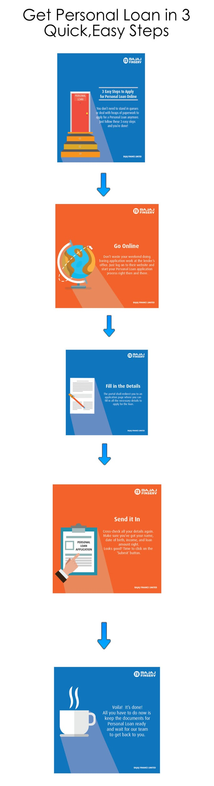
Checking Eligibility
Lending and borrowing of money involves some risk: make sure that you are eligible to apply for a loan first. In order to get a Personal Loan application approved, there are 3 criteria that you must fulfil.
- You must be an Indian citizen.
- You must be over 25 years of age when the loan is sanctioned.
- You must be a salaried individual with a work experience of over three years.
If these 3 criteria are applicable to you, you can successfully go ahead and apply for a Bajaj Finserv Personal Loan.
Minimum Salary Requirement
In order to apply for a Personal Loan, you must be earning more than the minimum salary requirement. The minimum salary requirement varies from city to city.


Name of the city Minimum salary requirement
Ahmedabad, Bangalore, Chennai, Coimbatore,  Delhi, Faridabad, Ghaziabad, Gurgaon, Hyderabad, Kolkata,  Mumbai, Noida, Pune,Surat, Thane | 40,000
Chandigarh, Cochin, Jaipur, Nagpur | 35,000
Aurangabad, Baroda, Bhubaneswar, Indore,  Madurai, Mysore, Nasik,Trivandrum, Vijayawada, Vizag | 30,000
Make sure you meet the minimum salary requirement before you apply for approval. Loans are not given to anyone who doesn’t match the requirement figures as per the different cities.
Choosing your Tenure
Once you have assured that you meet the minimum salary requirement, you can choose the tenure for which you will pay off your loan. This is the total period of time over which you will slowly repay the money you borrowed. The minimum tenure allowed is 12 months and the maximum tenure allowed is 60 months.
Personal Loan Eligibility Calculator
Alternatively, you can access the Personal Loan eligibility calculator on the Bajaj Finserv website. It is a quick and easy way to find out whether you match the eligibility criteria. Just fill in your personal details on the calculator and it will show you the amount of loan that you are eligible to take. This, however, is just an approximated calculation and it is suggested that it is only used for informational purposes.

In order to apply, you need to go and click on the ‘apply online’ button on the Bajaj Finserv website.
Getting your Loan Approved
Once you have made sure that you are eligible to apply for a Personal Loan, you can go online and submit your form details on the Bajaj Finserv website. The website will instantly approve the form and send it back if everything is good to go.

Once your loan gets approved, you can go ahead and reap the benefits of interest rates as low as 16%. Bajaj Finserv provides complete online access to their customers, providing key information like loan details, repayment history, interest certificates, and payment schedules.

