Magic of Thinking Positive
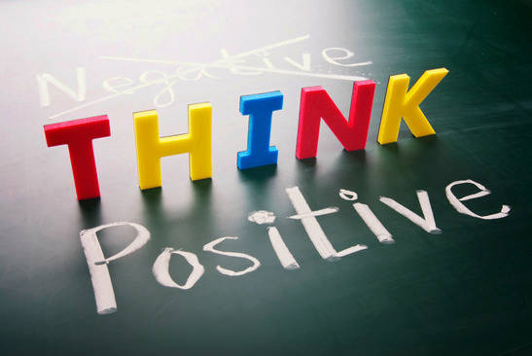

Yesterday is not ours to recover, but tomorrow is ours to win or lose.
A positive person anticipates happiness, health and success, and believes he or she can overcome any obstacle and difficulty.
With a positive attitude we experience pleasant and happy feelings. This brings brightness to the eyes, more energy, and happiness. Our whole being broadcasts good will, happiness and success. Even our health is affected in a beneficial way. We walk tall, our voice is more powerful, and our body language shows the way we feel.

The health benefits of positive thinking
Researchers continue to explore the effects of positive thinking on health. Health benefits that positive thinking may provide include:
- Increased life span
- Lower rates of depression
- Lower levels of distress
- Greater resistance to the common cold
- Better psychological and physical well-being
- Reduced risk of death from cardiovascular disease
- Better coping skills during hardships and times of stress

Ways to Overcome Negative Thoughts
- Don’t Play the Victim. You create your life- take responsibility. Don’t blame your fortune.
Even if our living situation becomes unbearable, there is always a way out. We just need to find out that way.

- Surround yourself with positive people
Talk to people who can put things into perspective and won’t feed your negative thoughts.
Beware of those who support your negative thoughts. Such friend is actually your biggest enemy.

- List three things that you are grateful for right now
Being grateful for what you already have & thanks to the almighty for that.

- Meditate or Indulge in Yoga session
The best thing about yoga is, it took us away from our thoughts and brought our attention to our breath. Yoga is very relaxing and helped in easing mind. It helps us to stay in present instead of jumping to what could happen.

- Smile
However it’s quite funny but effective. Force yourself to smile & it will really help in changing your mood and relive stress.

- Help Someone
Take the focus away from yourself & family and do something good for others. You’ll feel better.

- Read Positive quotes
Note with positive quotes, place it in your computer, fridge door, and mirror it’ll help you as a reminder to stay positive
- No one is perfect
Last but not the least always remember no one is perfect in this world. It’s easy to dwell on your mistakes. The only thing we can do now is learn from our mistakes and move forward.

