So the real quest for happiness is actually the quest towards Our Own Inner Self
If you turn your mind inward a little bit, and just observe what is happening inside you, you will always be happy. Unhappiness means you have gone away from Your Self. You have gotten caught up in the world outside of you. So take a step back, turn inward and look within, and then you find that 'you are happiness'.
It’s the Self or consciousness that always gives you happiness, like the Sun always gives you light. Can the Sun ever give you darkness, no! Similarly the Self always radiates happiness and energy. But when you move away from that, then your energy goes down and sadness wells up.
Broaden your vision

and know that life is much bigger than the small events and situations that take place.
What robs you of your smile is unpleasant events; events which do not bring you comfort, or which appear to give you misery. But when you realize that you are much bigger than pleasure and pain, and you are much bigger than the events in your life, both pleasant or unpleasant, then the smile on your face will not vanish. Things come and fleet away. And everything that comes and goes has a purpose. A thorn and a soft rose petal, they both have their purpose.
In the world, some things happen the way you want, and some things don’t happen the way you want. Bundle it all and put it aside. Nothing should take away your happiness.

What overshadows your happiness is:

'I want this & I want that'. Wanting something is what pushes happiness away.
Where the wanting and desires end, and the sharing begins, happiness is exactly there.
Whether a desire is fulfilled or not, just be happy. Don’t cling onto a desire, because whenever a desire is fulfilled, it leaves you in the same place that you were before the desire arose. And not all desires can be fulfilled. Some get fulfilled, some don’t.
The secret to happiness is in being without desires, and in focusing on how you can serve others. The more you serve, the more happiness you will get. Having this feeling, 'I don't want anything for myself, I am contented', brings happiness.
When you give and contribute to people who need you more than you need anything else, that also gives you the strength to move through those moments when you cannot smile.

Memories is not happiness

Happiness is that which is in the present.
In the world, people are either dreaming of happiness or remembering happiness. That is either being in the past or the future. But happiness is that which is in the present.
Many times you postpone your happiness until some perfect future date, but it never arrives. Be in the present. If you are happy now, the past will not torment you and the future will take care of itself. This is the art of living!
Remember one things:

You are responsible for your own happiness. Come what may, whoever says whatsoever, keep yourself happy.
Be determined that: ‘I am not going to let my happiness be taken away by anybody! Make this determination today and see what happens. Nature will support you!
When you find happiness within yourself, you see that your happiness is unconditional.

The 3 Things That Stop You From Being Happy
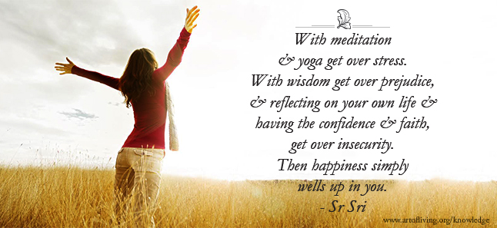
Every child is nothing but a bundle of joy, but as we grow up, somewhere, we lose that joy. A child smiles 400 times a day. When a child grows up and becomes an adolescent, he smiles only 17 times a day, and when he becomes an adult, he smiles occasionally and that too when someone else smiles. The whole question is, how do we reverse this? How do we get back to the innocence we were born with? This is the quest.
There are three things that stops us from being joyful like a child and we need to get rid of all these three.
1

Stress
If you ask me, 'What is stress', in my opinion, I see stress as wanting to do a lot but having no energy and no time.
Now to get rid of stress, either you have to reduce your needs or increase your energy. In these two things, what is most practical is not reducing your needs, but increasing your energy levels.
Now how do we increase our energy levels? Through breathing exercises, pranayama, meditation, and yoga. All of these increase the energy levels of a person in a short period time of 15 to 20 minutes. There are number of breathing techniques that help us relax and get back a lot of energy.
Relaxation that you get from sleep is dull relaxation. Another kind of relaxation is conscious relaxation. That relaxation brings your energy levels higher. That is called meditation. Meditation is not sitting and thinking something. It is going to the source of thought.
So reducing and eliminating stress is the first thing.
2

Insecurity
Insecurity of what? 'Oh, there is nobody for me. Who will take care of me?' I tell you, there is so much love and compassion on this planet, and there is a higher power which is all love and it will give you what you need and when you need.
If you look at your own life, in the past, how many times have you felt insecure?
All those moments you have spent feeling insecure, appears to be such a waste of time, isnt it? Count and see how much time you have spent being insecure in the past 20 years. How many days you spent in a gloomy mood? It is such a waste of time and energy, and not only that, it created toxins in your body. Do you know, your health gets disturbed by the feeling of insecurity.
Three things you must do:
1. Look back in the past and see that it was futile feeling insecure. This gives you strength
2. Know that there are good people on this planet. They will always come to your help
3. There is a power which is going to guide you and help you out
With this wisdom and understanding, get over insecurity.
3

Prejudice
Third is to get rid of prejudice. There are many types of prejudice. There is prejudice between generations where young people will not sit and share with senior citizens. There is a generation gap. There is prejudice about class, about gender, about religion, culture, language, and so on in many parts of the world; so many types of prejudices. Wisdom is to rise above prejudice and see the whole world as one family.
If everyone has this idea of a one world family, there will be no war, no crime and none of the problems that we are facing in the world today. See how many people are being killed. There is so much violence in the world. This is all because of lack of a broad vision and wisdom.

With meditation, yoga and breathing techniques, get over stress. With wisdom, get over prejudice, and reflecting on your own life and having the confidence and faith, get over insecurity.
Once you get over stress, insecurity and prejudice, then you are like a child, full of joy, and happiness simply wells up in you. Happiness is already there, it is just covered by these three things, and once you removed all these three things, it becomes obvious.

Having Faith Can Make you Happy!
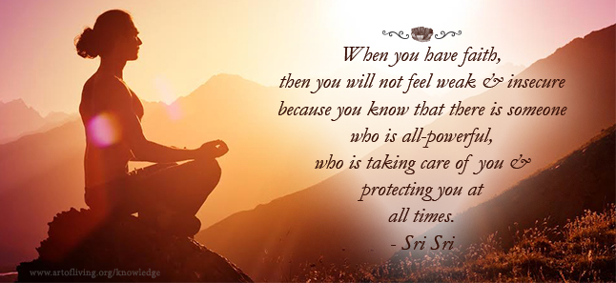
What you need to remember at all times is this, 'There is someone who loves me very dearly, and is taking care of me at all times. He cannot be without me and He is all capable of removing any lack that I have'. Knowing this brings such joy to your life.

Faith Makes You Limitless & Unstoppable
A new-born child is not able to do many things by itself until it becomes 5-10 years of age. Until then it is dependent on others for many of its needs.
In the same way, when we grow old and become 70-80 years of age, we become dependent on others around us.
It is only in this intermediate time in our lives that we are capable of doing something. And in that time period too, we will still be able to do only as much as our capabilities allow us to do.
What you are doing now is something you will not be able to do so well 20 years from now. So we are all dependent on both time and our capabilities. But when we remember that there is a Supreme Power which belongs to us so totally, which is capable of fulfilling all our needs, and which is with us at all times, then this strong faith alone can keep us happy at all times.

It does not matter what you call this Supreme power, whether you call it the Guru or God; when you have faith in you then you can be happy at all times, regardless of your capabilities.

When you have faith, then you will not feel weak and insecure in your old age also because you know that there is someone who is all-powerful who is taking care of you and protecting you at all times. So just having faith alone can make you so happy.
As age progresses, our strengths and capabilities diminish. This is natural. You see many people, as they grow old they become so dejected and insecure. Their face reflects only misery and sorrow. The older they get the more miserable they become. But for one who has strong faith, it is not like this at all. For a devotee, the older he gets, the more joyful and happy he becomes. He smiles more and more, and is happy at all times because a devotee thinks, 'Oh, I have seen it all. I have known and understood it all. I am happy and content from within. And God is there with me at all times to fulfill all of my needs'.
With this deep feeling of faith, a devotee remains happy at all times.
This is something we all must remember. This is why Spirituality is very essential in life. It is spirituality that brings happiness, enthusiasm, intuition, self-realization and the fulfillment of all that one wishes.

The 10 Steps To Happiness
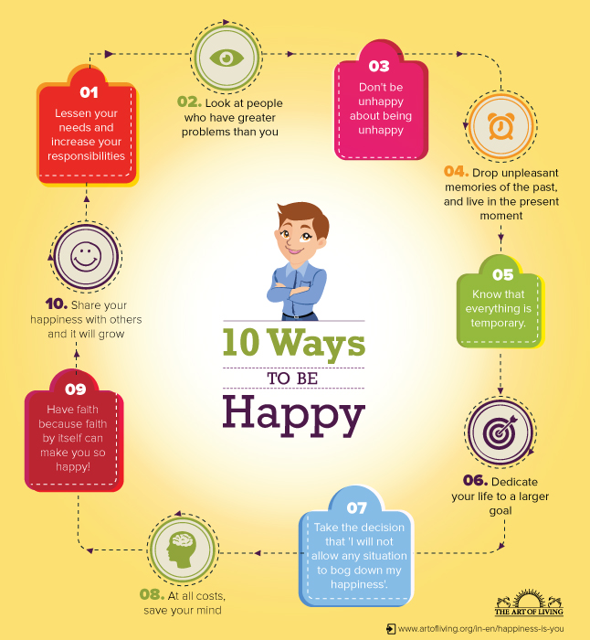
1

Reduce Your Needs & Increase Your Responsibilities
If you sit and make a note of all your responsibilities and all your needs, and if you find that your needs are more than your responsibilities, then life will lead to misery. But if you take more responsibility and have fewer needs, then you will be happy. This is the secret.
When you take more responsibility and your needs are less, everything simply comes to you - enthusiasm, happiness, creativity, etc.
2

Look At People Who Have Bigger Problems Than You
Once a wise man drew a line on a board and told his student to make the line shorter without touching or erasing it. How would you do it? You have to shorten a line without touching it.
The student then drew a much longer line underneath that line. So, the line automatically became shorter. The lesson here is that if your difficulties appear to be very big, lift your eyes because you are only focused on yourself.
If you lift your eyes up and look at those who are in a worse condition than you, you will suddenly feel that your burden is not as bad as you thought it was. If you think you have some big problem, look at people who have a greater problem. Suddenly, you will get a confidence that my problem is much smaller, and I can manage it.
So to be happy is to see those who have greater problems, then your problems will appear smaller. The moment your problems appear smaller, you will get the energy and confidence to deal with it or solve it.
In simple words, serve those who are in greater need.
3

Don't Be Unhappy About Being Unhappy
Never mind if you are unhappy for a little while, so what? If you think I should never be unhappy, then that becomes a cause of unhappiness.

4

Drop Unpleasant Memories Of The Past & Live In The Present Moment
How can you be happy if you’re holding onto unpleasant memories of the past? Unpleasant memories are the biggest hindrance for you to be in the present. The nature of the mind is such, it leaves all the pleasant memories and it grabs onto those few unpleasant events and chews on it. We have advanced in technology but we have not used that technology for our mind.
If you are happy now, the past will not torment you and the future will take care of itself.

5

Know That Everything Is Temporary
None of the events are permanent; pleasant or unpleasant, all pass and move away.
When you realize that everything is temporary, and it all fades away, then you can be perpetually happy.
6

Dedicate You Life To A Larger Goal
The key to happiness in life is to not stay stuck in 'Me, me, & mine'. Dedicate your life to some larger goal or to the service of others around you, then you will find that only happiness flows through your life.
7

Take The Decision That 'I Will Not Allow Any Situation To Bog Down My Happiness'
You Have To Take This Decision, Nobody Else Can Take It For You.
There is nothing great in smiling when everything is normal, and when everything is going the way you want. But if you awaken the valor inside of you, and say, ‘Come what may, I am going to keep smiling’, you will notice tremendous energy rise from within you. Then problems will feel like nothing; they just come and disappear.
Being happy, keeping the environment around you happy, and not losing your smile come what may, is the real sign of enlightenment.
8

At All Costs, Save Your Mind!
In your day to day life, people come and put some negativity in you, and that makes your mind and your determination shaky. Don’t let this happen. Put a filter to your ears and just smile through it.
It is natural and common that people will put out some negativity, but when you are deeply connected with your Self, and when you have intuition, then you will just smile through all such incidents. You will put a filter in your ears.
That is how the world is. There are some pleasant and some unpleasant things. How we manage them and keep our direction, that is what is most important.
9

Have Faith Because Faith By Itself Can Make You So Happy
What you need to remember at all times is this, 'There is someone who loves me very dearly, and is taking care of me at all times. He cannot be without me and He is capable of removing any lack that I have'.
Knowing this too brings such joy in one’s life.
10

Share Your Happiness With Others & It Will Grow
When you are content; when you are happy, you want to share it.
The nature of joy is to share with others. Joy has the tendency to spread, and whenever a person is genuinely happy and joyful from within, they want to just share it with the whole world.
Written by Shri Shri Ravi Shanker , Spritual Leader [ Referred by CA. Sanjeev Singhal ]

