Taxable Perquisite Value of Educational Facilities Rule 3(5)
Perquisite:-
It is a casual emolument or benefit attached to an office or position in addition to salary or wages. Here we are talking about free education facility provided few economic giant like NHPC etc.

When NOT TAXABLE in the hands of employees:-
Type of perquisite cover under section 17(2) | when is tax free
Education facility to employees’ family members | Not taxable if the employee is non-specified employee.
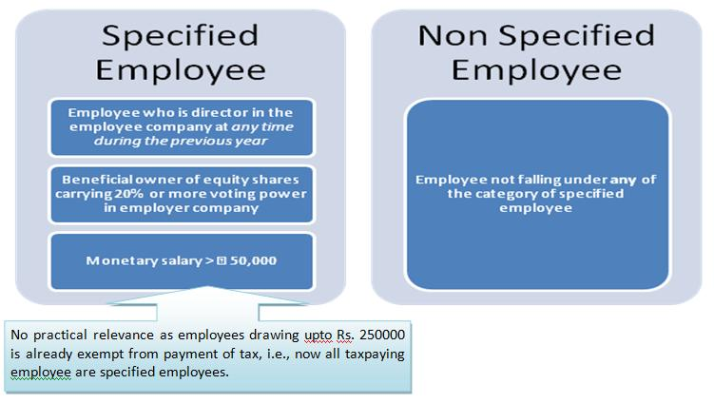
The tax implication of different mode of education facility can be explained as below:-
Nature of facility | Beneficiary | Manner of providing facility | Taxability in the hands of employee
Training of employee | Indirectly employer is benefited in terms improved productivity. | This may be in house or sourced from outside institution | Not Taxable
Fixed Education allowance for children (Max. cap is two children) | Employee as net cash in hand increases. | Direct Expenses | Exempt up to Rs. 100 per month for a maximum of 2 children.
Hostel allowance | Employee as net cash in hand increases. | Direct Expenses | Exempt up to Rs. 300 per month for a maximum of 2 children.
School fees directly paid by employer | No increase in net cash flow. An indirect benefit to employee. | Direct Expenses to school | Taxable
Reimbursement of expenses for education ( i.e., tuition fees) | Direct benefit. | Direct expenses | Taxable. [Circular no 35/7/65 – IT(B), dtd. 12th Feb, 1965]
Education institution owned and maintain by employer
OR
Education facility is provided in other institute by reason of employee’s employment with employer
Facility given to employee’s children | Direct benefit | No cash outflow | Cost of such education in similar institution less Rs. 1,000 per month per child less amount recover from employee
Facility given to employee’s member of household | Direct benefit | No cash outflow | Cost of such education in similar institution less amount recover from employee
Scholarship by employer | Cash flow in employee hand increases. | Direct expenses | Not Taxable
Same may be explained with the help of following diagram:-
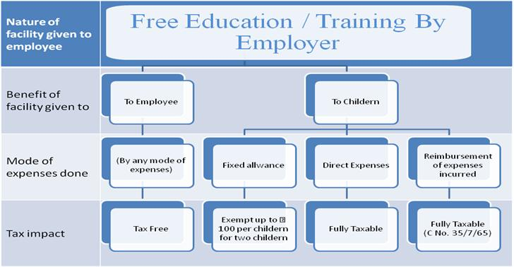
By: SensysTechnologies
For any further information or query you can be reached to experts of our panel at contact@sensysindia.com

