LEARN FROM THE GENIOUS -

MR AMITABH BACHCHAN
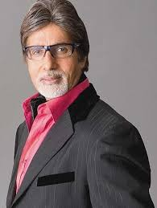

SMALL DESCRIPTION :

Amitabh Bachchan was born in the city of Allahabad in a Hindu Kayastha family. His father was Harivansh Rai Bachchan. Dr. Harivansh Rai Bachchan was a well-known poet of Hindi. Though his last-name was Srivastava, he adopted the pen-name Bachchan, under which was published all his work. It is with this last name that Amitabh debuted in films, and, for all public purposes, it has become the surname of all members of the current family. Bachchan attended Allahabad's jnana prabodhini, followed by Nainital's Sherwood College, where he majored in the art stream. He later went on to study at Kirori Mal College in Delhi University earning a degree in science. In his twenties, Bachchan gave up a job as freight broker for the shipping firm, Bird and Co., based in Calcutta, to pursue a career in acting.
He married actress Jaya Bhaduri in 1973 according to Bengali rites. The couple have two children: daughter Shweta and son Abhishek (who is also a Bollywood film actor).
He is a vegetarian , and is currently nominated for PETA's 'Sexiest Vegetarian' 2007.

Early career: 1969-1972

Amitabh Bachchan made his film debut in 1969 as one of the seven protagonists in Saat Hindustani. The movie was not a financial success, but Bachchan won his first National Film Award. This was followed by hit film Bombay to Goa.Comedian Actor Mehmood is responsible for his first commercial break in this film.
The critically acclaimed and commercially successful Anand (1970) followed, where he starred alongside the reigning superstar of the industry at the time, Rajesh Khanna. Bachchan held his own despite playing a supporting role, and won a Filmfare Best Supporting Actor Award for his intense performance.
Anand was followed by many unsuccessful films such as Reshma Aur Shera (1971) and Parwaana (1971). Then came 1973, and the start of the road towards the iconic status he would eventually come to hold for millions worldwide.

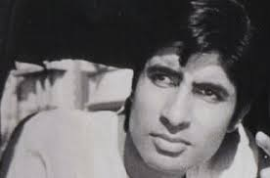 (IN ANAND)

Stardom: 1973-1983

Bachchan's first major box office success came when director Prakash Mehra cast him in the leading role for his film, Zanjeer. The movie was a sharp contrast to the romantic-themed ones that had generally preceded it, and established Amitabh in a new persona – the "angry young man" action hero of Bollywood. The next decade catapulted him to the pinnacle of Bollywood superstardom. He churned out at least one major hit every year, including Deewaar (1975), Sholay (1975) , Trishul (1978), Muqaddar Ka Sikander (1978), Don (1978), Kasme Vaade (1978), Kaala Patthar (1979) and Lawaaris (1981).

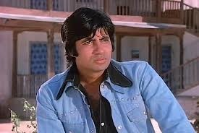 (IN SHOLAY)

Although the above-mentioned films cemented his status as Bollywood's pre-eminent action hero, Amitabh displayed a flair for more than just action roles. His remarkable comic timing was on display in such hits as Chupke Chupke (1975), Amar Akbar Anthony (1977) and Namak Halaal (1982). He was also successful as a romantic lead, with particularly notable performances in Kabhie Kabhie (1976) and Silsila (1981). In 1982 he was critically injured while filming Coolie. He spent many months recovering and resumed filming later that year. The film was released in 1983 and due to the huge publicity of Bachchan's accident, the film was a box office success

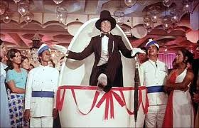 (IN AMAR AKBAR ANTHONY)
Political career: 1984-1987

In 1984, Amitabh briefly entered politics in support of long-time family friend, Rajiv Gandhi. He contested Allahabad's Parliament seat against H. N. Bahuguna, a well-known politician, and won his MP candidacy by the highest victory margin ever for a parliamentary candidate in Indian history (68.2% of the vote). His political career, however, was short-lived: He resigned after three years, leaving his term incomplete. The resignation followed Bachchan's implication in the 'Bofors scandal' by a newspaper, which he vowed to take to court. Bachchan was eventually found not to be guilty of involvement in the ordeal. But since then he detached himself from the Gandhi family and after the demise of Late Rajiv Gandhi he was in deep financial crises because of losses in ABCL. His old friend Amar Singh helped him during the crisis. So he started supporting Mulayam in his political campaigns in an unofficial capacity. Jaya Bachchan joined Samajwadi Party and became a Rajya Sabha Member. In February of 2007, the Samajwadi Party in conjunction with the TDP, DMK, and other fronts wants to nominate Amitabh Bachchan for the candidacy of President of India. But Bachchan has said that he has no plans to contest the presidential election.

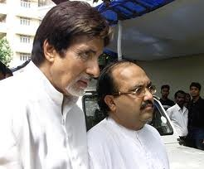 (IN POLITICS)
Career slump: 1988-1999
In 1988, Bachchan returned to films with Shahenshah, which was a box office success due to the hype of Bachchan's comeback. After the success of his comeback film however, his star power began to wane as all of his subsequent films failed at the box office. The 1991 hit film Hum looked like it might reverse this trend, but the momentum was short-lived as his string of box office failures continued. Notably, despite the lack of hits, it was during this period that Bachchan won his second National Film Award, for his memorable performance as a Mafia don in the 1990 film Agneepath. These years would be the last he would be seen on screen for some time. After the release of Khuda Gawah in 1992, Bachchan went into semi-retirement for five years. One of his delayed films Insaniyat was finally released in 1994 but was also a box office failure.
Bachchan setup Amitabh Bachchan Corporation, Ltd. (A.B.C.L.) in 1996 during his temporary retirement period with the vision of becoming a 10 billion (approx 250 million $US) India's premier entertainment company by the year 2000. ABCL's strategy was to introduce products and services covering the entire gamut of the India's entertainment industry. It's operations were mainstream commercial film production and distribution, audio cassettes and video discs, production and marketing of television software, celebrity and event management. Soon after the company was launched in 1996, the first film produced by the company was Tere Mere Sapne which was a modest success at the box office. And it helped launch the career of actor Arshad Warsi who went onto become a successful comic actor. ABCL produced a few other films none of which did well.
In 1997, Bachchan attempted to make his acting comeback with the film Mrityudaata, produced by ABCL. Though Mrityudaata attempted to reprise Bachchan's earlier success as an action hero (portrayed as an angry man) , unfortunately, like most of ABCL ventures, the film was a failure both financially and critically. ABCL was the main sponsor of the The 1996 Miss World beauty pageant, Bangalore and lost millions due to the poor management of the event. The fiasco and the consequent legal battles surrounding ABCL and various entities after the event, eventually led to its financial and operational collapse in 1997. The company went into administration and was later on declared as a failed company by Indian Industries board. The Bombay high court, in April of 1999 restrained Bachchan from selling off his Bombay bungalow 'Prateeksha' and two flats till the pending loan recovery cases of Canara Bank were disposed of. Bachchan had, however, pleaded that he had mortgaged his bungalow to Sahara India Finance for raising funds for his company.
Bachchan later attempted to revive his acting career and had average success with Bade Miyan Chote Miyan (1998) and received positive reviews for Sooryavansham (1999) but most, however, then believed that Bachchan's glory days were over as all his other films such as Lal Baadshah (1999) and Hindustan Ki Kasam (1999) were box office failures.

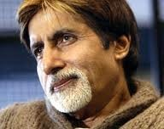 (TENSED DUE TO SLUMP CAREER)
Amitabh Bachchan's return as a superstar on KBC

The 15-year press ban Very few are aware of the ban on Bachchan – a ban that shook the film industry by its roots. Stardust and all the film magazines got together to form an association and banned Bachchan for 15 years during his peak. They decided not to print anything about Bachchan, in any of their publications. In response, Amitabh said that he had banned the press from entering his sets almost till the end of 1989. However, he had nothing personal against any particular magazine.

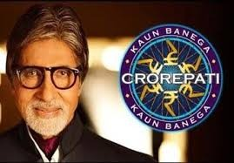 (IN KBC)
Television career
In the year 2000, Bachchan stepped up to host India's adaptation of the British television game-show, Who Wants to Be a Millionaire? entitled, Kaun Banega Crorepati (KBC). As it did in most other countries where it was adopted, the program found immediate and profound success, in no small part due to Bachchan's charisma. It is believed that Bachchan charged a whopping Rs 25 lakhs (2.5 million Indian Rupees, approximately US$60,000 ) per weekly episode which strengthed Bachchan and his family both financially and morally after the setbacks that he had to cope after ABCL's collapse. The Canara Bank also withdrew its law suit against Bachchan in November 2000. Bachchan hosted KBC till November 2005, and its success set the stage for his return to film popularity.
Comeback: 2000-present
In 2000, Bachchan appeared in Yash Chopra's box-office super hit, Mohabbatein, in which he played a stern, older figure that rivalled the character of India's new hearthrob, Shah Rukh Khan. Audiences appreciated Bachchan's work, as he played a character whose age approximately mirrored his own. Other hits followed, with Bachchan appearing as an older patriarch in Ek Rishtaa: A Bond of Love (2001), Kabhi Khushi Kabhie Gham (2001) and Baghban (2003). As an actor, he continued to exploit a range of characters suiting with his profile, receiving critical acclaim for his performances in Aks (2001), Aankhen (2002), Khakee (2004), Dev (2004) and most notably Black (2005). Taking advantage of this resurgence, Amitabh started endorsing a variety of products and services, appearing in many television and billboard advertisements.
Recently he starred with his son Abhishek in the hit films Bunty Aur Babli (2005), the Godfather tribute Sarkar (2005), and Kabhi Alvida Na Kehna (2006).All of them have been very successful at the box office and acclaimed by critics. His most recent releases Baabul (2006), Eklavya and Nishabd (2007) have failed to do well at the box office but his performances in each of them have been appreciated by critics. Zamaanat in which he plays the protagonist, has seen its release date postponed for over 10 years now for want of distributors willing to buy the movie's rights. He also made a guest-appearance as himself in the Kannada movie Amruthadaare directed by Nagathihalli Chandrashekhar.
Most recently on May 25, 2007 two of his films Cheeni Kum and the multi-starrer Shootout at Lokhandwala were released. Though he did a cameo in the film. Shootout at Lokhandwala has taken an excellent start at the box office in India and overseas and Cheeni Kum has picked up after a slow start. But ended up being an average fare.
His forthcoming releases include a supporting role in his first international English language film titled Shantaram which is directed by Mira Nair and stars Hollywood actor Johnny Depp in the lead. He is also appearing in an English-language film titled The Last Lear. On the sets of " The Last Lear" Bachchan turned dialogue writer and penned down some on-the-spot Hindi dialogues.

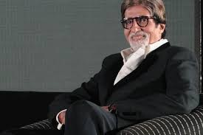 (TV CAREER)

Barabanki Land Scam

In the runup to the Uttar Pradesh state assembly elections, 2007, Amitabh Bachchan made a film extolling the virtues of the Mulayam Singh government. Unfortunately, his Samajwadi Party was routed, and Mayawati came to power. One of her first actions was to launch investigations against Amitabh Bachchan.
On June 2, 2007, a court ruled that he had been illegally granted agricultural land designated for landless Untouchable farmers. He may also be investigated on related charges of forgery. If he does not qualify as the owner of agricultural land elsewhere, he may also lose a 20 acre farmhouse property he had purchased at Maval near Pune.
In a related development, the Bombay High Court on June 21, 2007 issued notice to him in a case of alleged tax evasion and cover-up deals.

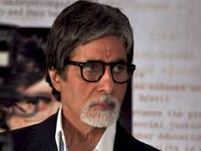

Health
While filming Coolie in 1982, Bachchan was seriously injured during the filming of a fight scene with co-star Puneet Issar. He was in the hospital with a ruptured intestine for months, and at times was close to death. A remarkable outpouring of support and concern by his fans and the nation in general followed. After recovering, Bachchan resumed shooting for Coolie, and it finally released as a huge success owing to its pre-release publicity.
The director, Manmohan Desai altered the ending for Coolie after Bachchan's accident. Bachchan's character was originally intended to have been killed off but after the change of script, the character lived in the end. It would have been inappropriate, said Desai, for the man who had just fended off death in real life to be killed on screen as well. Also, remarkably, in the released film the footage of the fight scene is frozen at the critical moment, and a caption appears onscreen marking this as the instant of the actor's injury and the ensuing publicity of the accident.
In November of 2005, Amitabh Bachchan was admitted to Lilavati Hospital once more, to undergo surgery for diverticulitis. This occurred after Bachchan complained of pains in his abdomen some days prior. During the period and that following his recovery, most of his projects were put on hold, including the television show he was in the process of hosting, Kaun Banega Crorepati. Amitabh returned to work in March of 2006.

RECENT :
Though today age of Mr Big B is more than 70+ , still his passion about acting in entertainment world is more enough to compete other stars and we can see it in PAA , satyagraha etc.
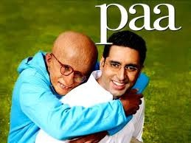 (IN PAA)

I salute you Mr Bachchan .

Regards,
Siddharth Bumb
www.facebook.com/DTandIDT
WWW.SIDDHARTHBUMB.BLOGSPOT.COM

