How to Pay LIC Premium Online :
Copy below link and paste in your browser
http://www.licindia.in/mobile
You will be directed to the website
The page will be displayed as below
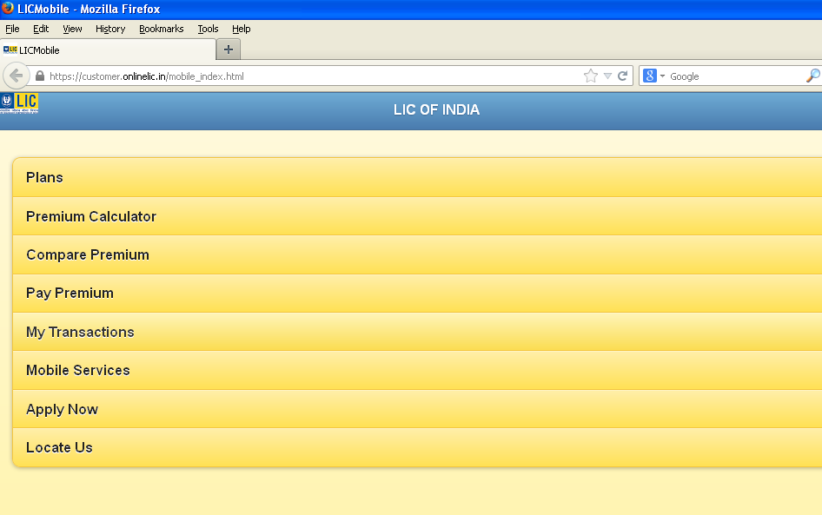

Click on Pay Premium

The page will appear as below
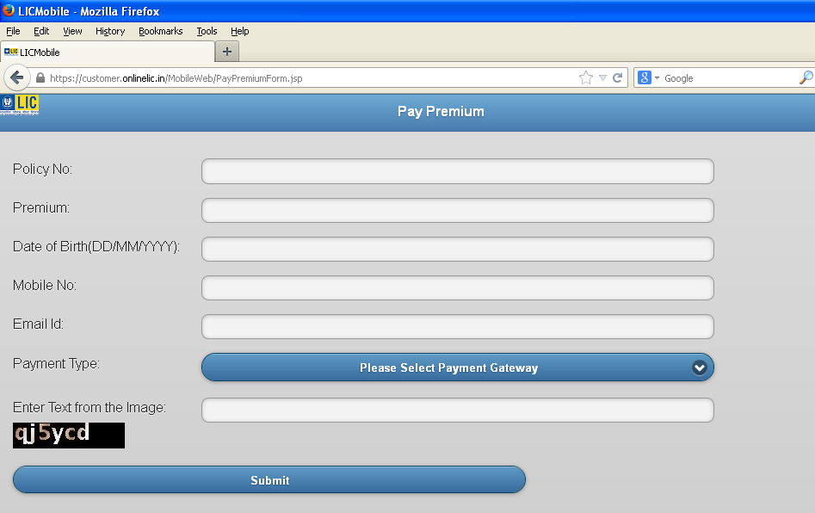

Fill the details

Below is the sample file :
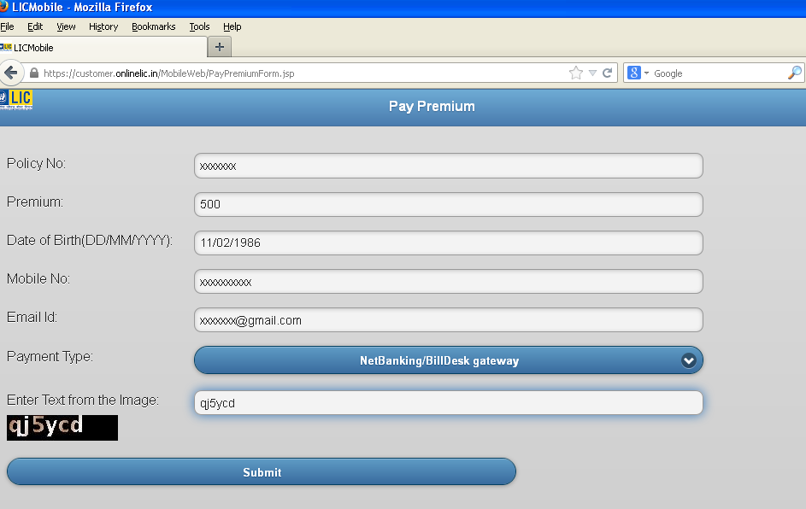

After entering the details click on submit you will be redirected to the your bank’s net banking for payment . After the payment is done a receipt is generated in pdf format . You can keep it for your future reference.
Note : If you don’t have netbanking user id and password you may request your banker to provide the same in which you maintain your savings account.

