Table of Contents
INTRODUCTION TO COMPUTER 3
COMPONENTS OF COMPUTER 4
OPERATING SYSTEM 5
MS OFFICE 2010 6
MS WORD 2010 7
FEATURES OF MS WORD 2010 8
TABLE IN MS WORD 2010 9
MAIL MERGE IN MS WORD 2010 10
TABLE OF CONTENTS 14
MS WORD SHORTCUT KEYS 15
MS EXCEL 2010 16
FEATURES OF MS EXCEL 2010 17
FORMULA FUCTION 18
LOAN AMORTISATION TABLE 19
PERSONAL INFORMATION SHEET 20
ATTANDANCE SHEETS 21
ENQUIRY SHEET 22
PIVOT TABLE 23
PIVOT CHART 24
CHARTS IN MS EXCEL 25
MS EXCEL SHORTCUT KEYS 26
MS POWERPOINT 2010 27
MS POWER POINT SHORTCUT KEYS 28
MS ACCESS 2010 29
KEYS 30
RELATIONSHIPS 31
FORMS 32
REPORTS 33
MS OUTLOOK 34
APPOINTMENT 35
MEETINGS 36
SCEDULING 38
SETTING RULES 40
e-FILING 42
DIGITAL SIGNATURES 46
TALLY 50
CREATING A NEW COMPANY 54
ACCOUNTING VOUCHER ENTRY 55
BALANCE SHEET 56
PROFIT AND LOSS ACCOUNT 57
TRIAL BALANCE 58
CASH FLOW STATEMENT 59
FUND FLOW STATEMENT 60
RATIO ANALYASIS 61
TALLY SHORCUT KEYS 62

INTRODUCTION TO COMPUTER
In the simplest definition computer is an electronic device-a flexible machine that can manipulate data. Computer is being used for tasks as addition up the supermarket bill, getting cash at an ATM, computer are also used by writers, television producers, musicians, poets, graphics illustrators and scholar of medieval history.
A computer is a programmable i.e. the computer depend totally on programmed, which the computer is using.(A PROGRAMME IS A LIST OF INSTRUCTIONS, TELLING THE COMPUTER ‘WHAT TO DO’).
The computer Hardware (machines and its components) is designed to be flexible as possible. By using computer programmed called computer software, one transform data this flexible hardware into a tool for specific purpose.


COMPONENTS OF COMPUTER
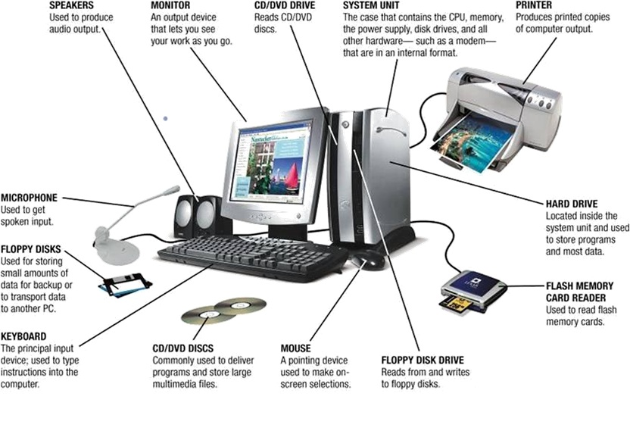

OPERATING SYSTEM
Operating system is system software which acts as an interface between user and hardware. There are big no of Operating systems available in market but few of them important are Windows, Mac, Linux, UNIX, Chrome, and Android.
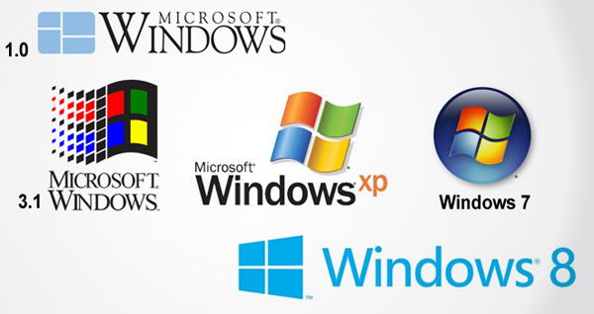

MS OFFICE 2010
Different components of MS Office 2010 are as following:-
- Microsoft Office Access 2010
- Microsoft Office Excel 2010
- Microsoft Office Groove 2010
- Microsoft Office InfoPath 2010
- Microsoft Office OneNote 2010
- Microsoft Office Outlook 2010
- Microsoft Office PowerPoint 2010
- Microsoft Office Publisher 2010
- Microsoft Office Word 2010

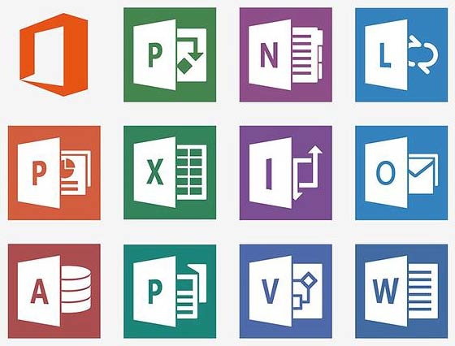

MS WORD 2010
We can work with WORD 2010 rich functionality just about anywhere: using an internet browser, a mobile phone or our desktop computer. Using Microsoft Office Mobile 2010, we can use our Window Phone 7 to work with our files from anywhere. Word Mobile 2010 is part of Office Mobile and is already on our Windows Phone 7 in the office hub, so we don’t need to download or installed anything to get started.
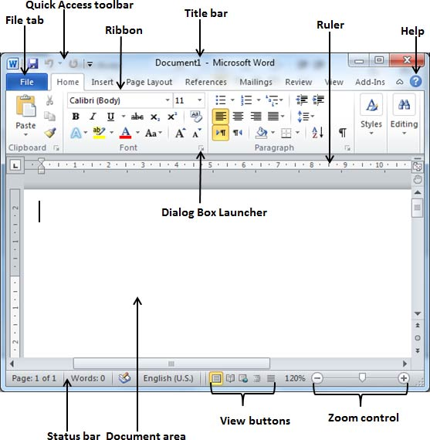

FEATURES OF MS WORD 2010
- Formatting Effects
- Navigation Pane
- Integration of Screenshot Features
- Background Removal Tool
- Backstage View
- Artistic Effect
- Open Type Features
- More Themes
- Protected View
- New Numbering Formats
- New Smart Art graphic picture layouts
- Better Picture compression and picture Cropping
- Work on the same document At the Same time.

TABLE IN MS WORD 2010

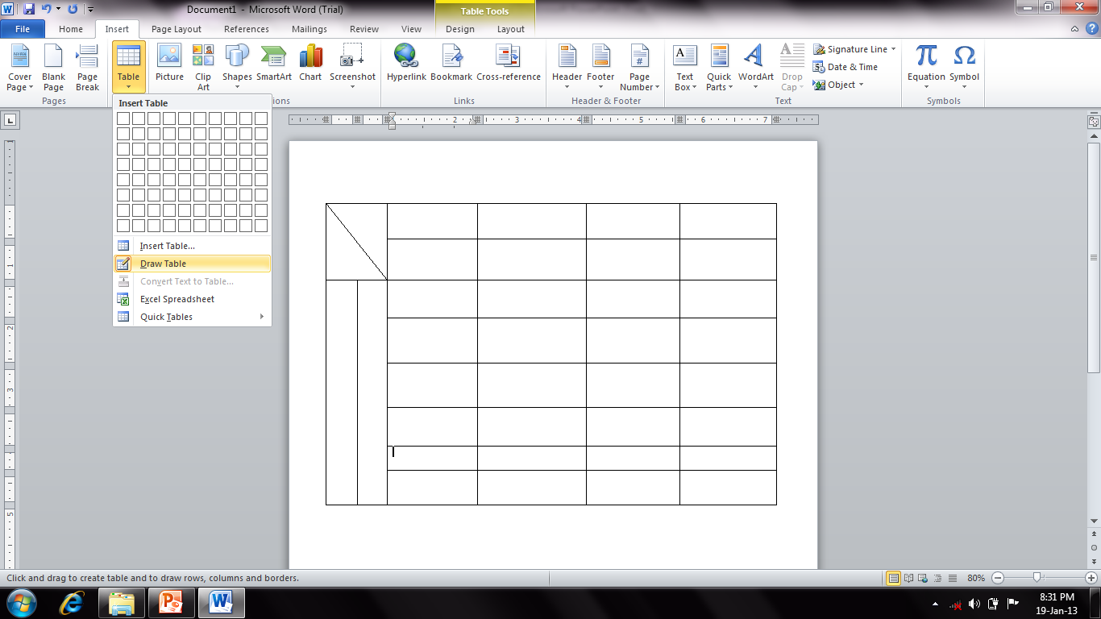

MAIL MERGE IN MS WORD 2010
We use mail merge when we want to create a set of documents, such as a form letter that is sent to many customers. Each document has the same kind of information, yet some of the content is unique. For example, in letters to our customers, we can personalize each letter to address each customer by name. The unique information in each letter comes from entries in a data source.
The mail merge process entails the following overall steps:
- Set up the main document. The main document contains the text and graphics that are the same for each version of the merged document — for example, the return address in a form letter.
- Connect the document to a data source. A data source is a file that contains the information to be merged into a document. For example, the names and addresses of the recipients of a letter.
- Refine the list of recipients or items. Microsoft Word generates a copy of the main document for each recipient or item in your data file. If you want to generate copies for only certain items in your data file, you can choose which items (or records) to include.
- Add placeholders, called mail merge fields, to the document. When we perform the mail merge, the mail merge fields are filled with information from our data file.
- Preview and complete the merge. We can preview each copy of the document before you print the whole set.
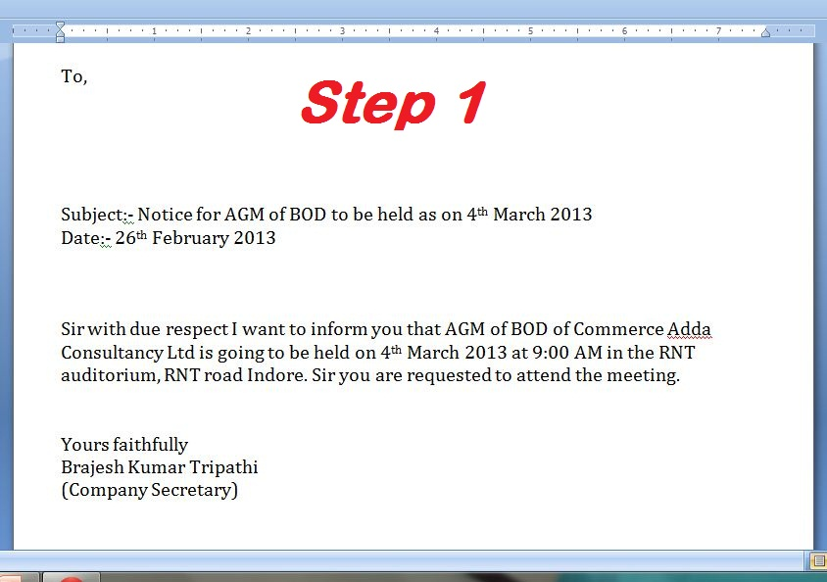
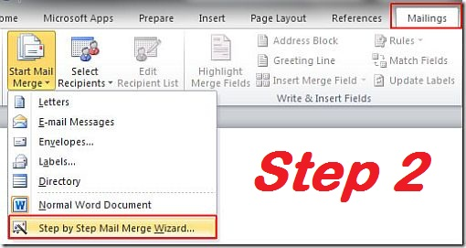

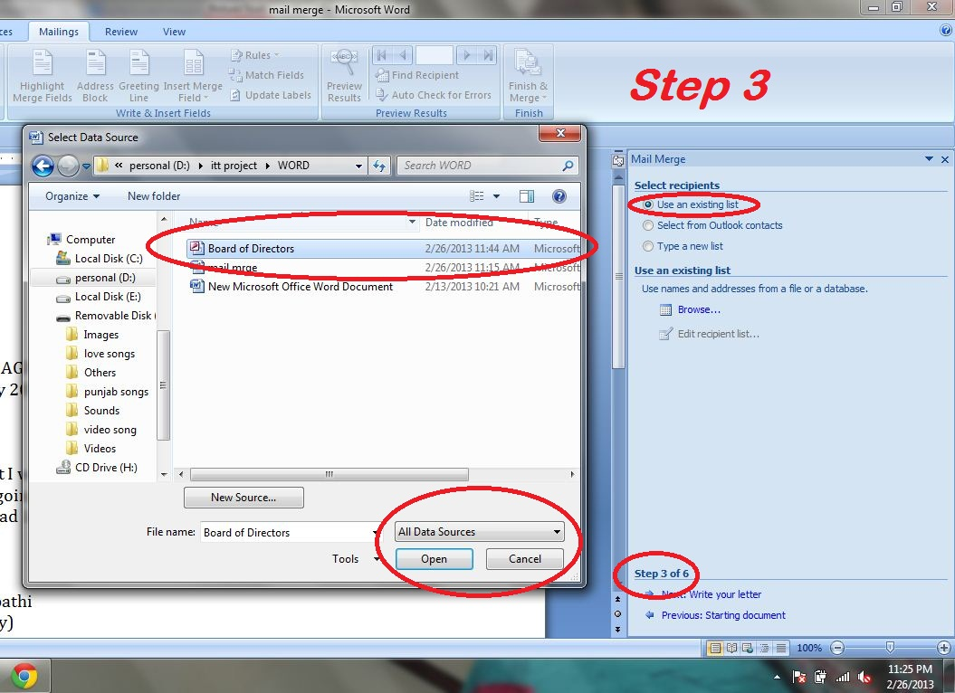

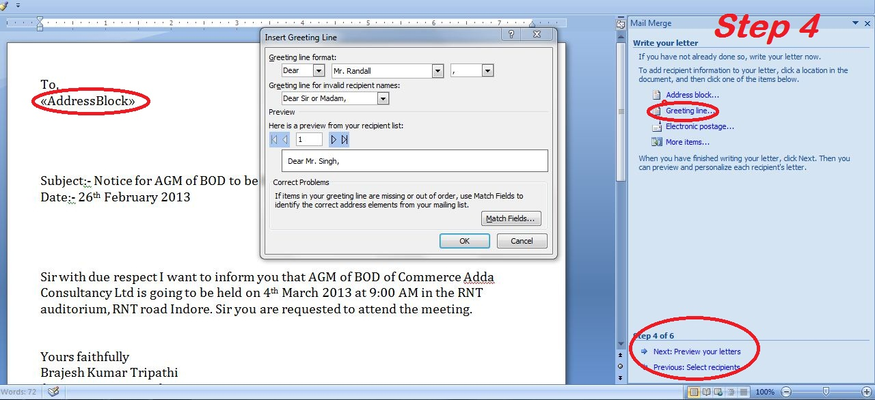
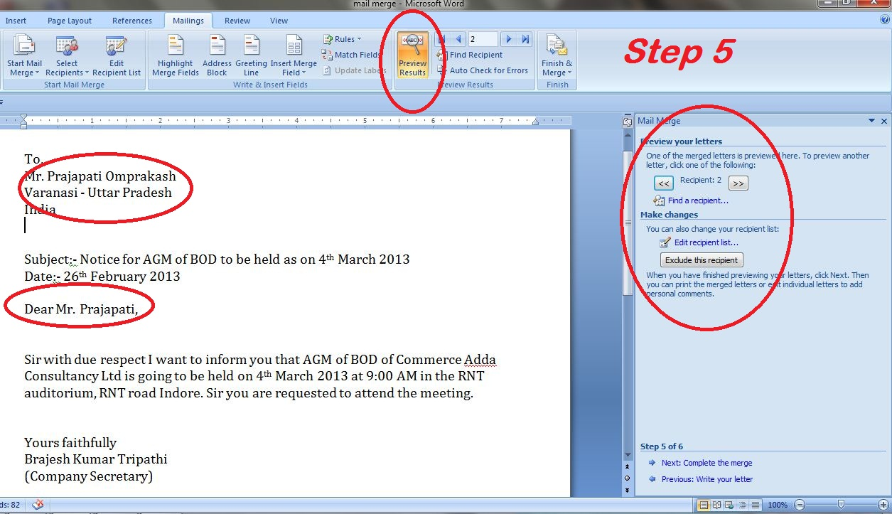
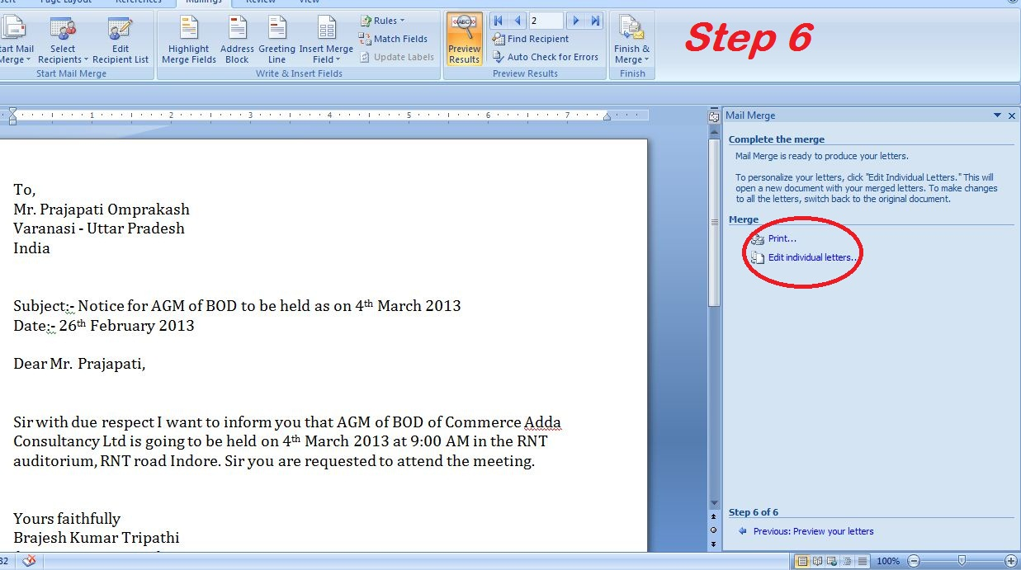

TABLE OF CONTENTS
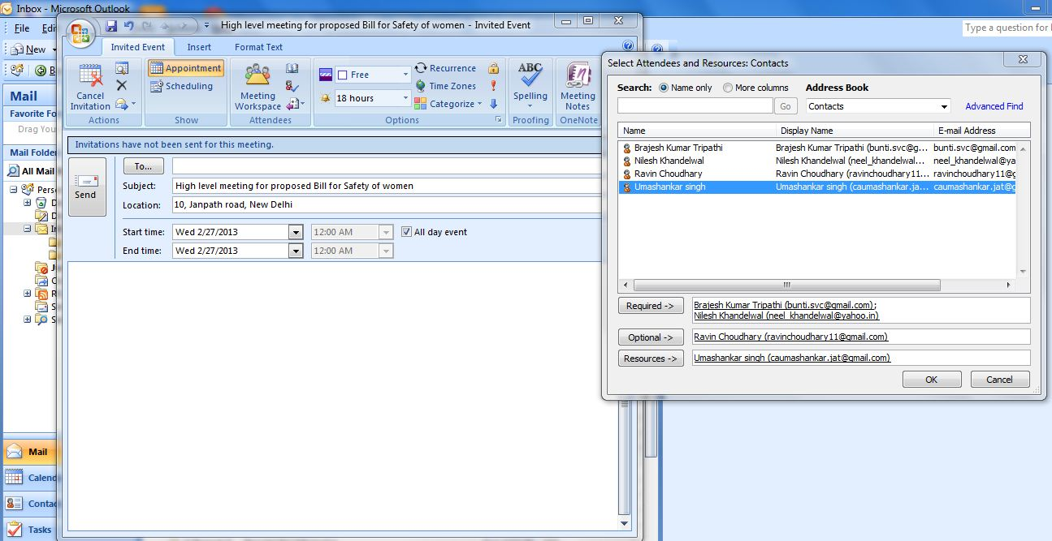

MS WORD SHORTCUT KEYS
Ctrl+Z | Undo last action | Ctrl+Y or F4 | Redo last action
Ctrl+X | Cut current selection | Ctrl+C | Copy current selection
Ctrl+V | Paste data from clipboard | Ctrl+F | Open find dialog box
Ctrl+G or F5 | Open Goto Dialog box | Ctrl+H | Open replace dialog box
Ctrl+Bksps | Delete one word towards left | Ctrl+Delete | Delete one word towards right
Shift+ | Select character to the right of the insertion point | Shift+Home | Select all the current line to the left of insertion point
Shift+ | Select character to the left of the insertion point | Shift+End | Select all the current line to the right of insertion point
Shift+PgUp | Select a screenful of text from insertion point up | Ctrl+Shift+ | Select one word to the right of insertion point
Shift+PgDn | Select a screenful of text from insertion point down | Ctrl+Shift+ | Select one word to the left of insertion point
Crtl+Shift+Home | Select all text from insertion point to the start of document | Crtl+Shift+ End | Select all text from insertion point to the end of document
Crtl+A | Selects entire document
Ctrl+B | Toggles bold on the selection | Ctrl+I | Toggles italics on the selection
Ctrl+U | Toggles underline on the selection | Ctrl+= | Toggles subscript on the selection
Ctrl+Shift+= | Toggles superscript on the selection | Ctrl+] | Increases font size by one point
Ctrl+[ | Decreases font size by one point | Ctrl+Shift+> | Increases font size
Ctrl+Shift+< | Decreases font size | Ctrl+L | Aligns selections to the left
Ctrl+E | Aligns selections to the center | Ctrl+R | Aligns selections to the right
Ctrl+J | Justify the selections | Ctrl+D | Open Font dialog box
Ctrl+Shift+P | Apply bullets to selection | Shift+F3 | Changes case of selection
Ctrl+Shift+C | Copy formats from selection | Ctrl+Shift +V | Paste formats to the selection
Ctrl+M | Indent Paragraph | Ctrl+Shift+F | Select font name list on formatting toolbar
Ctrl+Shif+S | Open style box
Ctrl+1 | Single Line Spacing | Ctrl+2 | Double Line Spacing
Ctrl+5 | 1.5 Line Spacing | F7 | Open Spellchecker
Shift+F7 | Open Thesaurus | Shift+F3 | Change Case

MS EXCEL 2010
Excel 2010 is spreadsheet software in the new Microsoft 2010 Office Suite. Excel allows you to store manipulate and analyze data in organized workbooks for home and business tasks. New innovations in Excel 2010 include the enhanced data viewing features of Spark lines and Slicers.
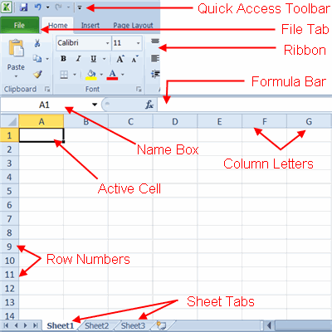

FEATURES OF MS EXCEL 2010
- Worksheet and graphics
- Data lists and Databases
- Data Exchange with other application
- Results oriented user interface
- Optimized memory consumption
- Access spread sheet from virtually anywhere
- Connect and share when working together

FORMULA FUCTION
Formulas are entries that have an equation that calculates the value to display. We DO NOT type in the numbers we are looking for; we type in the equation. This equation will be updated upon the change or entry of any data that is referenced in the equation.
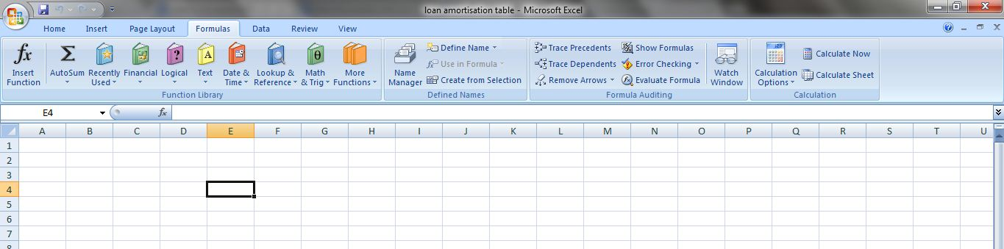

LOAN AMORTISATION TABLE
An amortization schedule is a table or chart showing each payment on an amortizing loan, including how much of each payment is interest and the amount going towards the principal balance. We can make loan amortization schedule easily with the help of functions in the Excel. One can easily make it if he know the principal amount, rate of interest, and no of installments.
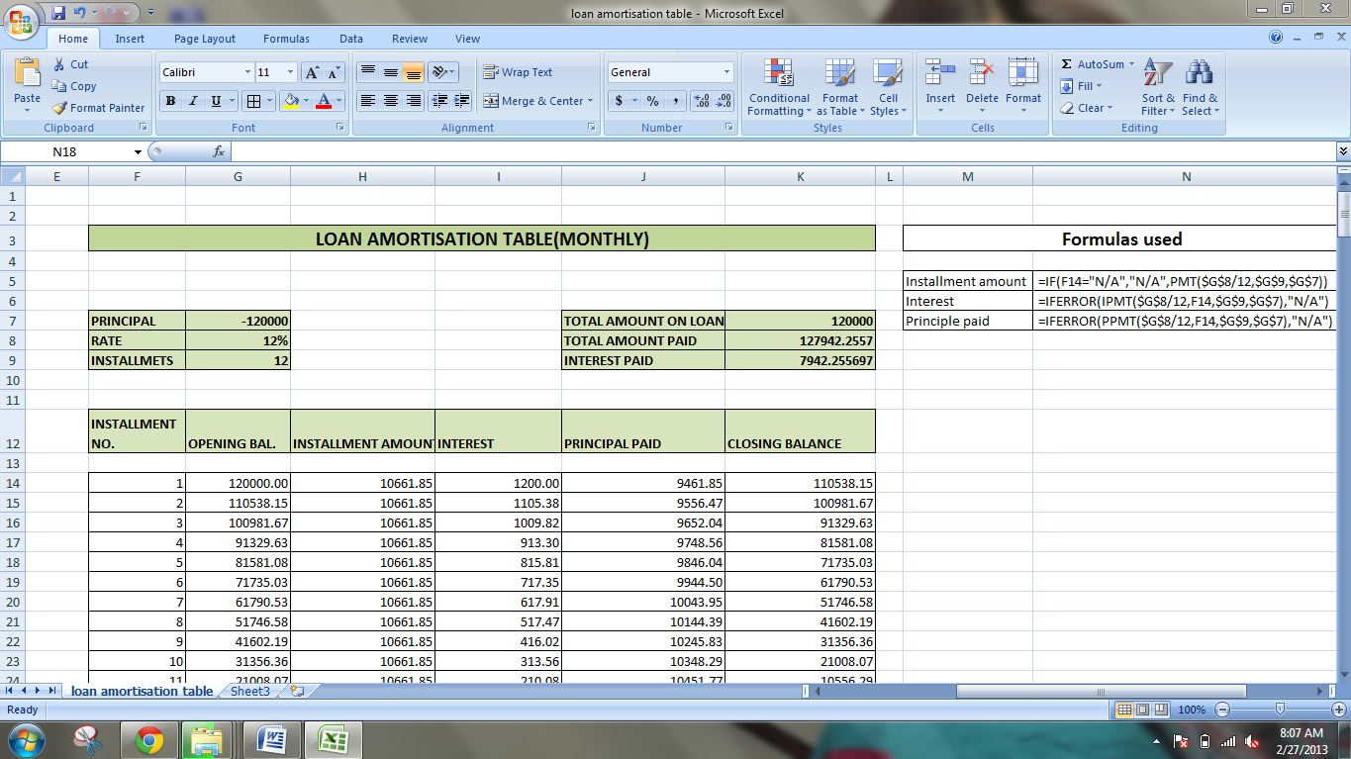

This is the example of the loan amortization schedule prepared in MS-Excel with the help of the financial functions and logical functions.

PERSONAL INFORMATION SHEET
We can use the auto updating feature of MS EXCEL to prepare and keep the records of student and employees as well.
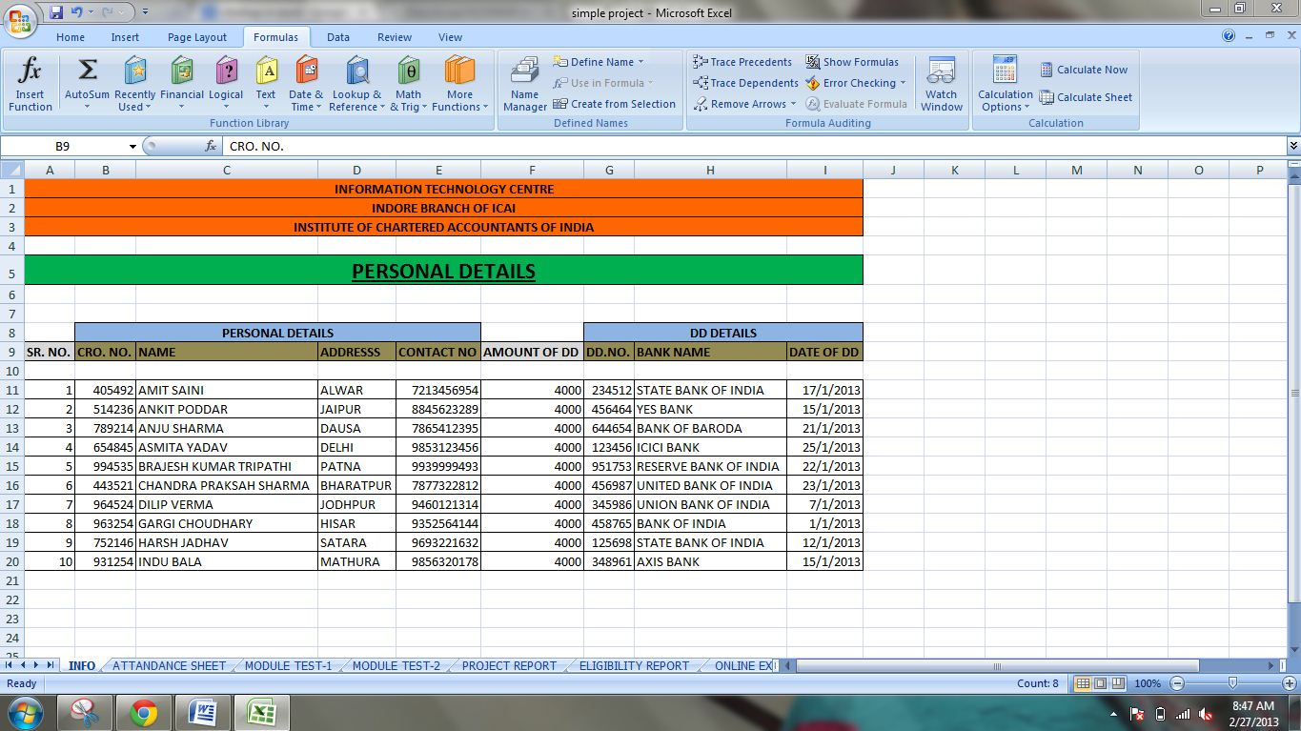

ATTANDANCE SHEETS
We can keep the attendance info of students/employees/ group. Moreover we can use logical functions to count absenteeism and use different rules for highlighting the cells.
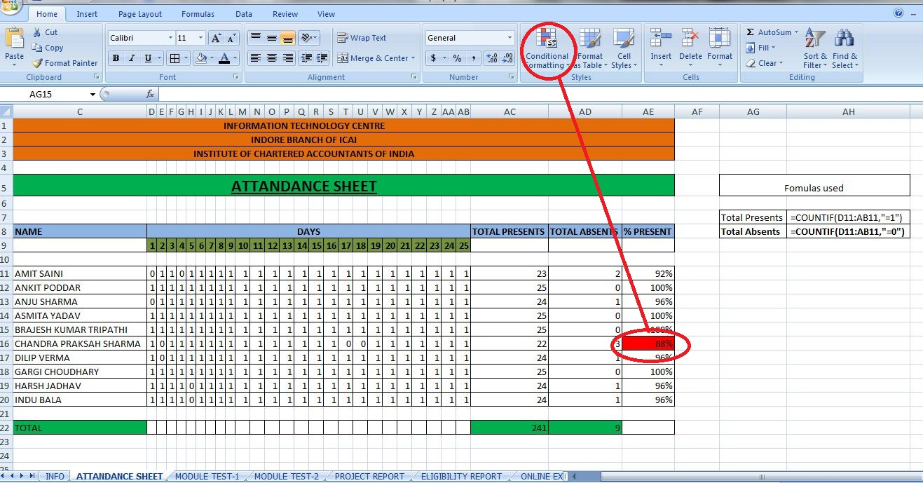

ENQUIRY SHEET
We can use different referencing features, functions like VLOOKUP and data validation rules to make an enquiry sheet from the data at other sheets.
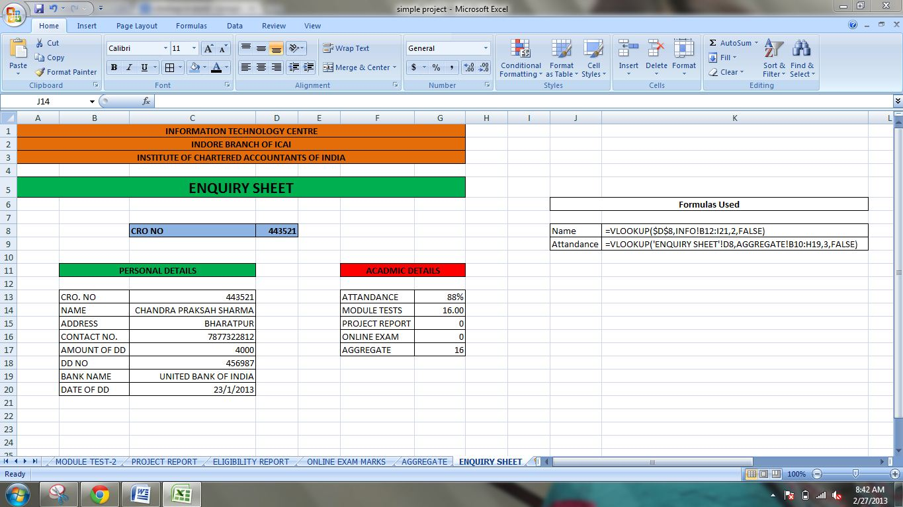

PIVOT TABLE
Pivot tables in Excel are a versatile reporting tool that makes it easy to extract information from large tables of data without the use of formulas.
Pivot tables are extremely user friendly in that by moving, or pivoting, fields of data from one location to another using drag and drop. We can look at the same data in a number of different ways.
In data processing, a pivot table is a data summarization tool found in data visualization programs such as spreadsheets or business intelligence software. Among other functions, a pivot-table can automatically sort, count, total or give the average of the data stored in one table or spreadsheet. It displays the results in a second table (called a "pivot table") showing the summarized data. Pivot tables are also useful for quickly creating unweighted cross tabulations.
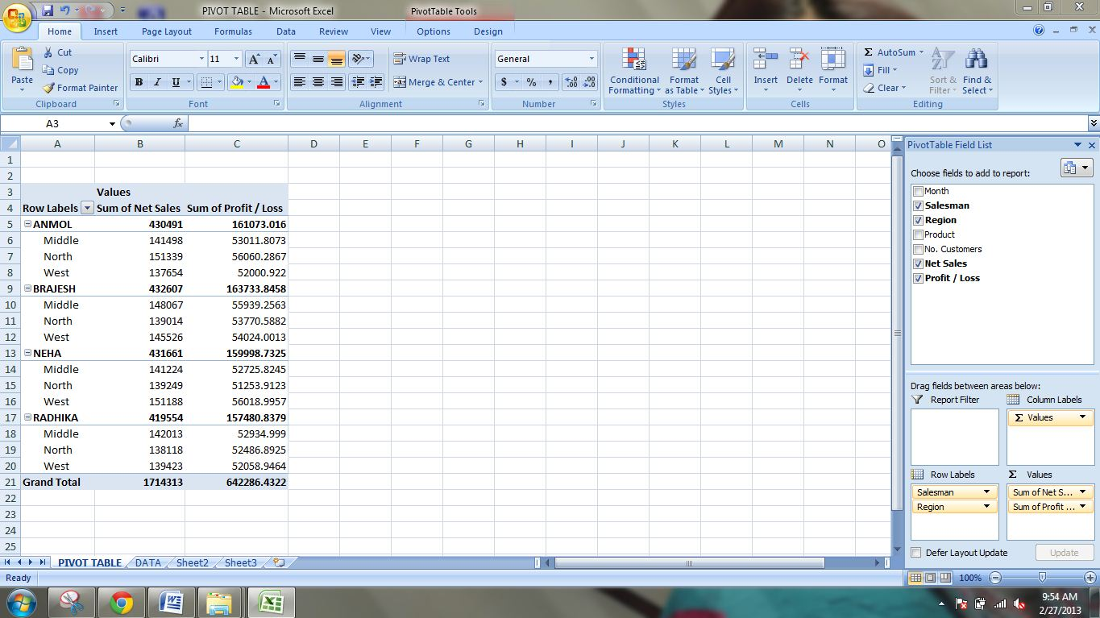

PIVOT CHART
A PivotChart report provides a graphical representation of the data in a PivotTable report, which in this case is called the associated PivotTable report. A PivotChart report is also interactive. When we create a PivotChart report, the PivotChart Filter Pane appears. We can use this filter pane to sort and filter the underlying data of the PivotChart report. Changes that we make to the layout and data in the associated PivotTable report are immediately reflected in the layout and data in the PivotChart report.
A PivotChart report displays data series, categories, data markers, and axes just as standard charts do. We can also change the chart type and other options such as the titles, the legend placement, the data labels, the chart location, and so on.
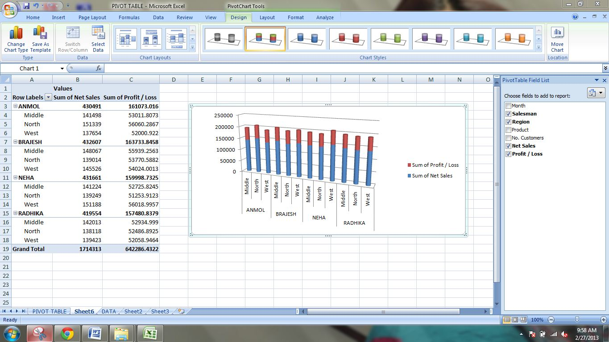

CHARTS IN MS EXCEL
A chart is designed to:
- Present information in graphic form
- Plot specific information
Using a chart is a great way to make complicated material—such as comparisons, patterns, and trends in data—easy to view and understand. For instance, rather than analyze several columns of worksheet numbers, we can use a chart to compare at a glance how the enrollment statistics of girls and boys are changing over a period of years.
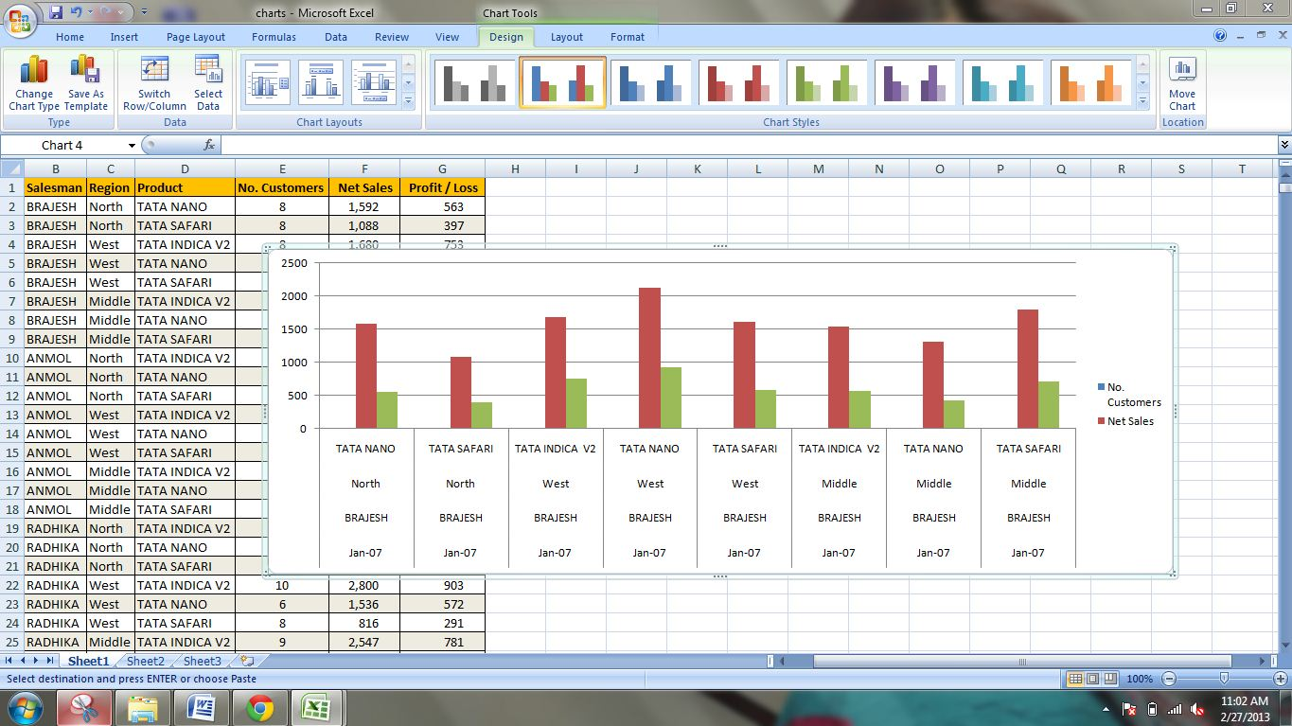

MS EXCEL SHORTCUT KEYS
F2 | Edit the selected cell. | F5 | Goto a specific cell. For example, C6.
F7 | Spell check selected text and/or document. | F11 | Create chart.
Ctrl + Shift + ; | Enter the current time. | Ctrl + ; | Enter the current date.
Alt + Shift + F1 | Insert New Worksheet. | Shift + F3 | Open the Excel formula window.
Shift + F5 | Bring up search box. | Ctrl + A | Select all contents of the worksheet.
Ctrl + B | Bold highlighted selection. | Ctrl + U | Underline highlighted selection.
Ctrl + I | Italic highlighted selection. | Ctrl + 5 | Strikethrough highlighted selection.
Ctrl + F9 | Minimize current window. | Ctrl + F10 | Maximize currently selected window.
Ctrl + F6 | Switch between open workbooks / windows. | Ctrl + Page up | Move between Excel work sheets in the same Excel document.
Ctrl + Page down | Move between Excel work sheets in the same Excel document. | Ctrl + Tab | Move between Two or more open Excel files.
Alt + = | Create a formula to sum all of the above cells | Ctrl + ' | Insert the value of the above cell into cell currently selected.
Ctrl + Shift + ! | Format number in comma format. | Ctrl + Shift + ^ | Format number in scientific format.
Ctrl + Shift + $ | Format number in currency format. | Ctrl + Shift + @ | Format number in time format.
Ctrl + Shift + # | Format number in date format. | Ctrl + Shift + % | Format number in percentage format.
Shift + Space | Select entire row. | Ctrl + Space | Select entire column
Ctrl+1 | Displays Format Cells dialog box.
Ctrl+9 | Hides the selected rows | Ctrl+0 | Hides the selected columns.
Ctrl+SHIFT+( | Unhide any hidden rows within the selection | Ctrl+SHIFT+) | Unhide any hidden columns within the selection.
Ctrl+SHIFT+& | Applies the outline border to the selected cells. | Ctrl+SHIFT_ | Removes the outline border from the selected cells.
F8 | Turns extend mode on or off. In extend mode the arrow keys extend the selection. | SHIFT+F8 | Enables to add a nonadjacent cells to a selection of cells by using the arrow keys

MS POWERPOINT 2010
Microsoft PowerPoint, usually just called PowerPoint, is a commercial presentation program developed by Microsoft. It is part of the Microsoft Office suite and generally uses a graphical approach to presentations in the form of slide shows that accompany the oral delivery of the topic.
The main purpose of MS PowerPoint is to enable the user to create dynamic, informational slides through the use of text, graphics, and animation. Slide presentations created with the software are often displayed on projection screens for business, training, or educational presentations, although they can be distributed as stand-alone files. Additionally, the slides can be arranged and printed to PDF handouts for reference.
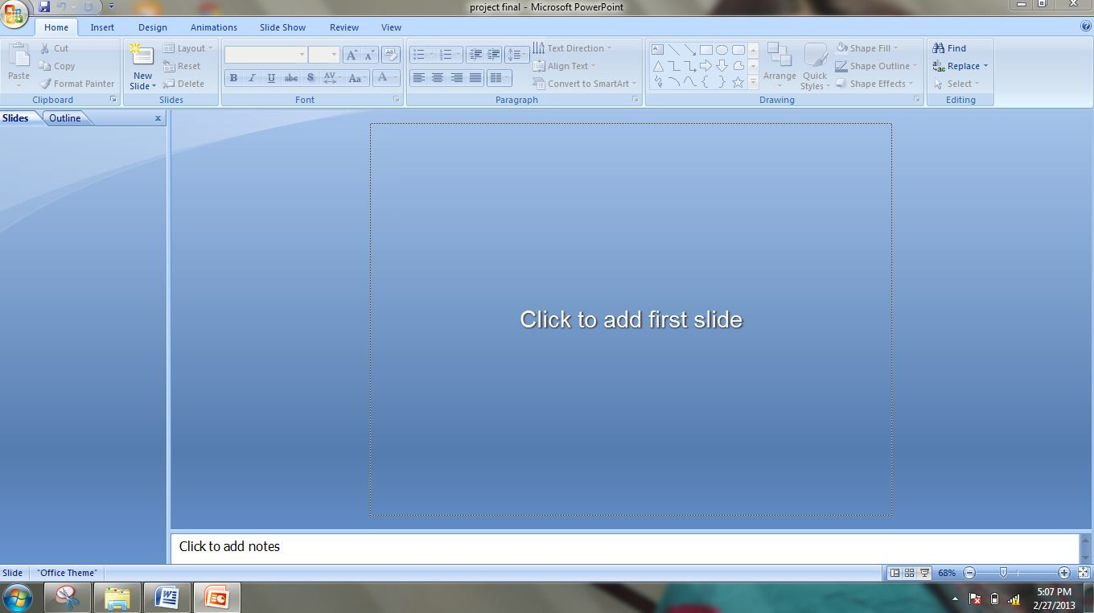

MS POWER POINT SHORTCUT KEYS
Ctrl + N | Opens a new blank presentation | Ctrl + M | Inserts a new slide
Ctrl + D | Duplicates the selected object | Ctrl + T | Opens the Font dialog box
F5 | Run slide show from beginning | Shift+F5 | Run slide show from current slide
During Slide Show
N, ENTER, PGDOWN, , ↓, SPACE | Perform the next animation or advance to the next slide | P, PGUP, ←↑ BACKSPACE | Perform the previous animation or return to the previous slide
<No>+ENTER | To go to slide number | ESC | End a slide show
W or COMMA | Display a white screen, or return to the slide show from a white screen | B or PERIOD | Display a black screen, or return to the slide show from a black screen
E | Erase on-screen annotations | H | Go to the next hidden slide
Ctrl+P | To redisplay hidden pointer and/or change the pointer to a pen | Ctrl+A | Visible hidden pointer and/or change the pointer to an arrow
Ctrl+H | Hide the pointer and navigation button immediately | Ctrl+U | Hide the pointer and navigation button automatically
SHIFT+F10 or Popup button | To display the shortcut menu

MS ACCESS 2010
Microsoft Access, also known as Microsoft Office Access, is a database management system from Microsoft that combines the relational Microsoft Jet Database Engine with a graphical user interface and software-development tools. It is a member of the Microsoft Office suite of applications, included in the Professional and higher editions or sold separately.
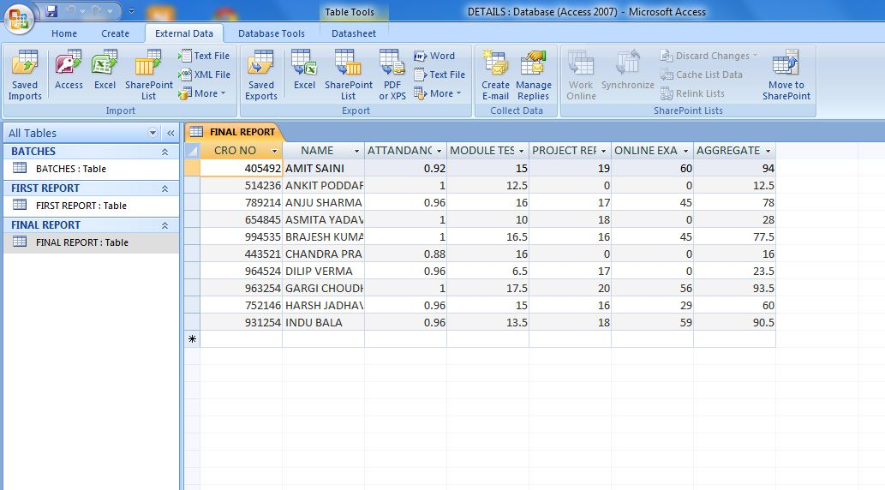

KEYS
Primary Key:- A primary key is a field or set of fields in your table that provide Microsoft Office Access 2007 with a unique identifier for every row. In a relational database, such as Office Access 2007, you divide your information into separate, subject based tables. You then use table relationships and primary keys to tell Access how to bring the information back together again. Access uses primary key fields to quickly associate data from multiple tables and combine that data in a meaningful way.
Foreign key:- A foreign key, simply stated, is another table's primary key.
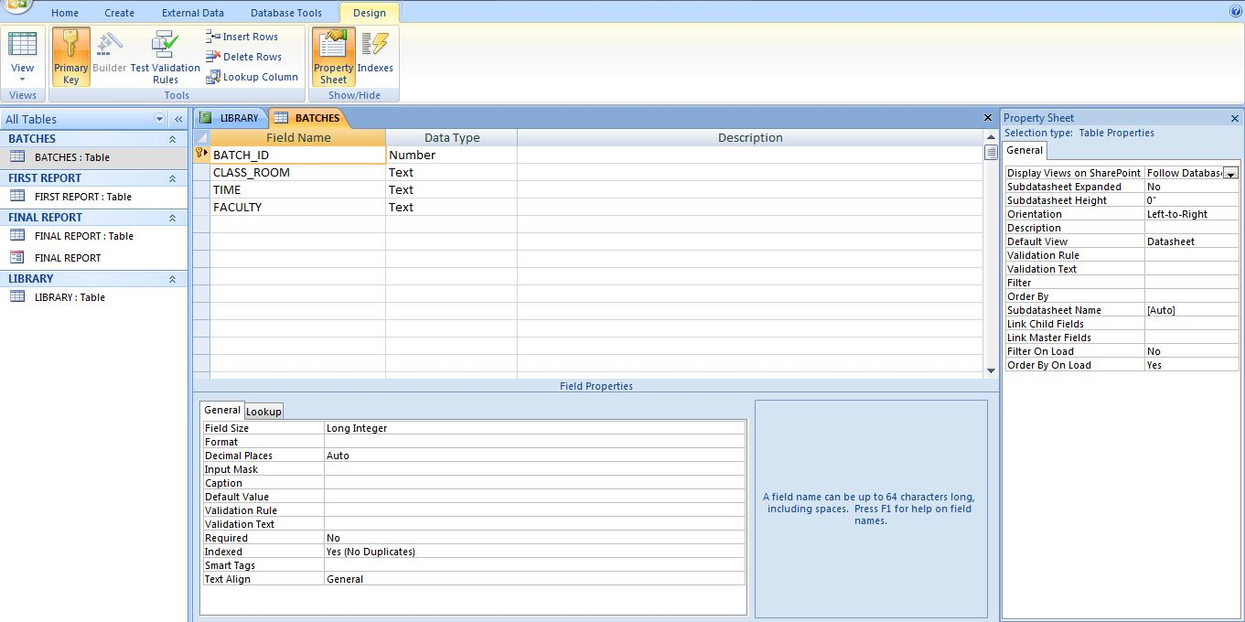

RELATIONSHIPS
One of the goals of good database design is to remove data redundancy (duplicate data). To achieve that goal, you divide your data into many subject-based tables so that each fact is represented only once.
TYPES OF RELATIONSHIPS
- ONE TO MANY :- Each record in first table is related to many records in other table.
- ONE TO ONE:- Each record in second table is related to only one record in second table and vice versa. It is a rare case of relationship.
- MANY TO MANY:- Each record is first table may be related to more than one record in next table and vice versa is also true.
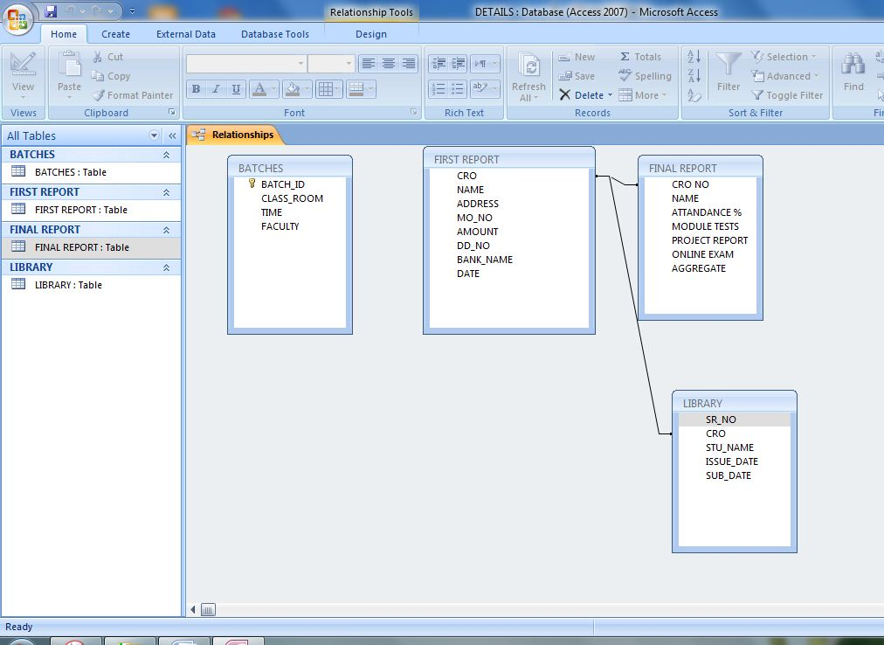

FORMS
A form is a database object that you can use to enter, edit, or display data from a table or a query. You can use forms to control access to data, such as which fields or rows of data are displayed. For example, certain users might need to see only several fields in a table with many fields. Providing those users with a form that contains just those fields makes it easier for them to use the database. You can also add buttons and other functionality to a form to automate frequently performed actions.
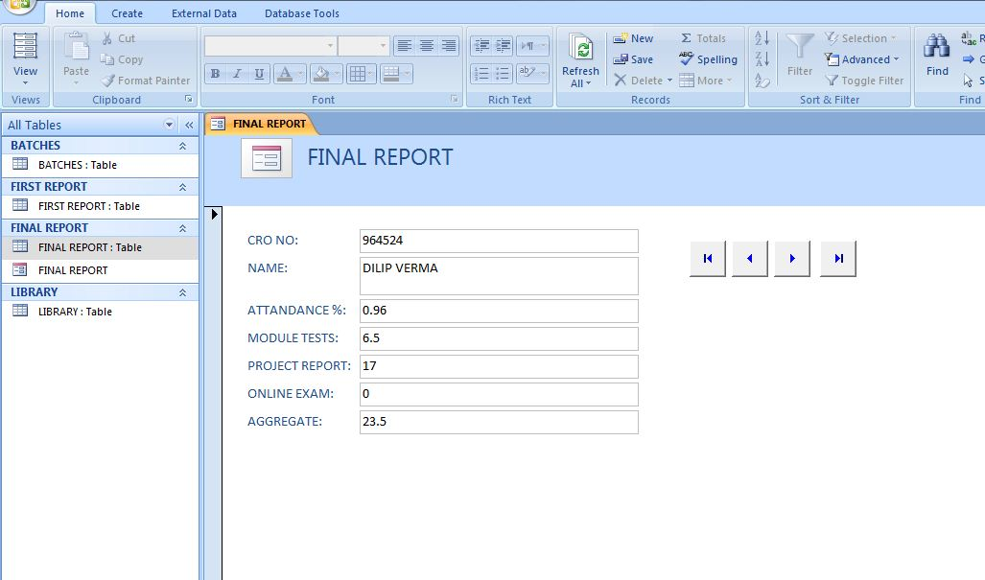

REPORTS
Reports are a great way to organize and present data from your Microsoft Access database. Reports enable you to format your data in an attractive and informative layout for printing or viewing on screen.
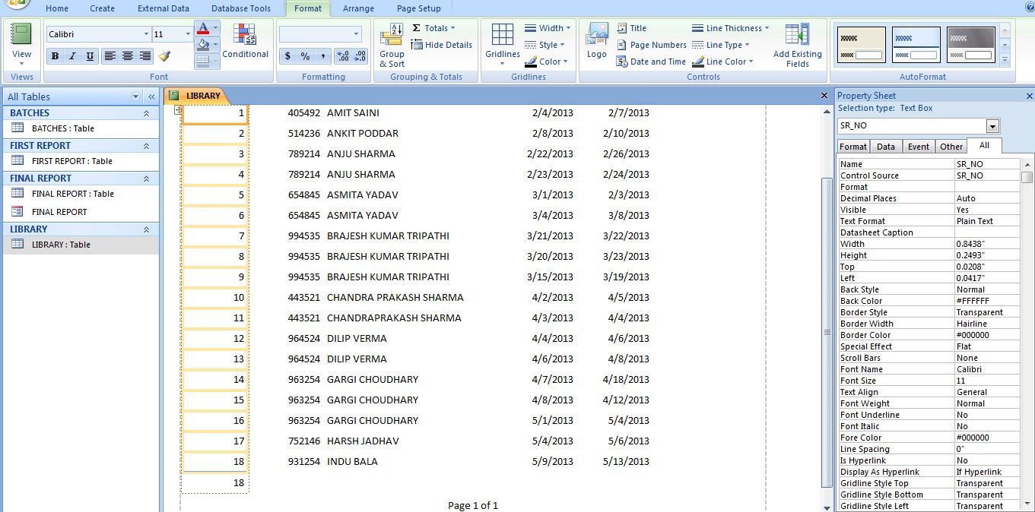

MS OUTLOOK
Microsoft Outlook is a personal information manager from Microsoft, available as a part of the Microsoft Office suite. The current version is Microsoft Office Outlook 2013 for Windows and Microsoft Office Outlook 2011 for Mac.
Although often used mainly as an email application, it also includes a calendar, task manager, contact manager, note taking, a journal and web browsing.
It can be used as a stand-alone application, or can work with Microsoft Exchange Server and Microsoft SharePoint Server for multiple users in an organization, such as shared mailboxes and calendars, Exchange public folders, SharePoint lists and meeting schedules.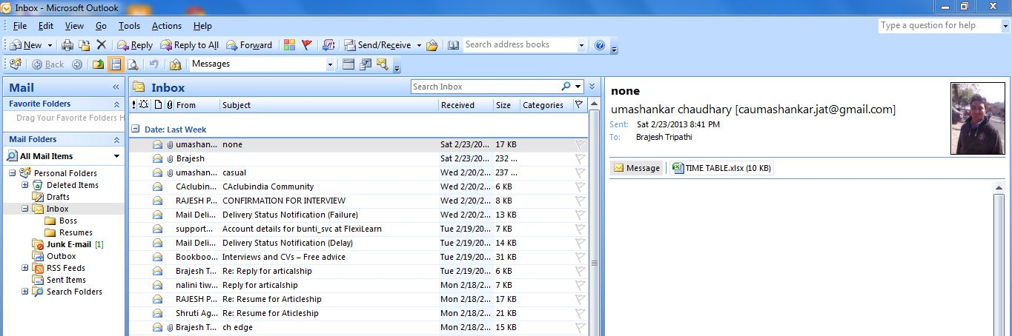

APPOINTMENT
Appointments are activities that you schedule in your calendar that do not involve inviting other people or reserving resources. You can schedule recurring appointments, view your appointments by day, week, or month, and set reminders for your appointments.
You can specify how the appointments in your calendar look to others by designating the time of the appointment as busy, free, tentative, or out of office. Also, others can give you permission to schedule or make changes to appointments in their calendars.

MEETINGS
A meeting is an appointment to which we invite people or reserve resources for. We can create and send meeting requests and reserve resources for face-to-face meetings or for online meetings. When we create a meeting, we identify the people to invite and the resources to reserve and we pick a meeting time. Responses to our meeting request appear in your Inbox. We can also add people to an existing meeting or reschedule a meeting.
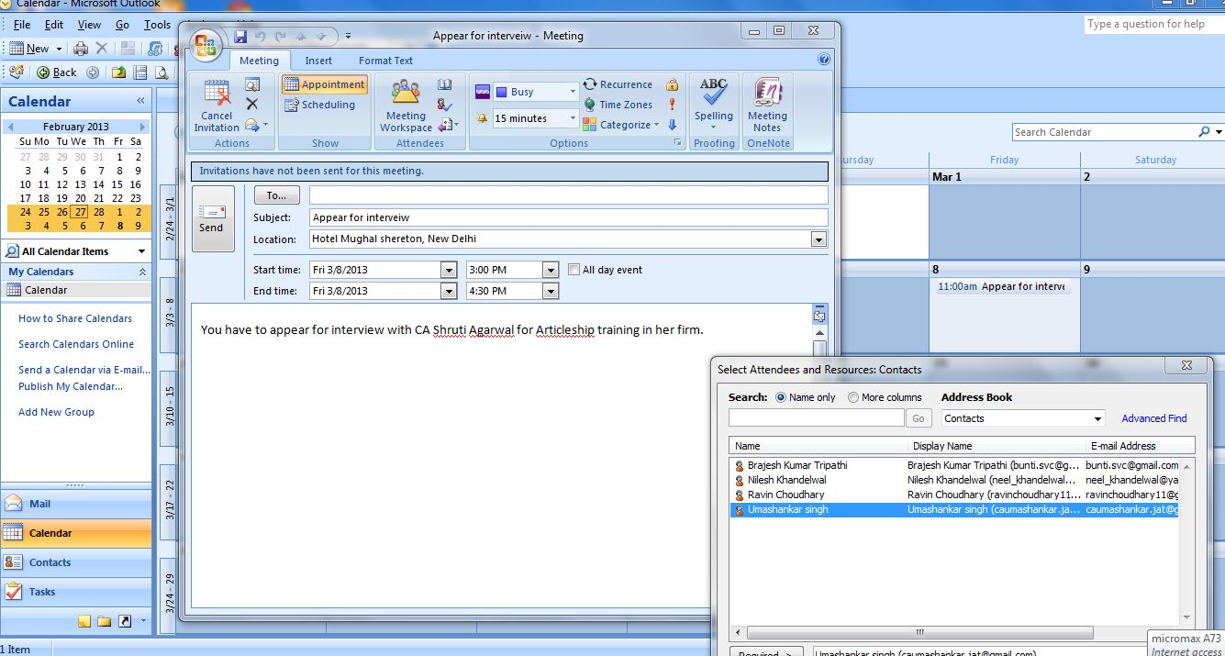
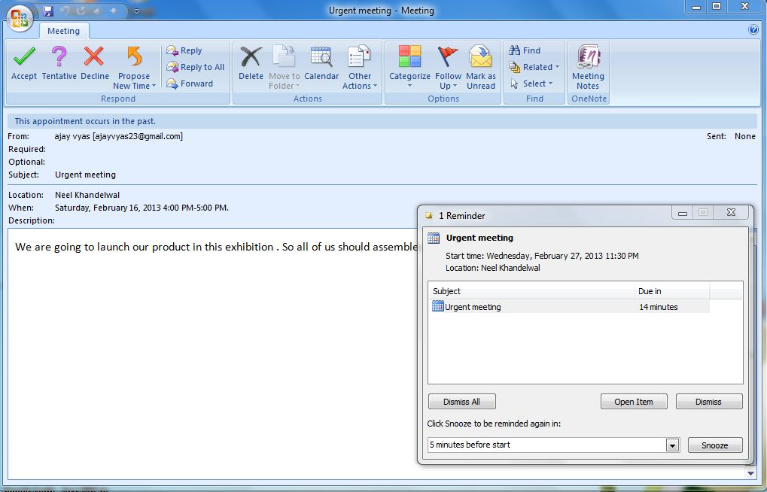

Above is the way in which the meeting request in our email will be seen.

SCEDULING
The Outlook calendar can be used for managing your own time, creating appointments and scheduling meetings with others. You are also able to view other peoples calendars if you have permissions to do so. Similarly, you can set up permissions for others to view your calendar, follow how to set up calendar permissions guidance to do this.
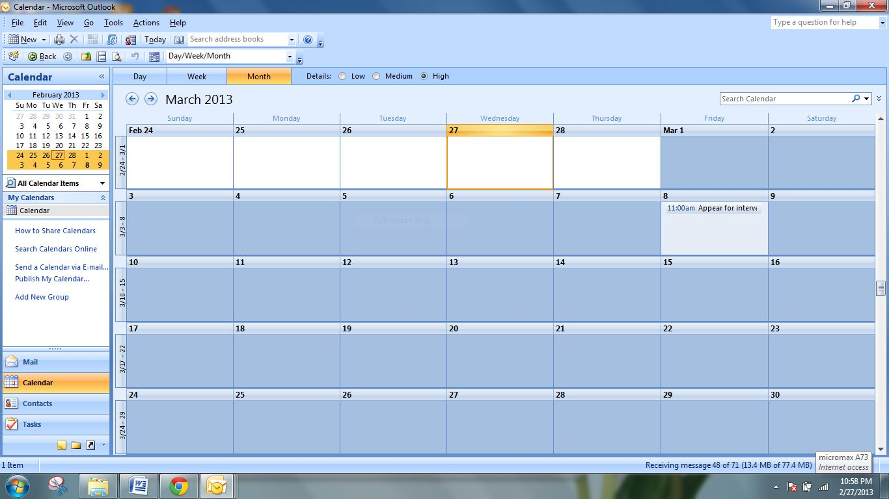
In the same way we can send our calendar to others to adjust it with their own calendar.
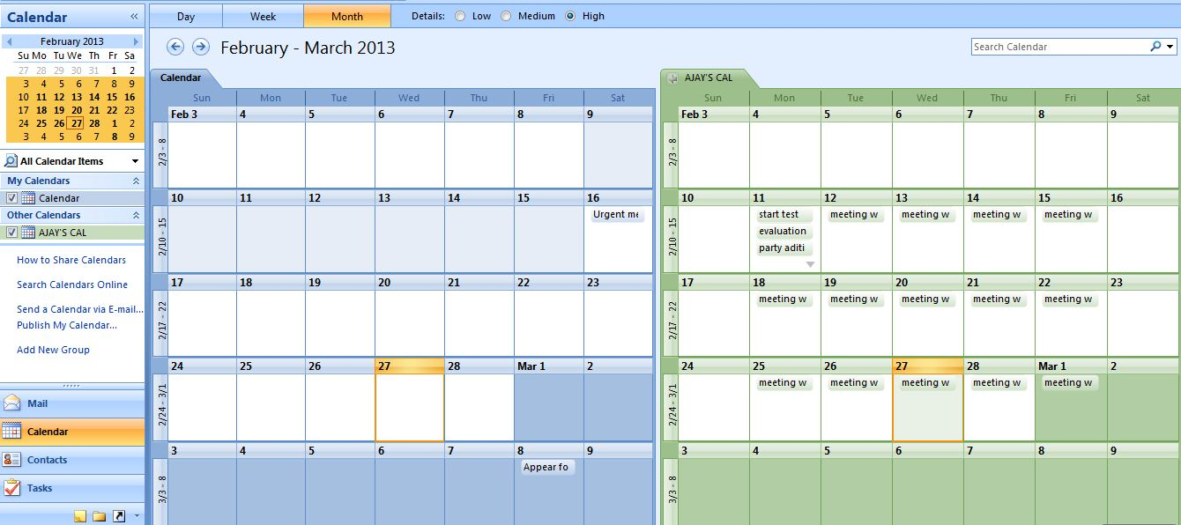

SETTING RULES
We can set different rules and criteria for inbox e.g. we can set a rule that mail from particular person goes to BOSS folder in inbox.
Also we can set rules so that mail with particular words in subject of mail will be sent to RESUME folder n inbox automatically.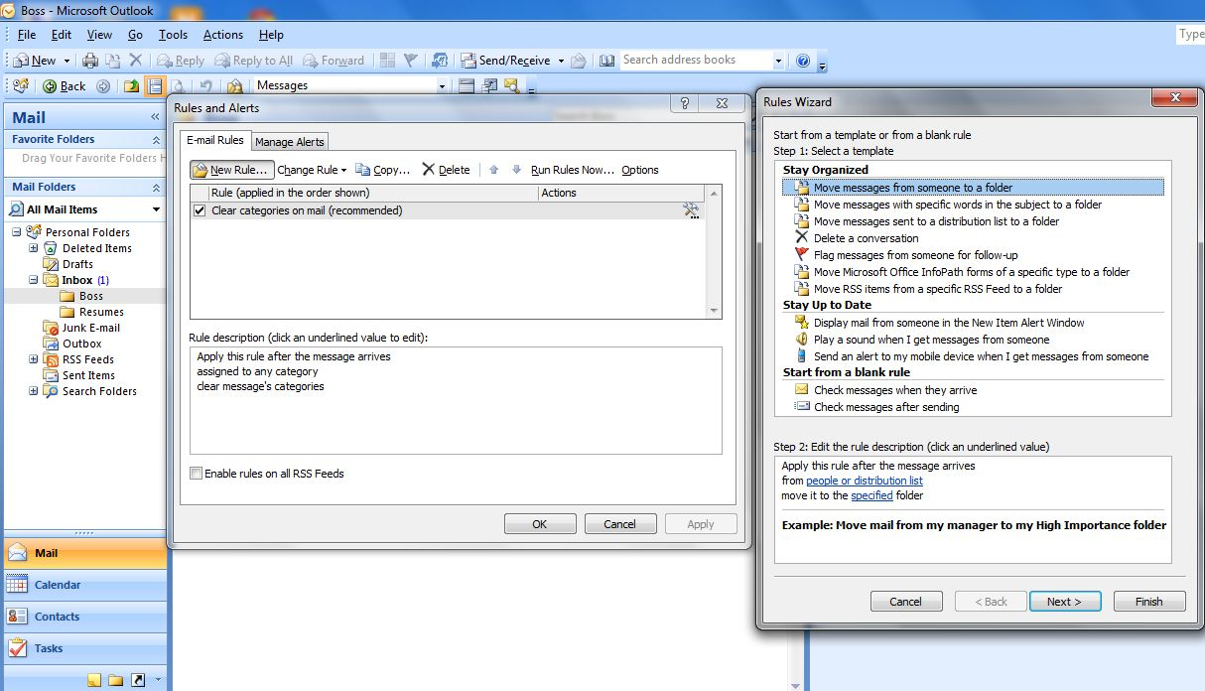
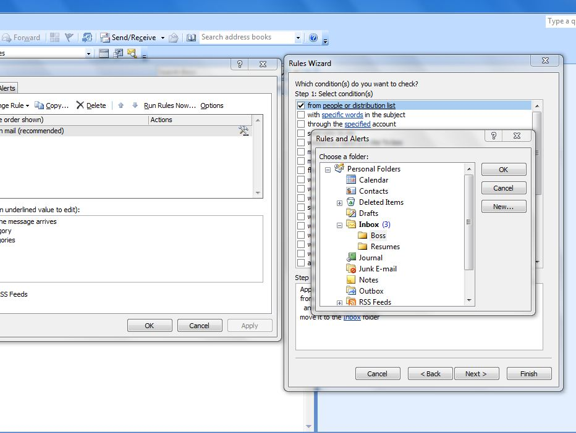

e-FILING
The process of using a computer program to transmit information electronically to another party. This allows the user to complete and submit the information in a timely fashion. The electronic filing system prevents the user from making small mistakes by alerting them if something does not register correctly. A large majority of federal and state revenue departments offer citizens the ability to file yearly tax returns using an electronic filing system.
Following is the ITR-1 form filled step by step
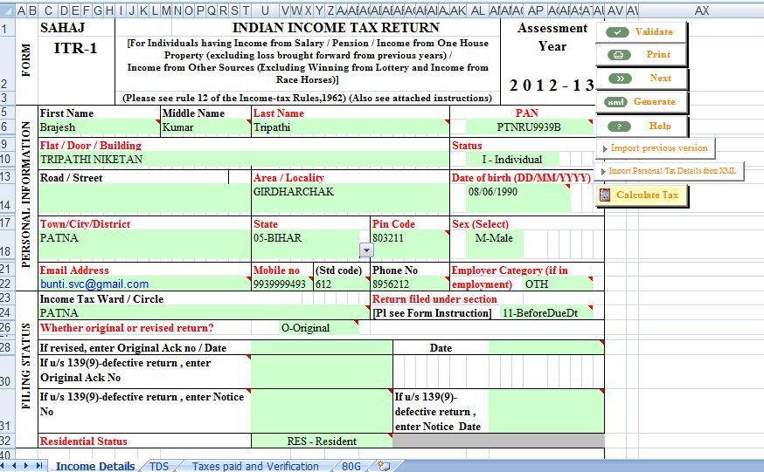
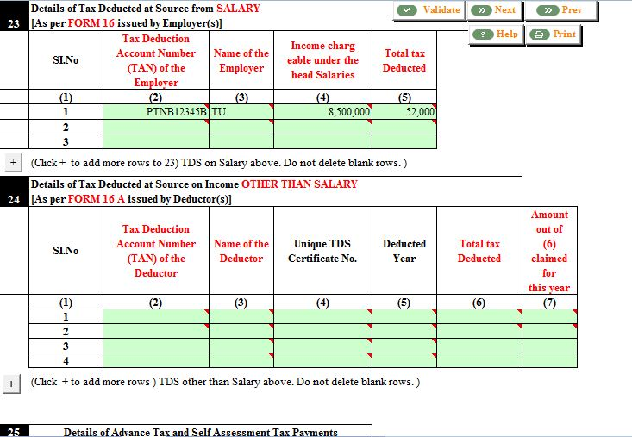
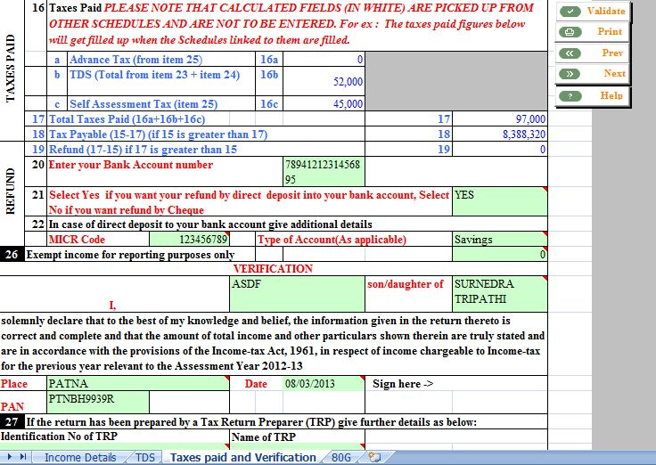

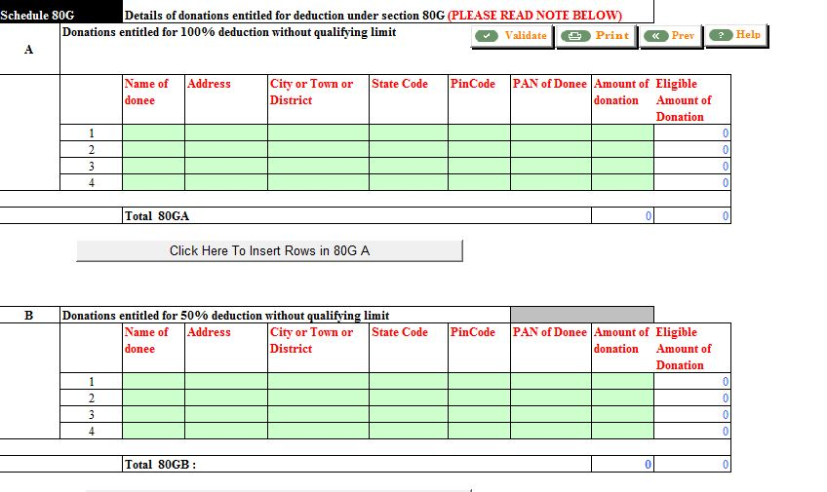
At last an xml file will be created in following format.
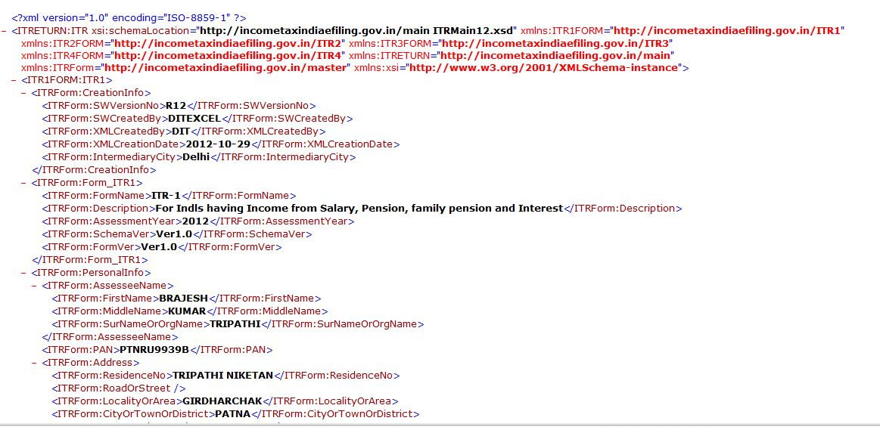

DIGITAL SIGNATURES
A digital signature or digital signature scheme is a mathematical scheme for demonstrating the authenticity of a digital message or document. A valid digital signature gives a recipient reason to believe that the message was created by a known sender such that they cannot deny sending it (authentication and non-repudiation) and that the message was not altered in transit (integrity). Digital signatures are commonly used for software distribution, financial transactions, and in other cases where it is important to detect forgery or tampering.
Digital signatures are often used to implement electronic signatures, a broader term that refers to any electronic data that carries the intent of a signature, but not all electronic signatures use digital signatures. In some countries, including the United States, India, and members of the European Union, electronic signatures have legal significance.
Digital signatures employ a type of asymmetric cryptography. For messages sent through a nonsecure channel, a properly implemented digital signature gives the receiver reason to believe the message was sent by the claimed sender. Digital signatures are equivalent to traditional handwritten signatures in many respects, but properly implemented digital signatures are more difficult to forge than the handwritten type. Digital signature schemes in the sense used here are cryptographically based, and must be implemented properly to be effective. Digital signatures can also provide non-repudiation, meaning that the signer cannot successfully claim they did not sign a message, while also claiming their private key remains secret; further, some non-repudiation schemes offer a time stamp for the digital signature, so that even if the private key is exposed, the signature is valid. Digitally signed messages may be anything represent able as a bitstring: examples include electronic mail, contracts, or a message sent via some other cryptographic protocol.

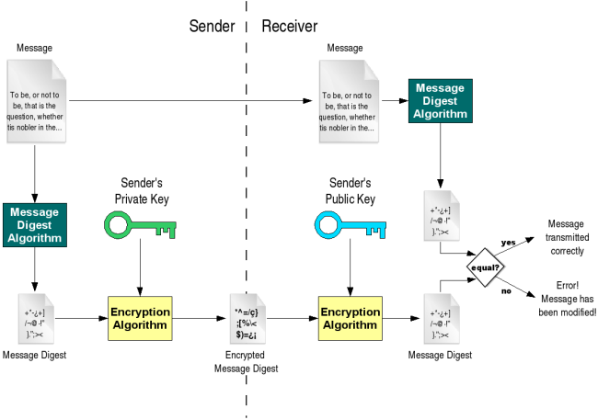
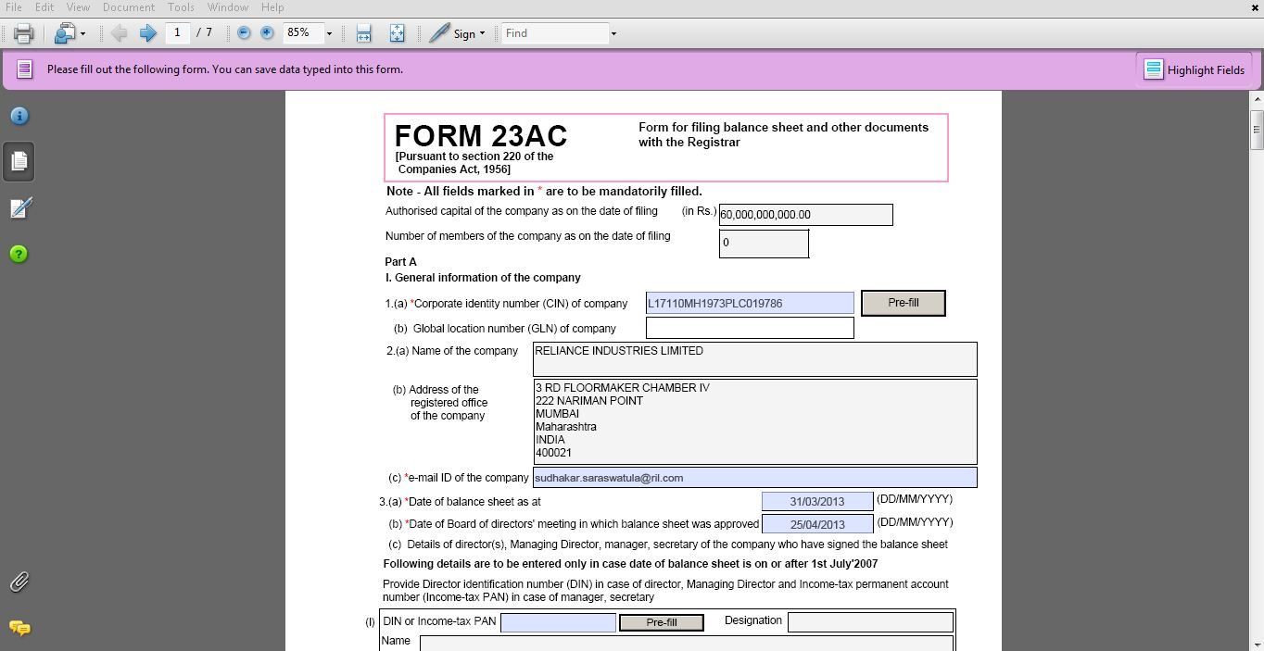
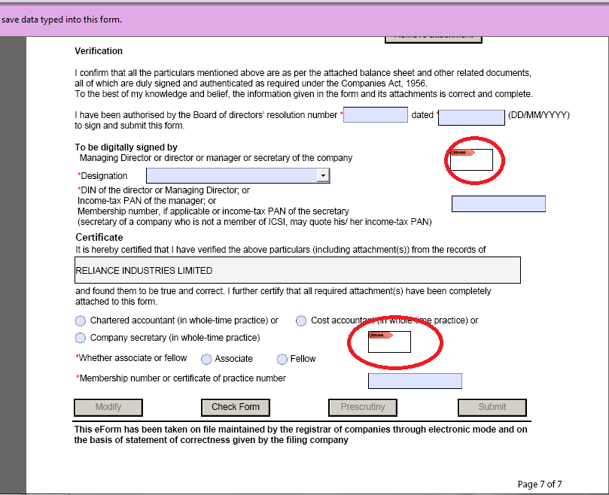

TALLY
Tally 9 is the world’s first concurrent multi-lingual business accounting and inventory management software. Tally has been designed specifically for Indian business owners like we, who have always wanted to maintain accounts in an Indian language of our choice. Tally is so technologically advanced that it can operate in almost all Indian languages concurrently! That means, we can maintain accounts in any Indian language, view it in another and print it in yet another language of our choice... at the same time!
Tally empowers business owners to manage business smoothly. It is designed keeping in mind the needs of the Indian businessman. We can send separate documents to suppliers, business associates, customers etc., in their language, while maintaining accounts in our language. In effect, we can conveniently transact business across the length and breadth of India, and language will no longer be a barrier.
Freedom from dependence on accounting professionals is yet another clear benefit that Tally enables… right from day one we can let our accountant enter information in any Indian language that he is comfortable with and we can review it in your preferred language –at just the click of a button.
Backed by the heritage of incredible simplicity, Tally takes one more significant step towards ensuring that concrete business advantages are realized from accounting on computers.
The advanced technology empowering Tally 9 allows us to:
What Does Tally Offer?
- Single-User Edition (TallySilver)
- Multi-User Edition (TallyGold).
- Best suited for small business at amazingly attractive prices!
Tally - Best For Business Accounting
- Complete Book-keeping
- Books, Registers and Statements of Accounts
- General Ledger
- Outstanding Management, including Credit Limits
- Accounts Receivables and Accounts Payables
- Flexible Voucher Numbering
- Flexible Classification of Account Heads
- Drill Down Display
- Date based Reporting
- Voucher and Cheque Printing
- Columnar Reports
- Bank Reconciliation
Tally - Best for Business Financial Management
- Funds Flows
- Receivables Turnover (Payment Performance of
Debtors)
- Branch Accounting
- Flexible Period Accounting
- Consolidation of Companies
- Budgeting and Control
- Cost Centers & Profit Centers, with Multiple Cost Categories
- Variance Analysis
- Ratio Analysis
- Scenario Management including Reversing Journals and Optional Vouchers
Tally - Best For Statutory Returns
- VAT Statutory Returns
- VAT Composition Returns
- Service Tax
- Tax Deducted at Source (TDS)
- Fringe Benefit Tax (FBT)
- Excise for Traders
What Makes Tally The Best?
- Simplicity in usage
- Speed in navigation
- Power of information management
- Flexibility in adapting to your business
- Concurrent multi-lingual capability
- No codes for convenience
- Real-time reporting
- Online help for user friendly experience
Tally - Best For Advanced Business Financial Management
- Multiple Companies
- Multi Currency Accounting
- Multiple Financial Years
- Comparison of Data using Multi-Columnar Reporting
- Memo Vouchers
- Post-dated Vouchers
- User-defined Voucher Types
- Sales and Purchase Extracts
- Cash Flows
- Daily Balances & Transaction Values
- Interest Calculations
- Percentage based Reporting
Tally allows us to get the information we require in the format we need. Just create our format in any ODBC compliant software like MS-Word or MS-Excel, and pull data from Tally. To create any report you want. Like Audit Reports and Schedule VI forms Or internal reports. We can even generate your export documentation by pulling data from Tally.
• Mail Tally Harness the power of the Internet! Tally uses the SMTP protocol for e-mail. Now, e-mail invoices to our customer or our purchase order. In fact, e-mail any Tally report or document as easily as we print! Even reminder letters and statement of accounts need not be printed and posted. Simply e-mail them. It is not only postage cost that we save, we save on so much of your valuable time.
• E-Tally You can improve your company's efficiency by sharing information with your extended enterprise: your customers, your bankers, your business partners and other associates. Now publish all reports and documents from Tally to a secure part of your website, using FTP, HTTP or secure HTTP protocols, in HTML format. We can use this feature to inform customers the new price-range and stocks available for sale. Or publish reports that your CEO can access, while traveling, using any internet browser.
• XML Tally Tally 9 enables us to exchange information with non-Tally systems, using XML. We can now share data across locations, amongst business associates and partners, and make your workflow seamless. We can now collaborate with others and share information like never before.
• On-line Help Tally 9 has built in Context Sensitive Help. Press the Help button while in Tally, and it will bring up the relevant topic.
• "Scenario" management the new "Scenario" Management capability allows us to plan, as well as analyze our business performance, under varying assumptions. We can get different views of our accounts and inventory information by selectively including Optional Vouchers and/or Reversing Journals and Memos. Use this feature for forecasting and planning. Prepare reports including provisional figures without affecting actual accounts using reversing journals that automatically reverse. This is useful for reporting interim statements.
• Print Preview This facility helps us check printed report formats and layouts before actual printing takes place.
• Direct Access to the Internet Tally allows you direct access to Web Browsing from within Tally.
• Tally 9 Cutting Edge technologies
Tally 9 has achieved major technological breakthroughs to enable you to benefit from collaborative technology such as protocol support for HTTP, HTTPS, FTP, SMTP, ODBC, and Raw Sockets with data interchange formats like XML, HTML, SOAP, SDF and related formats, rule-based collaboration supporting export, upload and synchronization.

CREATING A NEW COMPANY
We can create a new company in tally as the following image shows.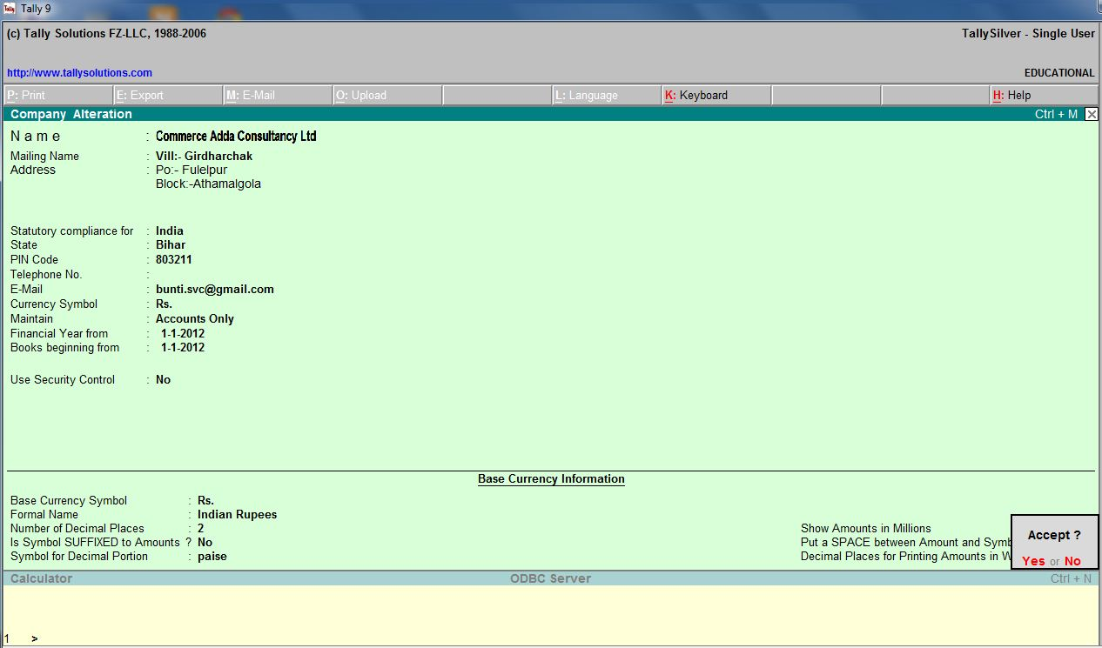

ACCOUNTING VOUCHER ENTRY
We can do this as shown in the following image.
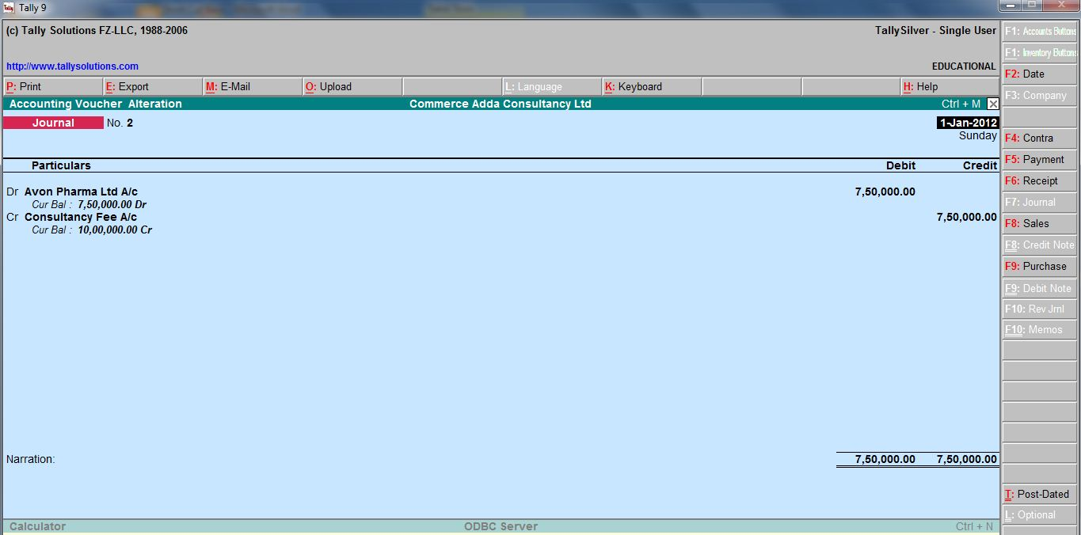

BALANCE SHEET
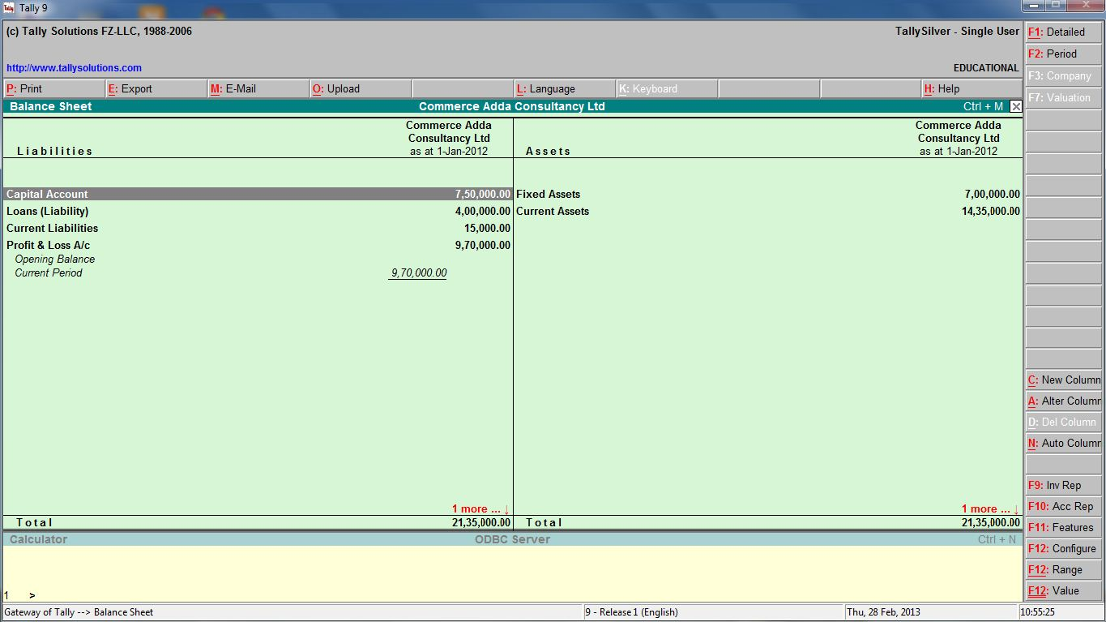

PROFIT AND LOSS ACCOUNT
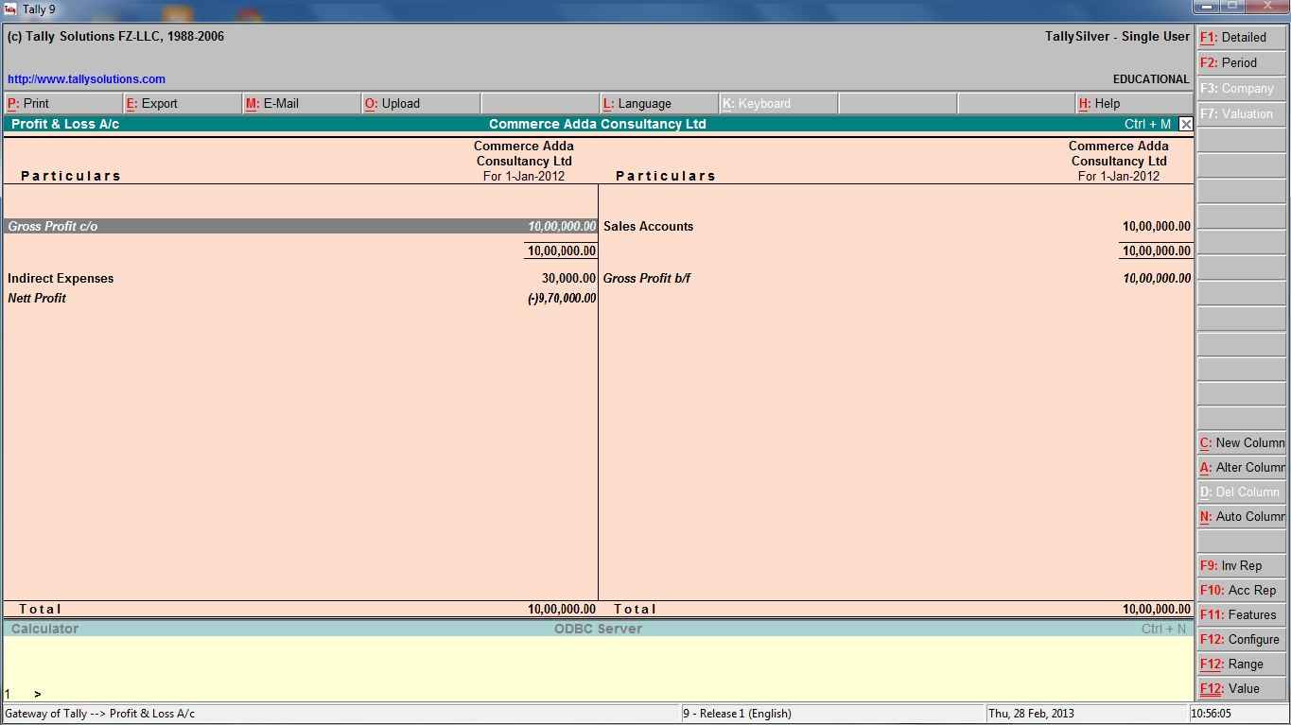

TRIAL BALANCE
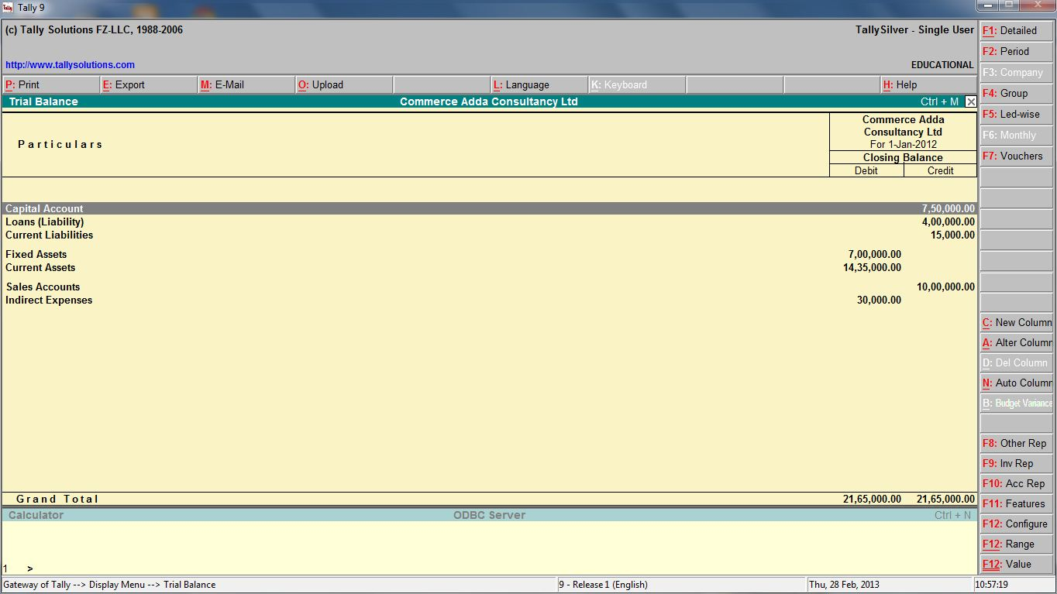

CASH FLOW STATEMENT
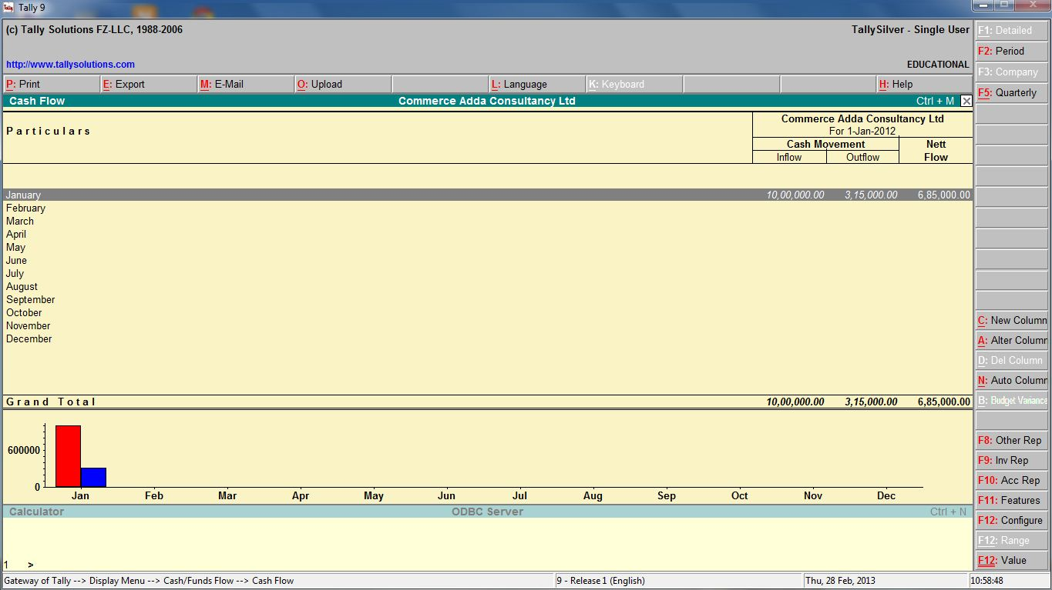

FUND FLOW STATEMENT
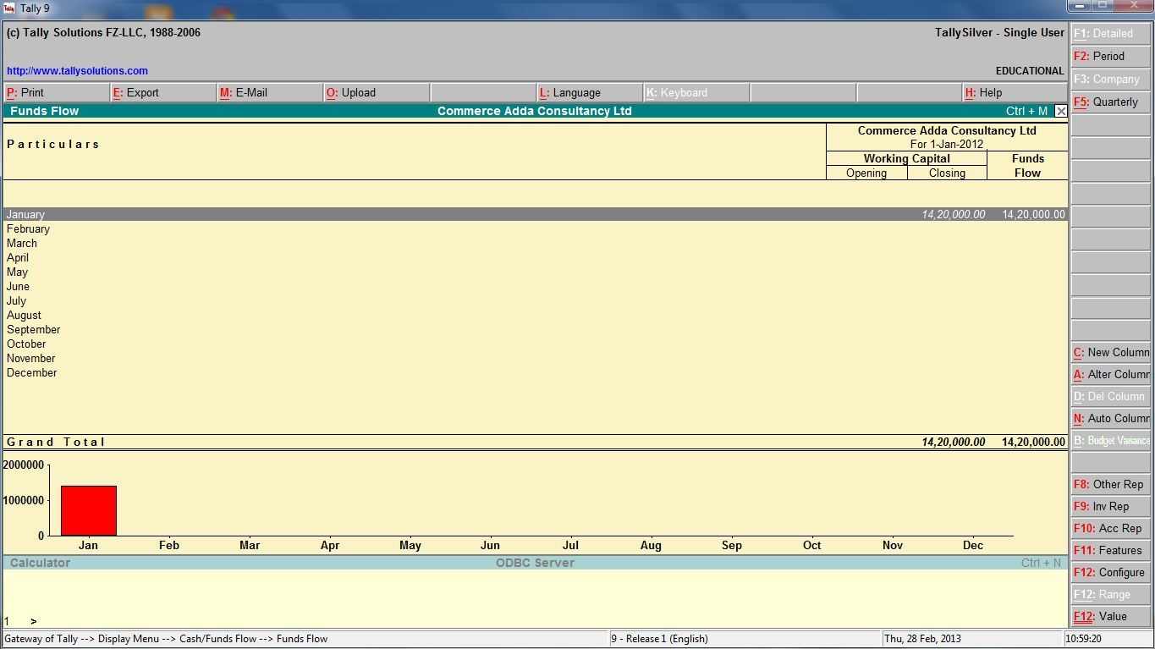

RATIO ANALYASIS
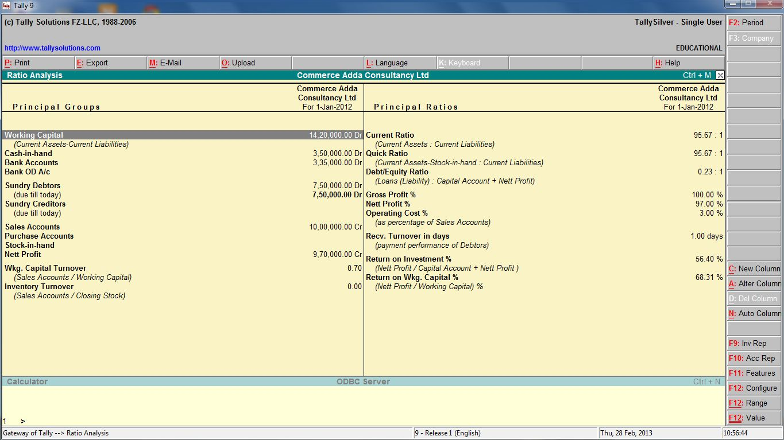

TALLY SHORCUT KEYS
Key | Functionality | Availability
F1 | To select a company | At all masters menu screen
F1 | To select the Accounts Button | At the Accounting Voucher creation and alteration screen
ALT+F1 | To select the Inventory Button | At the Inventory/Payroll Voucher creation and alteration screen
Ctrl + F1 | To select Payroll Vouchers to alter | At the Accounting/Inventory voucher creation or alteration screen.
F2 | To change the current date  To select company inventory features | At almost all screens in TALLY  At the F11: Features screen
F3 | To select the company  To select Company Statutory & Taxation features | At almost all screens in TALLY  At F11: Features screen
F4 | To select the Contra voucher | At Accounting / Inventory Voucher creation and alteration screen
F5 | To select the Payment voucher | At Accounting / Inventory Voucher creation and alteration screen
F6 | To select the Receipt voucher | At Accounting / Inventory Voucher creation and alteration screen
F7 | To select the Journal voucher | At Accounting / Inventory Voucher creation and alteration screen
F8 | To select the Sales voucher | At Accounting / Inventory Voucher creation and alteration screen
Ctrl+F8 | To select the Credit Note voucher | At Accounting / Inventory Voucher creation and alteration screen
F9 | To select the Purchase voucher | At Accounting / Inventory Voucher creation and alteration screen
Ctrl+F9 | To select the Debit Note voucher | At Accounting / Inventory Voucher creation and alteration screen
F10 | To select the Reversing Journal voucher | At Accounting / Inventory Voucher creation and alteration screen
Ctrl + F10 | To select the Memorandum voucher | At Accounting / Inventory / Payroll Voucher creation and alteration screen
F11 | To select the Functions and Features screen | At almost all screens in TALLY
F12 | To select the Configure screen | At almost all screens in TALLY
ALT + 2 | To Duplicate a voucher | At List of Vouchers – creates a voucher similar to the one where you positioned the cursor and used this key combination
ALT + A | To Add a voucher  To Alter the column in columnar report | At List of Vouchers – adds a voucher after the one where you positioned the cursor and used this key combination.  Alters the column in all the reports which can be viewed in columnar format
ALT + C | To create a master at a voucher screen (if it has not been already assigned a different function, as in reports like Balance Sheet, where it adds a new column to the report)  To access Auto Value Calculator in the amount field during voucher entry | At voucher entry and alteration screens, at a field where you have to select a master from a list. If the necessary account has not been created already, use this key combination to create the master without quitting from the voucher screen.  At all voucher entry screens in the Amount field
ALT + D | To delete a voucher  To delete a master  To delete a column in any columnar report  (if it has not been already assigned a different function, as explained above) | At Voucher and Master (Single) alteration screens. Masters can be deleted subject to conditions, as explained in the manual.  All the reports screen which can be viewed in columnar format
ALT + E | To export the report in ASCII, Excel, HTML OR XML format | At all reports screens in TALLY
ALT + I | To insert a voucher  To toggle between Item and Accounting invoice | At List of Vouchers – inserts a voucher before the one where you positioned the cursor and used this key combination.  At creation of sales and purchase invoice
ALT + L | To select the Language Configuration | At almost all screens in TALLY.
ALT + K | To select the Keyboard Configuration | At almost all screens in TALLY.
ALT + O | To upload the report at your website | At all reports screens in TALLY
ALT + L | To select language for Tally Interface | At almost all screens of TALLY
ALT + M | To Email the report | At all reports screens in TALLY
ALT + N | To view the report in automatic columns | At all the reports where columns can be added
ALT + P | To print the report | At all reports screens in TALLY
ALT + R | To remove a line in a report | At all reports screens in TALLY
ALT + S | To bring back a line you removed using ALT + R | At all reports screens in TALLY
ALT + U | To retrieve the last line which is deleted using Alt + R | At all reports screens in Tally
ALT+ V | From Invoice screen to bring Stock Journal screen | At Invoice screen → Quantity Field → Press Alt + V to select the Stock Journal.
ALT + W | To view the Tally Web browser. | At all reports screens in TALLY
ALT + X | To cancel a voucher in Day Book/List of Vouchers | At all voucher screens in TALLY
ALT + R | To Register Tally | At almost all screens in TALLY.
Ctrl + A | To accept a form – wherever you use this key combination, that screen or report gets accepted as it is. | At almost all screens in TALLY, except where a specific detail has to be given before accepting.
Ctrl + B | To select the Budget | At Groups/Ledgers/Cost Centres/ Budgets/Scenarios/Voucher Types/ Currencies (Accounts Info) creation and alteration screen
Ctrl + ALT + B | To check the Company Statutory details | At all the menu screens
Ctrl + C | To select the Cost Centre  To select the Cost Category | At Groups/Ledgers/Cost Centres/ Budgets/Scenarios/Voucher Types/ Currencies (Accounts Info) creation and alteration screen  At Stock Groups/ Stock Categories/ Stock Items/ Reorder Levels/ Godowns/ Voucher Types / Units of Measure ( Inventory Info) creation/alteration screen
Ctrl+ E | To select the Currencies | At Groups/Ledgers/Cost Centres/ Budgets/Scenarios/Voucher Types/ Currencies (Accounts Info) creation and alteration screen
Ctrl + G | To select the Group | At Groups/Ledgers/Cost Centres/ Budgets/Scenarios/Voucher Types/ Currencies (Accounts Info) creation and alteration screen
Ctrl + I | To select the Stock Items | At Stock Group/ Stock Categories/ Stock Items/ Reorder Levels/ Godowns/ Voucher Types / Units of Measure ( Inventory Info) creation/alteration screen
Ctrl + Alt + I | To import statutory masters | At all menu screens
Ctrl + L | To select the Ledger  To mark a Voucher as Optional | At Groups/Ledgers/Cost Centres/ Budgets/Scenarios/Voucher Types/ Currencies (Accounts Info) creation and alteration screen  At the creation and alteration of Vouchers
Ctrl + O | To select the Godowns | At Stock Group/ Stock Categories/ Stock Items/ Reorder Levels/ Godowns/ Voucher Types / Units of Measure ( Inventory Info) creation/alteration screen
Ctrl + Q | To abandon a form – wherever you use this key combination, it quits that screen without making any changes to it. | At almost all screens in TALLY.
Ctrl + R | To repeat narration in the same voucher type | At creation/alteration of voucher screen
Ctrl + Alt + R | Rewrite data for a Company | From Gateway of Tally screen
Ctrl + S | Allows you to alter Stock Item master | At Stock Voucher Report and Godown Voucher Report
Ctrl + U | To select the Units | At Stock Groups/ Stock Categories/ Stock Items/ Reorder Levels/ Godowns/ Voucher Types / Units of Measure ( Inventory Info) creation/alteration screen
Ctrl + V | To select the Voucher Types  To toggle between Invoice and Voucher | At Groups/Ledgers/Cost Centres/ Budgets/Scenarios/Voucher Types/ Currencies (Accounts Info) creation and alteration screen  At creation of Sales/Purchase Voucher screen
ALT + F1 | To close a company  To view detailed report  To explode a line into its details  To select Inventory vouchers to alter | At all menu screens  At almost all report screens  At almost all screens in TALLY  At the Inventory/ Payroll voucher creation or alteration screen.
ALT + F2 | To change the period | At almost all screens in TALLY
ALT + F3 | To select the company info menu  To create/alter/shut a Company | At Gateway of Tally screen
ALT + F4 | To select the Purchase Order Voucher Type | At Accounting / Inventory Voucher creation and alteration screens
ALT + F5 | To select the Sales Order Voucher Type  To view monthly and quarterly report | At Accounting / Inventory Voucher creation and alteration screens  At almost all report screens in TALLY
ALT + F6 | To select the Rejection Out Voucher Type  To change the Sales Order Voucher Type | At Accounting / Inventory Voucher creation and alteration screens
ALT + F7 | To select the Stock Journal Voucher Type  To accept all the Audit lists | At Accounting / Inventory Voucher creation and alteration screens  At TallyAudit Listing screen
ALT + F8 | To select the Delivery Note Voucher Type  To view the Columnar report | At Accounting / Inventory Voucher creation and alteration screens  At Ledger Voucher screen
ALT + F9 | To select the Receipt Note Voucher Type | At Accounting / Inventory Voucher creation and alteration screens
ALT + F10 | To select the Physical Stock Voucher Type | At Accounting / Inventory Voucher creation and alteration screens
ALT + F12 | To filter the information based on monetary value | At almost all report screens
Ctrl + F1 | To select payroll vouchers for alteration | At the Accounting/Inventory Voucher creation or alteration screen
Ctrl + ALT + F12 | Advanced Config | At Gateway of Tally
PgUp | Display previous voucher during voucher entry/alter | At voucher entry and alteration screens
PgDn | Display next voucher during voucher entry/alter | At voucher entry and alteration screens
ENTER | To accept anything you type into a field.  To accept a voucher or master  To get a report with further details of an item in a report. | You have to use this key at most areas in TALLY  At the receivables report – press Enter at a pending bill to get transactions relating to this bill (e.g., original sale bill, receipts and payments against this bill, etc)
ESC | To remove what you typed into a field  To come out of a screen  To indicate you do not want to accept a voucher or master. | At almost all screens in TALLY.
SHIFT + ENTER | Collapse next level details | At Voucher Register screen and Trial Balance report
SHIFT + ENTER | To explode a line into its details | In almost all Reports:  At a Group/Stock Group/Cost Category/Godown/Stock Category – displays Sub Groups and Ledgers/Stock Items/Cost Centres/Secondary Godowns/Secondary Stock Categories  At a Voucher – displays its entries and narration  At a Stock Item- displays its godowns and batch details  At Voucher Register screen – displays the next level details  At Trial Balance report - displays the next level details
Ctrl + ENTER | To alter a master while making an entry or viewing a report | At voucher entry and alteration screens  At all reports

