TDS certificate (Form 16 and 16A) is prepared and issued by the employer /deductor to the employee/deductee. TDS certificate can be downloaded from TIN website.
TDS certificate will be sent on registered e-mail ID as well as will be available for download on successful confirmation of KYC for the particular Financial Year and Quarter (any relevant quarter of the particular Financial Year in case of Form 16). The nomenclature of the file will be as under:
Form 16A: TAN_AY_Quarter_Form16A Reference Number_Part of file_of_Part of file.
Form 16: TAN_AY_Form 16 Reference Number_Part of file_of_Part of file.
For example: File name for Form 16A/ Form 16 will be
Form 16A: MUMA12345E_201112_Q1_FORM_16A_0000001717_00000001_0001_OF_0001.zip
Form 16: MUMA12345E_201112_FORM_16_0000001717_000000001_0001_OF_0001.zip
In case transactions are large in numbers, then the Form 16/ Form 16A file will be split in the size of 2MB.

Click here to download PDF converter utility (To convert Form 16/16A text file to PDF file).

On clicking the above link 'PDF Converter Utility.exe' will be downloaded, after unzipping the exe below, two PDF converter utilities will be extracted in the 'PDF Converter Utility' folder.
PDF Converter Utility_SHA1 and
PDF Converter Utility_SHA2
Note: System software requirements of the SHA2 (Secure Hash Algorithm) utility are more stringent as compared to SHA1 utility. Users are required to upgrade the system software on their machines to the pre-requisites specified for the SHA2 utility by March 31, 2012. After March 31, 2012, the support for SHA1 utility will be discontinued.
Configurations required for PDF Converter Utility_SHA1
Java 1.6 and above
Configurations required for PDF Converter Utility_SHA2
JRE version : SUN-java 1.6_update29 or higher version (32 bit) and
Windows XP SP3, Vista Windows 7, Windows 2003 with patch for SHA-2, Windows 7.
Utility once downloaded can be used for converting PDF file as and when required for all future files.
Procedure to convert zip file to PDF file:
1. The following software can be used for extraction of zip files:
1.1 WinZip version 9.0 and above
1.2 WinRaR version 3.90 and above
1.3 7-Zip version 4.65 and above
2. Import extracted text files through PDF converter utility.
3. To open 'PDF converter utility' double-click on 'Start_PDF_Utility.bat'. Utility will open as shown below.
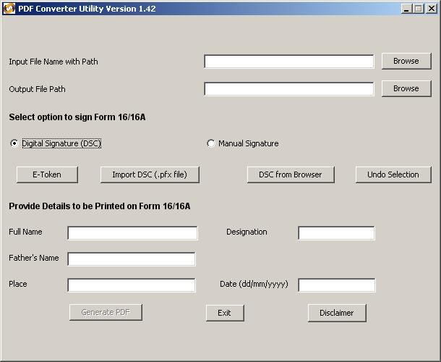
4. Input File Name with Path:
Click on browse and select the Form 16/16A input file; in case of multiple files select all the files
5. Output File Path:
Specify the path where 'PDF' file should be generated by the utility on completion of validation. The path can be same as the input file path or different. Do not specify any filename, provide the file path only.
6. Digital Signature of PDF:
6.1. E-Token: To select DSC from e-Token, click on e-Token, provide the name of e-Token (default eToken) and provide the password in the field 'E-Token Password'. Password is case sensitive.
6.2. Import DSC (.pfx file): To select .pfx file, click on 'Import DSC (.pfx file)' again click on browse and select the Digital Signature Certificate (DSC) and provide the DSC password in the field 'Digital Certificate Password'. Password is case sensitive. Click on 'Detect Certificate'.
6.3. DSC from Browser: To select DSC installed in browser, click on 'DSC from Browser' it will display DSC installed in browser. select the DSC through which you want to sign the PDF digitally.
7. Undo Selection: To deselect the DSC, click on 'Undo Selection'.
8. Provide Details to be Printed on TDS certificate
8.1 Full Name: Provide full name of responsible person to be printed on TDS certificate.
8.2 Designation: Provide designation of responsible person to be printed on TDS certificate.
8.3 Father's Name: Provide father's name of responsible person to be printed on TDS certificate.
8.4 Place: Provide place of the responsible person to be printed on TDS certificate.
8.5 Date: Provide date to be printed on Form 16A PDF. Date should be in dd/mm/yyyy format.
9. PDF File:
In case the input file is valid, utility will generate the folder (folder name will be TAN_FORM16_AY_Date for Form 16 and TAN_FORM16A_AY_Quarter_Date for Form 16A) which contains PDF of all the deductee PAN present in input file. Naming convention of PDF file is PAN_FORM16_AY.pdf for Form 16 and PAN_FORM16A_AY_Quarter.pdf for Form 16A.

