MICR Codes Meaning of
MICR (Magnetic Ink Character Recognition) code contains 9 digits, like 380002006 appearing at the bottom of the cheque, following the cheque number. Each Bank Branch has a unique MICR code. One wonders what these code are and how to make it easy to remember our branch code. If you are able to understand the code, it becomes easy to remember your Bank Branch MICR code.
First three digits of the code display the city and is derived form first 3 character of PIN( Postal Index Number) mentioned in the address of the Branch. Like as in case of Ahmedabad, PIN number of Ashram Road Branch is 380009, therefore first three digits of MICR code will be 380.
Digit 4,5&6 display the bank codes allotted to each bank by Reserve Bank of India. For example State Bank of India has been alloted "002" . Six digits of MICR code will become 380002
Digit 7,8 and 9 display the Bank Branch Codes allotted to each branches of bank. For Example SBI, Asharam
Road, Ahmedabad 380009 branch has been allotted code no. 006. Therefore 9 digits of MICR code of State Bank of India, Ashram Road Branch, Ahemdabad 380009 will be 380002006.
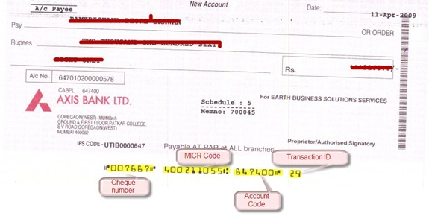

1) Cheque Number
As I mentioned earlier, the first set of numbers represent the cheque number. It is a six digit number.

2) MICR Code
It stands for Magnetic Ink Character Recognition. This number helps a bank to recognize the bank and branch that issued the cheque. You might be thinking that this can be done just by looking at the cheque, but banks have to process hundreds of cheques daily. Going through each and every cheque is a cumbersome process. Instead, the cheques are sorted through a cheque reading machine which uses this number to identify the bank and branch a cheque belongs to. This makes the process faster.
The MICR number is a nine digit number, which consists of three parts-
a) City Code: The first three digits represent the city code and are same as the first three digit of the PIN code of that city.
For e.g., a bank in Hyderabad will have first three digits of MICR code as 500 (since PIN code for Hyderabad starts with 500)
b) Bank Code: The next three digits represent the bank code. Every bank has a unique code assigned to it. For e.g., ICICI bank’s code is 229, for HDFC it is 240 and so on.
c) Branch Code: The last three digits represent the branch code.
Thus you can easily find which bank and branch a cheque belongs to by looking at its MICR number, and vice versa.
You can download the complete list of MICR codes from here.

3) Bank account Number
The third set of six digit numbers represents your account number (It consists of a few digits of your account number). But if you pick an old cheque book, issued probably before CBS (Core Banking Solution) was introduced, you won’t find this set of number present.
(Note: I am not completely sure of this. Branch Manager of the bank I visited told me this, and when I checked my ICICI cheque book, it tallied with my account number. If you see the sample cheque from Axis bank shown above, it matches there as well. But when I checked my HDFC account cheque book, I found this number and my account number to be different. If someone belongs to a banking background, or has some information about this, please tell others about it through your comments.)

4) Transaction ID
The last two digits tells whether a cheque is a local cheque our payable at par cheque. 29, 30 and 31 represents payable at par cheque, while 09, 10 and 11 represents local cheque. Payable at par cheque is a cheque that can be cashed at any branch of the issuing bank, while local cheque can be cashed only at the issuing branch. So, if you deposit a cheque in your bank, with code 10 written at the bottom of the cheque, it’ll take a few days for the money to come in your account. However since most of the branches these days are CBS (Core Banking Solution) enabled, so the cheques are generally payable at par.
One More Interesting Thing…
Before ending this post I want to point your attention to another interesting thing. These numbers are written in a different font style with a special ink that contains magnetic material so that it can be recognized by Magnetic Character Ink Reader.

