So Friend's finally we have reached another Milestone i.e. we (CA CLUBINDIA) have Crossed 9 lakhs Members.
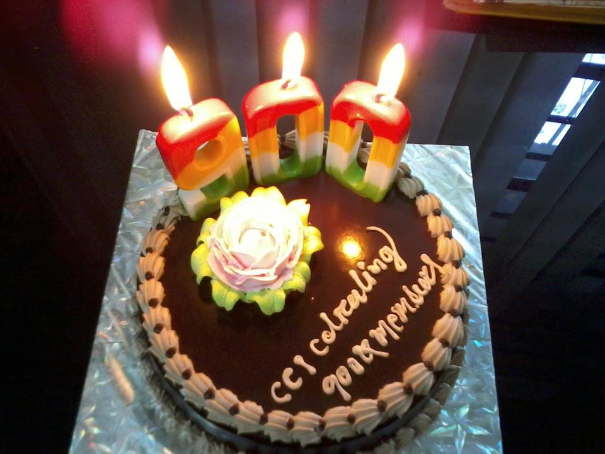
It feels so special to be a part CA CLUBINDIA (CCI).
It is a beautiful world of Professionals where one can share his/her Knowledge, one can ask & reply to the queries, write his thoughts & make Professional Relations with the Experts.
So on this Occasion i would like to dedicate this Article Specially to CA CLUBINDIA (CCI) & all the 30 Top Members who have given their best to make it the Best Professional Site.
http://www.caclubindia.com/top_members_list.asp (CACLUB INDIA Top 30 Members)
http://www.caclubindia.com/most_thanked.asp (CACLUB INDIA Most Thanked Member)
So here is a small Gratitude for all the members of CCI Family

- Introduction –
- CCI was launched by Mr. Vivek Jain the CEO of CACLUBINDIA in March 19, 1999.
- First of all i would salute you sir for converting your thought into reality. It’s Just because of you we all got a chance to be a part of this professional world.
- Since 1999 there were many up’s & down’s, but still destination was yet to be achieved anyhow.
- It’s just because of the Courage & innovative mind of the Developers we have reached so far.
- In 2005 CCI was given a new look & some great Features. - In May 2008 it created a Landmark by crossing 1, 50,000 members.
- In September, 2012 it crossed 9 Lakhs Members.
- On this Occasion (On Behalf of CCI) I would like to thank each one of you to be a part of it & making it the: Best Professional Site “of India.

Benefits of Joining CCI –
- First of all you will get a chance to be a member of India’s Number 1 Professional Site.
- You can add your CCI Account in your C.V showing your contribution & your excellence in writing. I would like to quote my own Example: It was my first Interview & the Interviewer was asking me questions on the basis of my C.V. So when he asked me why I have mentioned my CCI Account in my C.V, I just said to him to wait for a second & then I opened my account in his laptop & you won’t believe he was amazed to see my contribution & excellence of writing. From that moment it left an nice impression on him regarding me.
- There are around 3 Lakhs members (Chartered Accountants, Company Secretaries, Management Accountants, Lawyers, CFA as well as Financial Consultants) who have mastered in their respective life to share their knowledge as well as resolve your queries.
- If you will have a look on the past record all the CA, CS & CWA Rank holders are part of CCI Family & they have admitted that CCI have really helped them a lot in clearing the exams.
- One can ask query in the expert section & he/she will receive an immediate feedback from the experts.
- One can find all the material relating studies in the file section & also it keeps you updated of the changes/Amendments for the upcoming attempts.
- One can find Articles on all the topics with extensive knowledge written in an simple language.
- If you face any problem you can ask any of the experts to sought it out. My Personal Experience –
- I joined CCI on 17 December, 2010. It was just that I had given my exams of IPCC Group-1 & had heard about this site from many of my friends but unfortunately never got the time to join it. But as soon my exams ended I dint wasted a single day to be a part it. - It was just that I started writing on different topics & what I observed was I really lack in writing. So I started asking the Top members of that time what it takes to be a good Writer & Professional. Almost everyone helped me out in my initial days & I learnt to convert thoughts into writing.
- Days went & everyone started recognizing me.
- It was just because of CACLUBINDIA which made me realize of my skills & How to use them effectively.
- So it has been now around 2 years I have been a part of this Professional Family. I have undergone millions of changes (Positive: p) & I feel really proud to be a part of the Club.
- Here I am sharing my work which all of you have liked a lot.
http://www.caclubindia.com/articles/importance-of-exemption-in-ca-8444.asp#.UE3nirLib0A
http://www.caclubindia.com/articles/-big-4-s-do-they-create-a-better-ca-a-big-question--11333.asp
http://www.caclubindia.com/articles/good-options-for-a-ca-student-to-invest-a-must-read-by-all-11706.asp
http://www.caclubindia.com/articles/i-am-not-a-loser-for-all-the-ca-students-11789.asp#.UE3n57Lib0A
http://www.caclubindia.com/articles/life-of-a-ca-student-full-of-challenges--12134.asp
http://www.caclubindia.com/articles/auditing-a-beginners-guide-13749.asp#.UE3oArLib0A
http://www.caclubindia.com/articles/audit-of-educational-institutes-ei-s--13879.asp
http://www.caclubindia.com/articles/-audit-of-society-registered-under-societies-act-1860-14401.asp#.UE3oILLib0A
http://www.caclubindia.com/articles/-ledger-scrutiny-backbone-of-statutory-audit-14826.asp#.UE3oLrLib0A
http://www.caclubindia.com/articles/ledger-scrutiny-backbone-of-statutory-audit-part-2--15001.asp

CONCLUSION –
- At the end I just want to thank the Developers, Admin & all the members of this club for recognizing me & considering me worthy. Thanks & Regards SANYAM ARORA
Thanks & Regards
Sanyam Arora

