Budget: What's costlier, what's cheaper

Pranabda's Budget may be criticized for being lackluster but your bills just became costlier. Find out why

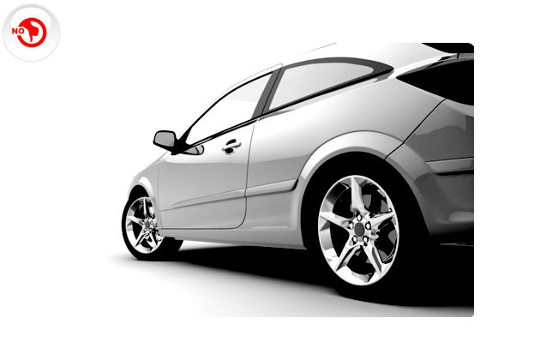
Pop the SUV dream as they now be more expensive. The excise duty on large cars has been increased to 27% from 22% earlier.

Service tax has been increased from 10% to 12% making your weekend brunch dearer

The service tax net has been widened making most leisure activities expensive
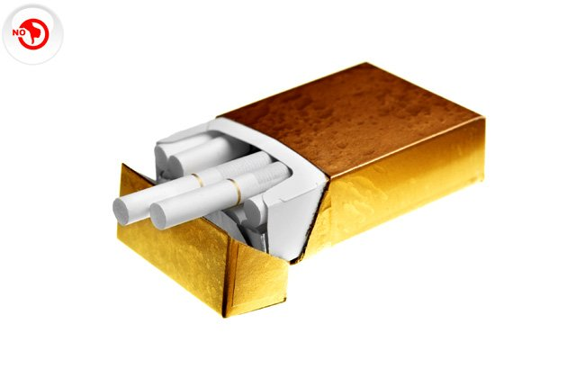
Long cigarettes will cost more with an increase in excise duty on cigarettes

Basic customs on gold has almost doubled. Is the yellow metal still a good investment?

Platinum got Costlier too
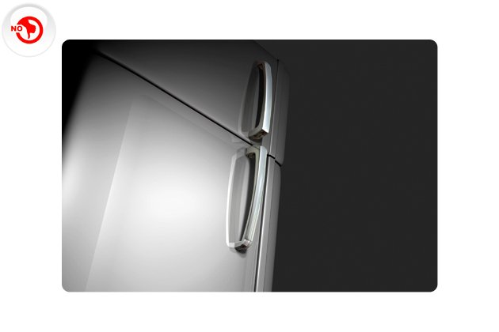
Refrigerator will now get costlier due to higher customs duty
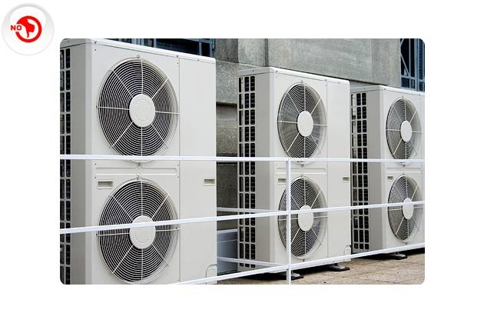
Get ready for a HOT summer. The hike in customs duty will hit air-conditioners too.

Gold prices may have gone up due to taxes but silver prices will get cheaper
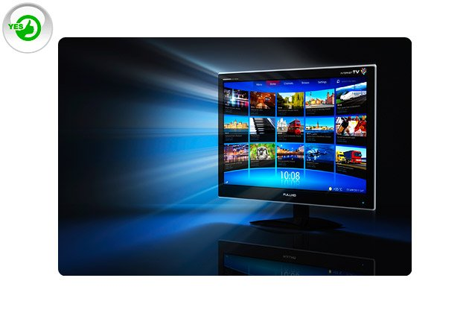
Customs duty on LCD and LED have reduced making television sets cheaper

Duty on bicycles and bicycles parts have been reduced making them cheaper

Bollywood exempted from service tax.

HIV, cancer drugs to be cheaper.

The FM has said that multi-brand retail will be supported so we can expect more number of Malls and Super Malls in the country.

