
If you have some hard work to do,
DO IT NOW.
Today the skies are clear and blue,
tommorrow clouds may come in view,
yesturday is not for you,
DO IT NOW !!!


If you have a song to sing,
SING IT NOW.
let the tones of gladness ring,
clear as song of bird in spring,
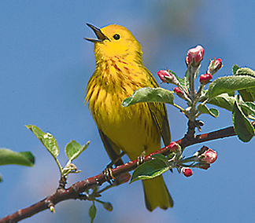
let each day some music bring,
SING IT NOW.

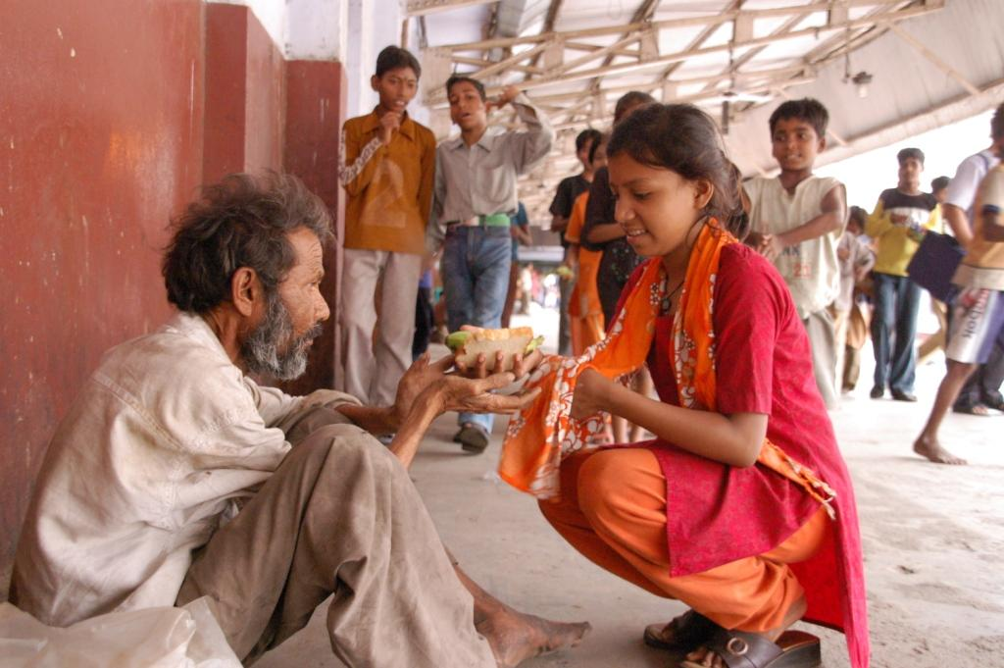
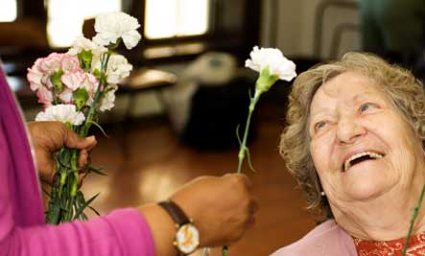

tomorrow may not come
your way!


If you have some kinds words to say, do a kindness while you may,

loved ones will not always stay,
SAY THEM NOW. SAY THEM NOW.
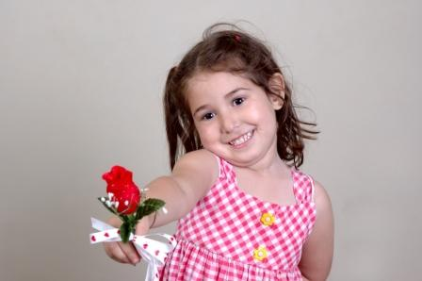

If you have a smile to show,
SHOW IT NOW.
make hearts happy, roses grow,
let the friends around you know,

the love you have before they go,
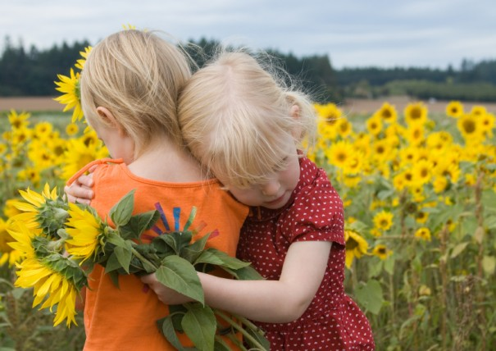
SHOW IT NOW!!!

