Why you should enable Auto Sweep in your Bank Account

Do you have a Bank Account? Off-course you do! How much money do you have in your account? 5,000? 20,000? or a few lacs? If you have a lot of cash, lying idle in your Bank Account, and at the same time you don’t want to commit to long-term investment, you need to enable the Auto-Sweep facility in your Savings Bank account. This will make sure you earn good interest on a major part on the cash lying in your Savings account.
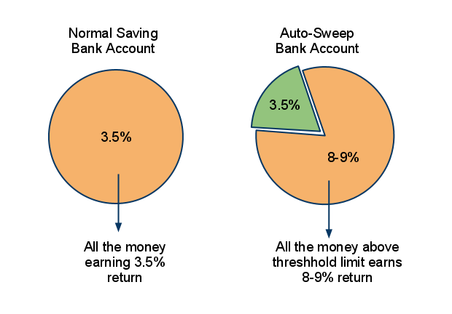
“Auto Sweep” is a facility which provides, the combined benefits of a Savings Bank account and Fixed Deposits. Auto-Sweep facility interlinks your saving bank account with a Deposit account and makes sure any extra amount lying in your bank account above a threshold limit is automatically transferred to Fixed deposits and you earn better interest on your money.

How ‘Auto Sweep’ works?

This is how Auto-Sweep works. You define a “threshold limit”, and money up to that limit will be in the form of cash in your savings account and any amount above this, “limit” will automatically be converted into a Fixed Deposit and you will start earning normal FD returns on that part of the money. At any point in time, if you need money more than is lying in your bank account, the money lying in the Fixed Deposits is Reversed-sweeped into your savings account and you can withdraw the amount you wish.

Example

Ajay opens a new Savings Bank account with SBI. He enables Auto-Sweep facility on his savings bank account and defines the threshold limit of Rs 30,000 . Now suppose he has Rs 10,000 lying in the bank, He will be earning normal 3-3.5% interest on this money. After that if he deposits Rs 60,000 in his account, his total balance would be 70,000. But as this is above his “threshold limit”, the extra amount of 40,000 will be converted into a fixed deposit automatically and start earning returns equal to normal Fixed deposits with SBI (for example 8%). This way he always has 30,000 in his account for his daily requirements, and he has 40,000 converted into Fixed deposits which again is available to him incase he requires it.
Now suppose he has to withdraw 10,000 from his account, he will actually withdraw it from the cash lying in saving bank , and his balance will reduce to 20,000. However on the other hand if he wants to withdraw Rs 50,000 . then in that case, as his account balance will be just 30,000, an additional Rs 20,000 will be auto-reversed from his Fixed Deposit and he can withdraw total 50,000 .

