10 Great Thoughts on Courage 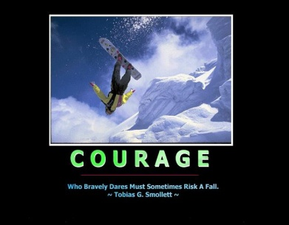

1. Doubt indulged becomes doubt realized. To determine to do anything is half the battle. Courage is victory, timidity is defeat.
-Nelson
2. Courage is knowing what not to fear.
-Plato
3. You can gain strength, courage and confidence by every experience in which you reallystop to look fear in the face. You are able to say to yourself, "I lived through this horror. Ican take the next thing that comes along." . . .You must do the thing which you think youcannot do.
-Eleanor Roosevelt
4. Step on your fear and it will turn into courage.
-Bob Lee
5. Courage charms us, because it indicates that a man loves an idea better than all thingsin the world, that he is thinking neither of his bed, nor his dinner, nor his money, but willventure all to put in act the invisible thought of his mind.
-Ralph Waldo Emerson
6. Courage is fear holding on a minute longer.
-General George Patton

7. Keep you fears to yourself, but share your courage.
-Robert Louis Stevenson

8. Courage is having done it before.
-Saying

9. One man with courage makes a majority.
-Anonymous

10. Courage consists, not in blindly overlooking danger but in seeing and conquering it.
-Jean Paul Richter

