Biography of Great Anna Hazare

From a tenacious soldier to a social reformer, and a right to information crusader, Anna Hazare’s journey of four decades has been unprecedented in terms of a non-violent yet effective campaign of resurrecting a barren village into an `ideal village’ model and empowering the faceless citizen through pioneering work on Right to Information. His efforts to empower grampanchayats, protect efficient government officers from frequent transfers and fight against the red tapism in government offices have also received accolades.

His tryst with the army came when many Indian soldiers became martyrs in the Indo-China War of 1962 and the Government of India had appealed to young Indians to join the Indian army. Being passionate about patriotism, he promptly responded to the appeal and joined the Indian Army in 1963. During his 15-year tenure as a soldier, he was posted to several states like Sikkim, Bhutan, Jammu-Kashmir, Assam, Mizoram, Leh and Ladakh and braved challenging weathers.
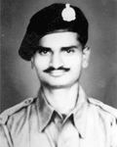
At times, Hazare used to be frustrated with life and wondered about the very existence of human life. His mind yearned to look out for a solution to this simple and basic question. His frustration reached the peak level and at one particular moment, he also contemplated suicide. For this, he had also penned a two page essay on why he wants to live no more. Fortunately for him, inspiration came from the most unexpected quarters – at the book stall of the railway station of New Delhi, where he was located then. He came across a book of Swami Vivekananda and immediately bought it.

He was inspired by Vivekananda’s photograph on the cover. As he started reading the book, he found answers to all his questions, he says. The book revealed to him that the ultimate motive of human life should be service to humanity. Striving for the betterment of common people is equivalent to offering a prayer to the God, he realized.
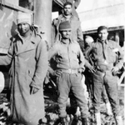
In the year 1965, Pakistan attacked India and at that time, Hazare was posted at the Khemkaran border. On November 12, 1965, Pakistan launched air attacks on Indian base and all of Hazare’s comrades became martyrs, It was a close shave for Hazare as one bullet had passed by his head. Hazare believes this was the turning point of his life as it meant he had a purpose to life. Anna was greatly influenced by Swami Vivekananda’s teachings. It was at that particular moment that Hazare took an oath to dedicate his life in the service of humanity, at the age of 26. He decided not not to let go of a life time by being involved merely in earning the daily bread for the family. That’s the reason why he pledged to be a bachelor. By then he had completed only three years in the army and so would not be eligible for the pension scheme. In order to be self-sufficient, he continued to be in the army for 12 more years. After that, he opted for voluntary retirement and returned to his native place in Ralegan Siddhi, in the Parner tehsil of Ahmednagar district.
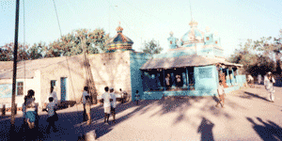
While in the army, Hazare used to visit Ralegan Siddhi for two months every year and used to see the miserable condition of farmers due to water scarcity. Ralegan Siddhi falls in the drought-prone area with a mere 400 to 500 mm of annual rainfall. There were no weirs to retain rainwater. During the month of April and May, water tankers were the only means of drinking water. Almost 80 per cent of the villagers were dependent on other villages for food grains. Residents used to walk for more than four to six kilometers in search of work and some of them had opted to open country liquor dens as a source of income.

More than 30-35 such dens located in and around the village had tarnished the dignity of the village and marred the social peace. Small scuffles, thefts and physical brawls resulted in loss of civic sense. Morality had reached such a nadir that some of the residents stole wooden logs of the temple of the village deity Yadavbaba to burn the choolah of one of the country liquor outfits.
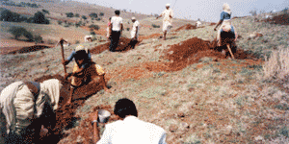
Hazare came across the work of one Vilasrao Salunke, a resident of Saswad near Pune who had started a novel project of water management through watershed development in a joint venture with the Gram Panchyat. Hazare visited the project and decided to implement it in Ralegan Siddhi. By keeping an eye on conserving every drop of water and preventing erosion of the fertile soil, he steered the villagers to begin working towards water conservation. At the outset, they completed 48 Nala Bunding work, contour trenches, staggered trenches, gully plugs, meadows development and of forestation of 500 hectares of land. Thereafter, they constructed five RCC weirs and 16 Gabion Weirs.

This resulted in increase in the ground water level. After that, Hazare along with his team worked out the cropping pattern suitable to the quality of soil and the water volume available for farming. This led to increase in the water table by making water available for 1,500 acres of land instead of 300 acres. As a natural sequel, this effort led to yielding of food-grains and the villagers became self-sufficient in terms of food. The table turned turtle – earlier there was no work available for the villagers, now manpower was required to be imported from neighbouring villages.
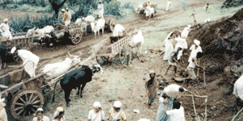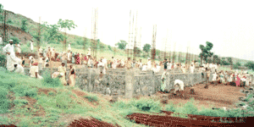
The changes in the economics brought all the villagers under one roof of unity and people voluntarily contributed in terms of labour and money to build a school, a hostel, a temple and other buildings. Mass marriages, grains bank, dairy, cooperative society, self-help groups for women and youth mandals helped develop the village in all aspects and gave a new face to it.
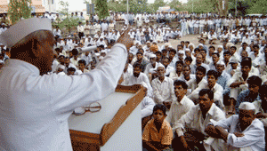
Hazare opines that proper planning of natural and human resources can result in the betterment of a person, area, village instead of exploiting such resources. He says, ``Today we all are exploiting the earthen resources like petrol, diesel, kerosene, coal and water. This can never be termed as perennial development as it is going to lead a state of destruction one day. The sources of energy are limited and hence I am concerned about the next generations. Today many of the villages of almost every state are feeling the brunt of water shortage. Building concrete jungles does not mean development as Gandhiji had rightly said.

Creation of a human idol should be the main objective rather than creating towering buildings. Surely, one needs to live for oneself and the family but simultaneously one owes something to your neighbour, your village and your nation too. For this, you need an idol who could lead to this goal. Such leadership is not created by power or money but only by virtues like pure thinking, matching action and willingness to sacrifice. It is the thumb rule of farming that – When a seed buries itself, it leads to a better yield. in order to get better yield of grains, one single grain needs to burry itself.

The society needs such volunteers who are ready to get buried in selfless service for the better future of the society.’’

Hazare’s Ralegan Siddhi became the first role model of an ideal village and has become a tourist spot for many visitors across the nation, since it shows the metamorphoses from the worst village to an ideal village. Visitors include politicians, researchers, social workers and students. Four postgraduate students have completed Ph. D. thesis on Ralegan Siddhi.

Social Life

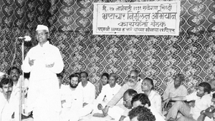
Anna rightly thought that Development is marred by corruption and started a new venture in 1991 called Bhrashtachar Virodhi Jan Aandolan (BVJA) or public movement against corruption. It was found that some 42 forest officers had duped the state government for crores of rupees through corruption in confederacy. Hazare submitted the evidences to the government but the latter was reluctant to take action against all these officers as one of the ministers of the ruling party was involved in the scam. A distressed Hazare returned the Padmashree Award to the President of India and also returned the Vriksha Mitra Award given by then prime minister of India Rajiv Gandhi.

He further went on an indefinite hunger strike in Alandi on the same issue. Finally, the government woke up from deep slumber and took action against the culprits. Hazare’s sustained campaign on this issue had a great effect - six of the ministers were forced to resign and more than 400 officers from different government offices were sent back to home.
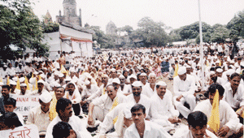
Hazare realized that it was not enough to merely take action against fraudulent ministers or officers but to change the entire system that was studded with loopholes. Hence, he campaigned for the Right to Information Act. The state government turned a blind eye towards the pleas in this regard and so he first agitated in the historical Azad Maidan in Mumbai in the year 1997. To create mass public awareness about RTI amongst the youth, Hazare traveled extensively throughout the state. The government kept promising that RTI Act would be made but never raised this issue in the house or the state assembly. Hazare did not relent – he agitated at least ten times.

Finally, again he went on an indefinite hunger strike at Azad Maidan in the last week of July 2003. At last, the President of India signed the draft of the Right to Information Act after his 12-day-long hunger strike and ordered the state government to implement it with effect from 2002. The same draft was considered as the base document for the making of the National Right to Information Act-2005.

After the implementation of the RTI Act-2005, Hazare travelled for more than 12,000 Kms across the state creating awareness about the Act. In the second phase, he interacted with more than one lakh college students and also conducted mass public meetings across 24 districts of the state. The third phase included daily 2-3 public meetings in more than 155 tehsil places. In this massive campaign, posters, banners were displayed and more than one lakh booklets of the provisions of the Act were distributed at a nominal price.

This created enough of awareness and people were educated on the issue of rights of citizens.
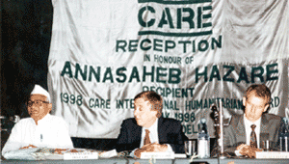
Hazare deservedly won the coveted Padmashree and then Padmabhushan. Care International of the USA, Transparency International, Seoul (South Korea) also felicitated him. Apart from this, he received awards worth Rs. 25 lakh and donated the entire amount for the Swami Vivekananda Kritadnyata Nidhi (social gratitude fund). Out of the two lakh rupees received from the above amount, mass marriages are carried of at least 25-30 poor couples every year.
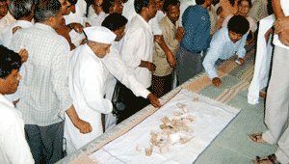
That Hazare has given his life for social betterment is reflected thus: ``I do have my home in the village but I have not entered it for the past 35 years. I have implemented schemes costing more than several crores of rupees but I do not have bank balance. Last 12 years I have been working in the field of eradication of corruption. This movement is run entirely by public support without and grants or sponsorships. I appeal for money wherever I go for a public meeting and urge them to contribute generously. The same money I use to carry out my campaigns. The money collected at such public meetings is counted in front of the villagers and my volunteers issue a receipt of the same on the spot.

He further states that, ``The movement that we started many years back without a penny in wallet, has spread its wings in all the 33 districts and 252 tehsils of the state. Hence we have been instrumental in offering rights to local bodies like Gramsabha, preventing red-tapism and initiating the law of transfers. This has prevented corruption on a large scale. This has also resulted in offering social justice to the economically backward class. The Union Government keeps on making various schemes for poor people in availing kerosene, LPG and pulses on ration card but the middlemen keep on gulping the subsidies of the same. Our efforts made these necessities available to the poor.’’

The state government promoted opening of cooperative societies, credit societies & urban banks. Believing in the principles of cooperative sector, the utmost lower class of the society invested their savings with such cooperative societies. However, the directors of such societies devoured the money and failed to pay back the basic amount to the members of the societies. This created havoc and people were duped for crores of rupees and did not have money for the marriages of their daughters or for medical treatment. Hazare agitated for over eight months. The result was that more than Rs. 125 crore was recovered from defaulters and the members of such societies heaved a sigh of relief. Recovery of around Rs. 400 crores is in the pipeline.
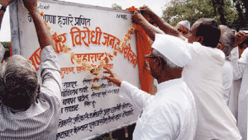
In the future, the BVJA will work for the decentralisation of power and laws related to the same. Says Hazare, ``we have decided to develop centers to create awareness amongst people about govt. schemes and train activists to know the modus operandi of corruption in each sector. As the state government has decided to set up committees at almost every nodal point like state, district, tehsil, and village level with one member on such committee represented by our organisation. We have trained more than 400 volunteers to work on such committees.

Actually the government should train the members of NGOs who can work in the sector of prevention of corruption. Then and then only we can dream of corruption-free state, concludes Hazare.
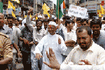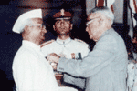
Sustainable development of any village by making it a “Model Village” and eradication of corruption are two sides of the same coin. If both are adopted, only then there will be an established welfare state.

