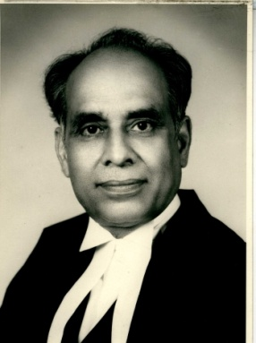  H.R. Khanna | 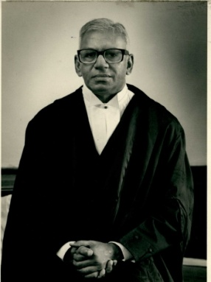  V.R. Krishna Iyer | 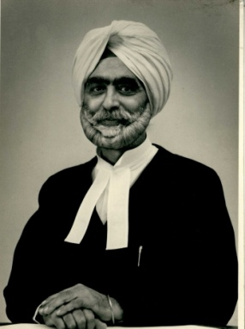  R.S. Sarkaria | 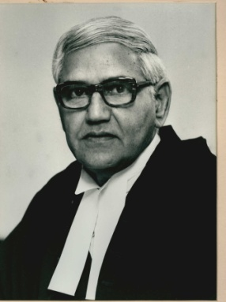  A.D. Koshal
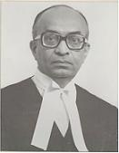  O. Chinnappa Reddy | 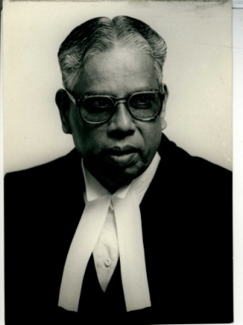  A.Varadarajan | 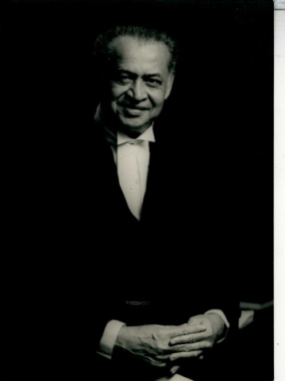  A.N. Sen | 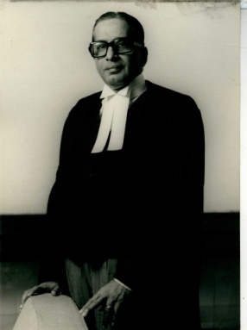  V. Balakrishna Eradi
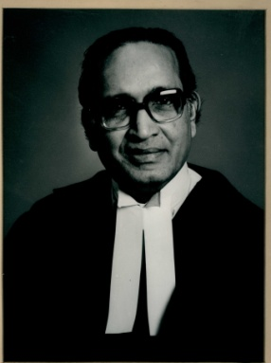  V. Khalid | 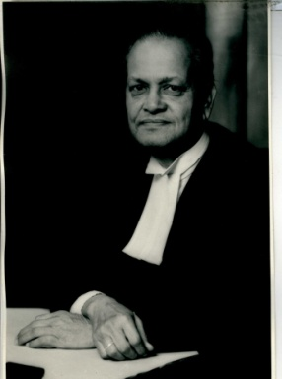  M.M. Dutt | 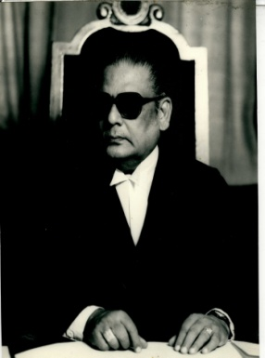  S. Natarajan | 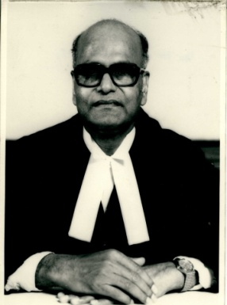  K. Jaganatha Shetty
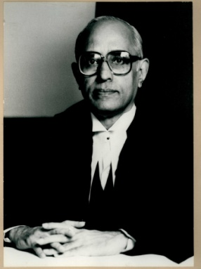  S. Ranganathan | 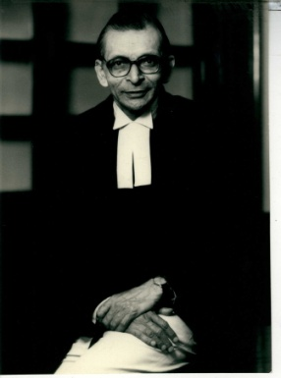  N.D. Ojha | 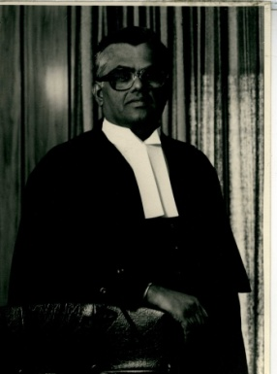  S.R. Pandian | 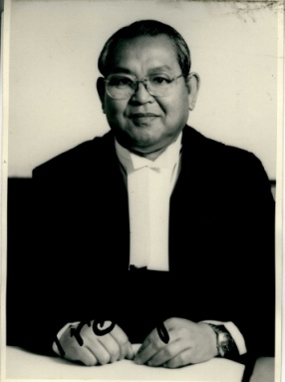  K.N. Saikia

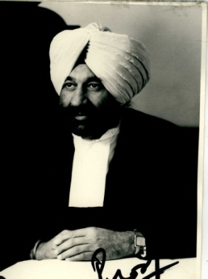  Kuldip Singh | 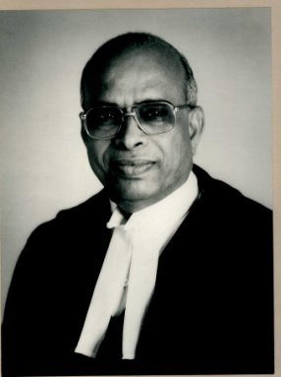  V.Ramaswami | 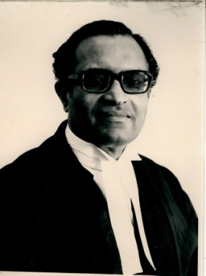  P.B. Sawant | 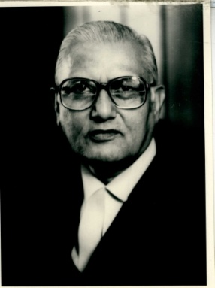  N.M. Kasliwal
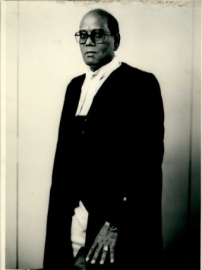  K. Ramaswamy | 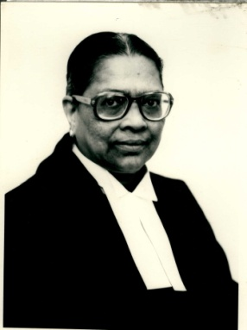  M. Fathima Beevi | 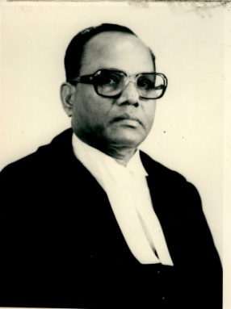  K.Jayachandra Reddy | 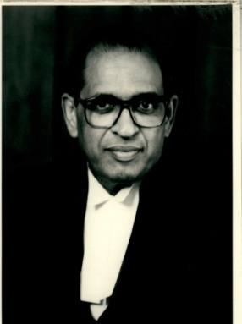  S.C. Agrawal
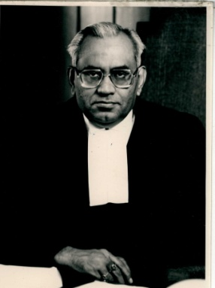  R.M. Sahai | 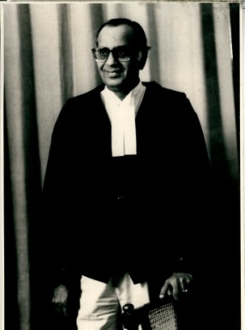  S. Mohan | 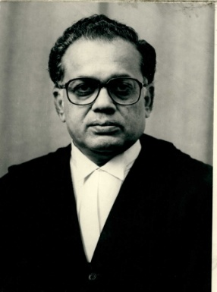  B.P. Jeevan Reddy | 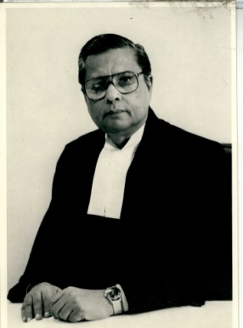  G.N. Ray
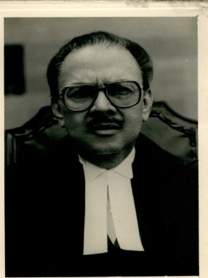  N.P. Singh | 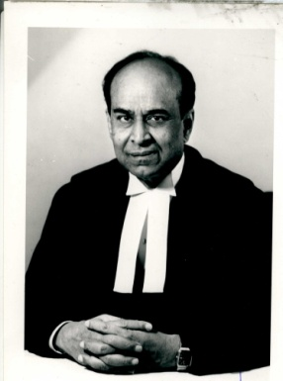  N. Venkatachala | 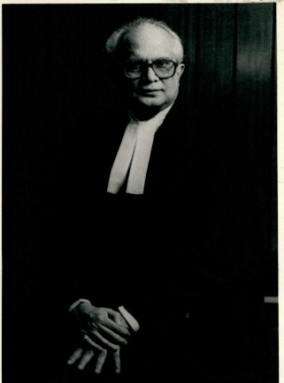  M.K. Mukherjee | 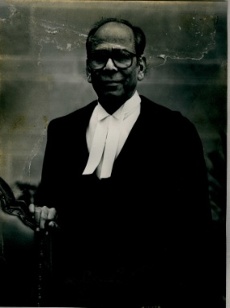  Faizanuddin

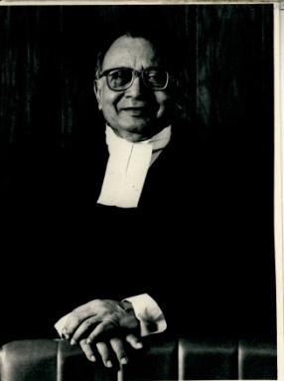  S.C. Sen | 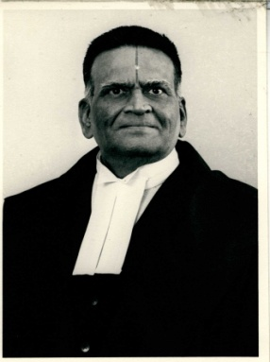  K.S. Paripoornan | 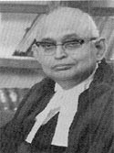  S.B. Majumdar | 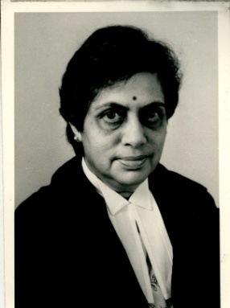  Sujata V. Manohar
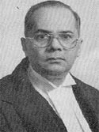  G.T. Nanavati | 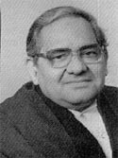  S. Saghir Ahmad | 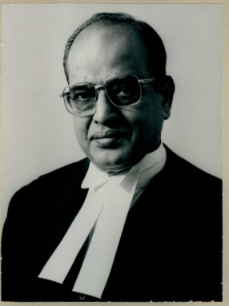  K. Venkataswami | 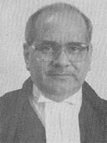  S.P. Kurdukar
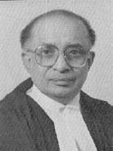  K.T. Thomas | 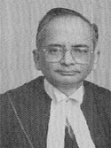  M. Jagannadha Rao | 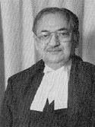  D.P. Wadhwa | 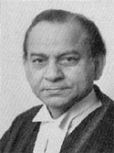  Ajay Prakash Misra
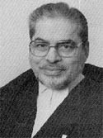  S.S.M. Quadri | 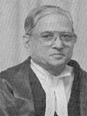  M.B. Shah | 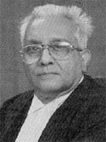  D.P. Mohapatra | 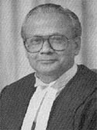  U.C. Banerjee

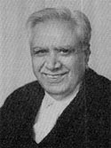  R.P. Sethi | 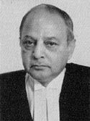  S.N. Phukan | 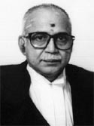  Doraiswamy Raju | 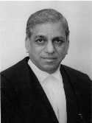  Shivaraj V. Patil
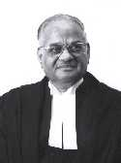  Brijesh Kumar | 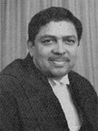  N. Santosh Hegde | 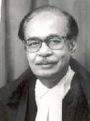  P. Venkatarama Reddi | 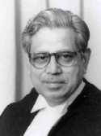  D.M.Dharmadhikari
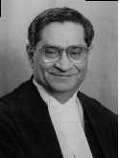  S. N. Variava | 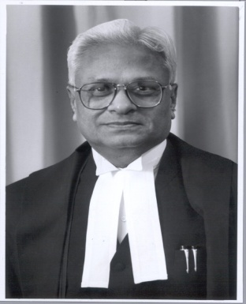  Arun Kumar | 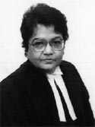  Ruma Pal | 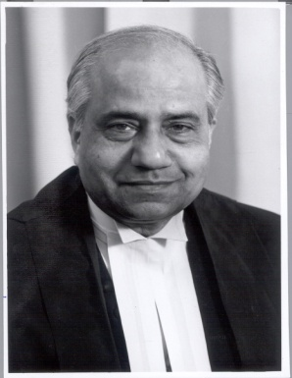  B.N. Srikrishna
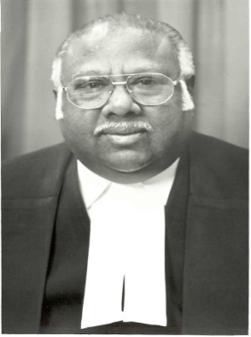  AR. Lakshmanan | 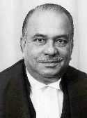  B.P. Singh | 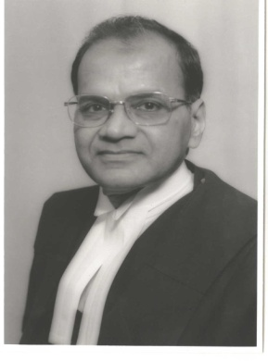  P.K. Balasubramanyan | 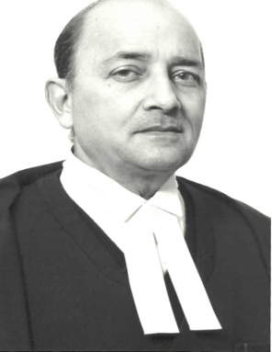  G.P. Mathur

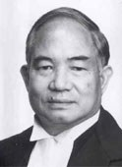  H.K. Sema | 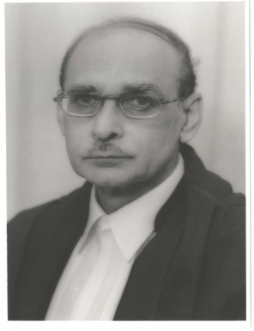  P.P. Naolekar | 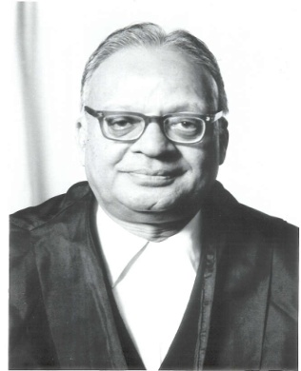  A.K. Mathur | 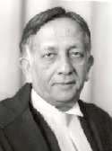  Ashok Bhan
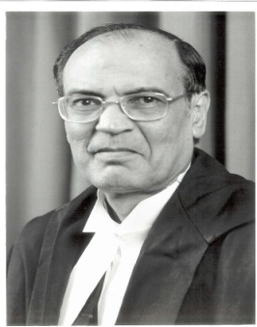  C.K. Thakker | 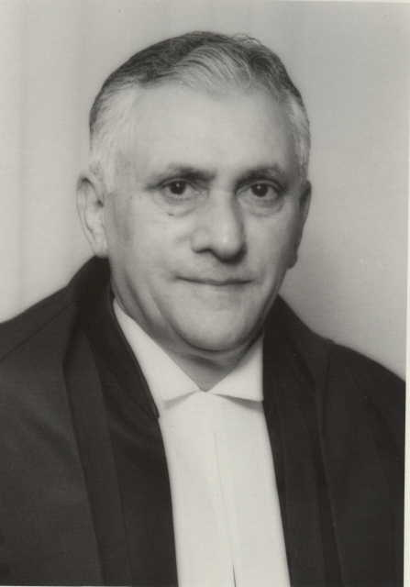  Lokeshwar Singh Panta | 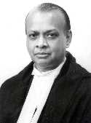  Arijit Pasayat | 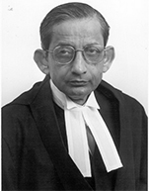  S.B. Sinha
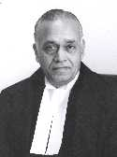  B.N. Agrawal | 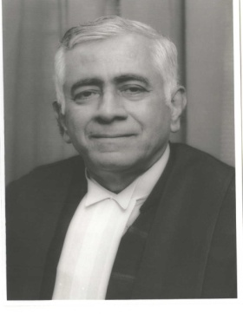  Tarun Chatterjee

Chief Justices of Supreme Court of India
No. | Name | Took office | Left office | Originating State | Major decisions during tenure as Chief Justice
01 | H. J. Kania | 15 August 1947 | 16 November 1951 | Bombay (now Mumbai) | AK Gopalan v. Union of India  State of Madras v. Champakam Dorairajan (Which led to the First constitutional amendment)
02 | Mandakalathur Patajali Sastri (M.P.Sastri) | 16 November 1951 | 3 January 1954 | Madras (now Chennai)
03 | Mehr Chand Mahajan | 3 January 1954 | 22 December 1954 | Lahore/Kashmir
04 | B. K. Mukherjea | 22 December 1954 | 31 January 1956 | West Bengal
05 | Sudhi Ranjan Das | 31 January 1956 | 30 September 1959 | West Bengal
06 | Bhuvaneshwar Prasad Sinha | 30 September 1959 | 31 January 1964 | Bihar
07 | P. B. Gajendragadkar | 31 January 1964 | 15 March 1966 | Bombay (now Maharashtra)
08 | A. K. Sarkar | 16 March 1966 | 29 June 1966 | West Bengal
09 | K. Subba Rao | 30 June 1966 | 11 April 1967 | Madras (now Tamil Nadu) | Golak Nath vs. The State of Punjab
10 | Kailas Nath Wanchoo | 12 April 1967 | 24 February 1968 | Uttar Pradesh
11 | M. Hidayatullah | 25 February 1968 | 16 December 1970 | present Chattisgarh
12 | Jayantilal Chhotalal Shah | 17 December 1970 | 21 January 1971 | present Gujarat
13 | S. M. Sikri | 22 January 1971 | 25 April 1973 | Punjab | Kesavananda Bharati vs. The State of Kerala
14 | A. N. Ray | 25 April 1973 | 28 January 1977 | West Bengal | ADM Jabalpur v. Shivakant Shukla
15 | Mirza Hameedullah Beg | 29 January 1977 | 21 February 1978 | Uttar Pradesh
16 | Y. V. Chandrachud | 22 February 1978 | 11 July 1985 | Bombay (now Maharashtra) | Shah Bano Case (headed the bench which delivered the verdict)
17 | P. N. Bhagwati | 12 July 1985 | 20 December 1986 | Bombay (now Maharashtra)
18 | R. S. Pathak | 21 December 1986 | 6 June 1989 | Uttar Pradesh
19 | E. S. Venkataramiah | 19 June 1989 | 17 December 1989 | Mysore (now Karnataka)
20 | S. Mukharji | 18 December 1989 | 25 September 1990 | West Bengal
21 | Ranganath Misra | 25 September 1990 | 24 November 1991 | Orissa
22 | Kamal Narain Singh | 25 November 1991 | 12 December 1991 | Uttar Pradesh
23 | M. H. Kania | 13 December 1991 | 17 November 1992 | Maharashtra
24 | Lalit Mohan Sharma | 18 November 1992 | 11 February 1993 | Bihar
25 | M. N. Venkatachaliah | 12 February 1993 | 24 October 1994 | Karnataka
26 | A. M. Ahmadi | 25 October 1994 | 24 March 1997 | Gujarat
27 | J. S. Verma | 25 March 1997 | 18 January 1998 | Madhya Pradesh
28 | M. M. Punchhi | 18 January 1998 | 9 October 1998 | Punjab
29 | A. S. Anand | 10 October 1998 | 1 November 2001 | Jammu & Kashmir
30 | S. P. Bharucha | 2 November 2001 | 6 May 2002 | Maharashtra
31 | B. N. Kirpal | 6 May 2002 | 11 November 2002 | Delhi
32 | G. B. Pattanaik | 11 November 2002 | 19 December 2002 | Orissa
33 | V. N. Khare | 19 December 2002 | 2 May 2004 | Uttar Pradesh | Best Bakery Case, T.M.A. Pai v. Union of India (reservation in private educational institutions)
34 | Rajendra Babu | 2 May 2004 | 1 June 2004 | Karnataka
35 | R. C. Lahoti | 1 June 2004 | 1 November 2005 | Uttar Pradesh
36 | Y. K. Sabharwal | 1 November 2005 | 14 January 2007 | Delhi | Land Ceiling Case (M.C. Mehta v. Union of India)
37 | K. G. Balakrishnan | 14 January 2007 | 11 May 2010 | Kerala | OBC Reservation case (Ashok Kumar Thakur v. Union of India)
38 | S. H. Kapadia  ( SITTING CJI ) | 12 May 2010 (incumbent) | 29 September 2012 | Maharashtra

