Correct timing to take water....very important
-
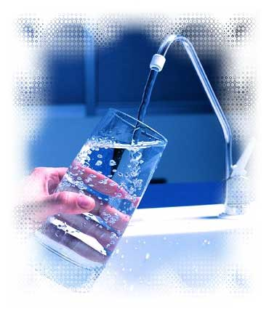

Correct timing to take water will maximize its effectiveness to Human body.
Two (02) glass of water - After waking up - Helps activate internal organs

One (01) glasses of water - 30 minutes before meal - Help digestion
One (01) glass of water - Before taking a bath - Helps lower blood pressure
One (01) glass of water - Before sleep - To avoid stroke or heart attack
