Tips for driving in the rains

Every year during the rainy season, there are more accident than what occurs during the regular months. The reasons are many some of the common reasons that could cause accidents are poor visibility, vehicles going out of control and the driver not concentrating enough due to rain. Driving safely during monsoon is very important to prevent such accidents

Here are some things that you can do to avoid accidents, especially during monsoon.
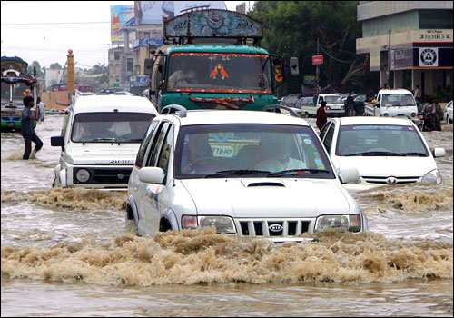
1.Start with the basics. Check the general condition of your car. Pay close attention to your the tyres, brakes and wipers (an often neglected accessory but which is critical in the rains for good visibility largely depends on the quality of the wipers). Replace if you have the slightest doubt.
2.Your tyres must have enough tread left (at least 2 - 3 mm). The quality of tyres is critical to the handling, performance and grip of your vehicle. They should not be either over or under inflated. It is wise to keep to the manufacturer's recommendations, even if your mechanic tells you otherwise. They are usually arrived at after days and weeks of testing before the vehicle is launched. Trust the car maker's judgement.
3. Ensure that your headlight beams are focussed optimally. Ensure that all other lights, especially the parking lights are functioning as they should.
4. Another neglected item is the foot pedals. Mostly the runner covers are worn out or totally missing. Change/replace them at once. In the rains, a slip while braking or changing gears because of wet footwear could prove costly or even dangerous.
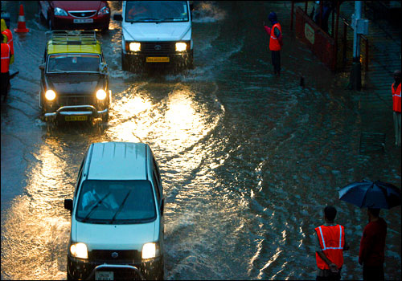
5. Many cars have their drain hole plug missing. Replace them at once. Missing or loose drain-hole rubber plugs will result in water seeping into the passenger compartment even it is not raining too heavily.
6. Like the windshield wiper, keep the windshield clean and the washer fluid topped up at all times. Using a newspaper to clean your windshield works wonders. Some also suggest wiping the glass with tobacco (your cigarettes could come in handy?!). Avoid using low quality cleaners on the windshield, as they leave marks behinds and can get into the scratches on the screen and distort and reduce your visibility.
7. Check the insulation of your car - rubber beadings on the doors and windows. If they appear loose or damaged tighten or change them. The condition of the beadings is crucial as they stop the rain from getting into the car, preventing rust and short-circuits.
8. Another hugely neglected item in a car's kit is safety tools - first-aid, basic medicines, torches, and umbrella etc.

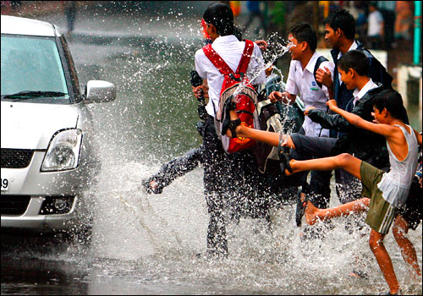
9. Wet mats or upholstery can result in smelly interiors. Go in for a quality air freshener. The type that is slotted on to the air con vents is effective and convenient. But make sure that they do not break the plastic of the air vent. Going in for natural fragrance like sandalwood-based fresheners are also a good choice. But avoid strong fragrances, as they can put-off people with allergies.
On the road
10. Contrary to popular notion, the first rains make road surfaces more slippery than water logged roads. And, cement surfaces tend to be more slippery than tar roads. In moderate to heavy rains you can be the victim of 'aqua-planing' - a thin film of water between the surface and the tyre of your car. Any sudden manoeuvre by you can cause skidding of the vehicle in such a situation can be treacherous and dangerous.
11. Drive by the gear. Drive steadily and in gear lower than you would normally do so that you ensure more control and traction with the surface, as the engine also acts as a brake.
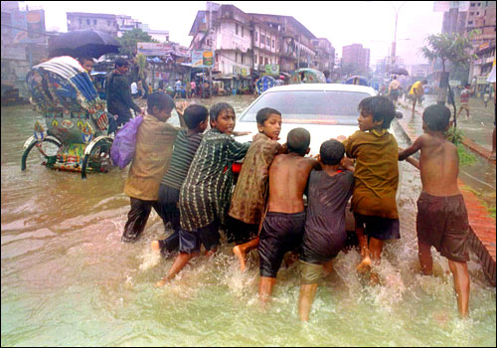
12. Maintain at least twice the distance between you and the car in the front, as braking distances are dramatically lengthened in wet surfaces.
13. Avoid the temptation to select the high beam in the rains, especially if there is mist or fog. Rather than increasing visibility it may actually increase the glare, especially for the oncoming traffic.
14. Avoid driving on painted surfaces on the road like the yellow lines and the divider lines as painted surfaces have substantially reduced traction.
15. Always attempt to drive on the central lane, if you are on a three lane road. Especially on the highways, as it will give you some space to manoeuvre in case of an emergency. Plus the extreme lanes usually are subject to water logging.
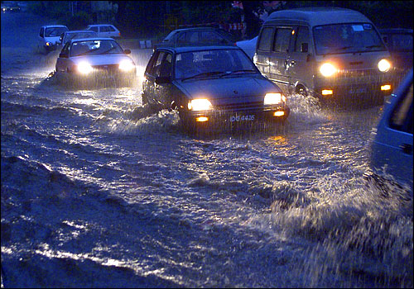
16. Always treat a puddle as a hole, a hazard. No knowing what is under the puddle; for all you know it could be a drain hole or a substantial pothole on the road. Enter the puddle with extreme caution and very slowly. In most cases, try to drive around the puddle.
17. Another thing which is mandatory for the Indian roads, especially the highways. Treat a truck in front with extreme caution. Countless accidents have happened when otherwise cautious drivers slammed into stationary trucks on the highway, as there were no indications that the truck was stationary. No warning lights, no hazard signs, no nothing. Most trucks in India don't even have their stop lights functioning. At high speeds it is well nigh impossible to tell a standing truck from a moving one.
18. Once you are through a puddle, do not assume that everything is back to normal. Select the lowest gear, slip the clutch, and rev hard. This is to enable the gases in the exhaust to be pushed out. Keep revving till you are sure that engine would not stall. If the car does stall, do not try to start again. You need to park and first ensure that water has not entered air intake or the exhaust. Otherwise, it will result in a 'hydrolock'.
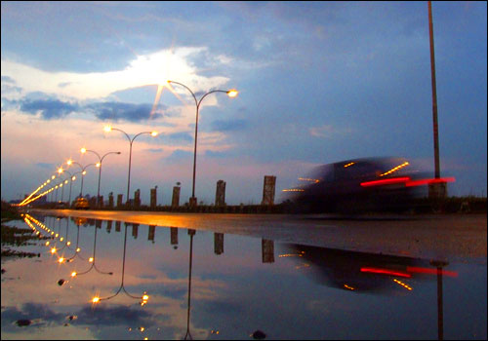
19. As importantly, once out of water, pump your brakes steadily till you feel that all the water has been dried from the brake discs or drums. Do not, repeat do not, attempt to drive if you get even a fleeting feeling that the brakes are not functioning. Don't try heroics like trying to dry the brakes on the move. Braking and finding that they are not engaging is a sinking feeling, felt to be believed.
20. If the rain is pelting, have patience, don't overtake needlessly or use your horns excessively. The vehicle in front may be slow, not because the driver is a retard, but an experienced one - who knows how rains and waterlogged road surfaces have dramatically different dynamics than on a dry surface. So be patient.
Being careful and trying to implement the things said above will help prevent any major problems that are commonly faced by drivers during the rainy season.
Happy driving in the monsoon .

