Now that's using your head, or hair rather...



The Force is strong within this one.

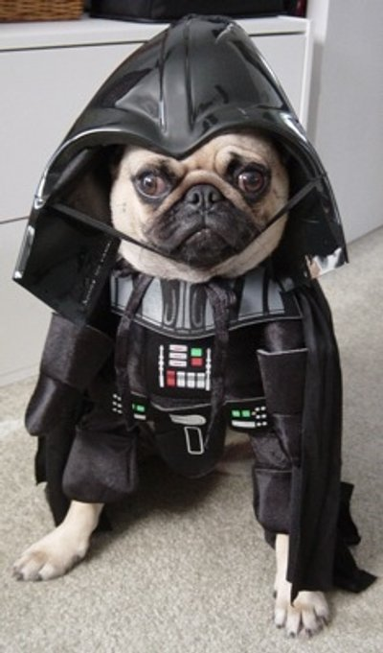

Who knew the Darth Vader brothers
where a couple of swingers!

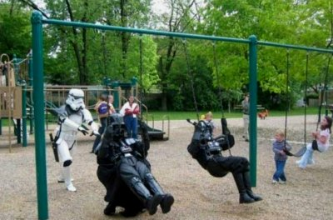

It wasn't me I swear!


This is going to be one wet pussycat .


For the dog owner who doesn't read signs.

