Financial Instruments Standards- Over view Focus on ECL
Currently under Indian GAAP, there is no comprehensive literature for accounting for financial instruments. While AS 13, Accounting for Investments deals with the accounting for investments in the financial statements and related disclosure requirements, it does not cover the classification and measurement of financial liabilities. While some other standards cover some other aspects of financial instruments, e.g. AS 11 the Effects of Changes in Foreign Exchange Rates covers certain forward exchange contracts.
Standards dealing with financial instruments under Ind AS
Under Ind AS, three Standards deal with accounting for financial instruments.
- Ind AS 32 Financial Instruments: Presentation deals with the presentation and classification of financial instruments as financial liabilities or equity.
- Ind AS 107 Financial Instruments: Disclosures sets out the disclosures required in respect of financial instruments.
- Ind AS 109 Financial Instruments contains guidance on the recognition, derecognition, classification and measurement of financial instruments, including impairment and hedge accounting.
At the outset, it may be noted that fair value of financial instruments should be determined in accordance with the principles enunciated in Ind AS 113 Fair Value Measurement.

Financial instrument is
Any contract that gives rise to a financial asset of one entity and a financial liability or equity instrument of another entity.
Financial asset is
A financial asset is any asset that is:
• cash;
• an equity instrument of another entity;
• a contractual right: - to receive cash or
- another financial asset from another entity; or
- to exchange financial assets or financial liabilities with another entity under conditions that are potentially favourable to the entity;
• a contract that will or may be settled in the entity’s own equity instruments under certain circumstances.
Examples of financial assets are investments in equity instruments, investments in debt instruments, trade receivables, cash and cash equivalents, derivative financial assets.

Financial liability is

A financial liability is any liability that is:
• a contractual obligation
- to deliver cash or another financial asset to another entity;
or - to exchange financial assets or financial liabilities with another entity under conditions that are potentially unfavourable to the entity; or
• a contract that will or may be settled in the entity’s own equity instruments under certain circumstances.

Classification of Financial Assets:

Financial assets have been classified into three categories as per Ind AS 109:

Financial assets shall be classified on the basis of both:
(a) The entity’s business model for managing the financial assets and
(b) The contractual cash flow characteristics of the financial assets.

Business Model ASSESSMENT: rationale
► The business model assessment should refer to how an entity manages its financial assets in order to generate cash flows and create value for the entity.
► The entity’s business model for managing financial assets is often observable through particular activities that are undertaken to achieve the objectives of that business model.
► Sales do not drive the business model assessment and information about past sales should not be considered in isolation.
► Business activities usually reflect the way in which the performance of financial assets is evaluated and reported, as well as the risks that typically affect the performance of the business model and how those risks are managed.

Amortized Cost Business Model (Examples of sales that would be consistent with a hold to collect business model):

The fact that the requirement to sell the financial asset is imposed by a third party (e.g., a regulator) is not relevant for assessment of business model.

Example:
Company Z generates trade receivables that are due in 30 days after the issue of an invoice. Z manages cash collections deals with customer queries and sends out reminders when amounts become overdue. The management focuses on monitoring the overdue status and collection teams are evaluated on the basis of the length of the cash collection period. When a receivable is overdue by 150 days and no payment plan has been agreed with a customer, Z’s policy is to sell the receivable, at a significant discount, to a debt collection company and Z has no further involvement with that receivable. This happens rarely.

Response: Bank will classify the financial asset as AC.

FVOCI Business Model (hold to collect and Sell)

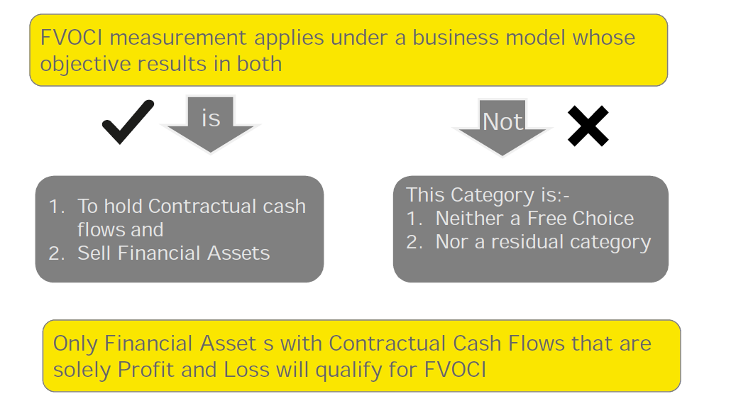

Example:
► A bank holds financial assets to meet its everyday liquidity needs.
► The bank seeks to minimise the costs of managing its liquidity needs and therefore actively manages the return on the portfolio.
► The bank typically holds some financial assets to collect contractual cash flows and sells others to reinvest in higher yielding assets or to better match the duration of liabilities.
► This strategy has resulted in significant and recurring sales activity in the past, which is expected to continue.

Response: Bank will classify the financial asset as FVOCI.

FVTPL Business Model
► FVTPL is the residual measurement category applicable to all instruments failing either the contractual cash flow or the business model test (this includes instruments held for trading, derivatives and equity instruments)
► FVO also applicable for financial instruments under a FVOCI business model if accounting mismatch is present.
Contractual cash flow characteristic test
► Contractual terms of the financial asset give rise, on specified dates, to cash flows that solely represent principal and interest payments.
► ‘Interest’ is consideration for the time value of money and the credit risk associated with the principal amount outstanding during a particular period of time.
► Meaning of interest
De minimis and non-genuine features to be disregarded
Conceptual basis for P&I is a basic lending-type relationship
Time value of money and credit risk as the most significant, but not the only, components of a basic lending-type return.
Liquidity risk and profit margin as other possible components.
► Contractual cash flow characteristic that introduces leverage do not have the characteristics of interest e.g. option, forward and swap contracts.
► An instrument that is subordinated to other instruments (e.g. to general creditors) may still have contractual cash flows that are principal and interest.

Contractual Cash Flow Characteristics’ test- Examples
Instruments that will qualify | Instruments that will NOT qualify
A bond with a stated maturity date. Principal and interest are linked to an inflation index that is not leveraged. | A convertible bond that is convertible into equity instruments of the issuer.
A variable interest rate loan with a stated maturity date that permits the borrower to change the period of the market interest rate at each interest reset date on an ongoing basis. | A loan that pays an inverse floating rate, i.e. the interest rate has an inverse relationship to the market interest rates.
A bond with a stated maturity date and pays a variable market interest rate which is capped. | A constant maturity bond with a five-year term that pays a variable rate that is reset periodically but always reflects a five-year maturity.

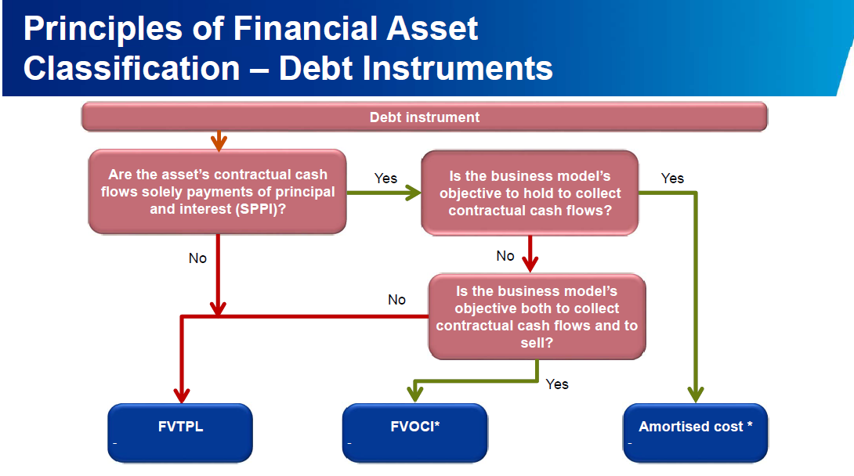

Classification of financial liabilities
Financial liabilities have been classified into two categories:
Category | Main Use
Fair value through profit or loss | ► Financial liabilities that are held for trading (including  derivatives)  ► Financial liabilities that are designated as FVTPL on  initial recognition  ► Contingent consideration recognised by an acquirer in a  business combination
Amortised Cost | ► All liabilities not in the above category

Initial Measurement
“The fair value of a financial instrument on initial recognition is normally the transaction price.”
However, if part of the consideration given or received is for something other than the financial instrument or the transaction was not transacted at arm’s length, the fair value is estimated using a valuation technique.

Please advice on initial measurement of following transactions
a) A Ltd Bank lends to B Ltd Bank loan of 10 million for 5 years and classify as asset under loans and advances. The Loan carries no interest. Market rate of interest is 10%.
b) A ltd grants interest free loan of 10 Lac to a employees for a period of two years. Market rate of interest is 10%
Solution:
a) Initial recognition at 6.21 million and this will accrete to 10 million over the term of the loan using effective interest rate method.
b) Fair value of the loan 10,00,000/(1.10)2 = 8,26,000. Difference of 1,74,000 is accounted for as employee compensation as per Ind AS 19.

Subsequent Measurements
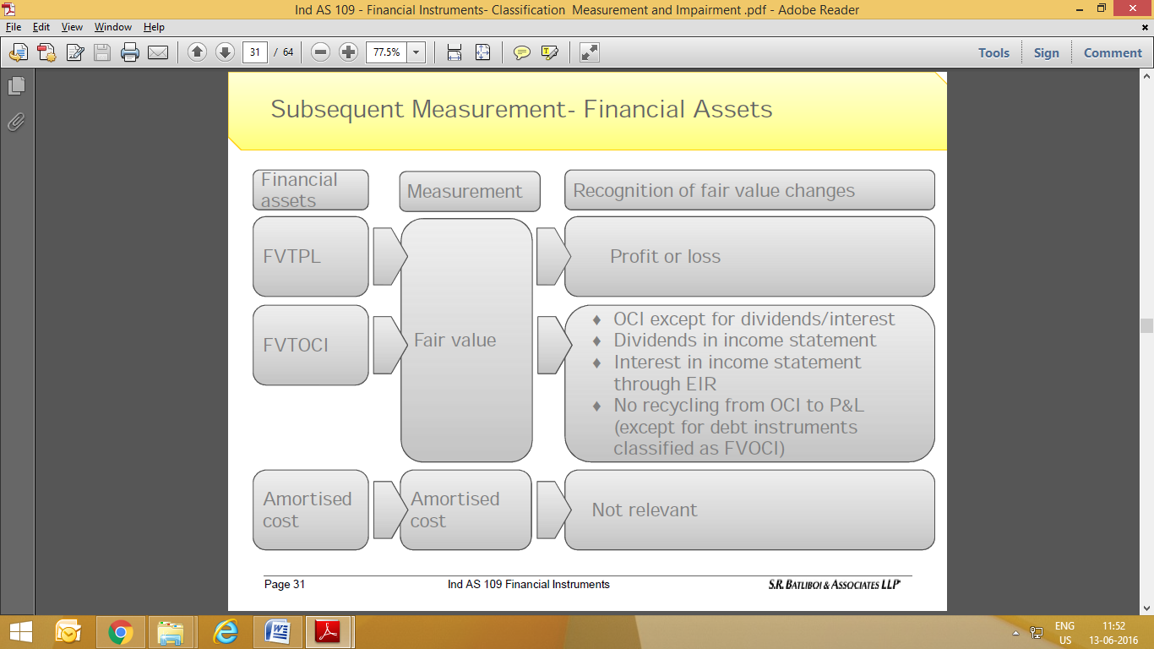
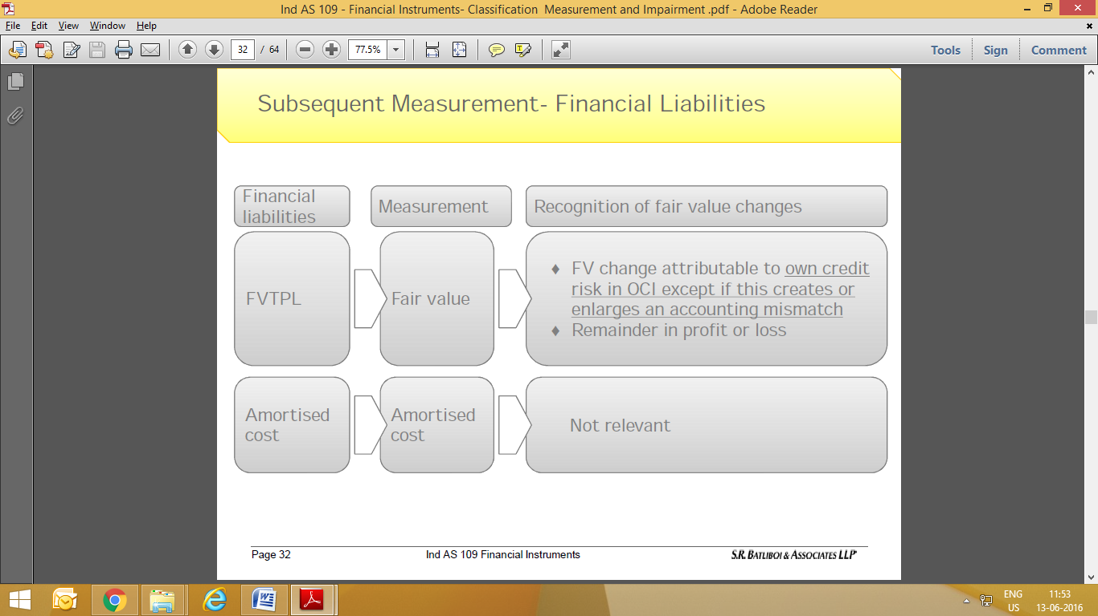
Impairment:
• The measurement of ECLs reflects a probability-weighted outcome, the time value of money and the best available forward-looking information.
• The need to incorporate forward-looking information means that application of the standard will require considerable judgement as to how changes in macroeconomic factors will affect ECLs. The increased level of judgement required in making the expected credit loss calculation may also mean that it will be more difficult to compare the reported results of different entities. However, entities are required to explain their inputs, assumptions and techniques used in estimating the ECL requirements, which should provide greater transparency over entities’ credit risk and provisioning processes.
• The need to assess whether there has been a significant increase in credit risk will also require new data and processes and the exercise of judgement.
• The effect of the new requirements will be to require larger loss allowances for banks and similar financial institutions and for investors in debt securities. On transition, this will reduce equity and have an impact on regulatory capital. The level of allowances will also be more volatile in future, as forecasts change.
• Adopting the expected credit losses requirements will require many entities to make significant changes to their current systems and processes; early impact assessment and planning will be key to managing successful implementation.

Scope and Variation of Expected Credit Loss Model

The impairment requirements would apply to:
► Debt instruments measured at amortised cost
► Debt instruments measured at fair value through other comprehensive income
► Loan commitments and financial guarantee contracts not measured at fair value through profit or loss.
► Trade receivables and contract assets
► Lease receivables

Expected Credit Loss Model: the basic General Approach

IFRS 9 introduces so-called “general model” of recognizing impairment loss. This model requires recognizing impairment losses in line with the stage in which the financial asset currently is. There are 3 stages:
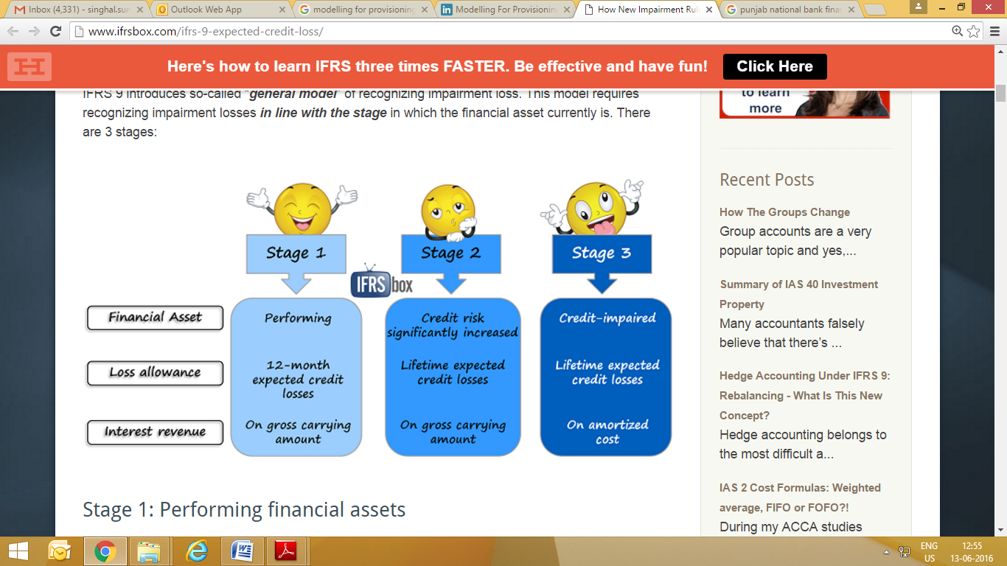

Stage 1: Performing financial assets

Here, we have financially healthy financial assets that are expected to perform normally in line with their contractual terms and there are no signs of increased credit risk.
IFRS 9 requires recognizing impairment loss amounting to 12-month expected credit losses immediately at initial recognition of these assets.

Stage 2: Financial assets with significantly increased credit risk
When the credit risk of certain financial asset significantly increased and the resulting credit quality is NOT low risk, then an entity needs to recognize full lifetime expected credit losses.
What are they?
They are present value of losses that arise if a borrower defaults on their obligations throughout the life of the financial instrument.
In fact, 12-month expected credit losses are just the portion of the life time expected credit losses.
Now, please be careful, because expected credit losses are in fact a difference between:
- The present value of cash flows based on the contract of a financial instrument; and
- The present value of cash flows that an entity really expects to obtain from the financial instrument.
As a result, the timing of payments from the financial instrument directly affects their present value and thus the amount of an impairment loss.
In practice, if you expect that debtor will pay you in full, but later than in line with the contract, there IS an impairment loss!

Stage 3: Credit-impaired financial assets

When your financial asset has already become credit impaired (meaning that certain default events have occurred), then an entity still recognizes lifetime expected credit losses.
However, this time, interest revenue is calculated and recognized based on the amortized cost(that is gross carrying amount less loss allowance).
In this stage, financial assets might need to be individually assessed.

- The new IFRS 9 impairment requirements requires threshold for the recognition of credit losses, i.e., it is no longer necessary for a credit event to have occurred before credit losses are recognised. Instead, an entity always accounts for ECLs, and updates the loss allowance for changes in these ECLs at each reporting date to reflect changes in credit risk since initial recognition. Consequently, the holder of the financial asset needs to take into account more timely and forward-looking information in order to provide users of financial statements with useful information about the ECLs on financial instruments that are in the scope of these impairment requirements.

IFRS 9 provides the following operational simplifications:

• A ‘low credit risk’ threshold equivalent to ‘investment grade’
• A more than 30 days past due rebuttable presumption.
• Use of a change in the 12-month risk of a default as an approximation for change in lifetime risk.

In Stages 1 and 2, there is a complete decoupling of interest recognition and impairment. Therefore, interest revenue is calculated on the gross carrying amount (without deducting the loss allowance). If a financial asset subsequently becomes credit-impaired (Stage 3 in the diagram at section 1.2 above), an entity is required to calculate the interest revenue by applying the EIR in subsequent reporting periods to the amortised cost of the financial asset (i.e., the gross carrying amount net of loss allowance) rather than the gross carrying amount.

In subsequent reporting periods, if the credit quality of the financial asset improves so that the financial asset is no longer credit-impaired and the improvement can be related objectively to the occurrence of an event (such as an improvement in the borrower’s credit rating), then the entity should once again calculate the interest revenue by applying the EIR to the gross carrying amount of the financial asset. When the entity has no reasonable expectations of recovering the financial asset, then the gross carrying amount of the financial asset should be directly reduced in its entirety. A write-off constitutes a derecognition event

12 month and life time expected credit loss
This is a component of life time expected credit loss which may be incurred because of defaults events on the financial instruments materializing within 12 months from the reporting date.
Major challenge:
- Differentiating between default event and significant increase in credit risk
- Segregate loss caused by a default event taking place within next 12 months from those taking place after 12 months.
Provisioning for bad debts is to be computed based on rigorous analysis of past data.
There will be a tough balancing act between the measurement requirement and corresponding cost.
Reporting entities, particularly those with regulatory capital requirement may face a negative impact since now the expected loss will also have to be provided as against the current practice of providing only incurred credit losses.
Transition from 12 month to life time provision is likely to cause an enhanced provision which will have an adverse impact on the capital adequacy.
Loss Allowance Recognition: Illustration
On 31 December 20X1 Bank B grants a loan to a borrower with low credit standing, but still at an acceptable level for B. The price of the loan does not reflect incurred credit losses.
Q: What loss allowance should B recognise in the statement of financial position at 31 December 20X1?
A. None.
B. 12-month expected credit losses.
C. Lifetime expected credit losses.

Its B 12 month Expected Credit loss

Under the general model of IND AS 109, all assets need to have a loss allowance.
Allowance covers either 12-month or lifetime expected credit losses depending on whether the asset’s credit risk has increased significantly.
Since the loan has just been granted and there has not been a significant increase in credit risk, an allowance equal to 12-month expected credit losses is appropriate.

An example of a low credit risk instrument is one that has an investment grade rating (although an external rating grade is not a prerequisite for a financial instrument to be considered low credit risk)
Significant increase in credit risk:
- The term has not been defined in the standard leaving it to the judgment of reporting agency.
- It is however clear that this cannot be aligned with the date when assets become credit impaired or with the internal definition of default being used by the reporting entity.
- Focus is not on the Magnitude of the Loss (LGD) but on increase in the risk of Default (PD), LGD is useful to measure the expected credit loss.

Some of the indicators indicating Significant increase in credit risk

Credit Impaired Financial Assets
A financial asset is credit-impaired when one or more events that have detrimental impact on estimated future cash flows of that financial asset have occurred like:
(a) Significant financial difficulty of issuer or borrower;
(b) Breach of contract, such as a default or past due event;
(c) lender(s) of the borrower, for economic or contractual reasons relating to borrower's financial difficulty, having granted to borrower a concession(s) that the lender(s) would not otherwise consider;
(d) It is becoming probable that borrower will enter bankruptcy or other financial reorganisation;
(e) Disappearance of an active market for that financial asset because of financial difficulties; or
(f) Purchase or origination of financial asset at a deep discount that reflects the incurred credit losses.

Note : It may not be possible to identify a single discrete event—instead, combined effect of several events may have caused financial assets to become credit-impaired.

Measurement of Expected Credit Loss
The standard defines credit loss as the difference between all contractual cash flows that are due to an entity in accordance with the contract and all the cash flows that the entity expects to receive (i.e., all cash shortfalls), discounted at the original EIR. When estimating the cash flows, an entity is required to consider:
• All contractual terms of the financial instrument (including prepayment, extension, call and similar options) over the expected life of the financial instrument. However, in rare cases when the expected life of the financial instrument cannot be estimated reliably, then the entity is required to use the remaining contractual term of the financial instrument.
• Cash flows from the sale of collateral held or other credit enhancements that are integral to the contractual terms.

Expected credit losses are an estimate of credit losses over the life of the financial instrument. Accordingly, an entity should consider the following for measuring expected credit losses,:
(a) the probability-weighted outcome: expected credit losses should represent neither a best or worst-case scenario. Rather, the estimate should reflect the possibility that a credit loss occurs and the possibility that no credit loss occurs;
(b) the time value of money: expected credit losses should be discounted to the reporting date; and
(c) reasonable and supportable information that is available without undue cost or effort.
An entity is required to use reasonable and supportable information that is available at the reporting date without undue cost or effort, and that includes information about past events, current conditions and forecasts of future conditions.
Although the model is forward-looking, historical information is always considered to be an important anchor or base from which to measure expected credit losses. However, historical data should be adjusted on the basis of current observable data to reflect the effects of current conditions and forecasts of future conditions.

IND-AS 109 does not mandate the use of an explicit probability of default to make this assessment. An entity may apply various approaches when assessing whether the credit risk on a financial instrument has increased significantly. An entity should consider reasonable and supportable information that is available without undue cost or effort when determining whether the recognition of lifetime expected credit losses is required.
Lifetime expected credit losses are expected to be recognised before a financial instrument becomes delinquent. Typically, credit risk increases significantly before a financial instrument becomes past-due or other lagging borrower-specific factors (for example, a modification or restructuring) are observed.

