Fund Management
Table of Contents
Version History 2
Acronym List 5
Executive Overview 7
A1 - Department Regular Code 9
A2 - Department Transfer Code 11
A3 - Main Account Code 13
A4 - Sub-Account Code 15
A5 - Apportionment Category Code 17
A6 - Receipt Indicator 19
A7 - Sub Classification Code 21
A9 - Reimbursable Flag Indicator 23
A10 - Fund Type Code 25
A11 - Advance Flag Code 27
A12 - Authority Type Code 29
A13 - Availability Time Indicator 31
A14 - Borrowing Source Code 33
A15 - Definite Indefinite Flag Indicator 35
A17 - Program Report Code 37
A18 - TAFS Status Indicator 39
A19 - Year of Budget Authority Indicator 41
A20 - Direct Transfer Agency Code 43
A21 - Direct Transfer Account Code 45
A24 - Availability Type Code 47
A25 - Expiration Flag Indicator 49
A26 - Financing Account Indicator Code 51
A27 - Beginning Period of Availability 53
A28 - Ending Period of Availability 55
B1 - Budget Function/Sub-Function Code 57
B2 - Budget Activity Identifier 59
B3 - Budget Sub Activity Identifier 61
B4 - Budget Line Item Identifier 63
B6 - Object Class Code 65
B8 - Contingency Code 68
B9 - BEA Category Indicator Code 70
CA1 - Funding Center Identifier 72
CA3 - Cost Center Identifier 74
CA4 - Project Identifier 76
CA5 - Activity Identifier 78
CA6 - Cost Element Code 80
CA7 - Work Order Number 82
CA9 - Transaction Quantity 84
CA10 - Unit of Measure Code 85
CA12 - Asset Unique ID 87
CA14 - MEPR Code 89
O1 - Organization Unique Identifier 91
O2 - Agency Disbursing Identifier Code 93
O3 - Agency Accounting Identifier Code 95
T1 - Transaction Type Code 97
T2 - USSGL/DoD Account Code 99
T3 - Debit/Credit Indicator 101
T4 - Begin/End Indicator 103
T5 - Transaction Effective Date 105
T6 - Transaction Post Date 107
T7 - Transaction Amount 109
T9 - Exchange/Non-Exchange Indicator 111
T10 - Custodial/Non-Custodial Indicator 113
T11 - Foreign Currency Code 115
T12 - Country Code 117
T13 - Entity/Non-Entity Indicator 119
T14 - Covered/Uncovered Indicator 121
T15 - Current/Non-current Indicator 123
T20 - Business Event Type Code 125
T21 - FMS Customer Code 126
T22 - FMS Case Identifier 128
T23 - FMS Case Line Item Identifier 130
TP1 - Federal/Non-Federal Indicator 132
TP2 - Trading Partner Indicator Code 134
TP3 - Business Partner Number 136

Acronym List
Term | Definition
AP | Accounts Payables
BCS | Budget Control System
BEA | Budget Enforcement Act
BEA | Business Enterprise Architecture
BETC | Business Event Type Code
BPN | Business Partner Number
BTA | Business Transformation Agency
CO | SAP Controlling Module
COE | Center of Excellence
DAI | Defense Agencies Initiative
DISA | Defense Information Systems Agency
DIT | Disbursements-In-Transit
DoD | Department of Defense
DSSN | Agency Disbursing Identifier
DUNS | Data Universal Numbering System
ECSS | Expeditionary Combat Support System (ERP System)
EI | BTA Enterprise Integration
EP | SAP Enterprise Portal
ERP | Enterprise Resource Planning
FACTS | Federal Agencies' Centralized Trial-Balance System
FBT | Funds Balance with Treasury
FI | SAP Finance Module
FM | SAP Funds Management Module
FMS | Foreign Military Sales
FY | Fiscal Year
GFEBS | General Fund Enterprise Business System (ERP System)
GL | General Ledger
HTTPS | Hypertext Transfer Protocol Secure
ISO | International Organization for Standardization
MEPR | Medical Expense and Performance Reporting
MILCON | Military Construction
MILPERS | Military Personnel
MTF | Medical Treatment Facility
O&M | Operations & Maintenance
OMB | Office of Management and Budget
OSD | Office of the Secretary of Defense
OUID | Organization Unique Identifier
OUSD | Office of the Under Secretary of Defense
PS | SAP Project Systems Module
RDT&E | Research, Development, Test & Evaluation
RPUID | Real Property Unique Identifier
SAG | Sub Account Group
Service(s) | Service(s) in this document refer to Web Service(s)
SF | Standard Form
SFIS | Standard Financial Information Structure
SGL | Standard General Ledger
SME | Subject Matter Expert
SSL | Secure Sockets Layer
TAFS | Treasury Appropriation Fund Symbol
UID | Unique Asset ID
UII | Unique Item Identifier
USC | United States Code
USSGL | United States Standard General Ledger
WBS | Work Break Down Structure
WCF | Working Capital Fund
XML | Extensible Markup Language

Executive Overview

Standard Financial Information Structure (SFIS), commonly pronounced "ess-fis", is a comprehensive "common business language" that supports information and data requirements for budgeting, financial accounting, cost/performance management, and external reporting across the DoD enterprise. SFIS standardizes financial reporting across the Department of Defense (DoD), thereby reducing the cost of auditability.

This document was developed in support of the SFIS directive identified in the BEA 8.0 and provides guidance to system owners and reviewers on what should be implemented in their SAP based system(s) to be compliant with the overall SFIS program guidance for both data and business and required business rules.

This Guide encompasses directions for configuring the SFIS elements within the SAP ERP family of programs. The contents and format of the guide will be advantageous to both experienced SAP configurators as well as subject matter experts (SMEs) and auditors whose tasks are more specific. Users of this guide should at least posses working knowledge of the SAP application and its financial capabilities. It is highly recommended that the guide be consulted before attempting to configure any SFIS elements.

The configuration settings contained herein provide relevant information for each of the SFIS elements following a consistent sintax structure so that users can easily obtain the necessary information for configuring each of the elements. Each SFIS element is described as follows:

- SFIS Element Details – Element Number, Name and Attributes, SFIS Component, a Description, an Example, Comments and the Authoritative Source.
- Associated Business Rules – Business Rule Number and Description.
- Design Considerations – Field Types and Characteristics.
- Process Walthrough – Module, Navigation, SAP Transaction Code, Form Field Name, Table Name, and Related Transactions.
- Screen Captures – Illustrates the relevant windows and fields as appropriate.

The guide presumes that the following characteristics are configured and assigned to appropriate classification.

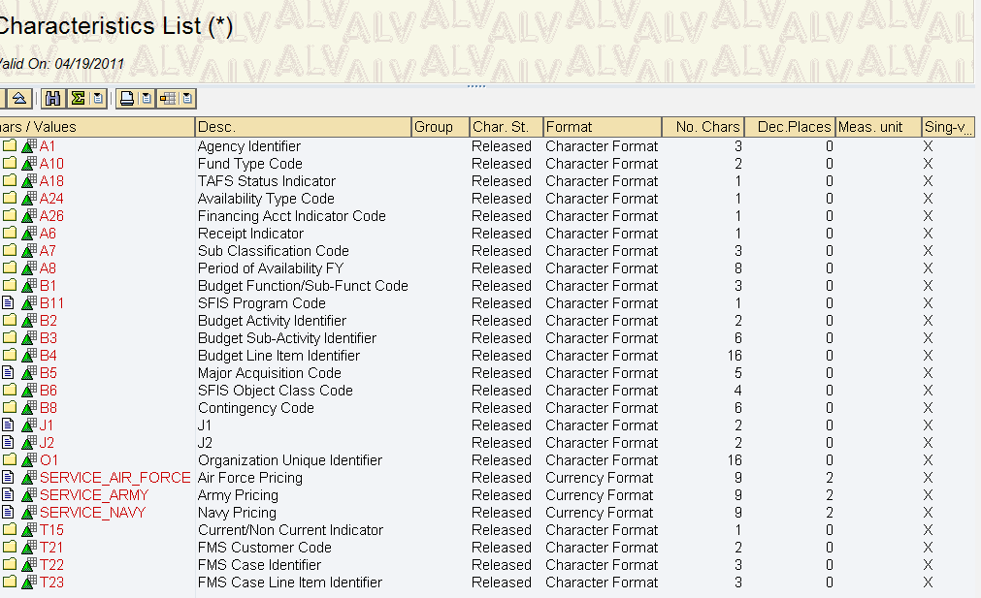
A1 - Department Regular Code
SFIS Element: | A1 - Department Regular Code | Length: | 3
SFIS Component: | Appropriation Account Information
Description: | Department Regular is the U.S. Treasury designated code representing the government agency accountable for one or more fund accounts established and maintained by the Treasury. The Department Regular element is an integral part of the Treasury Appropriation Fund Symbol (TAFS).
Example: | Code Agency  097 DoD, Office of the Secretary of Defense  021 Department of the Army  017 Department of the Navy  057 Department of the Air Force  096 Corps of Engineers
Comment: | Department Regular is a field on the Application of Funds Master Record in SAP. Application of Funds Master Data is equivalent to “Appropriation” in that the Application of Funds describes a “main account” tied to a particular “beginning and ending FY” and linked to a “department regular” and “department transfer” value if applicable. Allowed treasury values are inserted in the “Department Regular” field when creating a new “Application of Funds”. Since Funds are always assigned to an Application of Funds – the Department Regular for the Appropriation will be linked to all financial transactions in the system.
Source: | http://fms.treas.gov/fastbook/

BUSINESS RULES
# | Business Rule
A1 | Department Regular Code must be 3 numeric characters. ex. 097 (Note: Programs may use the two character code and derive the three character version - with a leading zero - at time of reporting if the software system in use has not yet been updated).  Authoritative source: http://fms.treas.gov/fastbook/
A1 | Each accounting system must store and maintain Department Regular Code values.
A1 | A Department Regular Code must be established in the accounting classification structure when the appropriation is signed by the President and must be maintained until available funding has been canceled.

DESIGN CONSIDERATIONS
Delivered Field | Derived Field | Characteristics
Delivered Field | Derived Field | FACTS I & II | Fund | Fund Center | Commitment Item | Functional Area | Funded Program | Application of Funds
X |  | X | X

PROCESS WALKTHRU
Module: | FM
Navigation: | Accounting-Public Sector Management-Funds Management- Master Data-Account Assignment Element- Fund- Application of Funds-Display
SAP Trans Code: | CT04 & FM6S
Form Field Name: | Display Application of Funds
Table Name: | IFMFUSE | Field Name: | DEPT_REG & ATNAM
Related Transactions: | FM6I, CT10

Screenshot: Location of “Department Regular” Field on Field on Display Characteristics

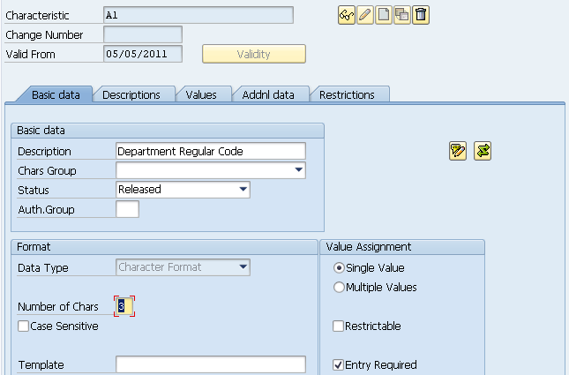
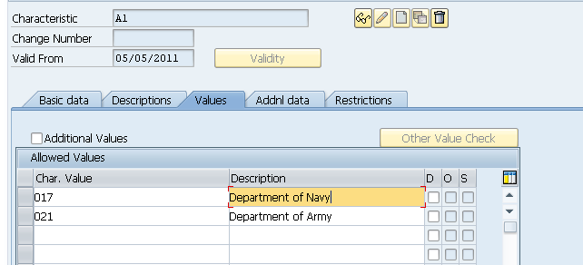

A2 - Department Transfer Code
SFIS Element: | A2 - Department Transfer Code | Length: | 3
SFIS Component: | Appropriation Account Information
Description: | The Department Transfer Code identifies the federal agency of obligation authority to the DoD or one of its components. For the transfer of obligation authority, the transfer agency retains responsibility for the fund account and the recipient agency charges against the fund account of the transfer agency.
Example: | Department Transfer No.089 - In this example, the Department Transfer Value "089"indicates transfer of obligation authority from Dept of Energy.  The field is left blank if no transfer is involved.
Comment: | Department Transfer is a field on the Application of Funds Master Record in SAP. Application of Funds Master Data is equivalent to “Appropriation” in that the Application of Funds describes a “main account” tied to a particular “beginning and ending FY” and linked to a “department regular” and “department transfer” value if applicable.
Source: | http://fms.treas.gov/fastbook/

BUSINESS RULES
# | Business Rule
A2 | Department Transfer Code must be 3 numeric characters. ex. 097 (Note: Programs may use the two character code and derive the three character version - with a leading zero - at time of reporting if the software system in use has not yet been updated).  Authoritative source: http://fms.treas.gov/fastbook/
A2 | Department Transfer Code must be used for accounting classification, general ledger posting, financial reporting, budgetary control, and funds control.
A2 | Each accounting system must store and maintain Department Transfer Code values.

DESIGN CONSIDERATIONS
Delivered Field | Derived Field | Characteristics
Delivered Field | Derived Field | FACTS I & II | Fund | Fund Center | Commitment Item | Functional Area | Funded Program | Application of Funds
X |  | X |  |  |  |  |  | X

PROCESS WALKTHRU
Module: | FM
Navigation: | Accounting-Public Sector Management-Funds Management- Master Data-Account Assignment Element- Fund- Application of Funds-Display
SAP Trans Code: | CT04 & FM6S
Form Field Name: | Display Application of Funds
Table Name: | IFMFUSE | Field Name: | DEPT_TRAN
Related Transactions: | FM6I, CT10

Screenshot: Location of “Department Transfer” Field on Display Characteristics

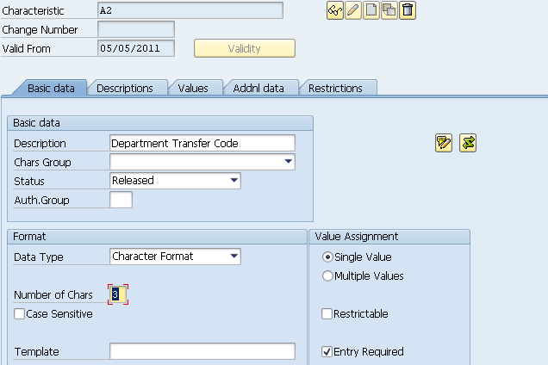
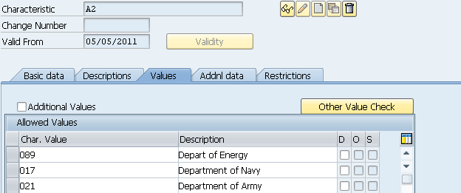

A3 - Main Account Code
SFIS Element: | A3 - Main Account Code | Length: | 4
SFIS Component: | Appropriation Account Information
Description: | The main account is identified by a four digit numeric data element representing a specific appropriation or fund account established by the US Treasury for expenditure or receipt authority issued by the US Congress.
Example: | Main Account Account Name  0740 Family Housing Construction, Air Force  2020 Operation & Maintenance, Army  2040 Research, Development, Test & Eval, Army  2050 Military Construction, Army  4557 Revolving Fund, National Defense Sealift  5095 Wildlife Conservation, Military Reservations  8097 Military Retirement Fund, Defen
Comment: | The main account is identified by a four digit numeric data element representing a specific appropriation or fund account established by the US Treasury for expenditure or receipt authority issued by the US Congress.
Source: | http://fms.treas.gov/fastbook/

BUSINESS RULES
# | Business Rule
A3 | Each Main Account Code must be associated with only one Fund Type Code.
A3 | Each Main Account Code must be associated with only one Budget Function/Sub-Function Code.
A3 | Main Account Code must be 4 numeric characters. ex. 0740  Authoritative source: http://fms.treas.gov/fastbook/
A3 | Main Account Code must be used for accounting classification, general ledger posting, financial reporting, budgetary control, and funds control.
A3 | Each accounting system must store and maintain Main Account Code values.
A3 | A Main Account Code must be established in the accounting classification structure when the appropriation is signed by the President and will be maintained until available funding has been canceled.

DESIGN CONSIDERATIONS
Delivered Field | Derived Field | Characteristics
Delivered Field | Derived Field | FACTS I & II | Fund | Fund Center | Commitment Item | Functional Area | Funded Program | Application of Funds
X |  | X |  |  |  |  |  | X

PROCESS WALKTHRU
Module: | FM
Navigation: | Accounting-Public Sector Management-Funds Management- Master Data-Account Assignment Element- Fund- Application of Funds-Display
SAP Trans Code: | FM6S
Form Field Name: | Display Application of Funds
Table Name: | IFMFUSE | Field Name: | DEPT_TRAN
Related Transactions: | FM6I, FM6U

Screenshot: Location of “Main Account” Field on Application of Funds Master Record

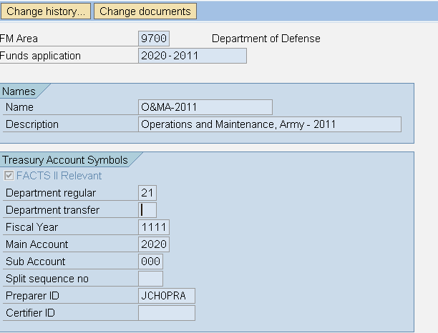

A4 - Sub-Account Code
SFIS Element: | A4 - Sub-Account Code | Length: | 3
SFIS Component: | Appropriation Account Information
Description: | Sub-Account Code is a field on the Application of Funds Master Record in SAP. Application of Funds Master Data is equivalent to “Appropriation” in that the Application of Funds describes a “main account” and “sub-account” tied to a particular “beginning and ending FY” and linked to a “department regular” and “department transfer” value if applicable. Allowed treasury values are inserted in the “Main Account” and “Sub-Account” field when creating a new “Application of Funds”. Since Funds are always assigned to an Application of Funds – the Sub-Account will be linked to all financial transactions in the system.
Example: | The following Sub-Accounts have been established specifically for the purpose of subdividing the DoD Defense Wide Working Capital Fund Account 4930, as follows:  97X4930.001 Defense Working Capital Fund, Army 31USC1535  97X4930.002 Defense Working Capital Fund, Navy 31USC1535
Comment: | The Sub-Account might indicate a series of subsidiary level receipt accounts or represent special subsidiary level accounts requested for use by an agency and approved by the US Treasury.
Source: | http://fms.treas.gov/fastbook/

BUSINESS RULES
# | Business Rule
A4 | Every financial transaction processed must have a valid Sub-Account Code.
A4 | The Sub-Account Code must be defaulted to “000” when one of the Treasury Sub-Account Code conditions does not apply.
A4 | Sub-Account Code must be 3 numeric characters. ex. 97X4930.001 (last 3 positions following period)  Authoritative source: http://fms.treas.gov/fastbook/
A4 | Sub-Account Code must be used for accounting classification, general ledger posting, financial reporting, budgetary control, and funds control.
A4 | Each accounting system must store and maintain Sub-Account Code values.

DESIGN CONSIDERATIONS
Delivered Field | Derived Field | Characteristics
Delivered Field | Derived Field | FACTS I & II | Fund | Fund Center | Commitment Item | Functional Area | Funded Program | Application of Funds
X |  | X |  |  |  |  |  | X

PROCESS WALKTHRU
Module: | FM
Navigation: | Accounting-Public Sector Management-Funds Management- Master Data-Account Assignment Element- Fund- Application of Funds-Display
SAP Trans Code: | FM5S
Form Field Name: | Display Application of Funds
Table Name: | IFMFUSE | Field Name: | DEPT_TRAN
Related Transactions: | FM5I. FM5U

Screenshot: Location of “Sub-Account” Field on Application of Funds Master Record

A5 - Apportionment Category Code
SFIS Element: | A5 - Apportionment Category Code | Length: | 1
SFIS Component: | Appropriation Account Information
Description: | An OMB distribution of budgetary resources, using Standard Form (SF) 132, Apportionment and Re-apportionment Schedule, to distribute budget or obligational authority by calendar quarter (category A) or by other specified time periods, or programs, activities, projects, or combinations thereof (category B). The category code indicates whether amounts distributed are category A or B apportionments, or not subject to apportionment (category C). The apportionment distribution represents that portion of the appropriation authorized for the obligation and expenditure of funds.
Example: | Examples of Apportionment Categories A, B and C  Category A - Period Apportionments  - 1st quarter amount, 2nd Quarter amount, 3rd Quarter Amount and 4th Quarter Amount.  Category B Examples- Apportionments for Specific Purposes, e.g.,:  - Tri-annual Apportionment-Research, Development of Product XYZ,  - Terrorist Defense Education (Special purpose)  Category C - Accounts Exempted from SF 132 Apportionment Requirements; Example for a no-year or multi-year account:  - Other Category C uses include: Non-expenditure transfers to other accounts; Expired accounts; Accounts that are fully obligated (expended) at the beginning of a fiscal period; Foreign currency accounts.
Comment: | The apportionment distribution represents that portion of the appropriation authorized for the obligation and expenditure of funds.
Source: | http://fms.treas.gov/fastbook/

BUSINESS RULES
# | Business Rule
A5 | Apportionment Category Code must be 1 alpha character. ex. A  Data values: A - Category A  B - Category B  C - Not subject to apportionment
A5 | Apportionment Category Code must be used for accounting classification, general ledger posting, financial reporting, budgetary control, and funds control.
A5 | Each accounting system must store and maintain Apportionment Category Code values.

DESIGN CONSIDERATIONS
Delivered Field | Derived Field | Characteristics
Delivered Field | Derived Field | FACTS I & II | Fund | Fund Center | Commitment Item | Functional Area | Funded Program | Application of Funds
X |  |  |  |  |  |  |  | X

PROCESS WALKTHRU
Module: | FM
Navigation: | Accounting-Public Sector Management-Funds Management- Master Data-Account Assignment Element- Fund- Application of Funds-Display
SAP Trans Code: | FMUSFG1
Form Field Name: | FACTS I & II Derivation of Attributes
Table Name: | IUSFGFDERIVE | Field Name: | FLG_APPORT
Related Transactions: | None

Screenshot: Location of “Apportionment Category” Field on FACTS I & II Derivation of Attributes

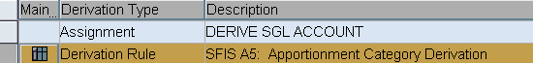
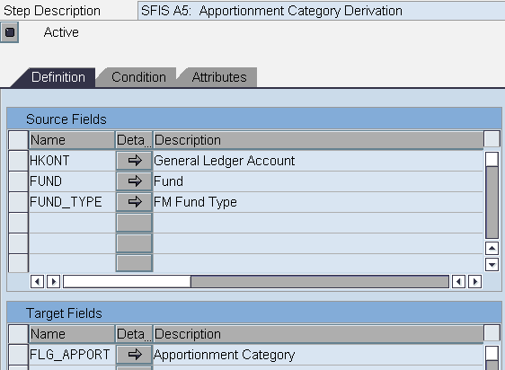
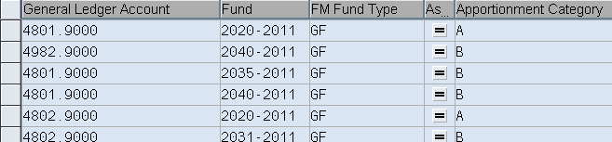

A6 - Receipt Indicator
SFIS Element: | A6 - Receipt Indicator | Length: | 1
SFIS Component: | Appropriation Account Information
Description: | The Receipt Indicator identifies a main account balance, or main account/subaccount combination, as either receipt or expenditure.
Example: | Not Applicable - This is a simple Yes or No field.
Comment: | None
Source: | http://fms.treas.gov/fastbook/

BUSINESS RULES
# | Business Rule
A6 | Receipt Indicator must be 1 alpha character. ex. Y  Data values: Y - Yes  N – No
A6 | Receipt Indicator must be used for accounting classification and financial reporting.
A6 | Each accounting system must identify and be able to report accounts or portions of accounts used for receipt purposes.

DESIGN CONSIDERATIONS
Delivered Field | Derived Field | Characteristics
Delivered Field | Derived Field | FACTS I & II | Fund | Fund Center | Commitment Item | Functional Area | Funded Program | Application of Funds
X |  |  |  |  |  |  |  | X

PROCESS WALKTHRU
Module: | FM
Navigation: | Accounting-Public Sector Management-Funds Management- Master Data-Account Assignment Element- Fund- Application of Funds-Display
SAP Trans Code: | FM5S
Form Field Name:
Table Name: | IFMFUSE | Field Name: | Receipt Indicator
Related Transactions: | None

Screenshot: Location of “Receipt Indicator” Field on Display Characteristics

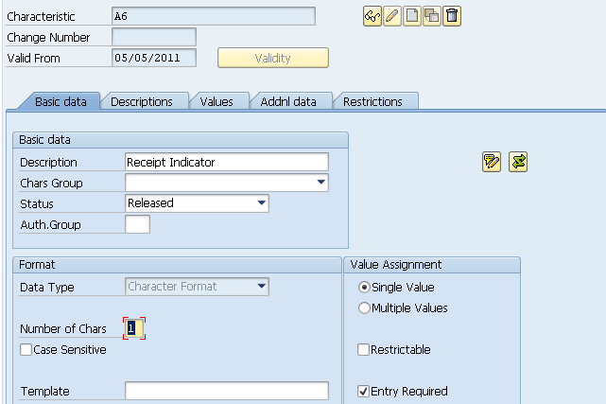
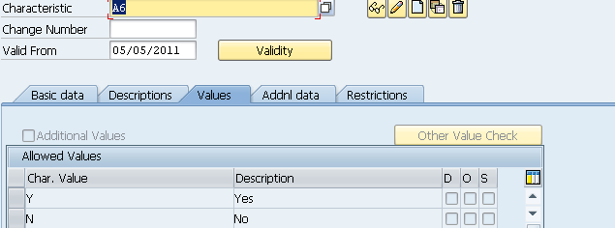

A7 - Sub Classification Code
SFIS Element: | A7 - Sub Classification Code | Length: | 2
SFIS Component: | Appropriation Account Information
Description: | Sub-Classification Codes are assigned in certain cases for grouping designated disbursement and/or receipt transactions below the level of appropriation or fund account represented by the main account, (reference Item A3, Main Account) for an Appropriation, Fund, or Receipt Account. Separate sub-class identification codes are assigned to agencies by the Treasury to be used as parenthetical prefixes to the main account when preparing Disbursing Officer Reports.
Example: | Examples of Federal Wide Sub-Class values representing special transaction sets identified by Treasury are:  46 Payments from Current Appropriations for Obligations of Closed Accounts  72 Unamortized Discount on Investments  85 Repayment of Borrowing from U.S. Treasury  98 Redemption (Sale) of U.S. Public Debt Securities
Comment: | None
Source: | http://fms.treas.gov/fastbook/

BUSINESS RULES
# | Business Rule
A7 | Sub-Class must be 2 numeric characters. ex. 46  Authoritative source: http://fms.treas.gov/tfm/index.html
A7 | Sub Class Code must be used for accounting classification and financial reporting.
A7 | Each accounting system must store and maintain Sub Class Code values.

DESIGN CONSIDERATIONS
Delivered Field | Derived Field | Characteristics
Delivered Field | Derived Field | FACTS I & II | Fund | Fund Center | Commitment Item | Functional Area | Funded Program | Application of Funds
X |  |  | X

PROCESS WALKTHRU
Module: | FM
Navigation: | Accounting-Public Sector Management-Funds Management- Master Data-Account Assignment Element- Fund- Application of Funds-Display
SAP Trans Code: | FM5S
Form Field Name: | Display Fund
Table Name: | IFMFUSE | Field Name: | Sub Classification Cod
Related Transactions: | None

Screenshot: Location of “Sub Classification” Field on Display Characteristics

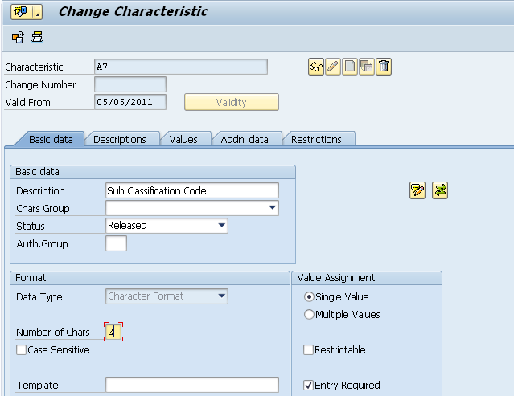
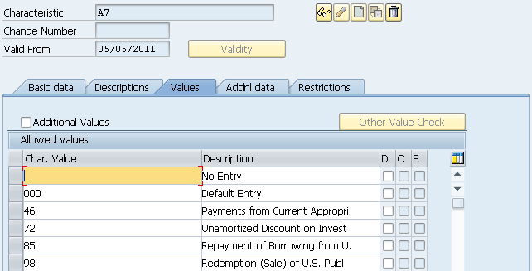

A9 - Reimbursable Flag Indicator
SFIS Element: | A9 - Reimbursable Flag Indicator | Length: | 1
SFIS Component: | Appropriation Account Information
Description: | The Reimbursable Indicator is used to flag those expenditures incurred for a designated TAFS account that are considered reimbursable to the account.
Example: | Sample: An “R" affiliated with the items posted to the 4 digit main account of a TAFS indicates those recoverable expenditures associated with the following:  - Reimbursements for Sale of Material, e.g., Sale of Inventory Material, Replacement of Like-Items, and Free Assets, i.e., assets disposed of not requiring replacement  - Reimbursable Expenditures From General Funds Based on Customer Orders  - Defense Working Capital Funds- To indicate the expenditure items to be recovered through full recovery pricing, including the full (direct and indirect) actual costs incurred, including Reserve Material, Military Personnel, Operations and Maintenance, Base Support, RDT&E, Design/Development, Construction, Unplanned Losses, and other recoverable costs.
Comment: | None
Source: | http://fms.treas.gov/fastbook/

BUSINESS RULES
# | Business Rule
A9 | When the funding source is a direct appropriation, the value must be “D”, otherwise the value is “R”.
A9 | Reimbursable Flag Indicator must be 1 alpha character. ex. R  Data values: R - Reimbursable  D – Direct
A9 | Reimbursable Flag Indicator must be used for financial reporting and budgetary funds.
A9 | Each accounting system must store and maintain Reimbursable Flag Indicator values.

DESIGN CONSIDERATIONS
Delivered Field | Derived Field | Characteristics
Delivered Field | Derived Field | FACTS I & II | Fund | Fund Center | Commitment Item | Functional Area | Funded Program | Application of Funds
X | X

PROCESS WALKTHRU
Module: | FM
Navigation: | Accounting-Public Sector Management-Funds Management- Master Data-Account Assignment Element- Fund- Application of Funds-Display
SAP Trans Code: | FMUSFG1- USG Derivation
Form Field Name: | Display Fund
Table Name: | IFMFUSE | Field Name: | Reimbursable Flag Indicator
Related Transactions: | None

Screenshot: Location of “Reimbursable Flag Indicator” Field on FACTS I & II Derivation of Attributes

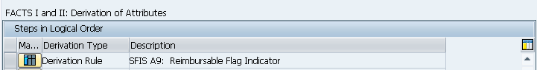
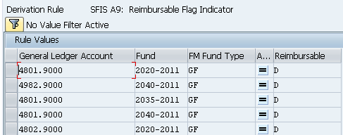

A10 - Fund Type Code
SFIS Element: | A10 - Fund Type Code | Length: | 2
SFIS Component: | Appropriation Account Information
Description: | The fund type is used as a basis in establishing the classification of the account symbol. It denotes and categorizes the account symbols (Main Account) with a standard numbering scheme for each particular type (e.g. general fund, special fund, trust fund and etc.) of fund. OMB and the Department of the Treasury will assign identification codes based on the type of fund involved and other characteristics of a proposed new main account.
Example: | 01 - General Fund,  02 - Special Fund,  07 - Trust (non-revolving) Fund,  08 - Trust Revolving Fund
Comment: | None
Source: | http://fms.treas.gov/fastbook/

BUSINESS RULES
# | Business Rule
A10 | Fund Type Code must be 2 numeric characters. ex. 01  Authoritative source: http://fms.treas.gov/ussgl/selection_page.html  Data values: 01 - General Fund  02 - Special Fund  03 - Public Enterprise Fund  04 - Intra-governmental Revolving or Management Fund  07 - Trust (non-revolving) Fund  08 - Trust Revolving Fund
A10 | Fund Type Code must be used for general ledger posting, financial reporting, budgetary control, and funds control.
A10 | Each accounting system must store and be able to report the Fund Type Code value assigned by Treasury.

DESIGN CONSIDERATIONS
Delivered Field | Derived Field | Characteristics
Delivered Field | Derived Field | FACTS I & II | Fund | Fund Center | Commitment Item | Functional Area | Funded Program | Application of Funds
X | X |  | X

PROCESS WALKTHRU
Module: | FM
Navigation: | Accounting-Public Sector Management-Funds Management- Master Data-Account Assignment Element- Fund
SAP Trans Code: | FM5S
Form Field Name: | Display Fund
Table Name: | IFMFUSE | Field Name: | Fund Type Code
Related Transactions: | None

Screenshot: Location of “Fund Type Code” Field on Display Characteristics

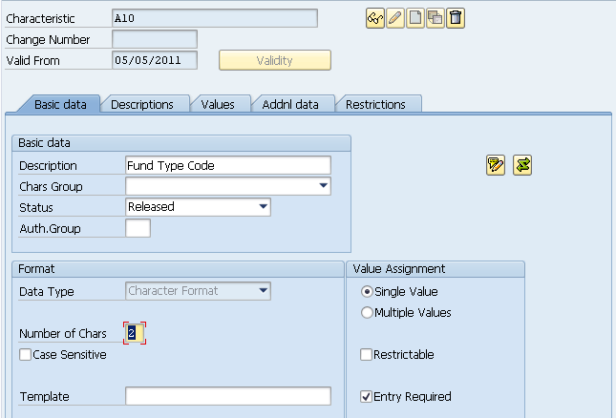
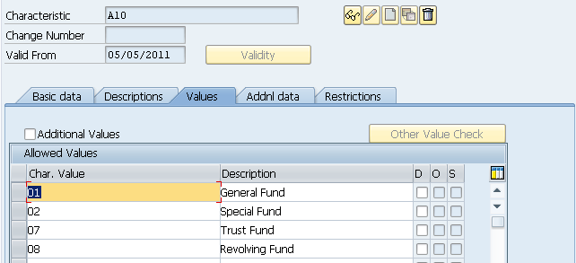

A11 - Advance Flag Code
SFIS Element: | A11 - Advance Flag Code | Length: | 1
SFIS Component: | Appropriation Account Information
Description: | The value of the Advance Flag identifies new budget authority made available in the current year based on an appropriation act intending future year funding. For instance, an appropriation passed in one year, may include funds that are not available for use until two years into the future. In the future year of availability, these funds are considered 'advanced from a prior year' appropriation act. In the case of budget authority made available close to the end of the current year for current fiscal year obligations that are liquidated in the following fiscal year; the authority is considered to be "advance funded". The values of the Advance Flag are more accurately associated with a code, rather than a flag. Flag is only used to correspond with the U.S. Treasury's representation of the data element for external reporting.
Example: | "P"= An appropriation was passed in FY 2004. It included funds not available until FY 2006. In FY2006 the Advance Flag "P" would be used to indicate these funds were advanced from a prior year appropriation.  "F"= If budget authority made available at the end of FY 2005 for FY2005 obligations to be liquidated in FY2006, then the Advance Flag would be "F", Advance from Future Year.  "X" = If new budget authority is made available in the current fiscal year based on an appropriation act intending current fiscal year use, then this flag is not applicable.
Comment: | None
Source: | http://fms.treas.gov/fastbook/

BUSINESS RULES
# | Business Rule
A11 | If any part of an appropriation for new budget authority becomes available one or more fiscal years beyond the current fiscal year for which the appropriation is passed, then the Advanced Flag value must be “P”.
A11 | If budget authority is provided in an appropriation act to cover obligations incurred late in the fiscal year to be liquidated in following the fiscal year for which the appropriation act is passed, then the Advanced Flag value must be “F”.
A11 | If there is not an advancement of an appropriation for budget authority, then the Advanced Flag value must be “X”.
A11 | Advance Flag Code must be 1 alpha character. ex. P  Data values: P - Advanced in Prior Year  F - Advanced from Future Year  X - Not applicable
A11 | Advance Flag Code must be used for general ledger posting, financial reporting, and budgetary control.
A11 | Each accounting system must be able to store and report funds that were either advanced in prior years or advanced from future years.

DESIGN CONSIDERATIONS
Delivered Field | Derived Field | Characteristics
Delivered Field | Derived Field | FACTS I & II | Fund | Fund Center | Commitment Item | Functional Area | Funded Program | Application of Funds
X | X | X

PROCESS WALKTHRU
Module: | FM
Navigation:
SAP Trans Code: | FMUSFG1
Form Field Name: | FACT I & II Derivation of Attributes
Table Name: | IUSFGFDERIVE | Field Name: | FLG_ADVANCE_9
Related Transactions: | None

Screenshot: Location of “Advance Flag Code” Field on FACT I & II Derivation of Attributes

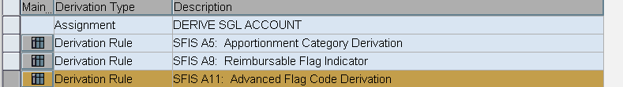
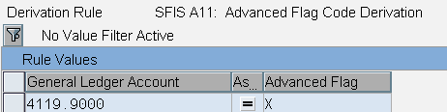

A12 - Authority Type Code
SFIS Element: | A12 - Authority Type Code | Length: | 1
SFIS Component: | Appropriation Account Information
Description: | The Authority Type identifies various types of budget or obligational authority authorized. Each type of authority includes specific legislative requirements and must be identified separately. Where unique identification is not possible through the accounts contained in the United States Government Standard General Ledger (USSGL), Authority Type codes have been applied. For example, the USSGL rescission accounts (USSGL accounts 4392 and 4393) do not distinguish between rescissions of appropriations or contract authority.
Example: | A "P" type indicator coded in an accounting transaction to post to USSGL rescission account 4392 would indicate rescission of an appropriation specified by an associated TAFS. A "C" authority type indicator included in a transaction posting to an SF132 line item would indicate Contract Authority.
Comment: | None
Source: | http://fms.treas.gov/fastbook/

BUSINESS RULES
# | Business Rule
A12 | Borrowing Source Code must be used when Authority Type Code value is “B”.
A12 | Authority Type Code must be 1 alpha character. ex. P  Data values: P - Appropriation  D - Advance Appropriation  B - Borrowing Authority  C - Contract Authority  R - Re-appropriation  S - Spending Authority From Offsetting Collections
A12 | Authority Type Code must be used for accounting classification, general ledger posting, financial reporting, budgetary control, and funds control.
A12 | Each accounting system must store and be able to report Authority Type Code values when applicable to an account.

DESIGN CONSIDERATIONS
Delivered Field | Derived Field | Characteristics
Delivered Field | Derived Field | FACTS I & II | Fund | Fund Center | Commitment Item | Functional Area | Funded Program | Application of Funds
X | X

PROCESS WALKTHRU
Module: | FM
Navigation: | None
SAP Trans Code: | FMUSFG1
Form Field Name: | FACT I & II Derivation of Attributes
Table Name: | IUSFGFDERIVE | Field Name: | FLG_AUTHOR
Related Transaction: | None

Screenshot: Location of “Authority Type Code” Field on FACT I & II Derivation of Attributes

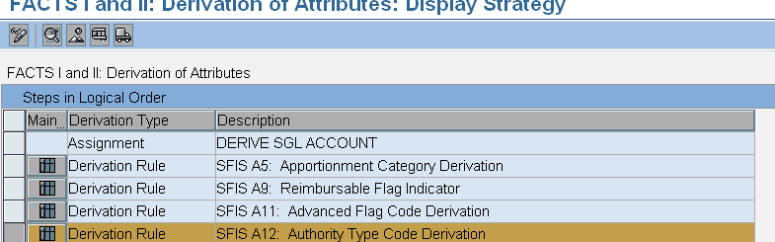

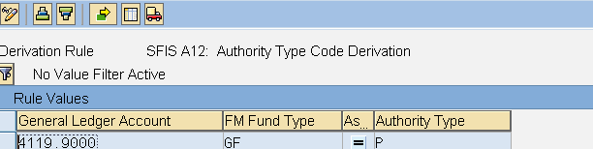

A13 - Availability Time Indicator
SFIS Element: | A13 - Availability Time Indicator | Length: | 1
SFIS Component: | Appropriation Account Information
Description: | The Availability Time value indicates whether a specific amount of funding is available for execution in the current reporting period (i.e., month, quarter, year), or in a subsequent reporting period. Note that a subsequent reporting period may be in the current fiscal year, or a subsequent fiscal year.
Example: | $1M is Appropriated for a one year period. $250,000 is apportioned each quarter. $250,000 is apportioned in the first quarter which would be classified as "A," available in the current reporting period. This funding is available for execution. The remaining $750,000 would be classified as "S," funding available in a subsequent period. All funds with an "S" status cannot be obligated against.  In the second quarter another $250,000 is apportioned. If none of the funds that were allocated in the first quarter were spent there would be $500,000 classified as "A", in the current reporting period and $500,000 classified as "S", available in a subsequent reporting period.
Comment: | This indicator specifies whether a budgetary resource:  - Is available for obligation in the current period (A),  - Will be available in a subsequent period (S)  - Is unavailable (blank).
Source: | http://fms.treas.gov/fastbook/

BUSINESS RULES
# | Business Rule
A13 | Availability Time Indicator must be 1 alpha character. ex. A  Data values: A - Available in current period  S - Available in subsequent period
A13 | Availability Time Indicator must be used for financial reporting and budgetary control.
A13 | Derivation of Availability Time Indicator based on an examination of the Period of Availability Fiscal Year Date associated with an appropriation against the current accounting period is an acceptable practice within each accounting system.

DESIGN CONSIDERATIONS
Delivered Field | Derived Field | Characteristics
Delivered Field | Derived Field | FACTS I & II | Fund | Fund Center | Commitment Item | Functional Area | Funded Program | Application of Funds
X | X | X

PROCESS WALKTHRU
Module: | FM
Navigation: | None
SAP Trans Code: | FMUSFG1
Form Field Name: | FACT I & II Derivation of Attributes
Table Name: | IUSFGFDERIVE | Field Name: | Availability Time Indicator
Related Transactions: | None

Screenshot: Location of “Availability Time Indicator” Field on FACT I & II Derivation of Attributes

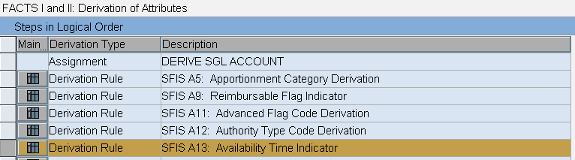

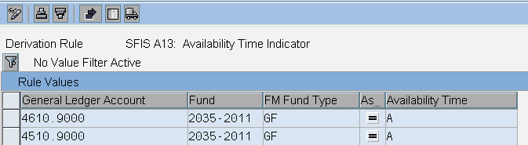

A14 - Borrowing Source Code
SFIS Element: | A14 - Borrowing Source Code | Length: | 1
SFIS Component: | Appropriation Account Information
Description: | The Borrowing Source identifies the source of funds borrowed under congressionally authorized borrowing authority.
Example: | DoD borrowed funds under congressionally authorized borrowing authority from the Department of the Treasury; therefore the Borrowing Source value will be "T".
Comment: | None
Source: | http://fms.treas.gov/fastbook/

BUSINESS RULES
# | Business Rule
A14 | Borrowing Source Code must be used when the funding source is from Borrowing Authority.
A14 | Borrowing Source Code must be 1 alpha character. ex. T  Data values: T - Treasury  P - Public  F - Federal Financing Bank
A14 | Borrowing Source Code must be used for general ledger posting, financial reporting, and budgetary control.
A14 | Each accounting system must store and be able to report Borrowing Source Code values when applicable.

DESIGN CONSIDERATIONS
Delivered Field | Derived Field | Characteristics
Delivered Field | Derived Field | FACTS I & II | Fund | Fund Center | Commitment Item | Functional Area | Funded Program | Application of Funds
X | X | X

PROCESS WALKTHRU
Module: | FM
Navigation: | None
SAP Trans Code: | FMUSFG1
Form Field Name: | FACT I & II Derivation of Attributes
Table Name: | IUSFGFDERIVE | Field Name: | FLG_AVAIL
Related Transactions: | None

Screenshot: Location of “Borrowing Source Code” Field on FACT I & II Derivation of Attributes

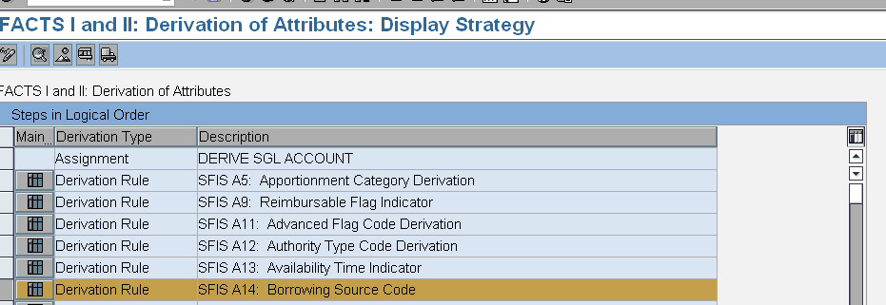

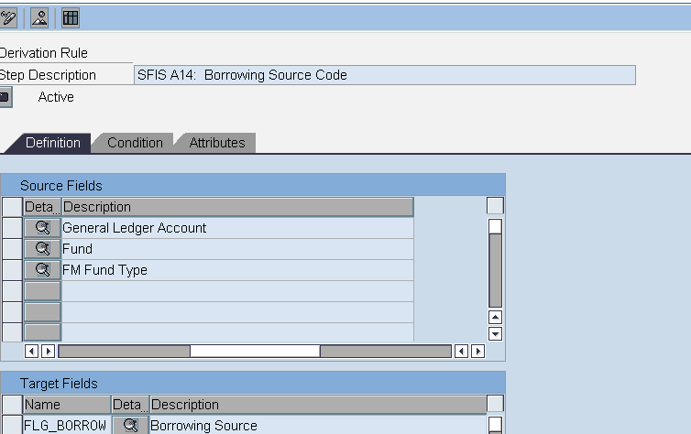

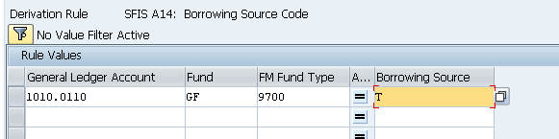
A15 - Definite Indefinite Flag Indicator
SFIS Element: | A15 - Definite Indefinite Flag Indicator | Length: | 1
SFIS Component: | Appropriation Account Information
Description: | The Definite/ Indefinite Flag indicates whether the amount of budget authority is definite (a specified amount, or a "not to exceed" amount specified) or indefinite (determined by other factors).
Example: | "D"=If the amount of the budget authority is a specified amount or has a "not to exceed" amount associated with it, then the "D" value will be used.
Comment: | None
Source: | http://fms.treas.gov/fastbook/

BUSINESS RULES
# | Business Rule
A15 | If the funding source is appropriated for a specific time or purpose, then the value must be “D”, otherwise the value is “I”.
A15 | Definite Indefinite Flag Indicator must be 1 alpha character. ex. D  Data values: D - Definite  I - Indefinite
A15 | Definite Indefinite Flag Indicator must be used for general ledger posting and financial reporting.
A15 | Each accounting system must store and be able to report Definite Indefinite Flag Indicator values according to whether the public law specifically identifies a funding amount for a budgetary line or program.

DESIGN CONSIDERATIONS
Delivered Field | Derived Field | Characteristics
Delivered Field | Derived Field | FACTS I & II | Fund | Fund Center | Commitment Item | Functional Area | Funded Program | Application of Funds
X | X

PROCESS WALKTHRU
Module: | FM
Navigation: | None
SAP Trans Code: | FMUSFG1
Form Field Name: | FACT I & II Derivation of Attributes
Table Name: | IUSFGFDERIVE | Field Name: | Definite Indefinite Flag Indicator
Related Transactions: | None

Screenshot: Location of “Definite Indefinite Flag Indicator” Field on FACT I & II Derivation of Attributes

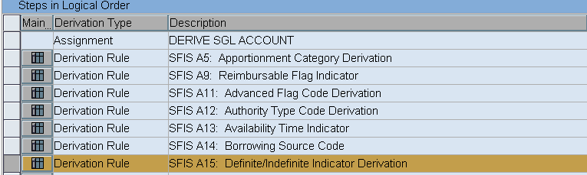

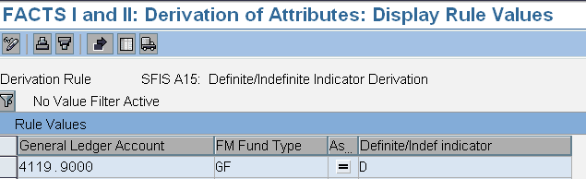

A17 - Program Report Code
SFIS Element: | A17- Program Report Code | Length: | 3
SFIS Component: | Appropriation Account Information
Description: | The Program Report Code identifies meaningful program reporting categories during the apportionment tracking process. The program report codes and associated amounts are reported as attachments to the Standard Form 132, Apportionment and Re-apportionment Schedule. DoD agencies (i.e. Navy, Army, Air Force, Marines, & other Treasury defined agencies) use the program report codes to group and track designated obligations on the SF133 Reports on Budget Execution and Budgetary Resources. For example, rather than reporting a single number for its obligations, a Department of the Navy account may separately show obligations for: maintaining land resources; performing major constructions; and performing base support. Program reporting categories are not used to apportion funds, are not subject to the Anti-deficiency Act, and are not shown on the actual SF132 apportionment or letter apportionment forms, but are included as attachments to these forms.
Example: | Sample Program Report Codes (for a Navy Housing, Main Account):  Report Code Description  001 Major Construction Housing  002 Improvements  003 Planning and Design
Comment: | Currently this element is only used in Military Construction, Family Housing.
Source: | http://fms.treas.gov/fastbook/

BUSINESS RULES
# | Business Rule
A17 | Program Report Code must be 3 numeric characters. ex. 001  Authoritative source: http://www.whitehouse.gov/omb/circulars_a11_current_year_a11_toc/
A17 | Program Report Code must be used for general ledger posting, and financial reporting
A17 | Each accounting system must store and maintain Program Report Code values.

DESIGN CONSIDERATIONS
Delivered Field | Derived Field | Characteristics
Delivered Field | Derived Field | FACTS I & II | Fund | Fund Center | Commitment Item | Functional Area | Funded Program | Application of Funds
X | X | X

PROCESS WALKTHRU
Module: | FM
Navigation: | None
SAP Trans Code: | FMUSFG1
Form Field Name: | FACT I & II Derivation of Attributes
Table Name: | IUSFGFDERIVE | Field Name: | Program Report Code
Related Transactions: | None

Screenshot: Location of “Program Report Code” Field on FACT I & II Derivation of Attributes

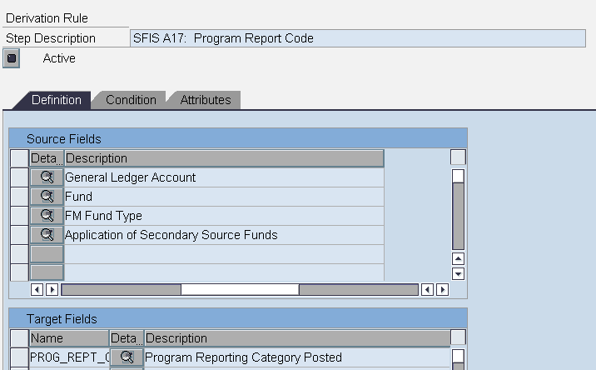
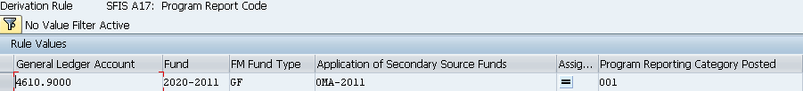

A18 - TAFS Status Indicator
SFIS Element: | A18 - TAFS Status Indicator | Length: | 1
SFIS Component: | Appropriation Account Information
Description: | The TAFS Status identifies the availability status of budget authority for incurring new obligations. Unexpired means the TAFS may incur new obligations. Expired means that the TAFS may liquidate obligations or make adjustments, but may not incur new obligations. If canceled, the TAFS will have no more reportable activity.
Example: | Use "U" if the TAFS can incur new obligations; or use "E", if the TAFS can only liquidate obligations or make adjustments, but may not incur new obligations.
Comment: | None
Source: | http://fms.treas.gov/fastbook/

BUSINESS RULES
# | Business Rule
A18 | If the current fiscal year is greater than the ending fiscal year of the Period of Availability Fiscal Year Date, but not greater than the ending fiscal year of the Period of Availability Fiscal Year Date +5, then the Treasury Appropriation Fund Symbol (TAFS) Status Indicator value must be “E”.
A18 | If the current fiscal year is greater than or equal to the beginning fiscal year of the Period of Availability, and less than or equal to the ending year of the Period of Availability, the Treasury Appropriation Fund Symbol (TAFS) Status Indicator value must be U.
A18 | TAFS Status Indicator must not be used for cancelled funds.
A18 | Treasury Appropriation Fund Symbol (TAFS) Status Indicator must be 1 alpha character, for example “U”.  Data values: U - Unexpired  E - Expired
A18 | Treasury Appropriation Fund Symbol (TAFS) Status Indicator must be used for identifying expired or unexpired status at time of reporting.

DESIGN CONSIDERATIONS
Delivered Field | Derived Field | Characteristics
Delivered Field | Derived Field | FACTS I & II | Fund | Fund Center | Commitment Item | Functional Area | Funded Program | Application of Funds
X | X | X

PROCESS WALKTHRU
Module: | FM
Navigation:
SAP Trans Code: | FMUSFG1
Form Field Name: | FACT I & II Derivation of Attributes
Table Name: | IUSFGFDERIVE | Field Name: | TAFS Status Indicator
Related Transactions: | None

Screenshot: Location of “TAFS Status Indicator” Field on FACT I & II Derivation of Attributes

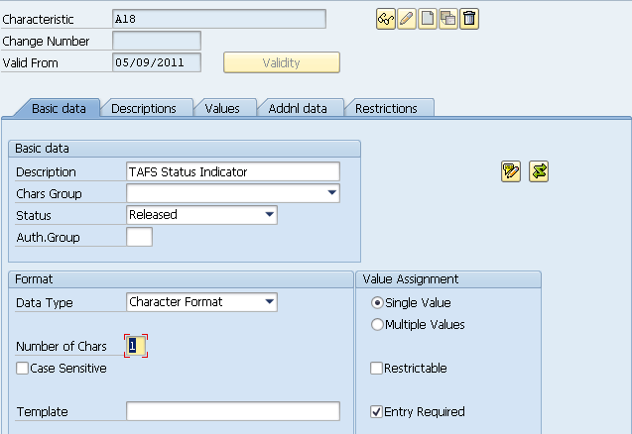
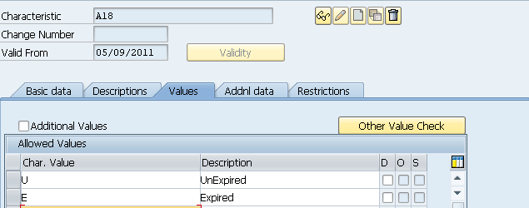

A19 - Year of Budget Authority Indicator
SFIS Element: | A19 - Year of Budget Authority Indicator | Length: | 3
SFIS Component: | Appropriation Account Information
Description: | Identifies the fiscal year when a Treasury Appropriation is provided with new no-year budget authority. Used for no-year funding authority TAFS to distinguish outlays from new obligation authority vs. outlays from carried forward balances. New Authority is required to be reported separately from balances brought forward on the OMB apportionment documents.
Example: | "NEW"=Outlays from new budget authority (i.e. made available in current fiscal year)  "BAL"=Outlays from balances brought forward from prior period(s) (i.e. made available in a previous fiscal year)
Comment: | None
Source: | http://fms.treas.gov/fastbook/

BUSINESS RULES
# | Business Rule
A19 | If the funding source is other than no year, the Year of Budget Authority Indicator is not allowed.
A19 | Year of Budget Authority Indicator must be 3 alpha characters, for example “NEW”  Data values:  NEW - Outlays from new budget authority  BAL - Outlays from balances brought forward
A19 | Year of Budget Authority Indicator must be used for general ledger posting, and financial reporting.
A19 | Derivation of Year of Budget Authority Indicator based on a comparison of the current reporting period date against the budget program year is an acceptable practice within the accounting system, however, the same data used for the derivation must be used to support general ledger posting logic.

DESIGN CONSIDERATIONS
Delivered Field | Derived Field | Characteristics
Delivered Field | Derived Field | FACTS I & II | Fund | Fund Center | Commitment Item | Functional Area | Funded Program | Application of Funds
X | X | X

PROCESS WALKTHRU
Module: | FM
Navigation:
SAP Trans Code: | FMUSFG1
Form Field Name: | FACT I & II Derivation of Attributes
Table Name: | IUSFGFDERIVE | Field Name: | FMFG_YR_BUD_AUTH
Related Transactions: | None

Screenshot: Location of “Year of Budget Authority Indicator” Field on FACT I & II Derivation of Attributes

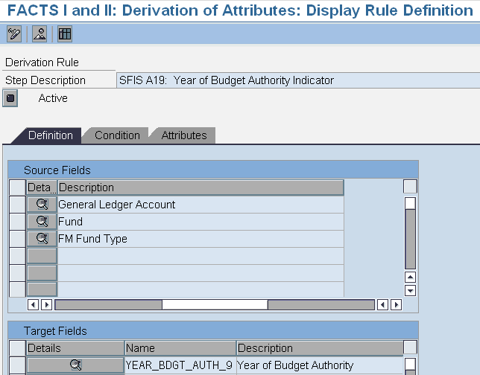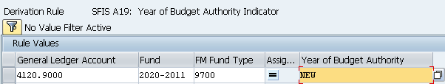
A20 - Direct Transfer Agency Code
SFIS Element: | A20 - Direct Transfer Agency Code | Length: | 3
SFIS Component: | Appropriation Account Information
Description: | The Direct Transfer Agency is the Treasury Department Code of the other Federal entity involved in budget authority transfer transactions with the DoD. For example, when recording the receipt of a transfer, this value identifies the agency that has transferred authority to a DoD component. Used in conjunction with the Direct Transfer Account and Transfer To From.
Example: | Examples of Transferring Agency Codes:  017-Navy  021-Army  072-USAID  019-Department of State  089-Department of Energy
Comment: | None
Source: | http://fms.treas.gov/fastbook/

BUSINESS RULES
# | Business Rule
A20 | Direct Transfer Agency Code must be posted in conjunction with Direct Transfer Account Code.
A20 | Direct Transfer Agency Code must be 3 numeric characters. ex. 097 (Note: Programs may use the two character code and derive the three character version - with a leading zero - at time of reporting if the software system in use has not yet been updated).  Authoritative source: http://fms.treas.gov/fastbook/
A20 | Direct Transfer Agency Code must be used for accounting classification, general ledger posting, financial reporting, and budgetary control.
A20 | Each accounting system must store and maintain Direct Transfer Agency Code values.

DESIGN CONSIDERATIONS
Delivered Field | Derived Field | Characteristics
Delivered Field | Derived Field | FACTS I & II | Fund | Fund Center | Commitment Item | Functional Area | Funded Program | Application of Funds
X | X | X

PROCESS WALKTHRU
Module: | FM
Navigation:
SAP Trans Code: | FMUSFG1
Form Field Name: | FACT I & II Derivation of Attributes
Table Name: | IUSFGFDERIVE | Field Name: | Direct Transfer Agency Code
Related Transactions: | None

Screenshot: Location of “Direct Transfer Agency Code” Field on FACT I & II Derivation of Attributes

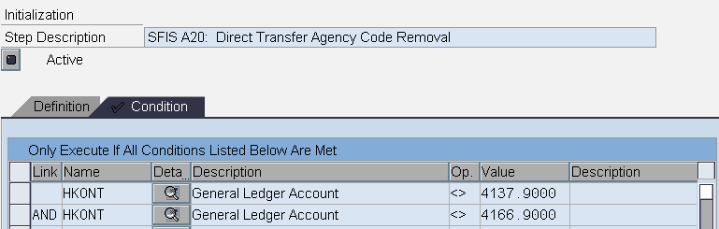
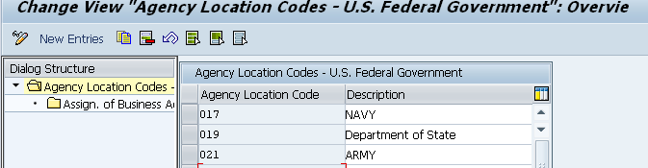

A21 - Direct Transfer Account Code
SFIS Element: | A21 - Direct Transfer Account Code | Length: | 4
SFIS Component: | Appropriation Account Information
Description: | The Direct Transfer Account identifies the Main Account of the Federal entity transferring-in budget authority transfer transactions to DoD. For example, when a DoD component records receipt of a budget authority transfer, this value identifies the 'transferred from' main fund account of the transferring agency.
Example: | Examples of Direct Transfer Accounts:  Transfer Account  0130 - Defense Health Program, Defense  0760 - Family Housing, Defense-Wide  1105 - Military Personnel, Marines
Comment: | The Direct Transfer Account identifies the Main Account of the Federal entity transferring-in budget authority transfer transactions to DoD. For example, when a DoD component records receipt of a budget authority transfer, this value identifies the 'transferred from' main fund account of the transferring agency.
Source: | http://fms.treas.gov/fastbook/

BUSINESS RULES
# | Business Rule
A21 | Direct Transfer Account Code must be posted in conjunction with Direct Transfer Agency.
A21 | Direct Transfer Account Code must be 4 numeric characters. ex. 0130  Authoritative source: http://fms.treas.gov/fastbook/
A21 | Direct Transfer Account Code must be used for accounting classification, general ledger posting, financial reporting, and budgetary control.
A21 | Each accounting system must store and maintain Direct Transfer Account Code values.

DESIGN CONSIDERATIONS
Delivered Field | Derived Field | Characteristics
Delivered Field | Derived Field | FACTS I & II | Fund | Fund Center | Commitment Item | Functional Area | Funded Program | Application of Funds
X | X

PROCESS WALKTHRU
Module: | FM
Navigation:
SAP Trans Code: | FMUSFG1
Form Field Name: | FACT I & II Derivation of Attributes
Table Name: | IUSFGFDERIVE | Field Name: | Direct Transfer Account
Related Transactions: | None

Screenshot: Location of “Direct Transfer Account Code” Field on FACT I & II Derivation of Attributes

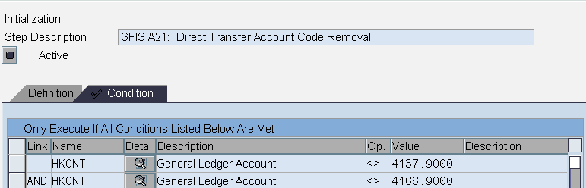

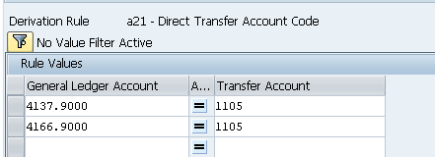

A24 - Availability Type Code
SFIS Element: | A24 - Availability Type Code | Length: | 1
SFIS Component: | Appropriation Account Information
Description: | The Availability Type value indicates whether budget authority is available for new obligations for a single specified year, multiple specified years, or for an indefinite period of years. This value is based on the Period of Availability (reference Item A8).
Example: | If budget authority is available for new obligations for one year then the Availability Type Flag will be "A" for Annual Appropriation.
Comment: | None
Source: | http://fms.treas.gov/fastbook/

BUSINESS RULES
# | Business Rule
A24 | If the Beginning Period of Availability is equal to the Ending Period of Availability, then Availability Type Code value must be “A”.
A24 | If the Ending Period of Availability is greater than the Beginning Period of Availability and is not “XXXX”, then Availability Type Code value must be “M”.
A24 | If the Ending Period of Availability value is “XXXX”, then Availability Type Code value must be “X”.
A24 | Availability Type Code must be 1 alpha character, for example “A”.  Data values: A - Annual  M - Multi-year  X - No year
A24 | Availability Type Code must be used for financial reporting and budgetary control.
A24 | Derivation of the Availability Type Code based on the type of appropriation and the Beginning Period of Availability and Ending Period of Availability associated with the Main Account Code in the accounting system is an acceptable practice.

DESIGN CONSIDERATIONS
Delivered Field | Derived Field | Characteristics
Delivered Field | Derived Field | FACTS I & II | Fund | Fund Center | Commitment Item | Functional Area | Funded Program | Application of Funds
X | X

PROCESS WALKTHRU
Module: | FM
Navigation: | Accounting-Public Sector Management-Funds Management- Master Data -Account Assignment Elements –Fund Display
SAP Trans Code: | FM5S
Form Field Name: | Display Fund
Table Name: |  | Field Name: | Availability Type Code
Related Transactions: | FM5I, FM5U

Screenshot: Location of “Availability Type Code” Field on Display Characteristics

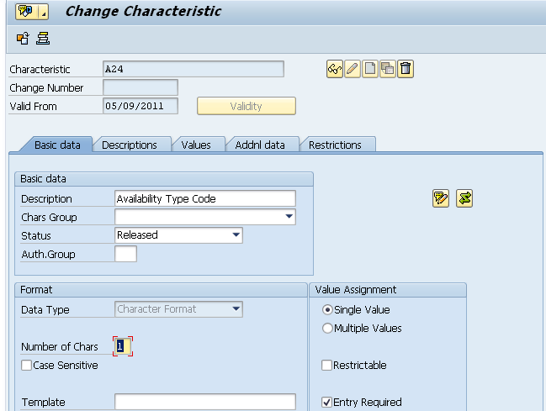
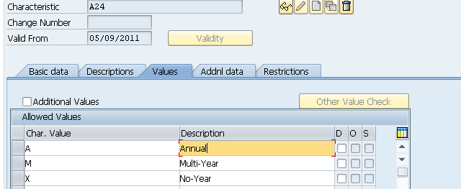

A25 - Expiration Flag Indicator
SFIS Element: | A25 - Expiration Flag Indicator | Length: | 1
SFIS Component: | Appropriation Account Information
Description: | The Expiration Flag indicates whether an appropriation will no longer be available for incurring new obligations as of September 30 of the reporting fiscal year. For example, in Fiscal Year 2001, “Y” would indicate that either an annual, or multi-year TAFS will expire on September 30, 2001, or that a no-year TAFS will be closed and cancelled on September 30, 2001.
Example: | If an appropriation will not be available for incurring new obligations at the end of the current fiscal year then the Expiration Flag value will be "Y".
Comment: | None
Source: | http://fms.treas.gov/fastbook/

BUSINESS RULES
# | Business Rule
A25 | If an annual or multi-year funding source will expire on September 30 of the current fiscal year, the Expiration Flag Indicator value must be “Y”, else the value must be “N”.
A25 | If a no-year funding source will cancel on September 30 of the current fiscal year, then the Expiration Flag Indicator value must be “Y”, else the value must be “N”.
A25 | Expiration Flag Indicator must be 1 alpha character, for example “Y”.  Data values: Y - Yes  N - No
A25 | Expiration Flag Indicator must be used for financial reporting.
A25 | Derivation of the Expiration Flag Indicator based on a comparison of the current reporting period date against the Period of Availability Fiscal Year Date in the accounting system is an acceptable practice.

DESIGN CONSIDERATIONS
Delivered Field | Derived Field | Characteristics
Delivered Field | Derived Field | FACTS I & II | Fund | Fund Center | Commitment Item | Functional Area | Funded Program | Application of Funds
X | X

PROCESS WALKTHRU
Module: | FM
Navigation: | Accounting-Public Sector Management-Funds Management- Master Data -Account Assignment Elements –Fund Display
SAP Trans Code: | FM5S
Form Field Name: | Display Fund
Table Name: |  | Field Name: | Expiration Flag Indicator
Related Transactions: | CT04

Screenshot: Location of “Expiration Flag Indicator” Field on Display Characteristics

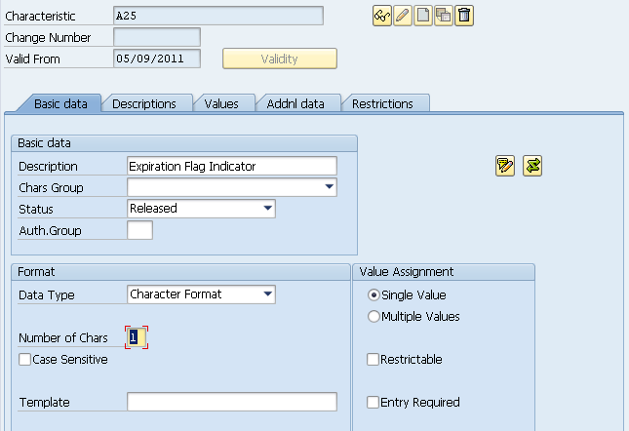
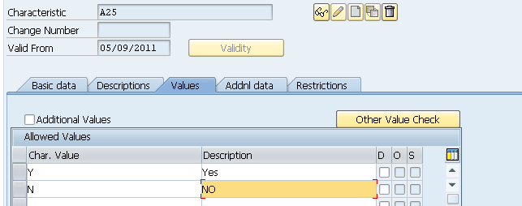

A26 - Financing Account Indicator Code
SFIS Element: | A26 - Financing Account Indicator Code | Length: | 1
SFIS Component: | Appropriation Account Information
Description: | Indicates whether the Federal account symbol is a Direct Loan Financing Account, a Guaranteed Loan Financing Account, or is not a financing account as defined by the Federal Credit Reform Act of 1990.
Example: | If the financing account is defined by the Federal Credit Reform Act of 1990 as a Guaranteed Loan Financing Account, then the Financing Account Indicator will be "G".
Comment: | None
Source: | http://fms.treas.gov/fastbook/

BUSINESS RULES
# | Business Rule
A26 | Financing Account Indicator Code must be 1 alpha character, for example “D”.  Data values: D - Direct  G - Guaranteed  N - Non-financing.
A26 | Financing Account Indicator Code must be used for general ledger posting, and financial reporting.
A26 | Each accounting system must store and maintain Financing Account Indicator Code values.

DESIGN CONSIDERATIONS
Delivered Field | Derived Field | Characteristics
Delivered Field | Derived Field | FACTS I & II | Fund | Fund Center | Commitment Item | Functional Area | Funded Program | Application of Funds
X | X

PROCESS WALKTHRU
Module: | FM
Navigation: | Accounting-Public Sector Management-Funds Management- Master Data-Account Assignment Element- Fund- Application of Funds-Display
SAP Trans Code: | FM6S
Form Field Name: | Display Application of Funds
Table Name: | IFMFUSE | Field Name: | DEPT_TRAN
Related Transactions: | CT04

Screenshot: Location of “Financing Account Indicator Code” Field on Display Characteristics

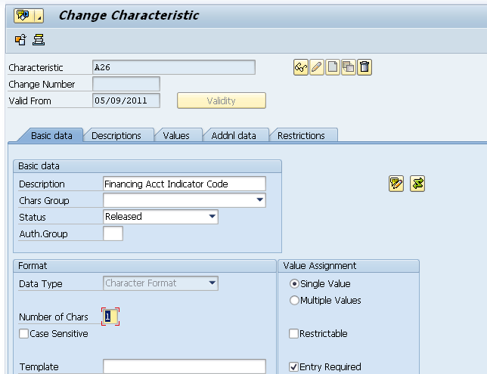

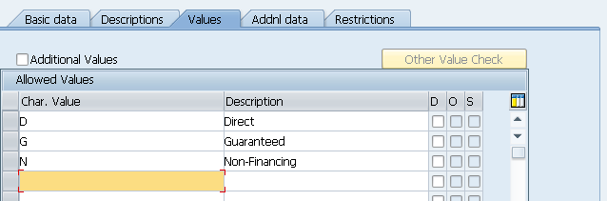

A27 - Beginning Period of Availability
SFIS Element: | A27 - Beginning Period of Availability | Length: | 4AN
SFIS Component: | Appropriation Account Information
Description: | In annual and multi-year accounts, identifies the first year of availability under law that an account may incur new obligations.
Example: | If multi-fiscal Year Period of Availability where the initial fiscal year of availability is FY2006 - 2006.  No year Funding - Program Year (PPPP)
Comment: | None
Source: | http://fms.treas.gov/fastbook/

BUSINESS RULES
# | Business Rule
A27 | If used for Annual or Multi-Year funding, Beginning Period of Availability must be four alpha-numeric characters.
A27 | If used for No-Year funding, Beginning Period of Availability must be four alpha-numeric characters.
A27 | If the Beginning Period of Availability is associated with a clearing /suspense Main Account, then it must be blank.
A27 | If the Beginning Period of Availability is associated with an unavailable receipt account, then it must be blank.
A27 | If used for Annual or Multi-Year funding, Beginning Period of Availability must be used for accounting classification, financial reporting, budgetary control, and funds control.
A27 | If used for Annual or Multi-Year funding, each accounting system must be able to store, maintain, and report the Beginning Period of Availability for annual and multi-year appropriations.
A27 | When the warrant is established by Treasury according to the signed appropriation bill, Beginning Period of Availability must be established and maintained in the accounting classification structure.

DESIGN CONSIDERATIONS
Delivered Field | Derived Field | Characteristics
Delivered Field | Derived Field | FACTS I & II | Fund | Fund Center | Commitment Item | Functional Area | Funded Program | Application of Funds
X |  | X

PROCESS WALKTHRU
Module: | FM
Navigation: | Accounting-Public Sector Management-Funds Management- Master Data-Account Assignment Element- Fund- Display Fund
SAP Trans Code: | FM5S
Form Field Name: | Display Fund
Table Name: | IFMFUSE | Field Name: | DEPT_TRAN
Related Transactions: | FM5I, FM5U

Screenshot: Location of “Beginning Period of Availability” Display Field on Display Characteristics

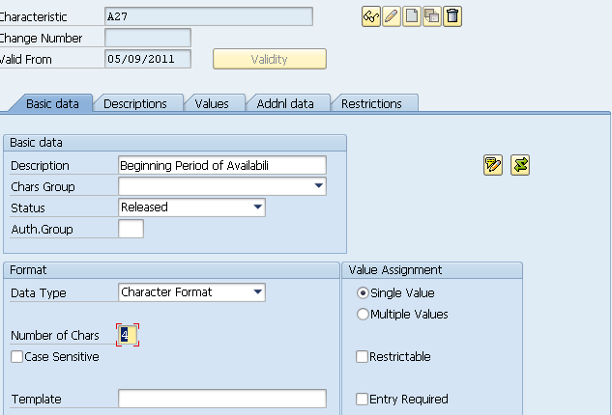
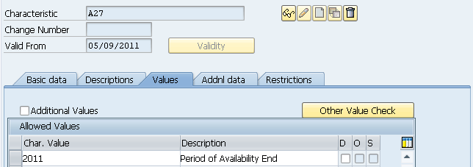

A28 - Ending Period of Availability
SFIS Element: | A28 - Ending Period of Availability Fiscal Year Date | Length: | 4AN
SFIS Component: | Appropriation Account Information
Description: | In annual and multi-year accounts, identifies the last year of availability under law that an account may incur new obligations.
Example: | If multi-fiscal year Period of Availability where the ending fiscal year of availability is FY2008 - 2008.  No year Funding - XXXX
Comment: | None
Source: | http://fms.treas.gov/fastbook/

BUSINESS RULES
# | Business Rule
A28 | Ending Period of Availability must be four alpha-numeric characters.
A28 | If the Ending Period of Availability is associated with no-year funding, then it must be “XXXX”.
A28 | If the Ending Period of Availability is associated with a clearing / suspense Main Account, then it must be blank.
A28 | If the Ending Period of Availability is associated with an unavailable receipt account, then it must be blank.
A28 | If used for Annual or Multi-Year funding, Ending Period of Availability is used for accounting classification, financial reporting, budgetary control, and funds control.
A28 | If used for Annual or Multi-Year funding, each accounting system must be able to store, maintain, and report the Ending Period of Availability for annual and multi-year appropriations.
A28 | When the warrant is established by Treasury according to the signed appropriation bill, Ending Period of Availability must be established and maintained in the accounting classification structure.

DESIGN CONSIDERATIONS
Delivered Field | Derived Field | Characteristics
Delivered Field | Derived Field | FACTS I & II | Fund | Fund Center | Commitment Item | Functional Area | Funded Program | Application of Funds
X |  | X

PROCESS WALKTHRU
Module: | FM
Navigation: | Accounting-Public Sector Management-Funds Management- Master Data-Account Assignment Element- Fund- Display Fund
SAP Trans Code: | CT04
Form Field Name: | Display Fund
Table Name: | IFMFUSE | Field Name: | DEPT_TRAN
Related Transactions: | CT10

Screenshot: Location of “Ending Period of Availability Fiscal Year Date” Display Field on Display Characteristics

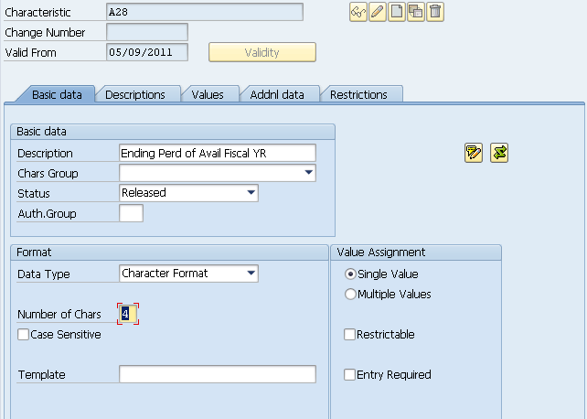

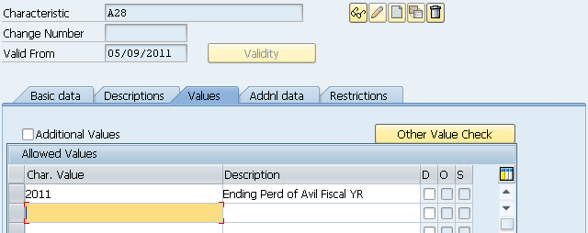

B1 - Budget Function/Sub-Function Code
SFIS Element: | B1 - Budget Function/Sub-Function Code | Length: | 3
SFIS Component: | Budget Program Information
Description: | Budget classifications are mandated by the Congressional Budget Act of 1974. The DoD budget functions and sub-functions are specific to the national defense and security mission of the Department, including the following:  1. Raising, equipping and maintaining armed forces,  2. Development and utilization of weapon systems,  3. Direct compensation and benefits paid to active military and civilian personnel,  4. Defense research, development, testing and evaluation,  5. Procurement, construction, stockpiling, and  6. Other budget functions/sub-functions undertaken to foster national security.  Sub-function classifications are subsidiary to the main budget functions. These include: DoD Military (051), Atomic Energy Defense ( 053), Defense Related Activities (054), Water Resources (303), Federal Employee Retirement and Disability(602), Veterans Education, Training and Rehabilitation, (702), Other Veterans Benefits and Services(705) and General Purpose Fiscal Assistance( 806)
Example: | Budget Function Examples:  050 National Defense  150 International Affairs  270 Energy  800 General Government  Budget Sub-Function Examples:  051 DoD Military,  053 Atomic Energy Defense,  054 Defense Related Activities,  303 Water Resources,  602 Federal Employee Retirement and Disability,  702 Veterans Education, Training and Rehabilitation,  705 Other Veterans Benefits and Services
Comment: | None
Source: | http://fms.treas.gov/fastbook/

BUSINESS RULES
# | Business Rule
B1 | Budget Function/Sub-Function Code must be 3 numeric characters. ex. 051  Authoritative source: http://www.whitehouse.gov/omb/circulars/a11/current_year/a11_toc.html
B1 | Budget Function/Sub-Function Code must be used for general ledger posting and financial reporting.
B1 | Each accounting system must store and maintain Budget Function/Sub-Function Code values at the lowest level.

DESIGN CONSIDERATIONS
Delivered Field | Derived Field | Characteristics
Delivered Field | Derived Field | FACTS I & II | Fund | Fund Center | Commitment Item | Functional Area | Funded Program | Application of Funds
X | X | X

PROCESS WALKTHRU
Module: | FM
Navigation:
SAP Trans Code: | FMUSFG1
Form Field Name: | FACT I & II Derivation of Attributes
Table Name: | ABADRHELP | Field Name: | BDGT_FUNC_CLSS
Related Transactions: | None

Screenshot: Location of “Budget Function/Sub-Function” FMUSFG1

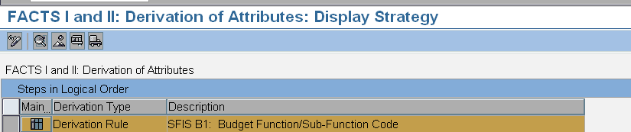
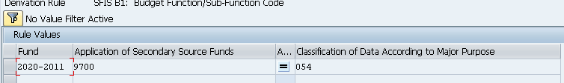

B2 - Budget Activity Identifier
SFIS Element: | B2 - Budget Activity Identifier | Length: | 2
SFIS Component: | Budget Program Information
Description: | Budget activity represents the first level of sub-division classification of the Budget and Fiscal Accounting Classifications. This subdivision represents the required DoD grouping and arrangement of appropriation and other fund accounts for budgetary and fiscal presentations. These budget and fiscal account classifications are included as integral DoD codification of appropriation / fund accounts.
Example: | PROCUREMENT uses "BA Code"- i.e. 01 Aircraft  RDT&E uses "BA Code"- i.e. 07 Operational Systems Development  MILCON uses "Major Construction Type"- i.e. 01 New Construction  O&M uses "BA Code"- i.e. 01 Operating Forces  MILPERS uses "Pay Type" - i.e. 01 Pay and Allowance of Officers  WCF uses "Business Line" - i.e. 01 Financial Operations Business Area
Comment: | If the subdivision of master data in the Customizing of Funds Management Government is active, you can subdivide your master data into several fields, so-called substrings.  By subdividing master data, you can provide a meaningful and clear structure for the account assignment elements used in your organization. In this field, you enter the value of a master data substring. Use the corresponding transactions to create your master data, in which you can then fit together the substrings created beforehand
Source: | http://fms.treas.gov/fastbook/

BUSINESS RULES
# | Business Rule
B2 | Budget Activity Identifier must be 2 numeric characters. ex. 01  Authoritative source: http://comptroller.defense.gov/Budget2011.html
B2 | Budget Activity Identifier must be used for financial reporting, budgetary control, and funds control.
B2 | Each accounting system must store and maintain Budget Activity Identifier values.
B2 | A Budget Activity Identifier must be associated to the accounting classification structure when the appropriation is signed by the President and will be maintained until available funding has been canceled.

DESIGN CONSIDERATIONS
Delivered Field | Derived Field | Characteristics
Delivered Field | Derived Field | FACTS I & II | Fund | Fund Center | Commitment Item | Functional Area | Funded Program | Application of Funds
X

PROCESS WALKTHRU
Module: | FM
Navigation: | Accounting-Public Sector Management-Funds Management-Master Data-Functional Area-FM-FUNCTION - Process Functional Area
SAP Trans Code: | FM_FUNCTION
Form Field Name:
Table Name: | FMFKBER_SUBSTRING | Field Name: | FNSUB1
Related Transactions: | None

Screenshot: Location of “Budget Activity Identifier” Display Functional Area

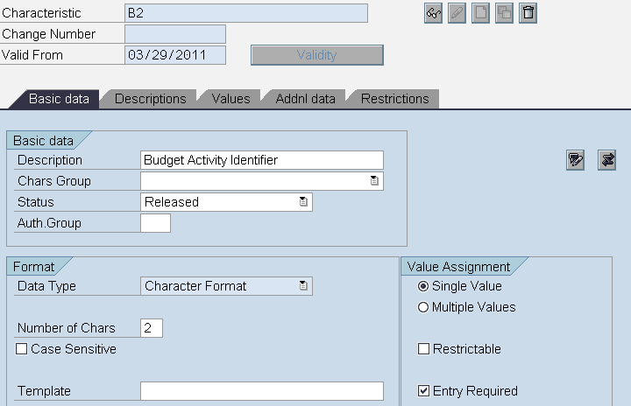
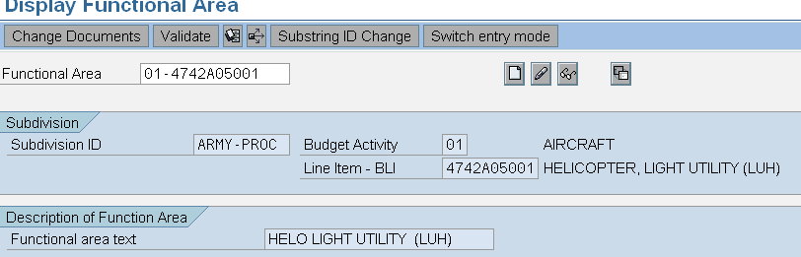

B3 - Budget Sub Activity Identifier
SFIS Element: | B3 - Budget Sub Activity Identifier | Length: | 6
SFIS Component: | Budget Program Information
Description: | Identifies further sub-divisions of the Treasury Account Fund Symbol below the Budget Activity Level.
Example: | PROCUREMENT uses "BSA Code"- i.e. 10 Fixed Wing  RDT&E does not use BSA  MILCON does not use BSA  O&M uses "AG Code"- i.e. Land Forces  MILPERS uses "Pay Type" - i.e. 05 Basic Pay  WCF uses "BSA" if needed
Comment: | None
Source: | http://fms.treas.gov/fastbook/

BUSINESS RULES
# | Business Rule
B3 | Budget Sub Activity Identifier must be a maximum of 6 numeric characters. ex. 05  Authoritative source: http://comptroller.defense.gov/Budget2011.html
B3 | Budget Sub Activity Identifier must be used for financial reporting and funds control.
B3 | Each accounting system must store and maintain Budget Sub Activity Identifier values.
B3 | A Budget Sub Activity Identifier must be established in the accounting classification structure when the appropriation is signed by the President and will be maintained until available funding has been canceled.

DESIGN CONSIDERATIONS
Delivered Field | Derived Field | Characteristics
Delivered Field | Derived Field | FACTS I & II | Fund | Fund Center | Commitment Item | Functional Area | Funded Program | Application of Funds
X |  |  |  |  |  | X

PROCESS WALKTHRU
Module: | FM
Navigation: | Accounting-Public Sector Management-Funds Management-Master Data-Functional Area-FM-FUNCTION - Process Functional Area
SAP Trans Code: | FM_FUNCTION
Form Field Name:
Table Name: | FMFKBER_SUBSTRING | Field Name: | FNSUB1
Related Transactions: | None

Screenshot: Location of “Budget Sub Activity Identifier” Display Field on Display Characteristics

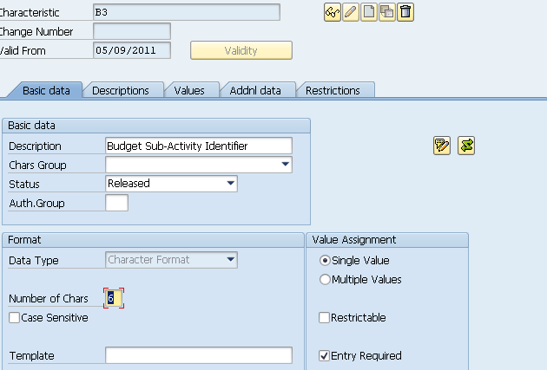
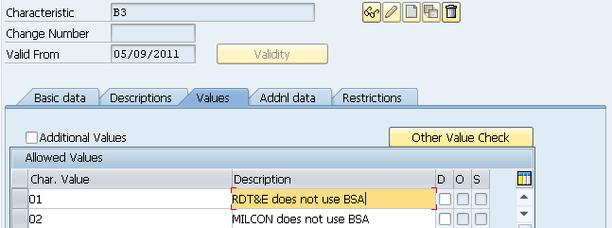

B4 - Budget Line Item Identifier
SFIS Element: | B4 - Budget Line Item Identifier | Length: | 16
SFIS Component: | Budget Program Information
Description: | Identifies further sub-divisions of the Treasury Account Fund Symbol appropriation, below the Budget Sub Activity Level.
Example: | PROCUREMENT uses "Weapons System Code"- i.e. 8485A11000 Utility Fixed Wing Cargo Aircraft  RDT&E uses "OSD Program Element" - i.e. BSA 0204136N F/A-18 Squadrons  MILCON uses "Location & Project" - i.e. 4962 05057041  O&M uses "SAG Code"- i.e. 020 Corps Combat Forces  MILPERS uses "Pay Type"  WCF uses "Activity" - i.e. Accounting-Navy
Comment: | None
Source: | http://fms.treas.gov/fastbook/

BUSINESS RULES
# | Business Rule
B4 | Budget Line Item Identifier may be up to 16 alpha numeric characters. ex. 4962 05057041  Authoritative source: http://comptroller.defense.gov/Budget2011.html
B4 | Budget Line Item Identifier must be used for accounting classification, financial reporting, budgetary control, and funds control.
B4 | Each accounting system must store and maintain Budget Line Item Identifier values.
B4 | A Budget Line Item Identifier must be established in the accounting classification structure when the appropriation is signed by the President and will be maintained until available funding has been canceled.
B4 | A Budget Line Item must be associated with at least one Program Code.

DESIGN CONSIDERATIONS
Delivered Field | Derived Field | Characteristics
Delivered Field | Derived Field | FACTS I & II | Fund | Fund Center | Commitment Item | Functional Area | Funded Program | Application of Funds
X

PROCESS WALKTHRU
Module: | FM
Navigation: | Accounting-Public Sector Management-Funds Management-Master Data-Functional Area-FM-FUNCTION - Process Functional Area
SAP Trans Code: | FM_FUNCTION
Form Field Name:
Table Name: | TFKB | Field Name: | FKBER
Related Transactions: | None

Screenshot: Location of “Budget Line Item Identifier” Display Field on Functional Area
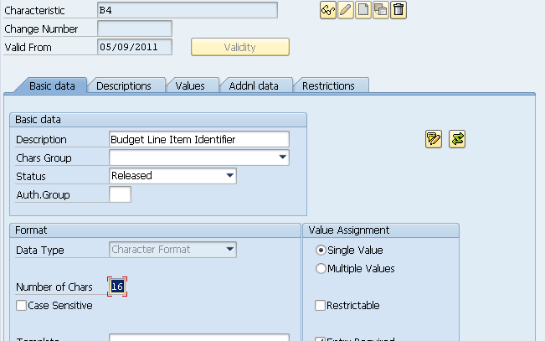
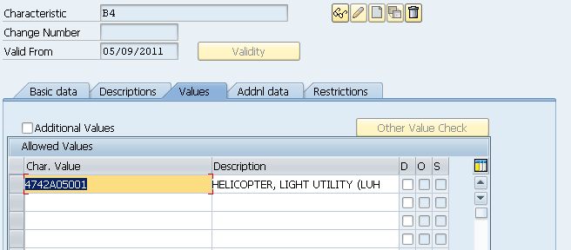

B6 - Object Class Code
SFIS Element: | B6 - Object Class Code | Length: | 3
SFIS Component: | Budget Program Information
Description: | Object classes are categories in a classification system that presents obligations by the items or services purchased by the Federal Government. These are the major object classes:  • 10 Personnel compensation and benefits.  • 20 Contractual services and supplies.  • 30 Acquisition of assets.  • 40 Grants and fixed charges.  • 90 Other.  OMB divides these major classes into smaller classes and presents them in object class schedules. The classes present obligations according to their initial purpose, not the end product or service. For example, if you pay a Federal employee who constructs a building, classify the obligations for the employee’s wages under Personnel compensation and benefits, rather than Acquisition of assets. If you purchase a building, classify the contractual obligations under Acquisition of assets.
Example: | Examples of major object classification codes, by code series:  Series Code Description  (11-19) Personnel compensation and benefits.  11 Personnel Compensation  11.1 Full-Time Permanent (Civilian)  11.3 Other Than Full Time Permanent  11.5 Other Personnel Compensation  11.7 Military Personnel  11.8 Special Personal Services Payments  11.9 Total Personnel Compensation  12 Personnel Benefits  12.1 Civilian Personnel Benefits  12.2 Military Personnel Benefits  13 Benefits of Former Personnel
Comment: | Commitment items reflect the functional structure of an organization in Funds Management. You can enter budget for commitment items and can post to them. When you enter postings in the Funds Management feeder systems and want the system to record the data in Funds Management, you must always specify a commitment item.  In the posting transaction, the system uses the link between the commitment item and the basic data in other components to derive the commitment item. You do not need to enter one manually.
Source: | http://fms.treas.gov/fastbook/

BUSINESS RULES
# | Business Rule
B6 | The Office of Management and Budget (OMB) designated object classification codes must be used when posting general ledger transaction to record the effect of budgetary expenditures.
B6 | Object Class Codes must be used to present obligations by the items or services purchased by the Federal Government.
B6 | Object Class Code must be 3 numeric characters. (For example 117 - to represent 11.7 as identified on the OMB Circular).  Authoritative source: http://www.whitehouse.gov/omb/circulars/a11/current_year/a11_toc.html
B6 | Object Class Code must be used for financial reporting.
B6 | Each accounting system must store and maintain Object Class Code values.

DESIGN CONSIDERATIONS
Delivered Field | Derived Field | Characteristics
Delivered Field | Derived Field | FACTS I & II | Fund | Fund Center | Commitment Item | Functional Area | Funded Program | Application of Funds
X | X |  |  |  | X

PROCESS WALKTHRU
Module: | Funds & Classification
Navigation: | Accounting - Public Sector Management - Funds Management- Master Data- Account Assignment Element- Commitment Item-Individual Processing
SAP Trans Code: | FMCIA & CT04
Form Field Name:
Table Name: | IFMCIDY& CAWN | Field Name: | FIPEX & ATWRT
Related Transactions:

Screenshot: Location of “Object Class Code” Display Field on Commitment Item

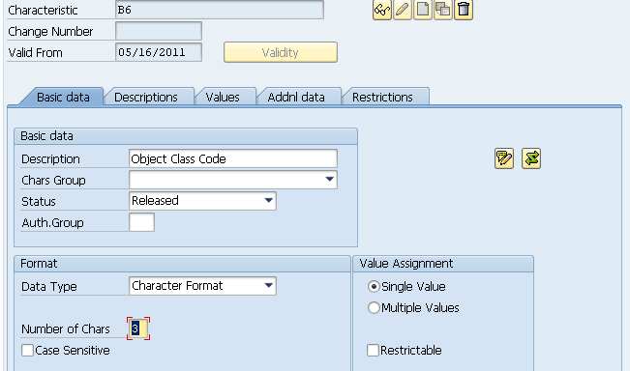
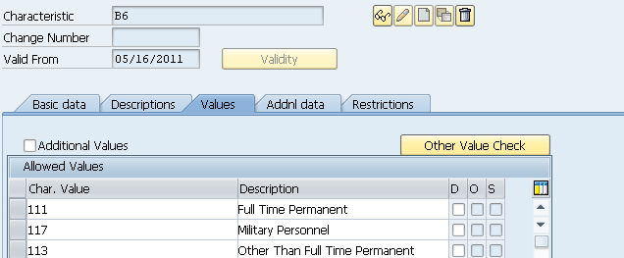

B8 - Contingency Code
SFIS Element: | B8 - Contingency Code | Length: | 6
SFIS Component: | Budget Program Information
Description: | This data element is intended to identify, for tracking purposes, special unplanned events, for which expenditures and costs are to be tracked, whereby funding might or might not have been previously established for contingency events, e.g., the "Tsunami Disaster" or the "9/11/01 Terrorist Attacks" or other similar unforeseen events. The purpose of the contingency code is to identify the budget execution records process for contingency events that occur, in order to provide a basis for recouping funds expended, i.e., to justify requests for resources needed to fund the contingency event after the fact.
Example: | None
Comment: | None
Source: | http://fms.treas.gov/fastbook/

BUSINESS RULES
# | Business Rule
B8 | The Contingency Code may be applied to any level of budget tracking level deemed appropriate.
B8 | When a Contingent need is realized, that requirement must be communicated to the Office of the Under Secretary of Defense (OUSD) Comptroller immediately.
B8 | Contingency Code must be 6 alpha numeric characters.  Authoritative source:  https://beis.csd.disa.mil/beis-xml/sfiscombo.xml
B8 | Contingency Code must be used for financial reporting, budgetary control, and funds control.
B8 | Each accounting system must store and maintain Contingency Code values.

DESIGN CONSIDERATIONS
Delivered Field | Derived Field | Characteristics
Delivered Field | Derived Field | FACTS I & II | Fund | Fund Center | Commitment Item | Functional Area | Funded Program | Application of Funds
X

PROCESS WALKTHRU
Module: | FM
Navigation: | Accounting-Public Sector Management-Funds Management-Master Data- Account Assignment Elements - Funded Program - FMMEASURED - Display
SAP Trans Code: | FMMEASURED
Form Field Name:
Table Name: | RCTAV | Field Name: | ATNAM
Related Transactions: | FMMEASURE

Screenshot: Location of “Contingency Code” Display Field on Commitment Item

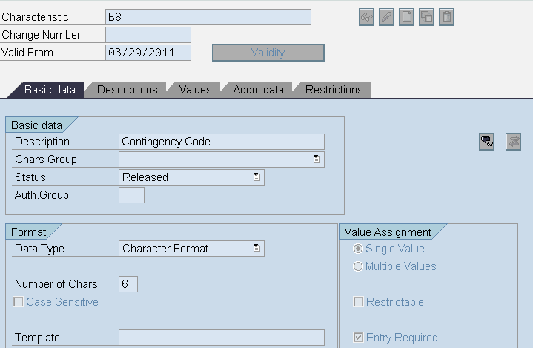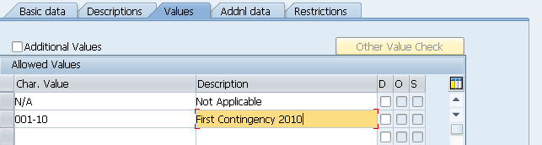

B9 - BEA Category Indicator Code
SFIS Element: | B9 - BEA Category Indicator Code | Length: | 1
SFIS Component: | Budget Program Information
Description: | A Budget Enforcement Act (BEA) designated category code representing one of three categories of a budget request. Budget categories are 1) mandatory, i.e., required funding requests based on legislative Acts, 2) discretionary, requests based on annual or period requests for funding or 3) emergency discretionary, requests based on the occurrence of emergency contingencies.
Example: | If a budget request is required based on the passing of new legislation or existing legislation then the BEA Category Indicator value will be "M
Comment: | This data element is intended to identify, for tracking purposes, special unplanned events, for which expenditures and costs are to be tracked, whereby funding might or might not have been previously established for contingency events, e.g., the "Tsunami Disaster" or the "9/11/01 Terrorist Attacks" or other similar unforeseen events. The purpose of the contingency code is to identify the budget execution records process for contingency events that occur, in order to provide a basis for recouping funds expended, i.e., to justify requests for resources needed to fund the contingency event after the fact.
Source: | http://fms.treas.gov/fastbook/

BUSINESS RULES
# | Business Rule
B9 | Budget Enforcement Act Category Indicator must be 1 alpha character. ex. D  Data values: D - Discretionary  M - Mandatory  E - Emergency Discretionary
B9 | Budget Enforcement Act Category Indicator must be used for accounting classification and financial reporting.
B9 | Each accounting system must store and maintain Budget Enforcement Act Category Indicator values.

DESIGN CONSIDERATIONS
Delivered Field | Derived Field | Characteristics
Delivered Field | Derived Field | FACTS I & II | Fund | Fund Center | Commitment Item | Functional Area | Funded Program | Application of Funds
X | X

PROCESS WALKTHRU
Module: | Funds Management
Navigation:
SAP Trans Code: | FMUSFG1
Form Field Name:
Table Name: | IUSFGFDERIVE | Field Name: | FLG_BEA
Related Transactions:

Screenshot: Location of “BEA Category Indicator” Display Field on Commitment Item

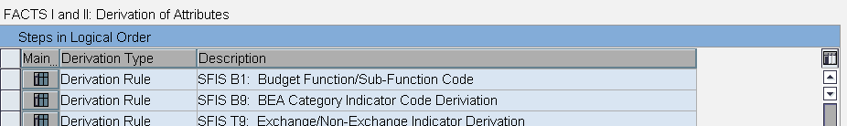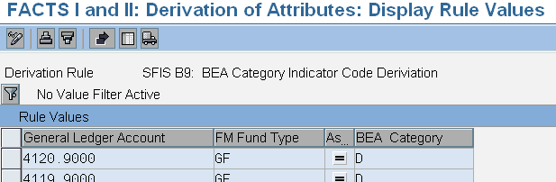

CA1 - Funding Center Identifier
SFIS Element: | CA1 - Funding Center Identifier | Length: | 16AN
SFIS Component: | Cost Accounting Information
Description: | Funding Center is a clearly defined responsibility area within an organizational unit to which budget authority is assigned.
Example: | None
Comment: | Funding Center is a clearly defined responsibility area within an organizational unit to which budget authority is assigned.
Source: | http://fms.treas.gov/fastbook/

BUSINESS RULES
# | Business Rule
CA1 | At the time of budget execution, a Funding Center Identifier must be associated with at least one cost object. Examples of cost objects are: Cost Centers, Project Identifiers, Activity Identifiers, Work Orders.
CA1 | Funding Center Identifier must be no more than 16 alpha-numeric characters.
CA1 | Funding Center Identifier must be used for budgetary control, funds control, and reporting.
CA1 | Each system must store and maintain Funding Center Identifiers.

DESIGN CONSIDERATIONS
Delivered Field | Derived Field | Characteristics
Delivered Field | Derived Field | FACTS I & II | Fund | Fund Center | Commitment Item | Functional Area | Funded Program | Application of Funds
X |  |  | X

PROCESS WALKTHRU
Module: | FM
Navigation: | Accounting - Public Sector Management - Funds Management  - Master Data - Account Assignment Elem - Funds Center - Individual Processing-Display
SAP Trans Code: | FMSC
Form Field Name:
Table Name: | IFMFCTRDY | Field Name: | FICTR
Related Transactions: | FMSA, FMSB

Screenshot: Location of “Funding Center Identifier” Display Field on Fund Center

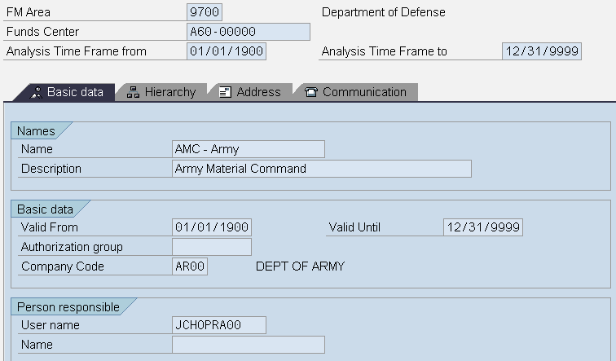

CA3 - Cost Center Identifier
SFIS Element: | CA3 - Cost Center Identifier | Length: | 16AN
SFIS Component: | Cost Accounting Information
Description: | A Cost Center is a clearly defined responsibility area where costs are incurred.
Example: | None
Comment: | An organizational unit within a controlling area that represents a defined location of cost incurrence. The definition can be based on: Functional requirements, Allocation criteria, Physical location, Responsibility for costs.
Source: | http://fms.treas.gov/fastbook/

BUSINESS RULES
# | Business Rule
CA3 | Cost Center Identifier must be associated with one or more Funding Center Identifiers.
CA3 | Cost Center Identifier must be no more than 16 alpha-numeric characters.
CA3 | Each system must store and maintain Cost Center Identifiers.

DESIGN CONSIDERATIONS
Delivered Field | Derived Field | Characteristics
Delivered Field | Derived Field | FACTS I & II | Fund | Fund Center | Commitment Item | Functional Area | Funded Program | Application of Funds
X | X

PROCESS WALKTHRU
Module: | Controlling
Navigation: | Accounting -Controlling – Cost Center - Individual Processing  - Display
SAP Trans Code: | KS03
Form Field Name:
Table Name: | CSKSZ | Field Name: | KOSTL
Related Transactions: | KS01, KS02

Screenshot: Location of “Cost Center Identifier” Display Field on Cost Center

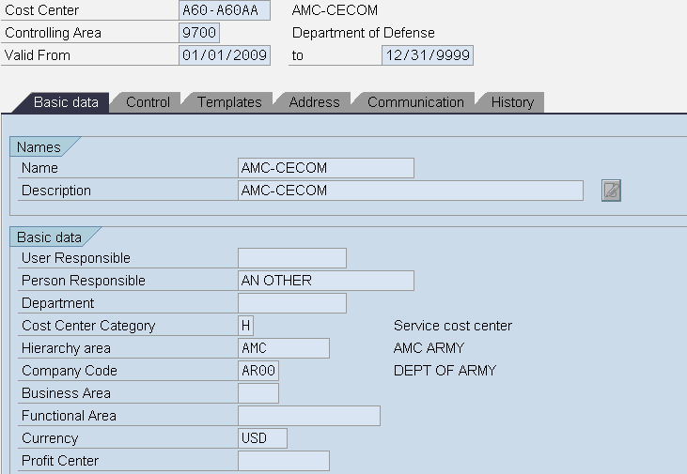

CA4 - Project Identifier
SFIS Element: | CA4 - Project Identifier | Length: | 24AN
SFIS Component: | Project Systems
Description: | A planned undertaking of work to be performed or product to be produced having a finite beginning and end.
Example: | None
Comment: | The project definition contains dates and organizational information that are binding for the entire project. The main objectives of the WBS are to split the project into manageable units, define basic dates, and determine its costs.  You can structure the WBS from various viewpoints:  By phase (logic or process oriented)  By function (function-oriented)  By object (object-oriented)
Source: | http://fms.treas.gov/fastbook/

BUSINESS RULES
# | Business Rule
CA4 | The Work Breakdown Structure may be applied as a breakdown for the Project Identifier.
CA4 | Each Project Identifier must be associated with one or more Funding Center Identifiers.
CA4 | If Project Identifier is used as the cost object, then the Project Identifier must be directly aligned with one or more Program Codes.
CA4 | Project Identifier may be no more than 24 alpha-numeric characters.
CA4 | If Project Identifier is used as the cost object, then the Project Identifier will be used for cost accumulation.
CA4 | If Project Identifier is used as the cost object, then each system must store and maintain Project Identifiers.

DESIGN CONSIDERATIONS
Delivered Field | Derived Field | Characteristics
Delivered Field | Derived Field | FACTS I & II | Fund | Fund Center | Commitment Item | Functional Area | Funded Program | Application of Funds
X | X

PROCESS WALKTHRU
Module: | Project Systems
Navigation: | Accounting – Project Systems-Project-Project Builder
SAP Trans Code: | CJ20N
Form Field Name:
Table Name: | PROJ | Field Name: | PSPID
Related Transactions: | CJ01, CJ02, CJ03

Screenshot: Location of “Project Identifier” Display Field on Project Definition

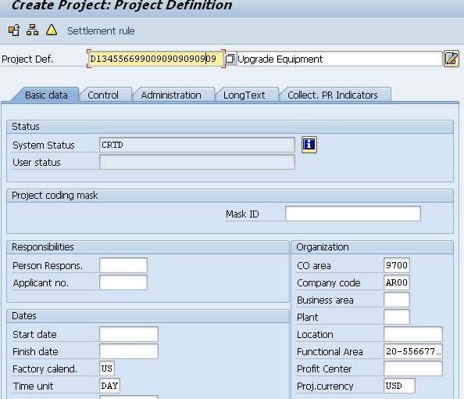

CA5 - Activity Identifier
SFIS Element: | CA5 - Activity Identifier | Length: | 15AN
SFIS Component: | Controlling
Description: | An Activity is a series of events, tasks, or units of work that are linked to perform a specific objective.
Example: | None
Comment: | Activity types describe the activity produced by a cost center and are measured in units of time or quantity. In activity type planning, control data determines whether the activity price for evaluation of the activity type is manually set or is derived iteratively through activity price calculation.
Source: | http://fms.treas.gov/fastbook/

BUSINESS RULES
# | Business Rule
CA5 | If Activity Identifier is used as the cost object, then the Activity Identifier must be directly aligned with one or more Program Codes.
CA5 | Each Activity Identifier must be associated with one or more Funding Center Identifiers.
CA5 | Activity Identifier must be no more than 15 alpha-numeric characters.
CA5 | An Activity Identifier must be associated with one or more Cost Element Codes.
CA5 | If Activity Identifier is used as the cost object, then Activity Identifier will be used for cost accumulation.
CA5 | If Activity Identifier is used as the cost object, then each system must store and maintain Activity Identifiers.

DESIGN CONSIDERATIONS
Delivered Field | Derived Field | Characteristics
Delivered Field | Derived Field | FACTS I & II | Fund | Fund Center | Commitment Item | Functional Area | Funded Program | Application of Funds
X | X

PROCESS WALKTHRU
Module: | Controlling
Navigation: | Accounting -Controlling – Cost Center Accounting - Cost Center - Activity Type -Individual Processing- Display
SAP Trans Code: | KL03
Form Field Name:
Table Name: | CSLAZ | Field Name: | LSTAR
Related Transactions: | KL01, KL02

Screenshot: Location of “Activity Identifier” Display Characteristics

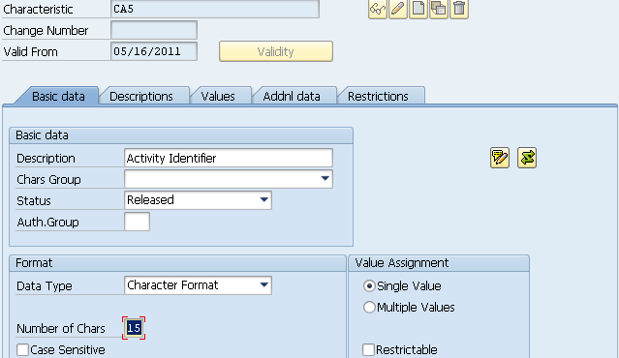
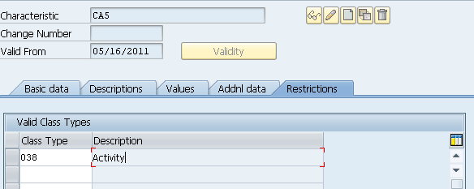

CA6 - Cost Element Code
SFIS Element: | CA6 - Cost Element Code | Length: | 15AN
SFIS Component: | Controlling
Description: | Cost Element is a classification of an organization's revenues, expenses or consumable resources. Cost Element Code only relates to primary cost. Cost Element Code does not relate to secondary cost which is identified as agency specific and not enterprise-level...
Example: | 6100.1212 - O/E-Personnel Compensation-Civilian  6100.1222 - O/E-Personnel Compensation-Military  6100.2522 - O/E-Purchased Services  6100.2601 - O/E-Supplies and Materials
Comment: | Every item that is relevant to costing is assigned to a cost element. For example, material costs (category M) are assigned to primary cost elements, while production costs (category E) and overhead costs (category G, P or X) are assigned to secondary cost elements
Source: | http://fms.treas.gov/fastbook/

BUSINESS RULES
# | Business Rule
CA6 | Each Cost Element Code must be associated to only one general ledger account.
CA6 | Cost Element Codes linked to posted costs must be associated with at least one cost object.
CA6 | Cost Element Code must be no more than 15 alpha-numeric characters.
CA6 | Cost Element Code must be used for cost accumulation that is to be posted to the general ledger.
CA6 | Each system must store and maintain Cost Element Codes.

DESIGN CONSIDERATIONS
Delivered Field | Derived Field | Characteristics
Delivered Field | Derived Field | FACTS I & II | Fund | Fund Center | Commitment Item | Functional Area | Funded Program | Application of Funds
X | X

PROCESS WALKTHRU
Module: | CO
Navigation: | Accounting -Controlling – Cost Center Accounting - Cost Element - Individual Processing- Display
SAP Trans Code: | KA03
Form Field Name:
Table Name: | CSLAZ | Field Name: | KSTAR
Related Transactions: | KA01, KA02

Screenshot: Location of “Cost Element Code” Display Field on Cost Element

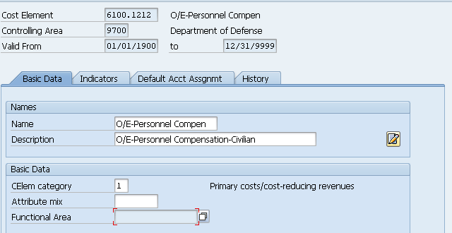

CA7 - Work Order Number
SFIS Element: | CA7 - Work Order Number | Length: | 16AN
SFIS Component: | Plant Maintenance
Description: | Identifies an individual unit of work, batch, or lot of a distinct product or service.
Example: | None
Comment: | Supports action-oriented planning as well as monitoring and allocation of costs
Source: | http://fms.treas.gov/fastbook/

BUSINESS RULES
# | Business Rule
CA7 | A Work Order Number must be associated with one or more Fund Center Identifiers.
CA7 | A Work Order Number must be associated with one or more Cost Element Codes.
CA7 | If Work Order Number is used as the cost object, then the Work Order Number must be directly aligned with one or more Program Codes.
CA7 | Work Order Number must be no more than 16 alpha-numeric characters.
CA7 | If Work Order Number is used as the cost object, then Work Order Number must be used for cost accumulation.
CA7 | If Work Order Number is used as the cost object, then each system must store and maintain Work Order Numbers.

DESIGN CONSIDERATIONS
Delivered Field | Derived Field | Characteristics
Delivered Field | Derived Field | FACTS I & II | Fund | Fund Center | Commitment Item | Functional Area | Funded Program | Application of Funds
X | X

PROCESS WALKTHRU
Module: | CO/PS
Navigation: | Logistics - Plant Maintenance - Maintenance Processing -Display
SAP Trans Code: | IW33
Form Field Name:
Table Name: | CAUFVD | Field Name: | AUFNR
Related Transactions: | IW31, IW32

Screenshot: Location of “Work Order Number” Display Field on Work Order

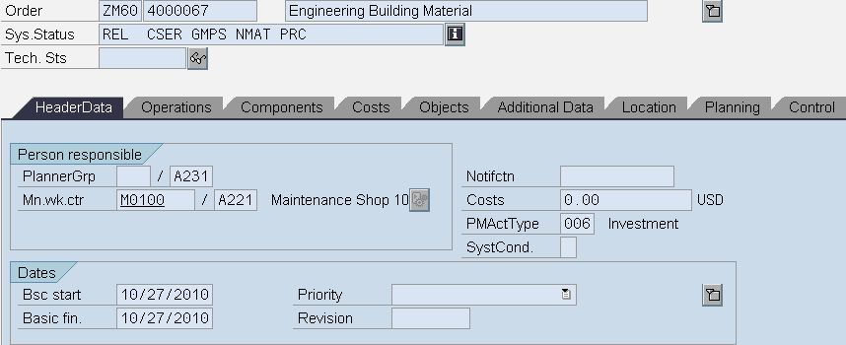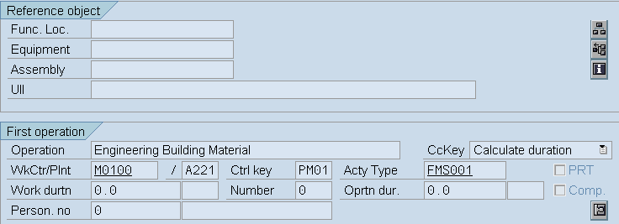

CA9 - Transaction Quantity
SFIS Element: | CA9 - Transaction Quantity | Length: | 10
SFIS Component: | Purchasing
Description: | Quantity of units involved in the transaction.
Example: | If DoD purchases 60 computers in one transaction, then the Transaction Quantity value will be "0000000060" for the transaction.
Comment: | The order quantity relates to the order unit. It is used in Goods Receiving and Invoice Verification for checking purposes. Enter the quantity to be ordered in the unit of measure
Source: | http://fms.treas.gov/fastbook/

BUSINESS RULES
# | Business Rule
CA9 | Transaction Quantity must be up to 10 numeric characters. ex. 0000000060  Data values: There is no list of values applicable for this element.
CA9 | Transaction Quantity must be used for asset accountability.
CA9 | Each accounting system must store and maintain Transaction Quantity values.

DESIGN CONSIDERATIONS
Delivered Field | Derived Field | Characteristics
Delivered Field | Derived Field | FACTS I & II | Fund | Fund Center | Commitment Item | Functional Area | Funded Program | Application of Funds
X | X

PROCESS WALKTHRU
Module: | CO
Navigation:
SAP Trans Code: | ME23N
Form Field Name:
Table Name: | MEPO1211 | Field Name: | MENGE
Related Transactions: | ME21N, ME22N

Screenshot: Location of “Transaction Quantity” Display Field on Purchase Order

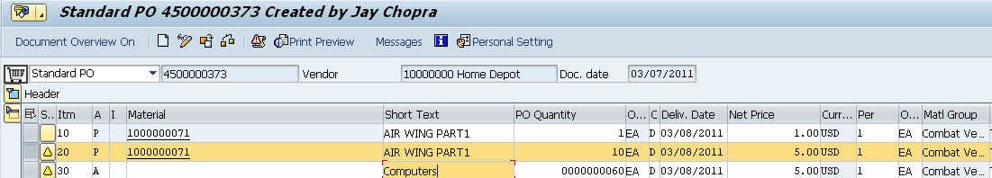

CA10 - Unit of Measure Code
SFIS Element: | CA10 - Unit of Measure Code | Length: | 3AN
SFIS Component: | Purchasing
Description: | The Unit of Measure Code indicates the count, measurement, container or form of an item.
Example: | None
Comment: | Specifies the unit of measure in which the material is ordered. In Inventory Management, the base unit is the same as the stock keeping unit.
Source: | http://fms.treas.gov/fastbook/

BUSINESS RULES
# | Business Rule
CA10 | A Unit of Measure Code must be used to identify any reported transaction quantity to ensure consistent comparisons across DoD organizations.
CA10 | Unit of Measure Code must be no more than 3 alpha-numeric characters.
CA10 | Unit of Measure Code must be used for cost control and reporting.
CA10 | Each system must store and maintain Unit of Measure Codes.

DESIGN CONSIDERATIONS
Delivered Field | Derived Field | Characteristics
Delivered Field | Derived Field | FACTS I & II | Fund | Fund Center | Commitment Item | Functional Area | Funded Program | Application of Funds
X | X

PROCESS WALKTHRU
Module: | Purchasing
Navigation: | Logistics- Materials Management- Purchasing- Purchase Order- Display
SAP Trans Code: | ME23N
Form Field Name:
Table Name: | MEPO1211 | Field Name: | MEINS
Related Transactions: | ME21N, ME22N

Screenshot: Location of “Unit of Measure Code” Display Field on Purchase Order

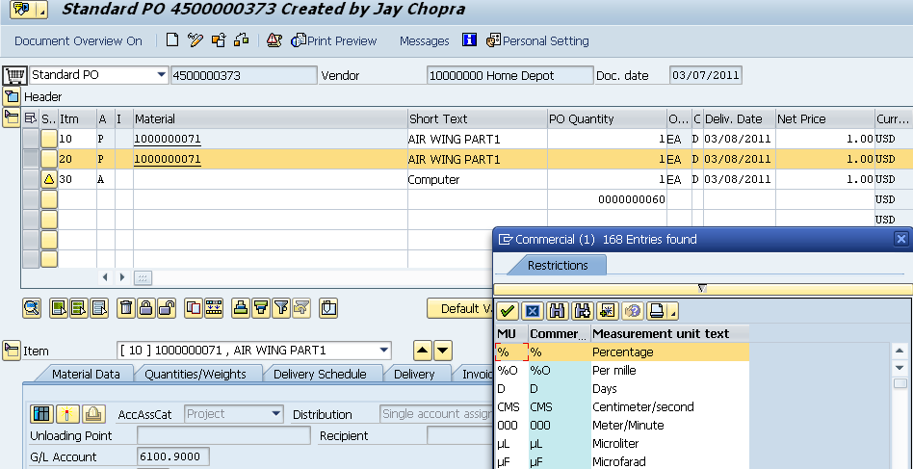
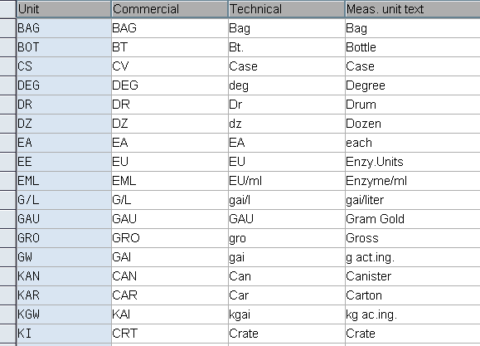

CA12 - Asset Unique ID
SFIS Element: | CA12- Asset Unique ID | Length: | 50AN
SFIS Component: | Equipment and Tools Management
Description: | Asset Unique identifier is assigned to all physical assets. It supports asset accountability and auditability. It is used to record the unique item identification number or the real property identification number. Unique item identification will provide accurate and accessible information about personal property that will make acquisition, repair, and deployment of items faster and more efficient. Real Property identification distinctively and uniquely identifies a piece of land, a building, structure, linear structure, or other real property improvements in which DoD has a legal interest.
Example: | Example No. 1-Unique Asset ID (UID): Real Property Items for a Water Treatment System:  RPUID System Component Name  111111111111316946 Water 111111111111110017 Tower  111111111111316946 Water 111111111111100009 Intake Pipe  111111111111316946 Water 111111111111110204 Treatment Facility  Example No.2- Unique (Asset) Item Identifier(UID) for Personal Property; Part Name - Signal Acquisition Remote(SAR)-Aircraft Black Box (retains unique identity), using DoD Construct #2: Data Identifier Format 06 (DI), (Ref. Source Col., "Acq".URL):Where,  Enterprise Identifier = "17V(MFR CAGE No) 98897", Original Part No.="1P(Original Part No)4L0014-163B" (Separate element, not part of UII), and Serial No.(S)="SSA10197".  Example No.3: UID for Personal Property: Name-Motor Vehicle (ISO Vehicle Identification Number (VIN) used in data matrix for a DoD UID Equivalent, in Text Element Identifier (TEI) format: "LD" (Issuing agency-DoD), “MFR-0CVA5"-(Enterprise Identifier), + "VIN6764A36458".
Comment: | Unique item identifier (UII), a globally unique number that identifies a single item.
Source: | http://fms.treas.gov/fastbook/

BUSINESS RULES
# | Business Rule
CA12 | Each Item Unique Identifier (IUID) construct may be serialized with the enterprise, or serialized within the part number.
CA12 | For items that are serialized within the enterprise identifier, unique identification is achieved by a combination of the issuing agency code, enterprise identifier and the serial number, which must be unique within the enterprise identifier.
CA12 | For items that are serialized within the part number, unique identification is achieved by a combination of the issuing agency code, enterprise identifier, the original part number, and the serial number.
CA12 | Each Real Property Unique Identifier (RPUID) must be an 18 character integer.
CA12 | At creation, the web based system-generated Real Property Unique Identifier (RPUID) non-intelligent identifier must be validated and cross-referenced to prevent duplication.
CA12 | The Real Property Unique Identifier (RPUID) must not contain spaces, hyphens, or other edit characters.
CA12 | A Real Property Unique Identifier (RPUID) may be referenced in a parent-child relationship to other RPUIDs for related subsets of assets, as needed for data linkages.
CA12 | Asset Unique ID must be a maximum of 50 alpha-numeric characters.  Authoritative source: http://www.acq.osd.mil/dpap/UID/
CA12 | Asset Unique ID must be used for asset accountability.
CA12 | Each accounting system must store and maintain Asset Unique ID values.

DESIGN CONSIDERATIONS
Delivered Field | Derived Field | Characteristics
Delivered Field | Derived Field | FACTS I & II | Fund | Fund Center | Commitment Item | Functional Area | Funded Program | Application of Funds
X | X

PROCESS WALKTHRU
Module: | CO/PS
Navigation: | Logistics- Plant Maintenance- Equipment- Display
SAP Trans Code: | IE03
Form Field Name:
Table Name: | RM63E | Field Name: | EQUNR
Related Transactions: | IE01, IE02

Screenshot: Location of “Asset Unique ID” Display Field on Equipment

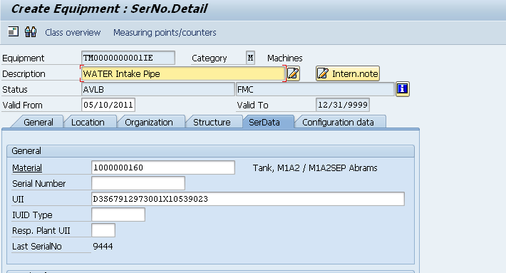

CA14 - MEPR Code
SFIS Element: | CA14 - MEPR Code | Length: | 4AN
SFIS Component: | Controlling
Description: | The Medical Expense and Performance Reporting (MEPR) code represents a functional cost account. Each position defines a specific 3-level hierarchical structure as prescribed in the DoD 6010.13-M, Appendix 3, Table AP3.T1.
Example: | D - ANCILLARY SERVICES  DC - Radiology  DCA - Diagnostic Radiology  DCB - Inactive  DCX - Cost Pool  DCZ - Radiology Not Elsewhere Classified  DD - Special Procedure Services  DDA - Electrocardiography  DDB - Electroencephalography  DDC - Electroneuromyography  DDD - Pulmonary Function  DDE - Cardiac Catheterization
Comment: | None
Source: | http://fms.treas.gov/fastbook/

BUSINESS RULES
# | Business Rule
CA14 | Each Medical Treatment Facility (MTF) incurring medical costs will report cost by Medical Expense and Performance Reporting (MEPR) code in accordance with DoD guidance.
CA14 | Each transaction containing a Medical Expense and Performance Reporting (MEPR) code must be substantiated by auditable source documentation.
CA14 | Medical Expense and Performance Reporting (MEPR) code must be 4 alpha-numeric characters where the first 3 positions will correspond to the MEPR code in DoD guidance and the 4th position will be reserved to accommodate expansion.
CA14 | The Medical Expense and Performance Reporting (MEPR) code must be used in accordance with DoD guidance to identify, record, and report data from fixed Medical Treatment Facilities (MTFs).
CA14 | Each system must store and maintain Medical Expense and Performance Reporting (MEPR) Code values.

DESIGN CONSIDERATIONS
Delivered Field | Derived Field | Characteristics
Delivered Field | Derived Field | FACTS I & II | Fund | Fund Center | Commitment Item | Functional Area | Funded Program | Application of Funds
 | X

PROCESS WALKTHRU
Module: | CO
Navigation:
SAP Trans Code: | KS03
Form Field Name:
Table Name: | CSKSZ | Field Name:
Related Transactions: | KS01, KS02

The MEPR code is a customised field and has not been created in the system.

Screenshot: Location of “MEPR Code” Display Field on Characteristics

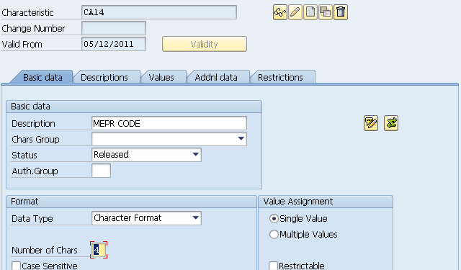
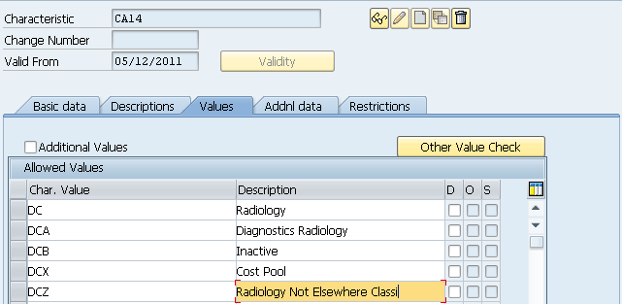

O1 - Organization Unique Identifier
SFIS Element: | O1 - Organization Unique Identifier | Length: | 16
SFIS Component: | Organizational Information
Description: | A character string that identifies a public or private organizational entity that supports a given mission, function, business objective or other criteria. The creation of an Organization Unique Identifier (OUID), a unique, simple and non-intelligent (containing no embedded information or smart codes) identifier will support standardized unique identification of organizations as required by the Department of Defense. This identifier will be used to identify all organizations within the DOD and non-DOD organizations to include, but not limited to, U.S. and foreign federal, civil and commercial entities.
Example: | None
Comment: | None
Source: | http://fms.treas.gov/fastbook/

BUSINESS RULES
# | Business Rule
O1 | When an Organization Unique Identifier is associated with any element, to include another Organization Unique Identifier, then the relationship must be available throughout the accounting lifecycle.
O1 | An Organization Unique Identifier must be associated with a unique or discrete combination of Department Regular Code, Main Account Code, Period of Availability Fiscal Year Date, Budget Activity Identifier, Budget Sub Activity Identifier, and Budget Line Item Identifier for funds allocation and funds control.
O1 | When an Organization Unique Identifier is created, then it must be associated to one Organization.
O1 | When an Organization is created, then it must have at least one Organization Unique Identifier associated to it.
O1 | When an Organization has a subordinate Organization, then the subordinate Organization(s) accounting information must be associated to the "parent" Organization.
O1 | When financial information is received by the financial data repository or system, then at least one Organization Unique Identifier must be associated with that information.
O1 | When an Organization Unique Identifier equivalent is used, then the equivalent should be used to determine the Organization Unique Identifier.
O1 | Organization Unique Identifier must be a maximum of 16 hexadecimal characters.
O1 | Organization Unique Identifier must be used for accounting classification, financial reporting, budgetary control, and funds control.
O1 | Each accounting system must store and maintain Organization Unique Identifier values.

DESIGN CONSIDERATIONS
Delivered Field | Derived Field | Characteristics
Delivered Field | Derived Field | FACTS I & II | Fund | Fund Center | Commitment Item | Functional Area | Funded Program | Application of Funds
 | X |  |  | X

PROCESS WALKTHRU
Module: | Cross-Application Components
Navigation: | Cross-Application Components - Classification System - Master Data -  Characteristics
SAP Trans Code: | CT04
Form Field Name:
Table Name: | RCTAV | Field Name: | ATNAM
Related Transactions: | CT10

Screenshot: Location of “Organization Unique Identifier” Display Field on Characteristics

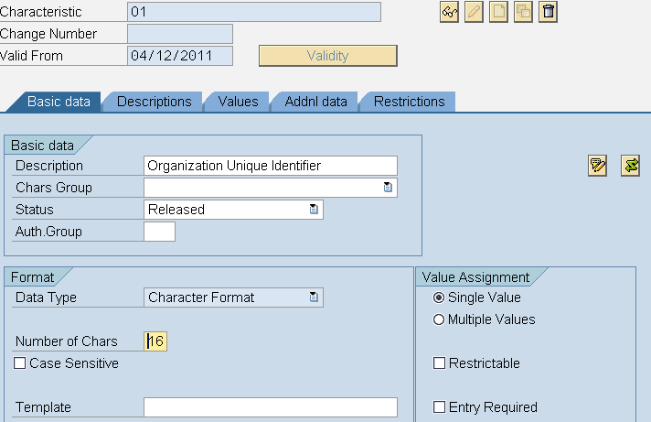
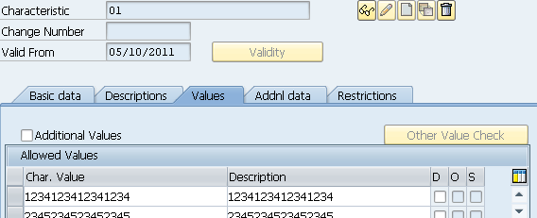

O2 - Agency Disbursing Identifier Code
SFIS Element: | O2 - Agency Disbursing Identifier Code | Length: | 8
SFIS Component: | Organizational Information
Description: | The Agency Disbursing Identifier is assigned to each disbursing office by the Treasury Department. The Agency Disbursing Identifier is an identification number that indicates authority to receive and disburse public funds and issue checks on the United States Treasury.
Example: | Sample Agency Disbursing Identifiers:  DSSN Installation/Activity  1700 Personnel Support Activity Detroit  5037 OPLOC Dayton  70051514 DEPARTMENT OF HOMELAND SECURITY
Comment: | The ALC is required on any transaction involving a "Funds Balance with Treasury" (FBT) account, and, in the current implementation, this means it is required on the customer/vendor line of invoices, and the "Disbursements-In-Transit" (DIT) account line.
Source: | http://fms.treas.gov/fastbook/

BUSINESS RULES
# | Business Rule
O2 | When an Agency Disbursing Identifier Code is associated with any other element, the association must be available throughout accounting lifecycle.
O2 | Agency Disbursing Identifier (DSSN/ALC) Code may be up to 8 numeric characters. ex. 1700  Authoritative source: https://beis.csd.disa.mil/beis-xml/sfiscombo.xml
O2 | Agency Disbursing Identifier Code must be used for financial reporting, and funds control.
O2 | Each accounting system must store and maintain Agency Disbursing Identifier Code values.

DESIGN CONSIDERATIONS
Delivered Field | Derived Field | Characteristics
Delivered Field | Derived Field | FACTS I & II | Fund | Fund Center | Commitment Item | Functional Area | Funded Program | Application of Funds
X | X

PROCESS WALKTHRU
Module: | AP
Navigation: | Accounting-Financial Accounting- Accounts Payable-Master record- Display
SAP Trans Code: | FK03
Form Field Name:
Table Name: | LFA1 | Field Name: | ALC
Related Transactions: | FK03, FK01, XK01, XK02, XK03

Screenshot: Location of “Agency Disbursing Identifier Code” Display Field on Vendor Master

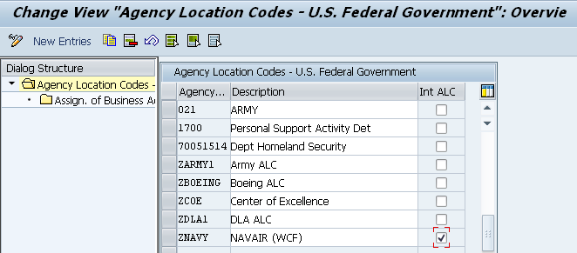
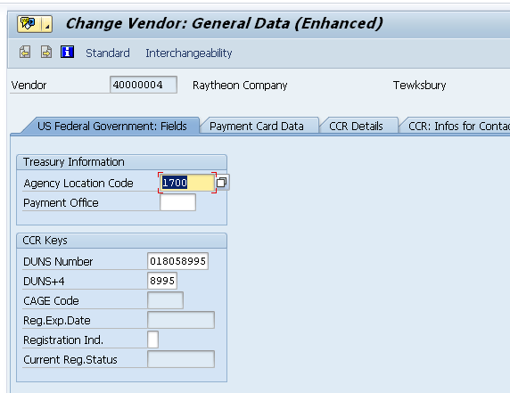

O3 - Agency Accounting Identifier Code
SFIS Element: | O3 - Agency Accounting Identifier Code | Length: | 6
SFIS Component: | Organizational Information
Description: | The Agency Accounting Identifier Code identifies the accounting system responsible for recording the accounting event. The Agency Accounting Identifier Code is intended to be an accounting system identifier, and therefore must be assigned to only one accounting system.
Example: | Sample Accounting Station Identifiers:  FSN/AAA/ADSN Installation  044311 DFAS INDIANAPOLIS DEFENSE AGENCY DAI/BTA ATTN: DFAS-AI-IS  021001 DFAS INDIANAPOLIS (GFEBS)  385300 EXPEDITIONARY COMBAT SUPPORT SYSTEM (ECSS) (DFAS COLUMBUS)
Comment: | The ALC is required on any transaction involving a "Funds Balance with Treasury" (FBT) account, and, in the current implementation, this means it is required on the customer/vendor line of invoices, and the "Disbursements-In-Transit" (DIT) account line.
Source: | http://fms.treas.gov/fastbook/

BUSINESS RULES
# | Business Rule
O3 | When an Agency Accounting Identifier Code is associated with any other element, the association must be available throughout accounting lifecycle.
O3 | Agency Accounting Identifier Code (FSN/AAA/ADSN) may be 6 numeric characters. ex. 000318  Authoritative source: https://beis.csd.disa.mil/beis-xml/sfiscombo.xml
O3 | Agency Accounting Identifier Code must be used for accounting classification and financial reporting.
O3 | Each accounting system must store and maintain Agency Accounting Identifier Code values.
O3 | If there are multiple reporting organizations managing accounting within the system, a single accounting system may have more than one Agency Accounting Identifier Code.
O3 | Different organizations may also use the same Agency Accounting Identifier Code, if managed within the same accounting system.
O3 | Each accounting system must be represented by at least one Agency Accounting Identifier Code.
O3 | An Agency Accounting Identifier Code must not represent more than one accounting system.

DESIGN CONSIDERATIONS
Delivered Field | Derived Field | Characteristics
Delivered Field | Derived Field | FACTS I & II | Fund | Fund Center | Commitment Item | Functional Area | Funded Program | Application of Funds
X

PROCESS WALKTHRU
Module: | AP
Navigation: | IMG-Functions for US Federal Government -Payment Processing -  Maintain Fiscal Station Number
SAP Trans Code: | SPRO
Form Field Name:
Table Name: | V_FMFGT_FSN | Field Name: | FSN
Related Transactions: | None

Screenshot: Location of “Agency Accounting Identifier Code” Display Field on Vendor Master

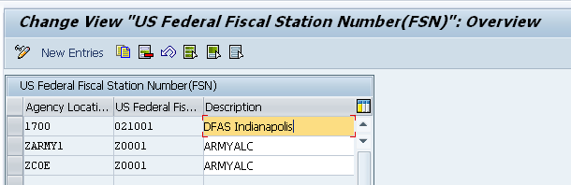

T1 - Transaction Type Code
SFIS Element: | T1 - Transaction Type Code | Length: | 4AN
SFIS Component: | Transactional Information
Description: | Transaction Type - A code to indicate the grouping of like types of business and/or accounting events, i.e., transactions, with general association, but not limited by the US Treasury designated groupings of transactions, as follows:  Axxx - Funding  Bxxx - Disbursements and Payables  Cxxx - Collections and Receivables  Dxxx - Adjustments/Writeoffs/Reclassifications  Exxx - Accruals/Nonbudgetary Transfers  Fxxx - Yearend Preclosing and Closing Entries  Gxxx - Memorandum Entries  Hxxx - Other Specialized Transactions
Example: | Examples of Transaction Types are as follows:  Transaction Type Value Type Name  A001 Allotment  B022 Commitment  C051 Revenue - Previously Accrued  D022 Adjustment - Financing Sources
Comment: | None
Source: | http://fms.treas.gov/fastbook/

BUSINESS RULES
# | Business Rule
T1 | Each Transaction Type Code may be associated with one or more general ledger transactions.
T1 | Each general ledger transaction must have only one Transaction Type Code value.
T1 | Transaction Type Code must be 4 alpha-numeric characters. ex. B201  Authoritative source: http://www.bta.mil/SFIS/sfis_resources.html
T1 | Transaction Type Code must be used for general ledger posting.
T1 | Each accounting system must maintain a chart of accounts and utilize general ledger posting logic that attains the same results as the United States Standard General Ledger (USSGL) Transaction Library.
T1 | Different Transaction Type Code values may be used only if, the accounting system is posting all applicable transactions using compliant general ledger posting logic.

DESIGN CONSIDERATIONS
Delivered Field | Derived Field | Characteristics
Delivered Field | Derived Field | FACTS I & II | Fund | Fund Center | Commitment Item | Functional Area | Funded Program | Application of Funds
X

PROCESS WALKTHRU
Module: | BCS/FI Postings
Navigation: | Accounting-Public Sector Management-Funds management-Budgeting- Budget Control System (BCS)- Entry Documents--Display
SAP Trans Code: | SPRO
Form Field Name:
Table Name: | BKPF | Field Name: | BUKRS
Related Transactions: | FMBB

Screenshot: Location of “Transaction Type Code” Display Field on Document Type Definition

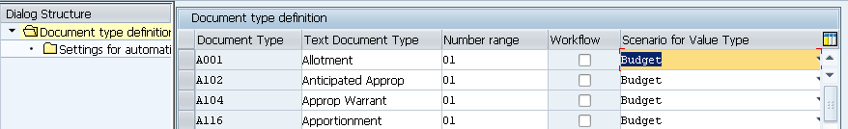

T2 - USSGL/DoD Account Code
SFIS Element: | T2 - USSGL/DoD Account Code | Length: | 9
SFIS Component: | Transactional Information
Description: | The USSGL/DoD Account Code is a unique code comprised of the four-digit United States Government Standard General Ledger (USSGL) account, as published in the USSGL Chart of Accounts, followed by a decimal and a DoD specific four-digit account extension. The USSGL/DoD Account Codes provide the basic structure for the DoD Standard Chart of Accounts required for standardized departmental reporting. USSGL/DoD Account Codes are comprised of budgetary, proprietary and memorandum accounts.
Example: | Examples of USSGL Account Nos. and Nomenclatures:  Number Nomenclature  1XXX (1000 Series) ASSETS  1010.0110 Fund Balance With Treasury-Funds Collected  2XXX LIABILITIES  2211.9000 Withholdings Payable  3XXX NET POSITION  3100.9000 Unexpended Appropriations - Cumulative  4XXX BUDGETARY ACCOUNTS  4032.9000 Estimated Indefinite Contract Authority  5XXX REVENUE and OTHER FINANCING SOURCES  ACCOUNTS  5100.0300 Revenue From Goods Sold - Sales at Exchange  6XXX EXPENSES  6100.9000 Operating Expenses/Program Costs  7XXX GAINS/LOSSES ACCOUNTS  7110.9000 Gains on Disposition of Assets - Other  8XXX MEMORANDUM ACCOUNTS  8801.9000 Offset for Purchase of Assets
Comment: | None
Source: | http://fms.treas.gov/fastbook/

BUSINESS RULES
# | Business Rule
T2 | Each General Ledger Account in the Accounting System must be associated with one and only one USSGL Account  Authoritative source: http://www.bta.mil/SFIS/sfis_resources.html
T2 | All general ledger accounts within the accounting system used for posting must begin with a valid 4-digit USSGL account number, but may be extended up to 10 alpha numeric characters. Ex. 1010.1000A
T2 | A "Reporting" Chart of Accounts must exist within the accounting system which enforces the following: Every "Posting" general ledger account must roll up to, or be subordinate to one and only one General Ledger Account Code within the Reporting Chart of Accounts with this linkage occurring at "time of transaction.".
T2 | The system Reporting Chart of Accounts must contain only accounts contained within the current OSD Comptroller Memorandum identifying the individual accounts within the Reporting Chart of Accounts.  Note: An exception to this requirement is that the system may contain memorandum accounts not used in financial reporting which are used for local purposes

DESIGN CONSIDERATIONS
Delivered Field | Derived Field | Characteristics
Delivered Field | Derived Field | FACTS I & II | Fund | Fund Center | Commitment Item | Functional Area | Funded Program | Application of Funds
X

PROCESS WALKTHRU
Module: | Funds Management
Navigation: | Accounting -Financial Accounting- General Ledger- Master Records  G/L Accounts- Individual Processing -Centrally
SAP Trans Code: | FS00
Form Field Name:
Table Name: | BSEG | Field Name: | SAKNR
Related Transactions: | FSP0

Screenshot: Location of “USSGL/DoD Account Code” Display Field on GL Account

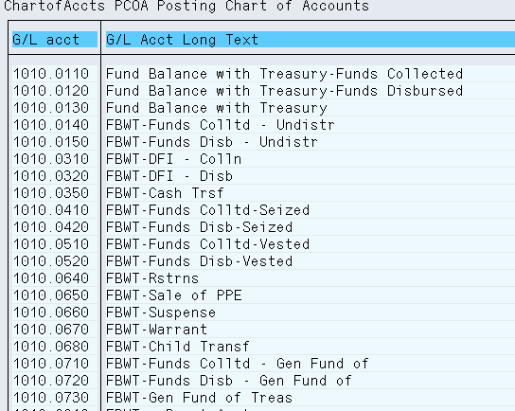

T3 - Debit/Credit Indicator
SFIS Element: | T3 - Debit/Credit Indicator | Length: | 1
SFIS Component: | Transactional Information
Description: | Indicator identifies whether the GL balance included in an automated trial balance is a debit or credit balance.
Example: | If the balance being reported is a net debit balance, then the value will be "D".
Comment: | None
Source: | http://fms.treas.gov/fastbook/

BUSINESS RULES
# | Business Rule
T3 | Debit/Credit Indicator must be 1 alpha character. ex. D  Data values: D - Debit  C - Credit
T3 | Systems may use posting keys which represent debits and credits.
T3 | Debit/Credit Indicator must be used for general ledger posting, and financial reporting.

DESIGN CONSIDERATIONS
Delivered Field | Derived Field | Characteristics
Delivered Field | Derived Field | FACTS I & II | Fund | Fund Center | Commitment Item | Functional Area | Funded Program | Application of Funds
X

PROCESS WALKTHRU
Module: | General ledger
Navigation: | Accounting- Financial Accounting- General Ledger- Posting- Enter G/L Account Document
SAP Trans Code: | FB50
Form Field Name:
Table Name: | ACGL_HEAD | Field Name: | SHKZG
Related Transactions: | FB01, FB02, FB03

Screenshot: Location of “Debit/Credit Indicator” Field on Enter GL Account Document
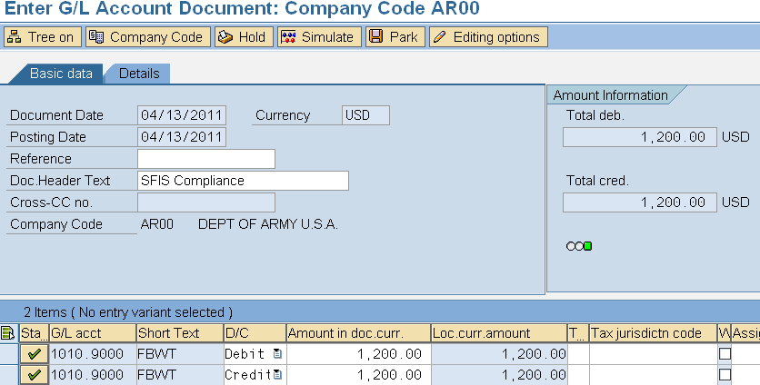
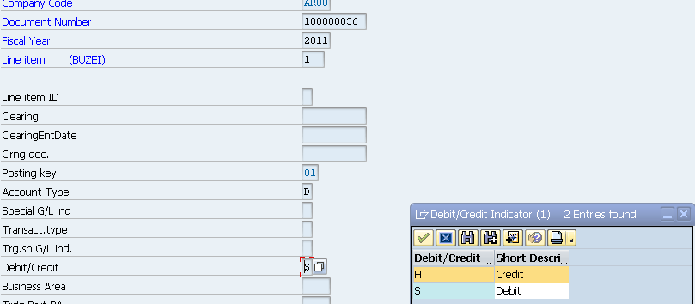

T4 - Begin/End Indicator
SFIS Element: | T4 - Begin/End Indicator | Length: | 1
SFIS Component: | Transactional Information
Description: | The Begin/End Indicator identifies a general ledger account balance as of the point in time that it represents. For instance, the balance of a general ledger account at the beginning of the reporting period, versus the balance at the end of the reporting period.
Example: | If a reported general ledger account balance represents the beginning balance, then the value will be "B".
Comment: | As is the case with the individual mandatory reports, within SAP, the begin/end indicator is specified on the report basis. The example provided in the screen shot is only used for the Total resources calculation done during the FACTS II edit check process.
Source: | http://fms.treas.gov/fastbook/

BUSINESS RULES
# | Business Rule
T4 | Each reported financial account balance must be associated with only one Begin/End Indicator.
T4 | Begin/End Indicator must be 1 alpha character. ex. B  Data values: B - Beginning Balance  E - Ending Balance
T4 | Begin/End Indicator must be used for financial reporting.
T4 | Derivation of the Begin/End Indicator based upon the status of the general ledger account balance with respect to the beginning or ending of the accounting period in the accounting system is an acceptable practice

DESIGN CONSIDERATIONS
Delivered Field | Derived Field | Characteristics
Delivered Field | Derived Field | FACTS I & II | Fund | Fund Center | Commitment Item | Functional Area | Funded Program | Application of Funds
X

PROCESS WALKTHRU
Module: | FM-Reporting
Navigation:
SAP Trans Code: | S_KI4_38000323
Form Field Name: | Accounting- Public Sector Management- Functions for the US Federal Government- Information System- Other- Trial Balance by Fund at SGL Account Level
Table Name: | FMUSFGT | Field Name:
Related Transactions: | None

Screenshot: Location of “Begin/End Indicator” Display Field on Trial Balance by Fund at SGL Account Level

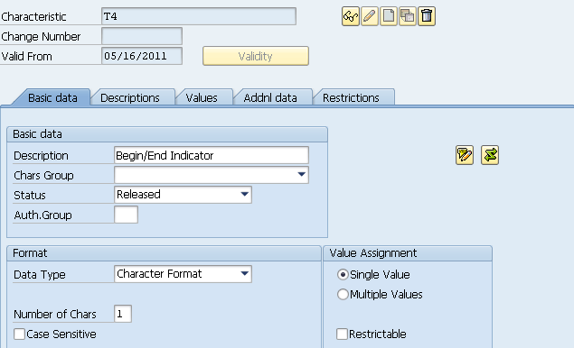
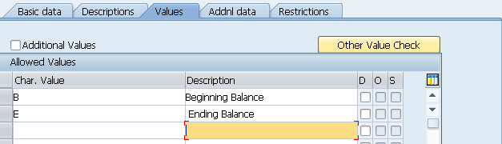

T5 - Transaction Effective Date
SFIS Element: | T5 - Transaction Effective Date | Length: | 8
SFIS Component: | Transactional Information
Description: | The effective date for a business event represented by a transaction type/transaction code. Although, this date frequently equals the Transaction Post Date, it is not always equal. As an example: an obligation that exists at the end of a reporting period is discovered just after the period ends. The obligation would be posted in the general ledger on a date after the end of the period; however, the transaction would be effective for a date prior to the period end, and would be included in the reports for that period.
Example: | If an obligation was authorized/executed on March 14, 2005 the appropriate value will be: "03142005", where 03 = Month, 14=Day, 2005 = Calendar Year
Comment: | None
Source: | http://fms.treas.gov/fastbook/

BUSINESS RULES
# | Business Rule
T5 | Transaction Effective Date must specify a Day, Month, and Year. ex. 03142005  Data values: There is no list of values applicable for this element.
T5 | Transaction Effective Date must be used for general ledger posting and financial reporting.
T5 | Each accounting system must store and maintain Transaction Effective Date values.

DESIGN CONSIDERATIONS
Delivered Field | Derived Field | Characteristics
Delivered Field | Derived Field | FACTS I & II | Fund | Fund Center | Commitment Item | Functional Area | Funded Program | Application of Funds
X

PROCESS WALKTHRU
Module: | General Ledger
Navigation: | Accounting- Financial Accounting- General Ledger- Posting- Enter G/L Account Document
SAP Trans Code: | FB50
Form Field Name:
Table Name: | ACGL_HEAD | Field Name: | BUDAT
Related Transactions: | FB01, FB02, FB03

Screenshot: Location of “Transaction Effective Date” Field on Enter GL Account Document

T6 - Transaction Post Date
SFIS Element: | T6 - Transaction Post Date | Length: | 8
SFIS Component: | Transactional Information
Description: | The Transaction Post Date is the date that an accounting transaction is actually posted to a general ledger. This date does not represent creation of a draft transaction that is merely saved, but not posted. It also does not indicate the period, or date, for which the transaction applies for reporting purposes, although these dates may be the same in some cases. As an example, an obligation that exists at the end of a reporting period is discovered just after the period ends. The obligation would be posted in the general ledger on a date after the end of the period; however, the transaction would be effective for a date prior to the period end, and would be included in the reports for that period.
Example: | A transaction record, such as recording a commitment, was posted in a general ledger system on May 14, 2005. The Transaction Post Date value would be: "05142005", where 05 = Month, 14=Day, 2005 = Calendar Year.
Comment: | None
Source: | http://fms.treas.gov/fastbook/

BUSINESS RULES
# | Business Rule
T6 | Transaction Post Date must specify a Day, Month, and Year. ex. 05142005  Data values: There is no list of values applicable for this element...
T6 | Transaction Post Date must be used for general ledger posting and financial reporting. .
T6 | Each accounting system must store and maintain Transaction Post Date values.

DESIGN CONSIDERATIONS
Delivered Field | Derived Field | Characteristics
Delivered Field | Derived Field | FACTS I & II | Fund | Fund Center | Commitment Item | Functional Area | Funded Program | Application of Funds
X

PROCESS WALKTHRU
Module: | General Ledger
Navigation: | Accounting- Financial Accounting- General Ledger- Posting- Enter G/L Account Document
SAP Trans Code: | FB50
Form Field Name:
Table Name: | ACGL_HEAD | Field Name: | BUDAT
Related Transactions: | FB01, FB02, FB03

Screenshot: Location of “Transaction Post Date” Field on Enter GL Account Document

T7 - Transaction Amount
SFIS Element: | T7 - Transaction Amount | Length: | 17
SFIS Component: | Transactional Information
Description: | The Transaction Amount is the signed value of an accounting general ledger transaction, expressed in U.S. dollars.
Example: | If a Transaction Amount is $53,000,000.00 then the value will be:  53,000,000.00
Comment: | None
Source: | http://fms.treas.gov/fastbook/

BUSINESS RULES
# | Business Rule
T7 | Transaction Amount may be up to 17 numeric characters in dollars and cents format separated by a decimal, for example “53000000.00”.  Data values: There is no list of values applicable for this element.
T7 | Transaction Amount must be used for general ledger posting, financial reporting, budgetary control, and funds control.
T7 | Each accounting system must store and maintain Transaction Amount values.

DESIGN CONSIDERATIONS
Delivered Field | Derived Field | Characteristics
Delivered Field | Derived Field | FACTS I & II | Fund | Fund Center | Commitment Item | Functional Area | Funded Program | Application of Funds
X |  | X

PROCESS WALKTHRU
Module: | General Ledger
Navigation: | Accounting- Financial Accounting- General Ledger- Posting- Enter G/L Account Document
SAP Trans Code: | FB50
Form Field Name:
Table Name: | ACGL_ITEM | Field Name: | WRBTR
Related Transactions: | FB01, FB02, FB03

Screenshot: Location of “Transaction Amount” Field on Enter GL Account Document 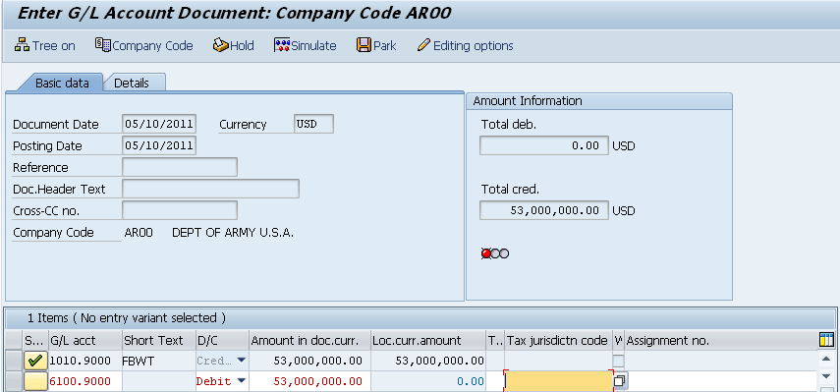

T9 - Exchange/Non-Exchange Indicator
SFIS Element: | T9 - Exchange/Non-Exchange Indicator | Length: | 1
SFIS Component: | Transactional Information
Description: | The Exchange/ Non-Exchange Indicator identifies those revenues that are, or are not, the result of the provision of a good or service. An example of exchange revenue is revenue that is received by a working capital fund for provision of depot services. An example of non-exchange revenue would be a grant.
Example: | If revenue is received by a working capital fund for provision of depot services then the Exchange/Non-Exchange Indicator value will be "X".
Comment: | None
Source: | http://fms.treas.gov/fastbook/

BUSINESS RULES
# | Business Rule
T9 | The Exchange/Non-Exchange Indicator must only be used, if recording revenue general ledger transactions.
T9 | Exchange/Non-Exchange Indicator must be 1 alpha character. ex. X  Data values: X - Exchange  T - Non-exchange
T9 | Exchange/Non-Exchange must be used for general ledger posting and financial reporting.
T9 | Each accounting system must store and maintain Exchange/Non-Exchange Indicator values.

DESIGN CONSIDERATIONS
Delivered Field | Derived Field | Characteristics
Delivered Field | Derived Field | FACTS I & II | Fund | Fund Center | Commitment Item | Functional Area | Funded Program | Application of Funds
X |  | X

PROCESS WALKTHRU
Module: | FM
Navigation:
SAP Trans Code: | FMUSFG1
Form Field Name:
Table Name: | TABADRSF | Field Name: | TARGET_FLD
Related Transactions:

Screenshot: Location of “Exchange/Non-Exchange Indicator” Display Field on FACTS I and FACTS II Derivation of Attributes

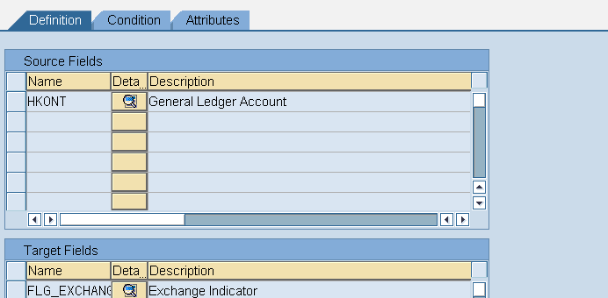
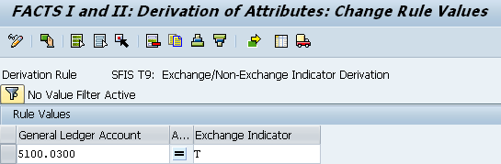

10 - Custodial/Non-Custodial Indicator
SFIS Element: | T10 - Custodial/Non-Custodial Indicator | Length: | 1
SFIS Component: | Transactional Information
Description: | Indicates whether the balance reported is custodial in nature (S) or noncustodial in nature (A), and is reported in a separate footnote of custodial activity. For example, revenue/receipts collected on behalf of another Agency represent custodial activity (S).
Example: | If the balance in a general ledger revenue account represents an amount that is custodial in nature and is reported in a separate footnote in the financial statements then the value for that account will be "S".
Comment: | None
Source: | http://fms.treas.gov/fastbook/

BUSINESS RULES
# | Business Rule
T10 | The Custodial/Non-Custodial Indicator must only be used when recording receivable, payable, revenue, and expense general ledger transactions.
T10 | Custodial/Non-Custodial Indicator must be 1 alpha character. ex. S  Data values: S - Custodial  A - Non-custodial
T10 | Custodial/Non-Custodial Indicator must be used for general ledger posting, and financial reporting.
T10 | Each accounting system must store and maintain Custodial/Non-Custodial Indicator values.

DESIGN CONSIDERATIONS
Delivered Field | Derived Field | Characteristics
Delivered Field | Derived Field | FACTS I & II | Fund | Fund Center | Commitment Item | Functional Area | Funded Program | Application of Funds
 | X | X

PROCESS WALKTHRU
Module: | FM
Navigation:
SAP Trans Code: | FMUSFG1
Form Field Name:
Table Name: | ABADRHELP | Field Name: | TARGET_FLD
Related Transactions:

Screenshot: Location of “Custodial/Non-Custodial Indicator” Display Field on Entry Document

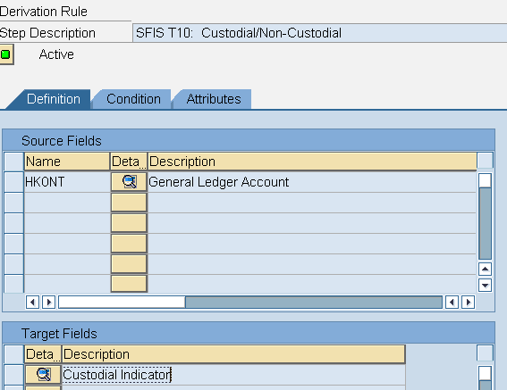
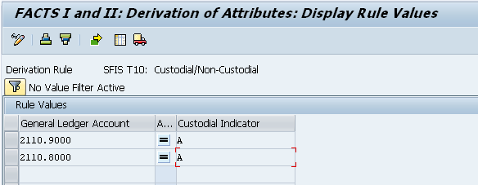

T11 - Foreign Currency Code
SFIS Element: | T11: Foreign Currency Code | Length: | 3AN
SFIS Component: | Transactional Information
Description: | The Foreign Currency Code is the primary code used to separately identify the foreign currency in which accounts payable will be disbursed when that disbursement will not be paid in U. S. dollars.
Example: | Sample Foreign Currency Codes (Per ISO Standard):  Code: Country-Currency (Alpha Designator)  971 Afghanistan (AFN)  036 Australian Dollar (AUD)  156 China (CNY)  978 France (EUR)  566 Nigeria (NGN)
Comment: | None
Source: | http://fms.treas.gov/fastbook/

BUSINESS RULES
# | Business Rule
T11 | Foreign Currency Code must be used when processing a disbursement or collection in other than US Dollars. ISO standard 4217 will be used to represent foreign currency code.
T11 | Foreign Currency Code must be 3 alpha-numeric characters. ex. 250  Authoritative source: http://www.currency-iso.org/iso_index/iso_tables/iso_tables_a1.htm
T11 | Foreign Currency Code must be used for financial reporting and budgetary control.
T11 | Each accounting system must store and maintain Foreign Currency Code values.

DESIGN CONSIDERATIONS
Delivered Field | Derived Field | Characteristics
Delivered Field | Derived Field | FACTS I & II | Fund | Fund Center | Commitment Item | Functional Area | Funded Program | Application of Funds
X |  | X

PROCESS WALKTHRU
Module: | General Ledger
Navigation: | Accounting-Financial Accounting-General Ledger- Posting- Enter G/L Account Document
SAP Trans Code: | FB50
Form Field Name:
Table Name: | BKPF | Field Name: | WAERS
Related Transactions: | FB01, FB02, FB03

Screenshot: Location of “Foreign Currency Code” Field on Enter GL Document

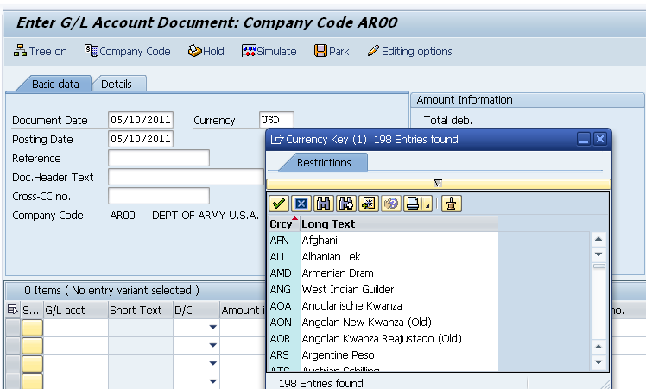

T12 - Country Code
SFIS Element: | T12 - Country Code | Length: | 6AN
SFIS Component: | Transactional Information
Description: | A code representing Countries, Dependencies, Areas of Special Sovereignty, and their Principal Administrative Divisions. Codes include former countries which have been divided or merged.
Example: | Code: Name:  CYM Cayman Islands  CAN Canada  CRI Costa Rica  IRQ Iraq  AFG Afghanistan
Comment: | None
Source: | http://fms.treas.gov/fastbook/

BUSINESS RULES
# | Business Rule
T12 | ISO 3166-1 contains a two-letter code which may be used as the general purpose code.
T12 | If script independence of Country Code is important, then ISO 3166-1 may be used which contains an alpha-3 country code having better mnemonic properties and a numeric-3 country code.
T12 | If an organization does business directly with administrative divisions of a country, then ISO 3166-2 codes may be used which consist of two parts separated by a hyphen; the first part is the ISO 3166-1 alpha-2 code element; the second part, based on national standards, is a maximum of three alpha or numeric characters.
T12 | Country Code must be a maximum of 5 alpha-numeric characters. ex. CA
T12 | Country Code must be used for financial reporting.
T12 | Each accounting system must store and maintain Country Code values.

DESIGN CONSIDERATIONS
Delivered Field | Derived Field | Characteristics
Delivered Field | Derived Field | FACTS I & II | Fund | Fund Center | Commitment Item | Functional Area | Funded Program | Application of Funds
X |  | X

PROCESS WALKTHRU
Module: | General Ledger
Navigation: | Accounting-Financial Accounting-Accounts Payables-Document Entry - Invoice
SAP Trans Code: | FB60 & Fk03
Form Field Name:
Table Name: | ADDR1_DATA | Field Name: | COUNTRY
Related Transactions: | FB01, FB02, FB03, FK01, FK02

Screenshot: Location of “Country Code” Field on Enter GL Document

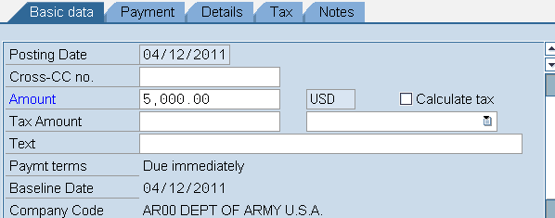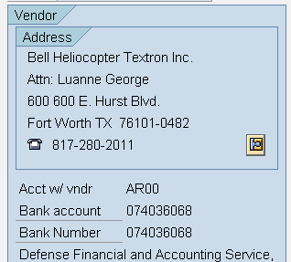
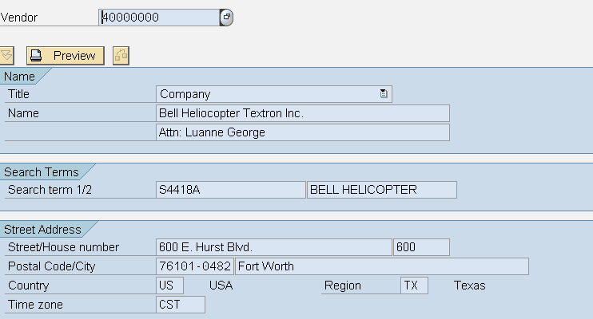

T13 - Entity/Non-Entity Indicator
SFIS Element: | T13 - Entity/Non-Entity Indicator | Length: | 1
SFIS Component: | Transactional Information
Description: | The Entity/ Non-Entity Indicator identifies assets as either those that the reporting entity has authority to use in its operations (Entity Assets), or held by an entity but are not available to the entity to use in its operations (Non-Entity Assets). The authority to use funds in an entity's operations means that entity's management has the authority to decide how funds are used, or management is legally obligated to use funds to meet entity obligations, e.g., repay loans from Treasury. An example of non-entity assets is income tax receivables, which the Internal Revenue Service collects for the U.S. Government but has no authority to spend.
Example: | If DoD does not have the authority to use an asset, such as cash or a building, in its operations then the Entity/Non-Entity Indicator value will be "O".
Comment: | None
Source: | http://fms.treas.gov/fastbook/

BUSINESS RULES
# | Business Rule
T13 | The Entity/Non-Entity Indicator must only be used when recording assets postings.
T13 | Entity/Non-Entity Indicator must be 1 alpha character. ex. E  Authoritative source: http://fms.treas.gov/ussgl/selection_page.html  Data values: E - Entity  O - Non-Entity
T13 | Entity/Non-Entity Indicator must be used for financial reporting.
T13 | Each accounting system must store and maintain Entity/Non-Entity Indicator values.

DESIGN CONSIDERATIONS
Delivered Field | Derived Field | Characteristics
Delivered Field | Derived Field | FACTS I & II | Fund | Fund Center | Commitment Item | Functional Area | Funded Program | Application of Funds
 |  | X

PROCESS WALKTHRU
Module: | FM
Navigation:
SAP Trans Code: | FMUSFG1
Form Field Name:
Table Name: | ABADRHELP | Field Name: | FLG_ENTITY
Related Transactions:

Screenshot: Location of “Entity/Non-Entity Indicator” Display Field on FACTS1 and II Derivation

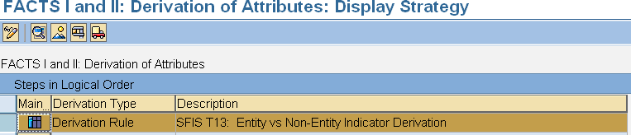
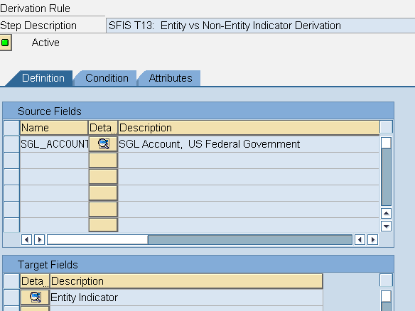
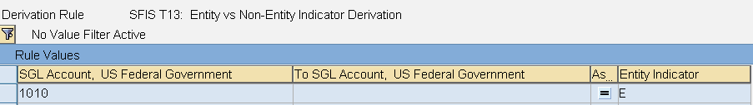

T14 - Covered/Uncovered Indicator
SFIS Element: | T14 - Covered/Uncovered Indicator | Length: | 1
SFIS Component: | Transactional Information
Description: | Covered (C) liabilities are those covered by budgetary resources. Uncovered (U) Liabilities are those not covered by budgetary resources. As an example, there will generally be congressionally approved budget resource earmarked for liquidation of the current portion of environmental liabilities. This is an example of a covered liability. On the other hand, there will generally not be budgetary resources in place for the liquidation of the long-term portion of environmental liabilities (resources will be allocated as the liability becomes more immediate). The latter is an example of an uncovered liability.
Example: | If budgetary resources have not been earmarked to liquidate a long-term liability, such as the non-current portion of an environmental liability, then the liability is considered uncovered and will use the value "U".
Comment: | None
Source: | http://fms.treas.gov/fastbook/

BUSINESS RULES
# | Business Rule
T14 | If a liability is not supported by an appropriation as of the fiscal year end, then it must be classified as uncovered, else classify as covered.
T14 | Covered/Uncovered Indicator must be 1 alpha character. ex. C  Authoritative source: http://fms.treas.gov/ussgl/selection_page.html  Data values: C - Covered  U - Uncovered
T14 | Covered/Uncovered Indicator must be used for financial reporting.
T14 | Each accounting system must store and maintain Covered/Uncovered Indicator values.

DESIGN CONSIDERATIONS
Delivered Field | Derived Field | Characteristics
Delivered Field | Derived Field | FACTS I & II | Fund | Fund Center | Commitment Item | Functional Area | Funded Program | Application of Funds
 | X

PROCESS WALKTHRU
Module: | FM
Navigation:
SAP Trans Code: | FMUSFG1
Form Field Name:
Table Name: | ABADRHELP | Field Name: | FLG_ENTITY
Related Transactions:

Screenshot: Location of “Covered/Uncovered Indicator” Display Field on FACTS I and II Derivation

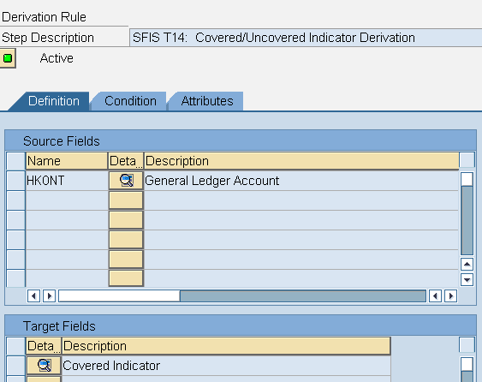
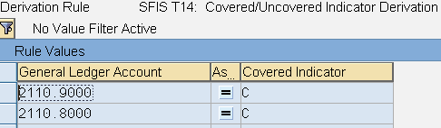

T15 - Current/Non-current Indicator
SFIS Element: | T15 - Current/Non-current Indicator | Length: | 1
SFIS Component: | Transactional Information
Description: | Current/ Non-Current indicates those liabilities that will be liquidated with current resources. For instance, liabilities that are expected to become due and payable within a year are generally considered to be a current liability.
Example: | If a liability will be liquidated within the next 12 months from the end of the reporting date, then it is considered a current liability and will use the value "C."
Comment: | None
Source: | http://fms.treas.gov/fastbook/

BUSINESS RULES
# | Business Rule
T15 | If a liability is to be liquidated within 12 months from the time of reporting, then the value must be “C”, else the value will be “N”.
T15 | Current/Non-Current Indicator must be 1 alpha character. ex. C  Authoritative source: http://www.whitehouse.gov/omb/circulars_index-ffm/  Data values: C - Current  N - Non-current
T15 | Current/Non-Current Indicator must be used for financial reporting.
T15 | Each accounting system must store and maintain Current/Non-Current Indicator values.

DESIGN CONSIDERATIONS
Delivered Field | Derived Field | Characteristics
Delivered Field | Derived Field | FACTS I & II | Fund | Fund Center | Commitment Item | Functional Area | Funded Program | Application of Funds
 |  | X

PROCESS WALKTHRU
Module: | FM
Navigation:
SAP Trans Code: | FMUSFG1
Form Field Name:
Table Name: | ABADRHELP | Field Name: | FLG_ENTITY
Related Transactions:

Screenshot: Location of “Current / Non-Current Indicator” Display Field on FACTS I and II Derivation

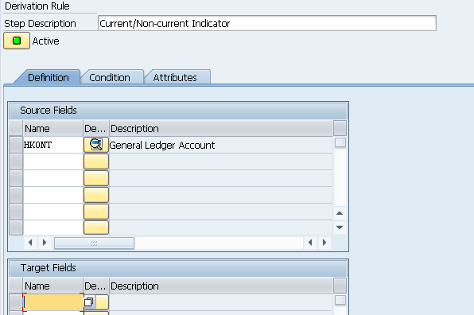

T20 - Business Event Type Code
SFIS Element: | T20 - Business Event Type Code (BETC) | Length: | 8
SFIS Component: | Transactional Information
Description: | Indicates the type of financial activity, such as payments, collections, borrowings, etc., being reported in the Government wide Accounting and Reporting (GWA) system. BETC in effect replaces the Treasury's transaction codes and standard sub-classes that are currently used on central accounting reports. New U.S. Treasury requirement effective 08/01/2006 per TFM Bulletin No. 2006-04, Volume I.
Example: | Examples of Business Event Type Codes are as follows:  BETC Value Business Event  COLL Offsetting Collection  UNRLDISC Unrealized Discount  DISB Gross Disbursement
Comment: | None
Source: | http://fms.treas.gov/fastbook/

BUSINESS RULES
# | Business Rule
T20 | Business Event Type Code (BETC) must be no more than 8 alpha characters. ex. COLL  Authoritative source: http://fms.treas.gov/gwa/factsheet_betc.html
T20 | Each system must store and maintain Business Event Type Code (BETC) values.
T20 | Business Event Type Code (BETC) must be used for general ledger posting, and financial reporting.

DESIGN CONSIDERATIONS
Delivered Field | Derived Field | Characteristics
Delivered Field | Derived Field | FACTS I & II | Fund | Fund Center | Commitment Item | Functional Area | Funded Program | Application of Funds
X

PROCESS WALKTHRU
Module: | FM
Navigation: | Accounting - Public Sector Management - Functions for the US Federal Government- Payment Processing – IPAC - Outgoing Payments and Collections - Upload File Creation
SAP Trans Code: | FMFG_IPAC
Form Field Name:
Table Name: | BSEG | Field Name: | KIDNO
Related Transactions:

This element is being added to the standard SAP software and will be available for backport, when it becomes available.

T21 - FMS Customer Code
SFIS Element: | T21 - FMS Customer Code | Length: | 2AN
SFIS Component: | Transactional Information
Description: | FMS Customer represents the country receiving the product and/or service in the FMS transaction.
Example: | Code Customer  S3 SLOVENIA  EI IRELAND  UK UNITED KINGDOM
Comment: | None
Source: | http://fms.treas.gov/fastbook/

BUSINESS RULES
# | Business Rule
T21 | Foreign Military Sales (FMS) Customer Code must be 2 alpha-numeric characters. ex. EI  Authoritative source: http://www.dsca.mil/samm/
T21 | Foreign Military Sales (FMS) Customer Code must be used for financial reporting, budgetary control, and funds control.
T21 | If the system executes Foreign Military Sales (FMS) transactions, then each system must store and maintain FMS Customer Code values.

DESIGN CONSIDERATIONS
Delivered Field | Derived Field | Characteristics
Delivered Field | Derived Field | FACTS I & II | Fund | Fund Center | Commitment Item | Functional Area | Funded Program | Application of Funds
 | X | X |  |  |  | X

PROCESS WALKTHRU
Module: | FM
Navigation:
SAP Trans Code: | CT04
Form Field Name:
Table Name: | CAWN | Field Name: | ATWRT
Related Transactions: | CT10

Screenshot: Location of “FMS Customer Code” Display Field on Characteristics

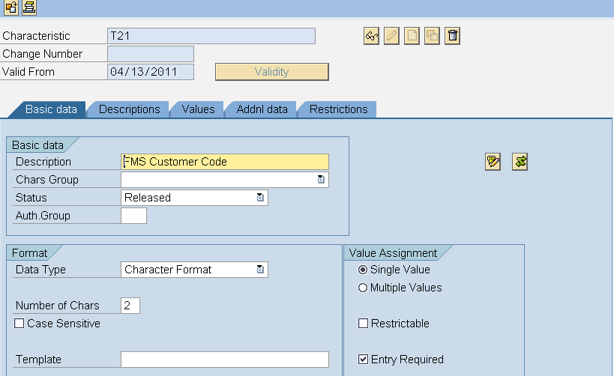
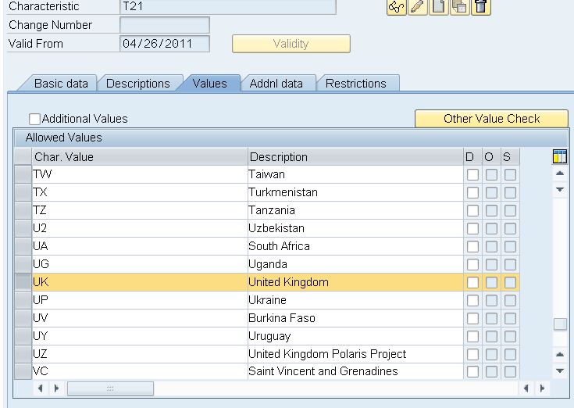

T22 - FMS Case Identifier
SFIS Element: | T22: FMS Case Identifier | Length: | 3AN
SFIS Component: | Transactional Information
Description: | FMS Case is used to reflect an FMS contractual sales agreement (Letter of Offer and Acceptance) between the U.S. and an eligible foreign country.
Example: | None
Comment: | None
Source: | http://fms.treas.gov/fastbook/

BUSINESS RULES
# | Business Rule
T22 | Foreign Military Sales (FMS) Case Identifier must be 3 alpha-numeric characters.  Authoritative source: http://www.dod.mil/comptroller/fmr/15/15_02.pdf
T22 | Foreign Military Sales (FMS) Case Identifier must be used for financial reporting, budgetary control, and funds control.
T22 | If the system executes Foreign Military Sales (FMS) transactions, then each system must store and maintain FMS Case Identifier values.
T22 | Each Foreign Military Sales (FMS) Case Identifier must have at least one Foreign Military Sales (FMS) Customer.
T22 | Each Foreign Military Sales (FMS) Case Identifier must have at least one Foreign Military Sales (FMS) Case Line Item Identifier.

DESIGN CONSIDERATIONS
Delivered Field | Derived Field | Characteristics
Delivered Field | Derived Field | FACTS I & II | Fund | Fund Center | Commitment Item | Functional Area | Funded Program | Application of Funds
 | X | X

PROCESS WALKTHRU
Module: | FM
Navigation: | Cross-Application Components - Classification System - Master Data -  Characteristics
SAP Trans Code: | CT04
Form Field Name:
Table Name: | CAWN | Field Name: | ATWRT
Related Transactions: | FM_FUNCTION, CT10

Screenshot: Location of “FMS Case Identifier” Display Field on Characteristics

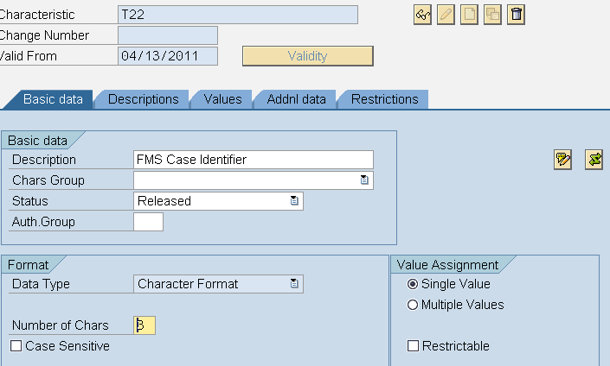
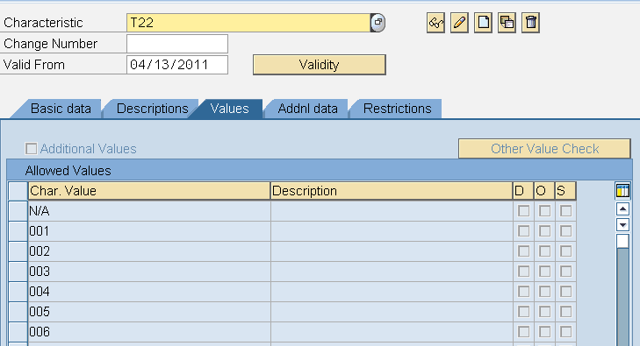

T23 - FMS Case Line Item Identifier
SFIS Element: | T23 - FMS Case Line Item Identifier | Length: | 3AN
SFIS Component: | Transactional Information
Description: | The FMS Line is used to identify a detailed line item requirement contained within the (Letter of Offer and Acceptance).
Example: | None
Comment: | None
Source: | http://fms.treas.gov/fastbook/

BUSINESS RULES
# | Business Rule
T23 | Foreign Military Sales (FMS) Case Line Item Identifier must be 3 alpha-numeric characters.  Authoritative source: http://www.dod.mil/comptroller/fmr/15/15_02.pdf
T23 | Foreign Military Sales (FMS) Case Line Item Identifier must be used for financial reporting, budgetary control, and funds control.
T23 | If the system executes Foreign Military Sales (FMS) transactions, then each system must store and maintain FMS Case Line Item Identifier values.
T23 | Foreign Military Sales (FMS) Case Line Item Identifier must be associated with only one FMS Case Identifier.

DESIGN CONSIDERATIONS
Delivered Field | Derived Field | Characteristics
Delivered Field | Derived Field | FACTS I & II | Fund | Fund Center | Commitment Item | Functional Area | Funded Program | Application of Funds
 | X | X

PROCESS WALKTHRU
Module: | FM
Navigation: | Cross-Application Components - Classification System - Master Data -  Characteristics
SAP Trans Code: | CT04
Form Field Name:
Table Name: | CAWN | Field Name: | ATWRT
Related Transactions: | FM_FUNCTION

Screenshot: Location of “FMS Case Line Item Identifier” Display Field on Characteristics

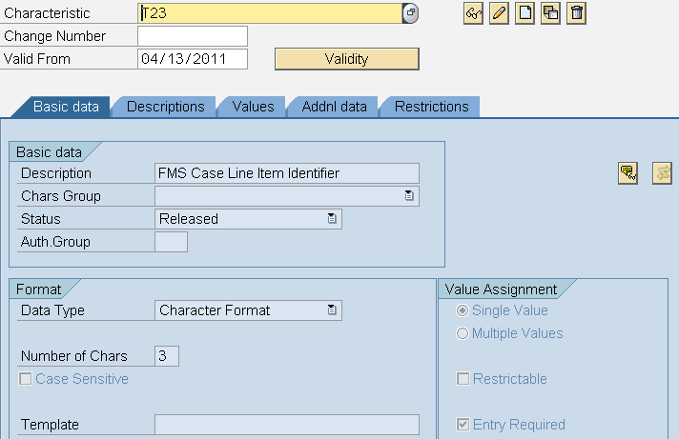
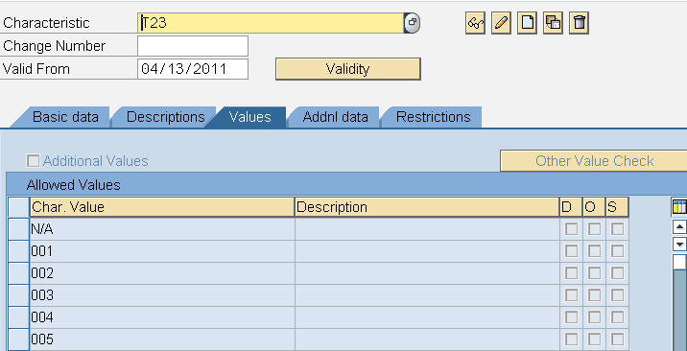

TP1 - Federal/Non-Federal Indicator
SFIS Element: | TP1 - FMS Case Line Item Identifier | Length: | 1
SFIS Component: | Trading Partner Information
Description: | Indicates the type of entity involved in transactions with the reporting entity (that is, other Federal entities (F) or Non Federal entities such as private or local/state/tribal/foreign governments (N)). For FACTS I reporting, "F" equates to Federal and "N" equates to Non-Federal. For FACTS II reporting, "F" equates to Federal, "N" equates to Non-Federal, and "E" equates to Non-Federal Exception.
Example: | If the Navy records revenue for services performed for the Department of State, then the Navy would use the Federal/Non-Federal Indicator value of "F" for the transaction.  If a State or local government has a statute or another legal requirement prohibiting advancing funds for reimbursable work.
Comment: | None
Source: | http://fms.treas.gov/fastbook/

BUSINESS RULES
# | Business Rule
TP1 | If the Trading Partner Number has a value, Federal/Non-Federal Indicator Code value must be “F”.
TP1 | Federal/Non-Federal Indicator must be 1 alpha character. ex. F  Data values: F - Federal  N - Nonfederal  E - Non-Federal Exception
TP1 | Federal/Non-Federal Indicator must be used for general ledger posting and financial reporting.
TP1 | Each accounting system must store and maintain Federal/Non-Federal Indicator values.

DESIGN CONSIDERATIONS
Delivered Field | Derived Field | Characteristics
Delivered Field | Derived Field | FACTS I & II | Fund | Fund Center | Commitment Item | Functional Area | Funded Program | Application of Funds
 | X | X

PROCESS WALKTHRU
Module: | FM
Navigation:
SAP Trans Code: | FMUSFG1
Form Field Name:
Table Name: | IUSFGFDERIVE | Field Name: | FLG_FEDERAL
Related Transactions: | FM_FUNCTION

Screenshot: Location of “Federal / Non-Federal Indicator” Display Field on Characteristics

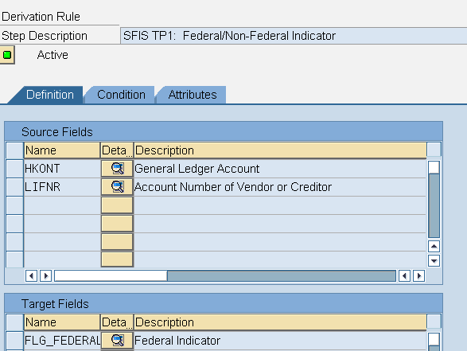
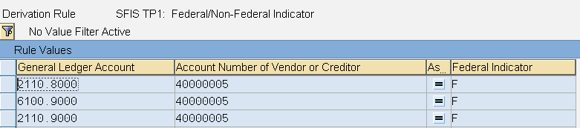

TP2 - Trading Partner Indicator Code
SFIS Element: | TP2 - Trading Partner Indicator Code | Length: | 3
SFIS Component: | Trading Partner Information
Description: | The Trading Partner Indicator represents the Department Regular Code of the other Federal entity involved in transactions with the reporting entity. Used in conjunction with the Federal/Nonfederal attribute of "F". For example, the Department of the Navy records revenue for services performed for Department of State. For the Navy revenue transaction, the Department of State will be considered a trading partner, and its Department Regular Code will be used as the Trading Partner Indicator.
Example: | Examples of Federal (F) Trading Partner Indicators Using the Department Regular Code of the Agency:  013 -Department of Commerce  017- Department of the Navy  011-Executive Office of the President  019-Department of State
Comment: | None
Source: | http://fms.treas.gov/fastbook/

BUSINESS RULES
# | Business Rule
TP2 | A Trading Partner Indicator Code value is required, whenever the trading partner is a federal entity.
TP2 | Trading Partner Indicator Code must be 3 numeric characters. ex. 017  (Note: Programs may use the two character code and derive the three character version - with a leading zero - at time of reporting if the software system in use has not yet been updated).  Authoritative source: http://fms.treas.gov/fastbook/
TP2 | Trading Partner Indicator Code must be used for general ledger posting and financial reporting.
TP2 | Each accounting system must store and maintain Trading Partner Indicator Code values.

DESIGN CONSIDERATIONS
Delivered Field | Derived Field | Characteristics
Delivered Field | Derived Field | FACTS I & II | Fund | Fund Center | Commitment Item | Functional Area | Funded Program | Application of Funds
 | X | X

PROCESS WALKTHRU
Module: | FM
Navigation:
SAP Trans Code: | FMUSFG1
Form Field Name:
Table Name: | IUSFGFDERIVE | Field Name: | FLG_FEDERAL
Related Transactions: | FM_FUNCTION

Screenshot: Location of “Trading Partner Indicator Code” Display Field on Characteristics

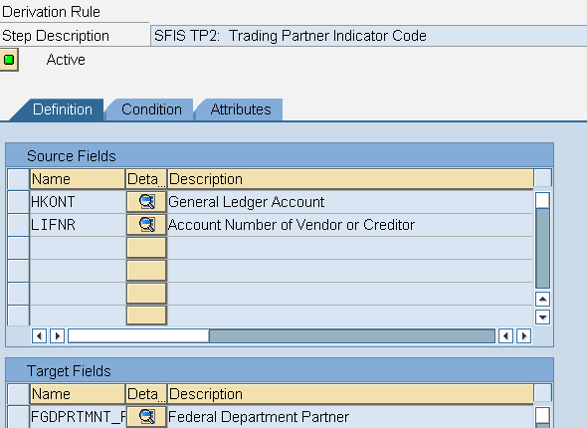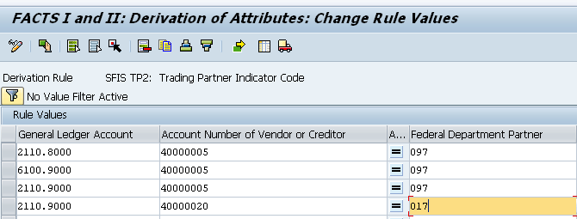

TP3 - Business Partner Number
SFIS Element: | TP3 - Business Partner Number | Length: | 9AN
SFIS Component: | Trading Partner Information
Description: | The Business Partner Network number is a unique, 9-character alpha-numeric identifier. It is primarily used to identify buying or selling entities processing intra-governmental transactions. The Federal Agency Registration (Fed Reg) site is the registration point and authoritative source for BPN numbers and associated registration data. Federal civilian agencies have obtained Data Universal Numbering System (DUNS) numbers from Dun and Bradstreet for use as Business Partner Number (BPN) numbers. DoD uses an equivalent BPN, which consists of the letters “DOD” and the 6-character Department of Defense Activity Address Code (DoDAAC). Both the DUNS and TPN are considered BPN numbers as they meet Fed Reg requirements and are unique identifiers.
Example: | Sample DOD Business Partner Numbers (DOD+DODAAC No.):  "DODF28500 - HQ AFCEE/ERB"  "DODHC1016- Defense Information Systems Agency"  "DODN31698 - Office of the Secretary of the Navy"  Sample Business Partner Numbers Outside of DoD  "DUNS No. (9 Digits)" + 4 Digits (to designate a location or unit within the organization identified by the DUNS No.)
Comment: | None
Source: | http://fms.treas.gov/fastbook/

BUSINESS RULES
# | Business Rule
TP3 | BPN Number from the Business Partner Network must be used in conjunction with Department Regular Code, Main Account Code and Sub-Account Code for eliminations.
TP3 | The Business Partner Network (BPN) Number for each Federal civilian agency, or Non-government entity, must be the nine digit Data Universal Numbering System (DUNS).
TP3 | The Business Partner Network (BPN) Number for DoD must be DoD plus the six characters DoD Activity Address Code (DoDAAC).
TP3 | System must ensure that all Intra-government Transactions contain a BPN Number.
TP3 | Business Partner Number must be 9 alpha-numeric characters. ex. DoDN31698  Authoritative source: http://www.bpn.gov/
TP3 | Business Partner Number must be used for general ledger posting and financial reporting for any transaction involving a Federal Government/Non-Federal Exception vendor or customer.
TP3 | Each accounting system must store and maintain Business Partner Number values.
TP3 | The system may derive the proper BPN value off of the DoDAAC when communicating outside the system by appending the characters “DOD” to the DoDAAC.

DESIGN CONSIDERATIONS
Delivered Field | Derived Field | Characteristics
Delivered Field | Derived Field | FACTS I & II | Fund | Fund Center | Commitment Item | Functional Area | Funded Program | Application of Funds
 | X | X

PROCESS WALKTHRU
Module: | AP
Navigation: | Accounting - Financial Accounting - Accounts Payable- Master Records-Display
SAP Trans Code: | XK03
Form Field Name:
Table Name: | RF02K | Field Name: | LIFNR
Related Transactions: | XK01, XK02, FK01, FK02, FK03

Screenshot: Location of “Business Partner Number” Display Field on Vendor Master

