How to change in tally.ERP9 last year closing balance current year opening balance
Option -1
First Open your company in tally Gateway of Tally Screen then change the Period (ex. To 1.04.2012 from 31.03.2013).
Option-2
Split Your company in tally First Open your company Gateway of tally Screen Press Alt+F3—Split Company Data—Select your company-Split from (Ex.1.04.2012) Then Opening new company open in tally.
Option-3
Export Import Option in tally First Open Your company Gateway of Tally Press Display––list of Accounts–– Press ALT+E
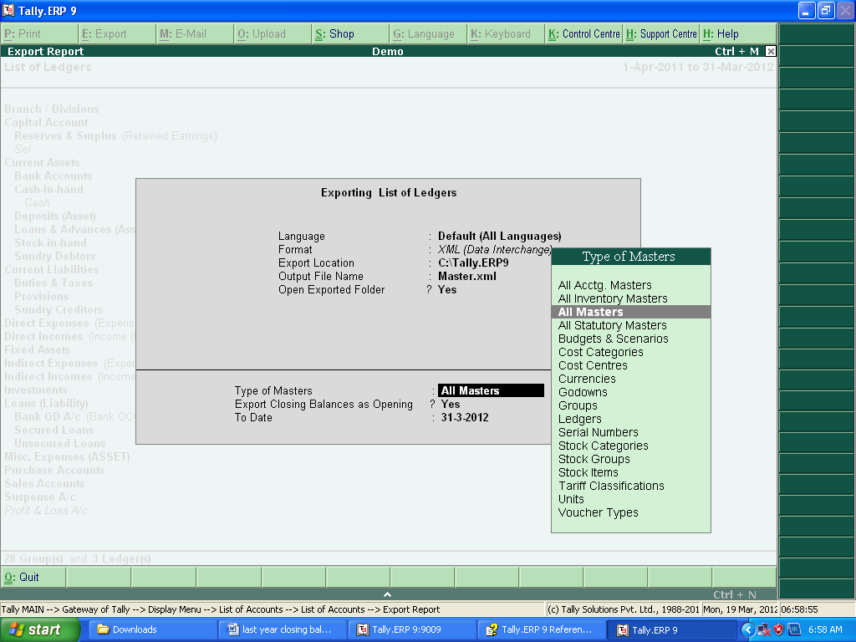
Export the file.
Create Newly Company Current Financial year Gateway of Tally Press Import of Data—Master
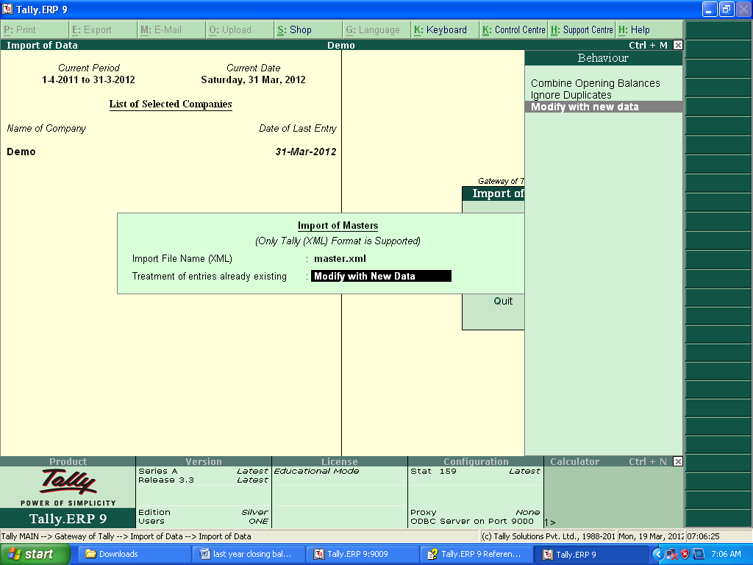
Import of Master Then Over.

DELTA SYSTEMS-Chennai
(Tally Sales, Support & Training)
Selvakumaran-G
Cell no.9176588818/9176289674.
Mail id: delsys05@gmail.com

