IFRS 11 – Changes to Joint Venture Accounting – Impact on Oil and Gas Companies

Introduction:-

The Financial Statements of many Oil and Gas companies could look very different in the near future as a result of the changes to the accounting for Joint Agreements (formerly Joint Ventures). This could affect key performance measures and ratios for companies in the Oil & Gas sector, which raises the question of how such changes should be communicated to investors and other key stakeholders.
IFRS 11:-
IFRS 11 provides investors with greater clarity about an entity’s involvement in joint arrangements by requiring entities to recognize the contractual rights and obligations arising from their joint arrangements. Parties to a joint arrangements should recognize on the balance sheet their rights and obligations arising from the arrangement as assets and liabilities.

Check List to find Joint Agreement:-

Is it Joint Arrangement?

Does the contractual Arrangement give all the parties (or group of the parties) control of the joint arrangement collective > If yes it is Joint Agreement

Does the decision about the relevant activities require the unanimous consent of all the parties that collectively control the arrangements? > If yes it is Joint Agreement

New Terms New concept:-

- In the Oil and Gas sector it would refer to as Joint Ventures are now collectively referred to as “Joint Arrangements”
- The Term “Proportionate Consolidation” has been used widely the US issuers’ books of accounting where an entity recognizes its share of the assets and liabilities of the Joint Venture.
- IFRS 11 requires that certain joint arrangements be equity accounted while for others, the investor’s interest in the individual assets, liabilities, revenues and expenses will be recognized.

New rules for accounting for Joint Agreements differ from existing requirements?

IFRS 11 Joint Arrangements was issued to replace IAS 31 Interests in Joint Ventures. To simplify IFRS 11 does two key things:

- First, it changes the classification of IAS 31 jointly controlled entities if separation between the arrangement and the party is deemed ineffective. These arrangements are treated similarly to jointly controlled assets / operations under IAS 31 and are now called Joint operations.
- Second, the free choice of using the equity method or proportionate consolidation to account for the remainder of IAS 31 jointly controlled entities, now called Joint ventures is eliminated. So Joint Ventures must now always use the equity method.

New Definition of Joint Control under IFRS
IFRS 11 describes the key aspects of joint control as follows:
- Contractually Agreed – Contractual agreements are usually, but not always, written, and set out the terms of the arrangements.
- Control and relevant activities – IFRS 10 describes how to assess whether a party has control, and how to identify the relevant activities.
- Unanimous consent – Exists when the parties to an arrangement have collective control over the arrangement, but no single party has control.

How are interests in Joint Arrangements accounted for ?

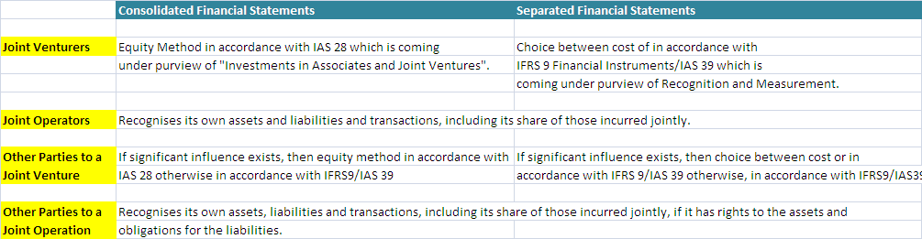

Difference between Joint Ventures and Joint Operations:-

IAS 31 – Joint Ventures
IFRS 11 – Joint Arrangements

Joint Operations Vs Joint Ventures:-
JCA’s and JCO’s:
- These are now called “Joint Operations” under IFRS 11.
- The accounting for these arrangements will generally be the same as under IAS 31.
- The Joint Operator defined as the party having joint control of a joint operation and not be confused with the operator of the joint arrangement continues to recognize its Assets and Liabilities, revenues and expenses and/or its relative shares thereof.
JCE’s:
- JCE’s rights to assets and obligations for liabilities also possible under current JCE’s may be classified as joint operations under IFRS 11. Regardless of legal structure, where the party has rights to the assets and obligations for the liabilities for the underlying joint agreement, it will be classified and accounted for as a joint operation, and accounted for as above.

Proportionate Consolidation Vs IFRS 11 – JCA / JCO accounting:-
Proportionate consolidation is used under US GAAP. Under this proportionate consolidation is used to describe a method of accounting that would be the equivalent to IFRS’s JCA/JCO accounting.
To illustrate this we have assume the below example of few transactions and how it got accounted in the books.
- Where a joint operator has rights to a specified percentage of all assets for example 50% and obligations for the same specified percentage of all liabilities. So there shouldn’t be any difference between the accounting for a joint operation and proportionate consolidation.

- However, where the joint operator has rights to a specified percentage of certain assets and differing rights to other assets, and/or different obligations for various liabilities, the financial statements would look different when accounting for those individual rights and obligations, as compared with proportionately consolidating the same percentage of all assets and liabilities.

50% / 50% Joint Agreement

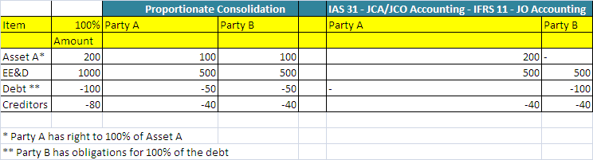

Conclusion:
The rights and obligations provided to a party under these contractual agreements will drive the accounting. Therefore, an entity will have to ensure it has a detailed understanding of the specific rights and obligations of its arrangements to be able to determine the impact of these new standards.

