PAYROLL SET UP WITH TALLY
Before start payroll set up in Tally you have to set up for company features by using F11 key. Cost Profit Center Management
Maintain Payroll (YES)
More than ONE Payroll (YES)

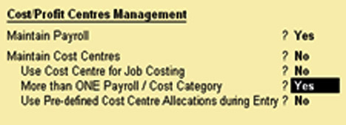

The four steps include:
1. Creating Pay heads
2. Creating Employee Master
3. Creating Salary details
4. Process payroll and generating Payslips.

- Pay Heads can be as follows
- Earning for Employees (Indirect Expenses).
- Deductions from Employees (Current Liabilities)
- Gratuity (Current Liabilities)
- Loans & Advances (Current Assets)
- Reimbursement Employee (Indirect Expenses).

1. Create Pay Heads
- Go to Gateway of Tally Select the Payroll Info.
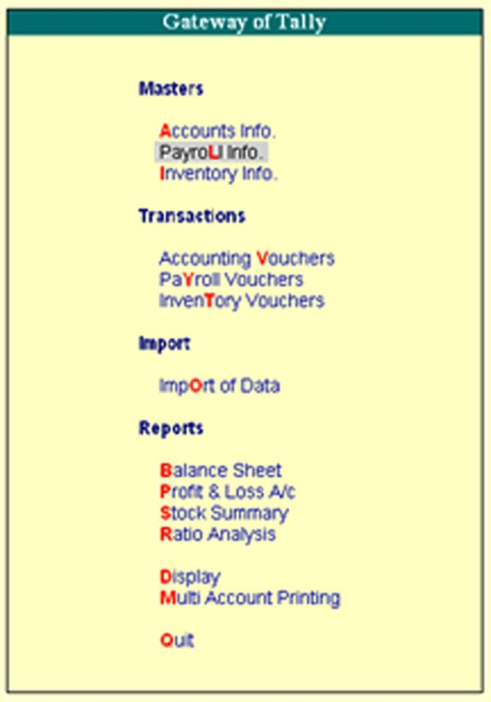

- Select Pay Heads.
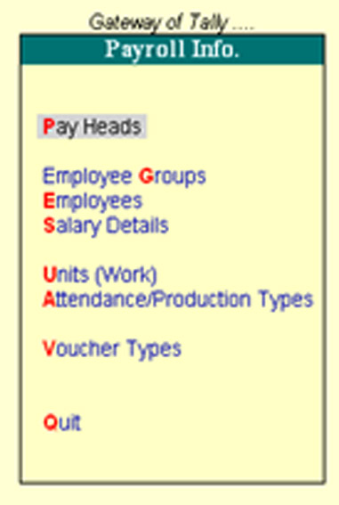

- Select Create.
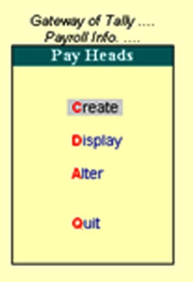
- In the Name Column type Basic Salary or other allowances.
- Pay head Type (Earnings for Employee)
- Select under Indirect Expenses.
- Select (YES) for Affect Net Salary
- Select Basics Salary or other allowances for appear in pay slip.
- If you want to use Gratuity YES/NO.
- Calculation typed Select As user Defined Value and save the all settings.
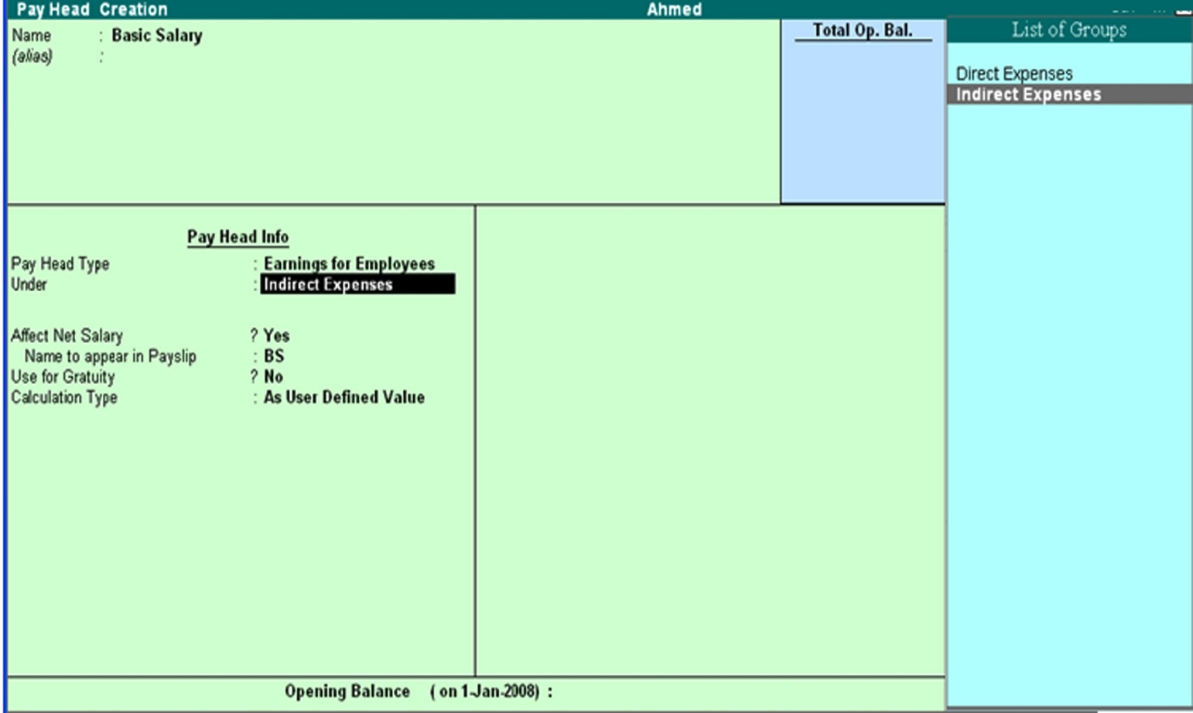

- Create Employee Master

- Go to get way of Tally and Select the payroll Info.
- Select Employee Group.

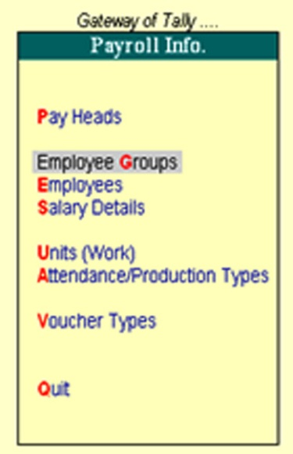

- Select Create (Single Group).
- In Category Select Primary cost category.
- In name select employee name or Primary and save.
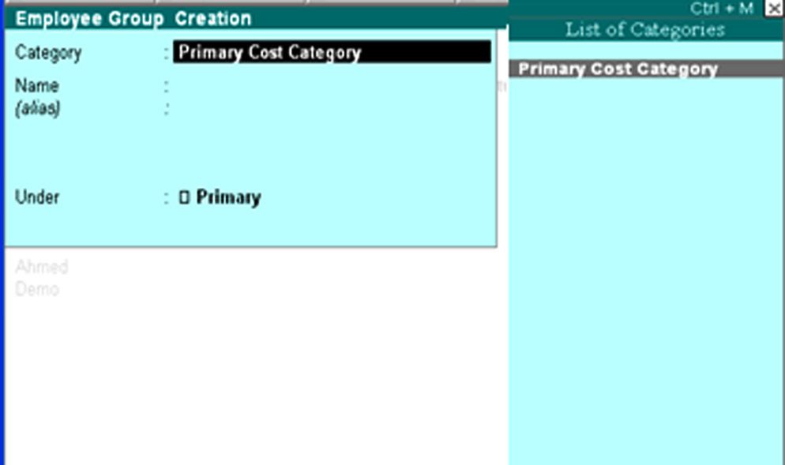

A. Create an Employee under Employee Group

- Go to get way of Tally and Select the payroll Info.
- Select the Employees.
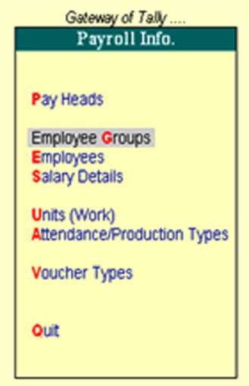
- Select the Create (Single Employees).
- Create the Employee Name.
- Select the group or Primary in under and give details of Employee and save.
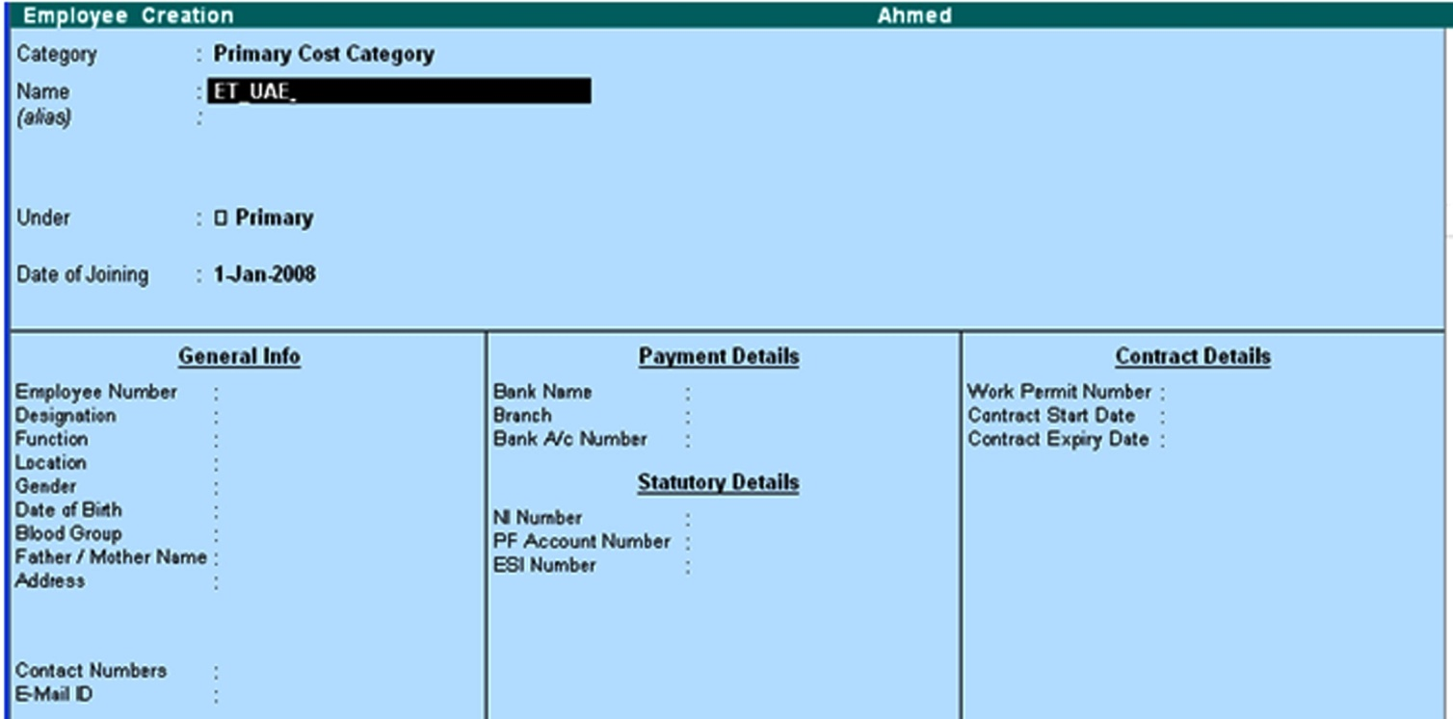

- Create Salary Details
- Go to get way of Tally and Select the payroll Info.
- Select the Create in Salary Details.

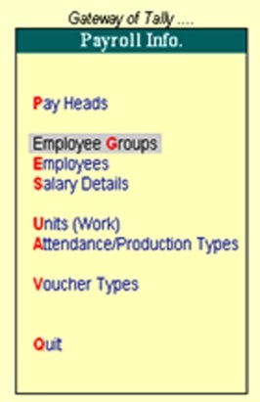
- Select the Employee from the list of Employee/Group.
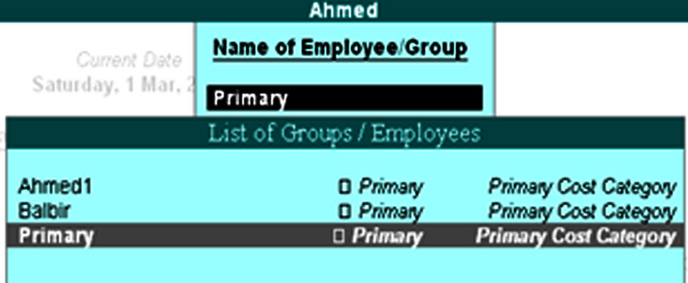
- Select the Basic Salary Other allowances in salary details. (Give link from Pay Heads).
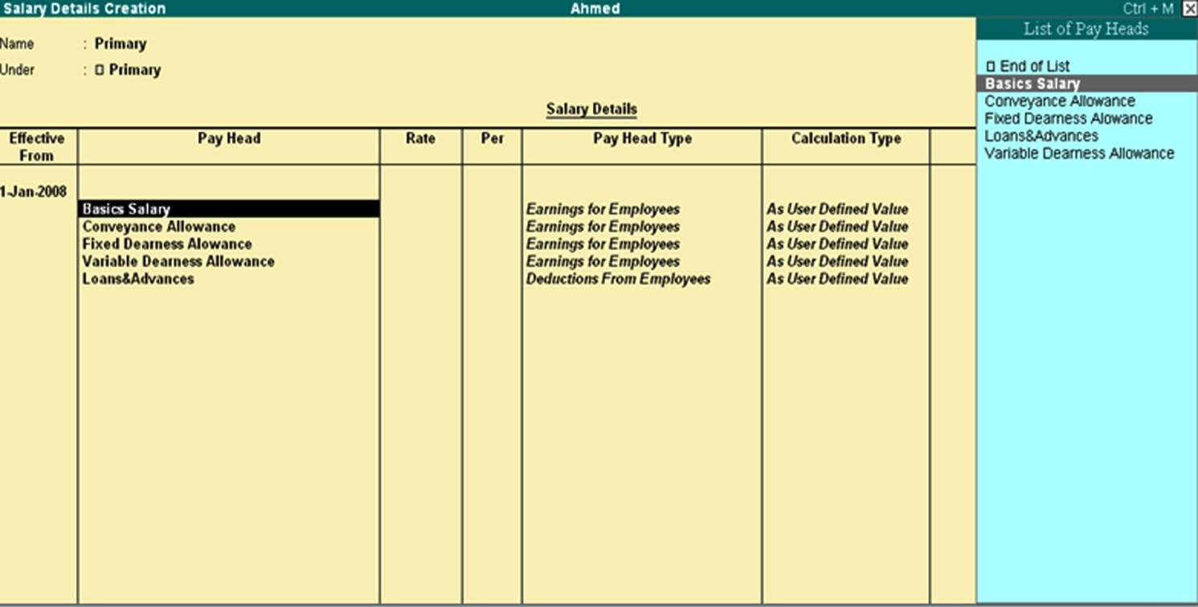

4. Process payroll and generating Pay slips.
Pass payroll vouchers to enter all Earnings and Deductions in payroll transactions that are paid along with the salary pay slip
For all employees. Displays the net amount paid to him for given pay period.
- Go to Gateway of Tally and select the payroll vouchers.
- Pass the entry
Dr. the Employee with details
Cr. The Cash/Bank A/c.
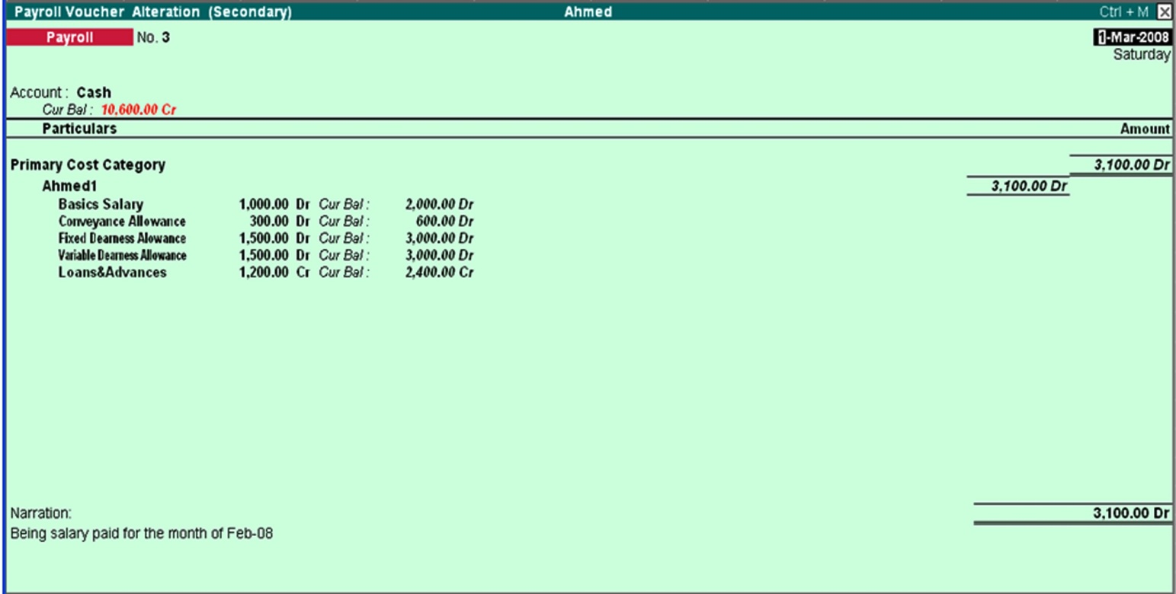

For Generate pay slip.
- Go to Gateway of Tally and select the Display.
- Select the Pay reports.
- Select the statements of Payroll.


- Select the Pay slip.
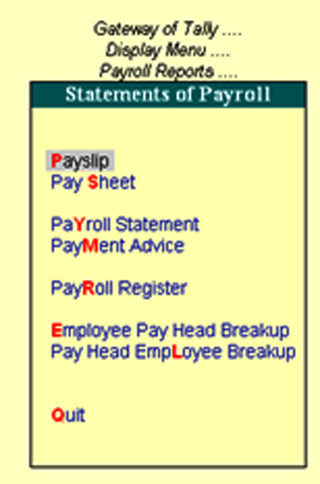

- And select the employee.
- You can print the pay slip.

