Auditing Worksheets
Unit Performance Objectives
In this unit, you will learn how to:
- find referenced cells.
- find formulas that refer to a cell.
Unit Prerequisite Knowledge
To understand the concepts and perform the tasks in this unit, you should know how to:
- understand formulas in Excel.
Lesson:

Finding Referenced Cells

Displaying the Auditing Toolbar
People make mistakes. Entering data on worksheets involves many opportunities for error. In fact, statistics show that the number of errors on computer worksheets exceeds 25%. The Auditing toolbar is Excel’s primary source for tools that allow you to audit your worksheet to find and correct the errors that will inevitably occur.
To display the Auditing features, click on Formulas tab and point to Formula Auditing group.
Excel displays the Auditing toolbar:
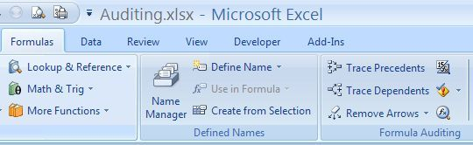
The following table describes the buttons on the Auditing toolbar:
Option | Description
Trace Precedents | allows you to find the cells that supply data to a formula. If data is supplied from more than one level of cells, click on this button again for each level. Excel displays a blue arrow from all cells supplying data to the selected cell.
Trace Dependents | allows you to find all cells that depend on the selected cell. For example, if you select a cell containing data, you can find all of the formula cells that refer to the cell data.
Remove All Arrows | allows you to remove all tracer arrows in the worksheet.
Trace Error | allows you to find the source of an error. Excel displays a red arrow from the source of the error to the selected cell. Select the error cell in the highest level to display all levels contributing to the error. This button works only when an error message appears in the selected cell.
Circle Invalid Data | allows you to display a red circle around a cell that breaks the validation rules you stipulate.
Clear Validation Circles | allows you to remove all validation circles.

Finding Cells Referenced in a Formula
In an extensive worksheet, a cell displaying totals may contain a formula that is dependent upon a number of cells on different levels throughout the worksheet. The Trace Precedents command allows you to view the levels that precede the current level. In so doing, you can view all the cells that are referenced in the formula.
To find cells referenced in a formula, use the following steps:

Click on the cell containing the formula you want referenced.
- It is best to select the cell containing the formula that is on the highest level. Then you can see all the levels flowing into that cell.

Click on Formulas tab and point to Formula Auditing group.

Click on the Trace Precedents button on the Auditing toolbar.
Excel displays a blue arrow from the preceding level that supplies data to the formula.

If there is more than one level supplying data to the formula, continue to click on this button to display arrows for each level.
The following screen displays a formula and the data supplying it:
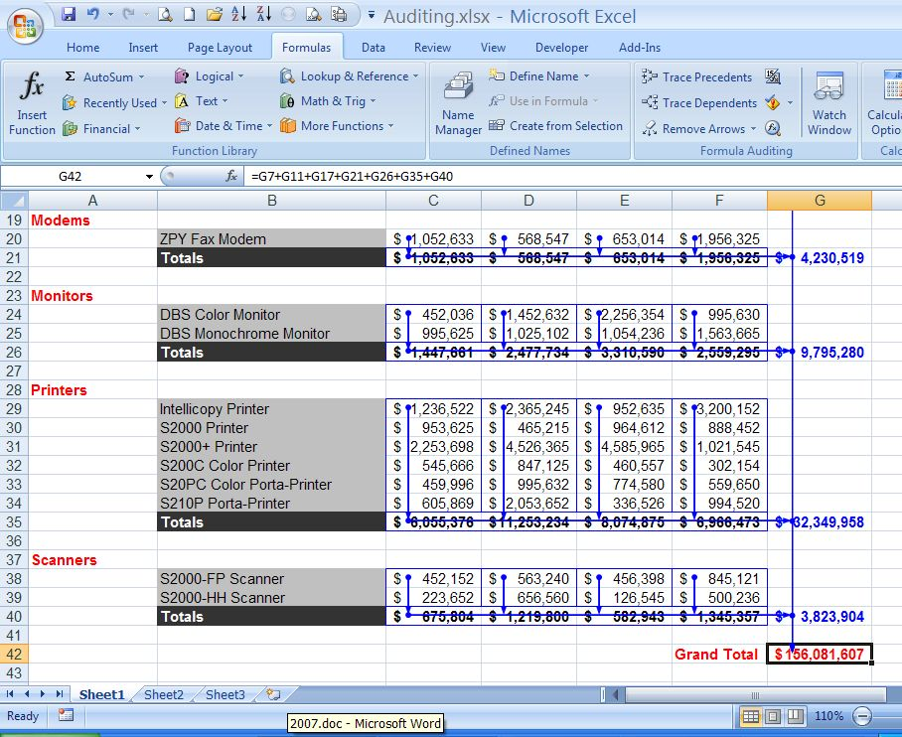

Removing Arrows
When you no longer need the tracer arrows, you can easily remove them, either individually for each formula and level or all at once.

Removing Precedent Arrows
To remove arrows for each formula and level, use the following steps:

Click on Formulas tab and point to Formula Auditing group.

Click on the Remove Precedent Arrows button once for each level you want to remove.
Excel removes the arrows for one level each time you click on the button.

Removing All Arrows
To remove all tracer arrows at one time, click on Formulas tab and point to Formula Auditing group, and then click
Excel removes all tracer arrows from the worksheet.
- Using this method removes all arrows, including dependent and error arrows. In fact, this is the only way to remove error arrows.

Key Points to Remember
- The Auditing toolbar is Excel’s primary source for tools that allow you to audit your worksheet to find and correct the errors that will inevitably occur.
- You can view all the cells that are referenced in a formula by clicking on the formula cell and click on Formulas tab and point to Formula Auditing group.
- You can remove arrows one level at a time by clicking on the Remove Precedent Arrows button.
- When you no longer need to view the tracer arrows, you can remove them all at once by clicking on the Remove All Arrows button.
Lesson:

Finding Formulas that Refer to a Cell
While finding cells referenced in formulas involves tracing precedents, finding formulas that refer to a cell involves tracing dependents. Similarly, just as it is best to select a cell on the highest level when tracing precedents, it is best to select a cell on the lowest level when tracing dependents. In this way, you can see all the formulas that refer to the cell.
To find formulas that refer to a cell, use the following steps:

Click on the cell for which you want to find dependent formulas.
- It is best to select a cell on the lowest level possible. Then you can see all the levels that originate from that cell.

Click on Formulas tab and point to Formula Auditing group.

Click on the Trace Dependents button
Excel displays a blue arrow from the selected cell to all formulas on that level that refer to the cell.

If the cell is referred to by formulas on more than one level, continue to click on this button to display arrows for each level.
The following screen displays the formulas that refer to the selected cell:
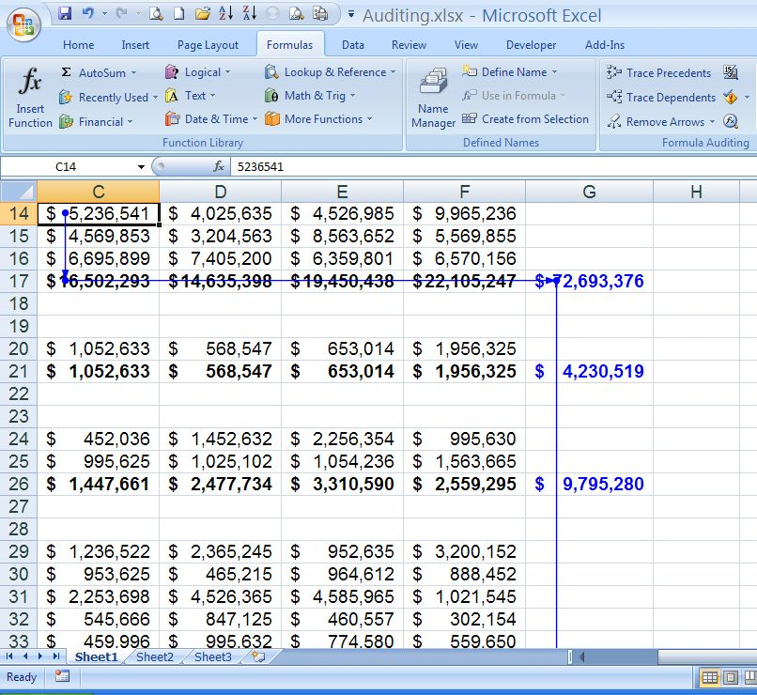
- Each cell with an arrowhead contains a formula that refers to cell C14.

Key Point to Remember
- You can view all of the formulas that refer to a cell by clicking on the cell and clicking on the Trace Dependents button on the Formulas tab.
- It is best to select a cell on the lowest level when tracing dependents. In this way, you can see all of the formulas that reference the particular cell.

