Working with Data in Lists
Unit Performance Objectives
In this unit, you will learn how to:
- Create and work with data lists.
- Sort data.
- Create subtotals.
- Apply data validation to cells.
Unit Prerequisite Knowledge
To understand the concepts and perform the tasks in this unit, you should know how to:
- Open, save, close, and create Excel workbooks.
- Enter, select, and edit information.
Lesson:

Understanding Data Lists
A database is an organized collection of information. Everyone who has used a rotary card file or a phone book has used a database. Databases are made up of records and fields. In the phone book, each record contains the name, address, and phone number of an individual. The fields in the phone book are last name, first name, address, and phone number.
In Excel, a worksheet list can serve as a database. A list typically consists of multiple labeled columns of similar types of data (for example, sales results). The rows in an Excel list serve as records, while columns serve as fields. When you have a data list in Excel, you can sort the list, filter the list to show only specific data, and subtotal certain values in the list.
The following screen displays an example of an Excel list that can serve as a database:
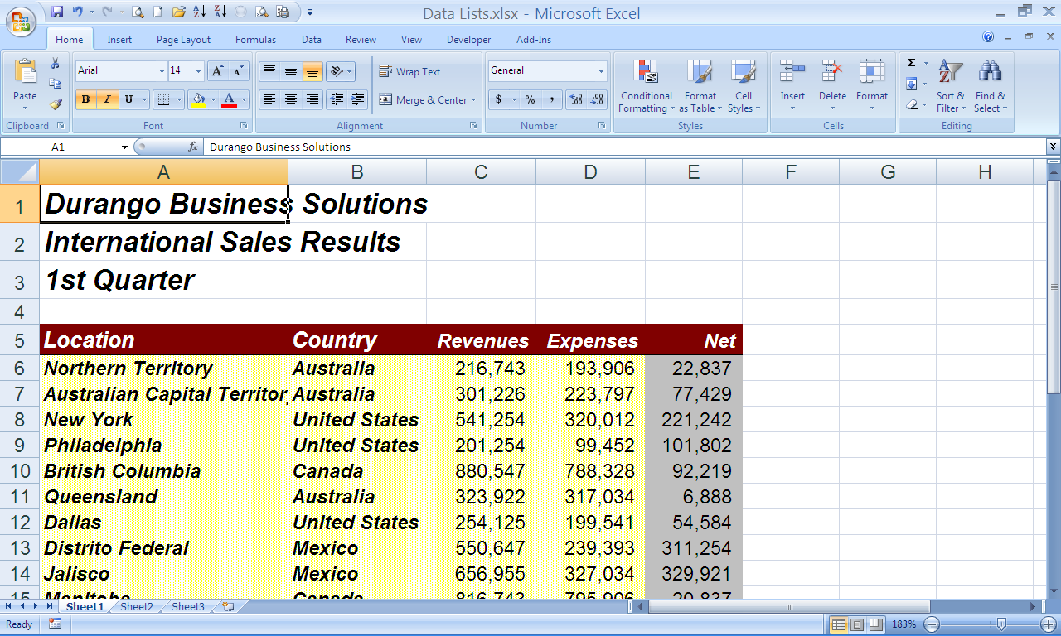
field name
record
field
The following table describes the parts of a database:
Part | Description
Record | is one row in the database. It contains all the information for one set of data.
Field | is one column in the database. It contains one category of information, such as names or phone numbers. You should create a separate field for each category of information for which you might need to search.
Field name | is a name given to a field in the database. A field name must be in the row directly above the first row of records and can contain up to 255 characters.

There is nothing you must do to designate a list as a database. Excel automatically treats any list as a database, allowing you to perform any of the commands on the Data tab. You should, however, follow these simple rules when creating your data list:
- Include only one list per worksheet.
- Include one blank column and one blank row between the list and any other data in the worksheet.
- Include column labels at the top of the list and format the labels to differentiate them from the rest of the data in the table.
- Do not include any blank rows or columns in the data list.

Key Points to Remember
- Databases are made up of records and fields. The rows in an Excel list serve as records, while columns serve as fields.
- Any list in Excel can serve as a database as long as you follow a few rules when creating your list.
Lesson:

Sorting Data

Performing a Simple Sort
Excel allows you to perform both simple and complex sorts on lists of data. You can sort alphabetically or numerically, and in ascending or descending order. You can quickly and easily sort a list by selecting a cell in the column by which you want to sort. In addition, Excel detects and excludes column labels from the sort. For example, you can select any cell in a column and Excel sorts the column, even if the selected cell is the column heading.
You can perform a simple sort of a list by using the Sort & Filter group of Data tab ribbon or Editing group of Home tab. Simple sorts involve sorting rows using the contents of a single column as the basis of the sort.
To sort a list using the Sort Ascending or Sort Descending, click button on the Sort & Filter group of Data tab ribbon or Editing group of Home tab, use the following steps:

Select a cell in the column by which you want to sort.

Do one of the following:
- Click on the Sort Ascending button to sort the list in ascending order.
- Click on the Sort Descending button to sort the list in descending order.
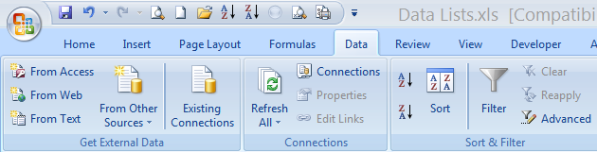
Sort Descending
Sort Ascending
Excel sorts the list according to your specifications.
- To undo the last sort, click on the Undo button on the Quick Access toolbar.

Restoring the Original Order of the List
You can create a column next to the list you are sorting, number the rows in the list, and restore the list to its original order by sorting on the new column.
If you want to perform a series of sorts and return the list to its original order, use the following steps:

Insert a column adjacent to the list.

Type consecutive numbers in the top two cells of the column, beginning with the cell beside the first row of information.

Use AutoFill to complete the consecutive numbering for the entire length of the list.

When you have completed the series of sorts and want to return the list to its original order, sort the numbered column in ascending order.

Performing Complex Sorts
Complex sorts involve sorting multiple columns in priority sequence. Excel allows you to specify up to three columns by which you can sort the list. For example, you may want to sort first by category, then by region, and finally by representative. Multiple column sorts require the use of the Sort command on the Sort & Filter group of Data tab. When you sort by more than one column, Excel uses the second and third columns as tie-breakers if records have the same values in the first or second columns.
To sort your data using multiple columns, use the following steps:

Select a cell in the range you want to sort.
- If you do not want to sort every field, select the range that contains the fields you want to sort.

Point to the Sort & Filter group of Data tab and click on Sort.
Excel displays the Sort dialog box:
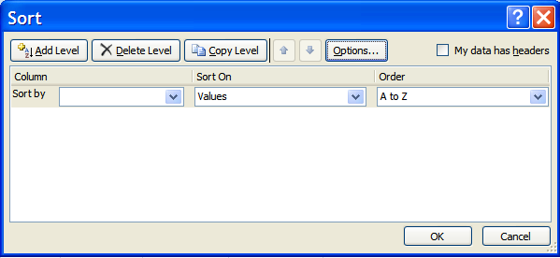
- If you have used the Sort command before, Excel displays the last column you selected in the Sort by list. Otherwise, Excel displays the left-most column.

Select the first column by which you want to sort from the Sort by list.

Click on Sort on, depending on what you want Excel to sort the column.

Specify the Order by clicking on Order.

If your list has headers, check My data has headers.

Click on OK.
Excel sorts the data in your list according to your specifications.

Changing the Sort Options
Excel allows you to set the options for a sort to better control how your data is sorted.
To change the sort options, use the following steps:

Select a cell in range you want to sort.

Click on the Sort & Filter group of Data tab and click on Sort.
Excel displays the Sort dialog box.

Click on Options.
Excel displays the Sort Options dialog box:
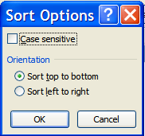
The following table describes the options available in the Sort Options dialog box:
Option | Description
Case sensitive | sorts on capitalization so that the lowercase version of a word precedes an uppercase.
Sort top to bottom | sorts rows according to values in the specified column(s).
Sort left to right | sorts columns according to values in the specified row(s).

Make your selections from the options provided.

Click on OK.
Excel returns you to the Sort dialog box.

Click on OK.
Excel sorts the list according to your specifications.

Key Points to Remember
- You can perform a simple sort using the click button on the Sort & Filter group of Data tab ribbon or Editing group of Home tab. Select the column by which you want to sort and click on the appropriate button.
- Excel allows you to specify the priority of up to three columns by which you can sort the list. To sort by multiple columns, click on Sort & Filter group of Data tab and click on Sort.
- You can change the options that control your sort by clicking on Options in the Sort dialog box.
Lesson:

Creating Subtotals
Excel allows you to create subtotals of values in lists automatically without having to create a formula. Using the Subtotals command on the Outline group of Data tab, you can quickly and easily calculate subtotals based on the values in a particular column. Excel also adds a grand total at the bottom of the list.
To create subtotals, use the following steps:

Sort the data according to how you want to calculate subtotals. For example, if you have a list of sales for all of your locations and you want to calculate a subtotal for each country, sort the list by country.

Point to the Outline group of Data tab and click on Subtotals.
Excel displays the Subtotal dialog box:
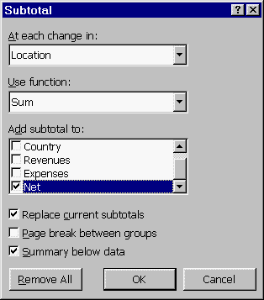

Click on the field that you want Excel to use to group records for each subtotal from the At each change in list.

Click on the function you want to use to create the subtotals from the Use function list.
- Excel defaults to the Sum function for numeric values and the Count function for text.
The following table describes the functions available in the Use function list:
Function | Description
Sum | adds the values in the subtotal.
Count | displays the number of non-blank labels in the subtotal.
Average | averages the values in the subtotal.
Max | displays the largest value in the subtotal.
Min | displays the smallest value in the subtotal.
Product | displays the product of the values in the subtotal.
Count Nums | displays the number of cells that contain values in the subtotal.
StdDev | displays the standard deviation for a population based on data taken from a sample of the population, where the sample is the subtotal group.
StdDevp | displays the standard deviation for a population, where the subtotal group is the population.
Var | displays the variance for a population based on data taken from a sample of the population, where the sample is the subtotal group.
Varp | displays the variance for a population, where the subtotal group is the population.

In the Add subtotal to list, select the column(s) for which you want Excel to calculate a subtotal.
The following table describes the additional options Excel displays:
Option | Description
Replace current subtotals | overwrites any existing subtotals with new subtotals. Clear this if you want Excel to insert the new subtotals beneath existing subtotals.
Page break between groups | inserts a page break before each group of subtotaled data.
Summary below data | displays the summary rows and Grand Total row below the group(s) of data you selected. Clear this check box if you want to display the subtotal rows and the grand total row above the data.
Remove All | deletes all subtotals you have already applied to the selected information.

Select or clear the options as necessary.

Click on OK.
Excel inserts subtotals in your list:
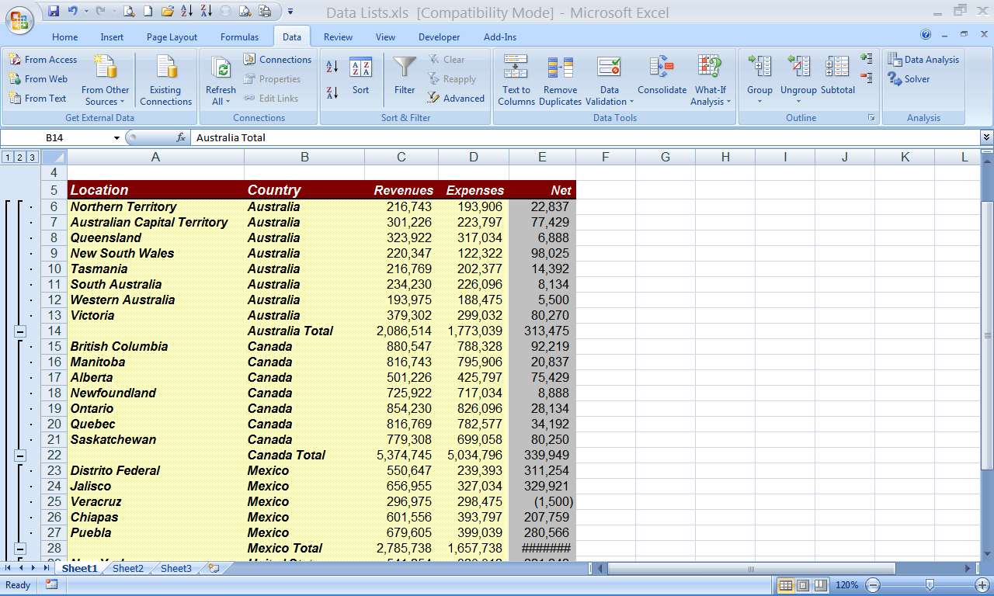
- When Excel displays subtotals, it also displays outline symbols to the left of the worksheet. You can manage the appearance of the list with subtotals by clicking on the outline symbols. For example, you can expand or condense the outline by clicking on the + or - symbol.

Removing Subtotals
You can remove subtotals from the list when you no longer want them to appear in the list.
To remove subtotal values from your list, use the following steps:

Click on the Data tab and locate outline group and click on Subtotals.
Excel displays the Subtotal dialog box.

Click on Remove All.
Excel removes the subtotal values from the list.
- If the last action you performed was adding the subtotals, you can also click on the Undo button to remove the subtotals.

Key Points to Remember

You can add subtotals to your list according to the values in a particular column. To add subtotals, sort by the column for which you want to calculate subtotals, click on the Data tab and locate outline group and click on Subtotals.

To delete subtotals, click on the Data tab and locate outline group and click on Subtotals and click on Remove All.

Lesson:

Using Data Validation
You can use data validation to make sure users enter acceptable data in a cell. You can specify the type of data that the user must enter (for example, numeric or date) and a range within which the data must fall. You can also provide the user with a list from which he or she can make a selection.

Restricting Cells to Numbers, Dates, or Times
You can restrict the allowable data in a field to either whole numbers, decimal numbers, dates, or times.
To restrict cells to numbers, dates, or times, use the following steps:

Select the cell or range to which you want to apply data validation.

Click on the Data tab and locate Data tools group and click on Data Validation.
Excel displays the Data Validation dialog box.

If necessary, click on the Settings tab.
Excel displays the Settings tab:
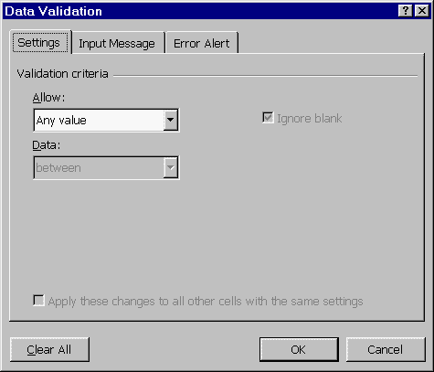

Select one of the following options from the Allow list:
Option | Description
Any value | allows any value in the cell(s). You can select this option to remove data validation from a cell.
Whole number | allows only whole numbers in the cell(s).
Decimal | allows whole numbers or decimal numbers in the cell(s).
Date | allows only dates in the cell(s). When you enter a date in the field, you must use a valid date format.
Time | allows only times in the cell(s). When you enter a time in the field, you must use a valid time format.

Select the operator you want to use to specify the allowable range from the Data list.

Specify the minimum end of the range in the Minimum box, if necessary.

Specify the maximum end of the range in the Maximum box, if necessary.
- You can enter a value, a cell address, or a formula for either the minimum or maximum limit.
- Depending on the operator you choose, you may need to specify a minimum, maximum, or both.
- If you select the equal to or not equal to operator, specify the value in the Value box.

Do one of the following:
- To allow blank cells in the range for which you are setting data validation, make sure the Ignore blank check box is selected.
- To treat blank cells as if they contain zeros, clear the Ignore blank check box.

Click on OK.
Excel returns to your worksheet and applies the data validation settings.
- If you set validation for a cell that already contains data, Excel does not alert you if the data is invalid.
- When a user attempts to enter invalid data into a field with data validation, Excel displays a message stating that the data is invalid. The user must then enter valid data.
- Setting data validation does not affect the format of the cells. If necessary, you must format the cells as numbers, dates, or times.
- You can also restrict cells to a particular number of characters by selecting Text length from the Allow list. To enter a formula to determine if the entry is valid or not, select Custom from the Allow list.

Restricting Cells to a List of Values
You can provide the user a list of allowable entries for a cell. The user can either type one of the allowable entries or select it from the list attached to the cell.
To restrict cells to a list of values, use the following steps:

Enter the list of allowable entries in an empty area of the worksheet.
- Place the list in a row or column on the same worksheet as the cells. Do not include any blank cells within the list.
- You can also name the range that contains the list and then specify the named range in the Data Validation dialog box. Using this method you can easily add to or change the entries in the list without affecting the data validation.
- If you prefer, you can enter the list items directly in the Data Validation dialog box, rather than in a separate range. This method works best for short lists.

Select the cell or range to which you want to apply data validation.

Click on the Data tab and locate Data tools group and click on Validation.
Excel displays the Data Validation dialog box.

If necessary, click on the Settings tab.

Select List from the Allow list.

In the Source box, do one of the following:
- Specify the range address or range name containing the list of allowable values.
- Type the list of allowable values, separating each value with a comma.
- You can also click on the Hide Dialog Box button to select the range directly in the worksheet.
- If you type the address or name of the range containing the list values, make sure you include an equal sign (=) as the first character (for example, =$A$1:$A$5). If you use the Hide Dialog Box button to select the range, Excel enters the equal sign for you. You must also express the range using absolute cell references, which you can accomplish by preceding each row number or column letter with a dollar sign ($).

Do one of the following:
- To allow blank cells in the range, make sure the Ignore blank check box is selected.
- To not allow blank cells, clear the Ignore blank check box.

To provide a drop-down list from which the user can select a valid entry, make sure the In-cell dropdown check box is selected.

Click on OK.
Excel returns to your worksheet and applies the data validation settings.
- When you click on a cell that contains a list, Excel displays a drop-down arrow to the right of the cell border.
- If you set validation for a cell that already contains data, Excel does not alert you if the data is invalid.
- When a user attempts to enter invalid data into a field with data validation, Excel displays a message stating that the data is invalid. The user must then enter valid data.

Displaying an Input Message
You can display a message when the user clicks on a cell with data validation to provide information about the type of data the user should enter in the cell. Excel displays the message next to the selected cell.
To display an input message, use the following steps:

Select the cell or range for which you have defined data validation.

Click on the Data tab and locate Data tools group and click on Validation.
Excel displays the Data Validation dialog box.
- You can also define the data validation settings at this point.

Click on the Input Message tab.
Excel displays the Input Message options:
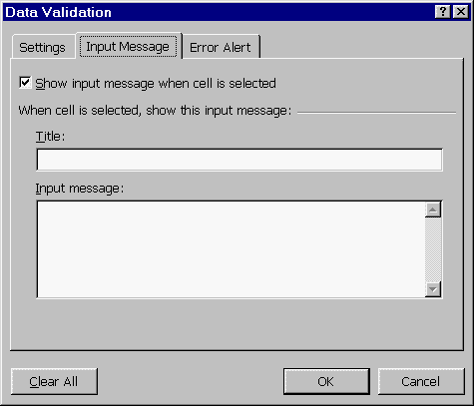

Select the Show input message when cell is selected check box, if necessary.

Type the title for the message box in the Title box.

Type the message in the Input message list.

Click on OK.
Excel saves the input message and returns to your worksheet.
- You can display an input message by clicking on the cell containing the message.

Displaying an Error Alert
By default, when a user enters invalid data in a cell with data validation, Excel displays an error message. You can customize the message that Excel displays. You can display a stop message (the default), a warning message, or an information message.
To display an error alert, use the following steps:

Select the cell or range for which you have defined data validation.

Click on the Data tab and locate Data tools tab menu and click on Validation.
Excel displays the Data Validation dialog box.
- You can also define the data validation settings at this point.

Click on the Error Alert tab.
Excel displays the Error Alert options:
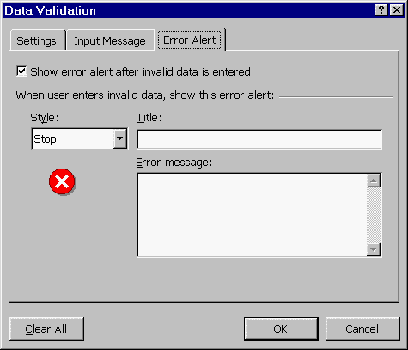

If necessary, select the Show error alert after invalid data is entered check box.

Select one of the following options from the Style list:
Option | Description
Stop | displays an error message and does not allow the user to enter the invalid data. The user can either select Retry or Cancel.
Warning | displays a warning message. The user can click on Yes to continue entering the invalid data, No to try again to enter valid data, or Cancel to stop entering data.
Information | displays an information message. The user can click on Yes to enter the invalid data or Cancel to stop entering data.

As you click on each option, Excel displays the corresponding icon below the Style list. This is the icon that Excel displays in the error message.

Type the title for the message box in the Title box.

Type the error message in the Error message list.

Click on OK.
- When a user enters invalid data in the cell, Excel displays your error alert. Excel does not display the error alert if information is copied into the cell or placed in the cell by a formula or macro.
- To display circles around any cells that contain invalid data, click on the Data tab and locate Data tools group, click on the Circle Invalid Data button. Excel displays circles around any cells whose data does not meet the data validation rules. Excel only circles data entered after the validation rule was set. To remove the circles, click on the Clear Validation Circles button.

Key Points to Remember
- You can use data validation to ensure that the proper type of data is entered in a cell.
- You can restrict a cell to whole numbers, decimal numbers, dates, times, or the values in a list that you define.
- To apply data validation to a range of cells, select the cells, click on the Data tab and locate Data tools group, and click on Data Validation.
- To display an input message in a cell with data validation, click on the Input Message tab in the Data Validation dialog box. Type the title for the message box and the message.
- To display a customized error alert when a user enters invalid data in a cell, click on the Error Alert tab in the Data Validation dialog box. Select the message style, type the title for the message box, and type the message.

