Filtering and Querying Data
Objectives
In this unit, you will learn how to:
- filter data.
- work with the Advanced Filter.
- perform Web queries.
Knowledge
To understand the concepts and perform the tasks in this unit, you should know how to:
- work with data in lists.
Lesson:

Filtering Data
Since lists can include information of some magnitude, there may be times when you want to exclude or remove data not essential to your current evaluation of the list. By establishing criteria, you determine what data is essential. Filtering is a screening process designed to exclude items not essential for the desired result. When you filter a list, you hide, temporarily, all the rows that do not meet the established criteria. Excel provides you with built-in filtering mechanisms that allow you to establish simple criteria, such as the data form, or complex criteria using more advanced filters. Also, you can create a custom filter for your data.

Using AutoFilter
Excel’s AutoFilter feature allows you to view a subset of the data in a list by displaying only those rows that meet the criteria you establish. When you use AutoFilter, Excel displays drop-down arrows next to each column in the list. You can then select criteria from the list. For example, you can display a specific category such as Australia or Mexico in the column labeled Country.
- AutoFilter works best when your list includes column labels, although they are not necessary.
To filter a list using AutoFilter, use the following steps:

Click on any cell in the list.

Click on the Data tab and locate Sort & Filter group, and click on Filter.
Excel displays an arrow next to each column in the list:
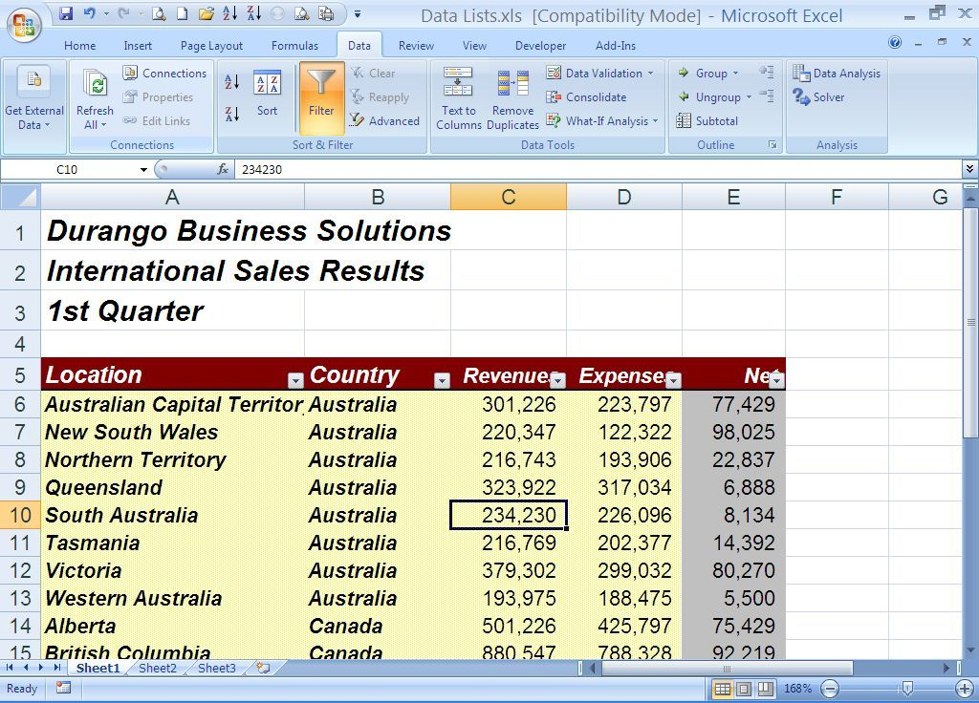

Click on the arrow in the column you want to filter.

Click on the item in the column by which you want to filter the list.
Excel displays only those rows that contain the item you selected and hides the other rows.
The following screen displays a filtered list:
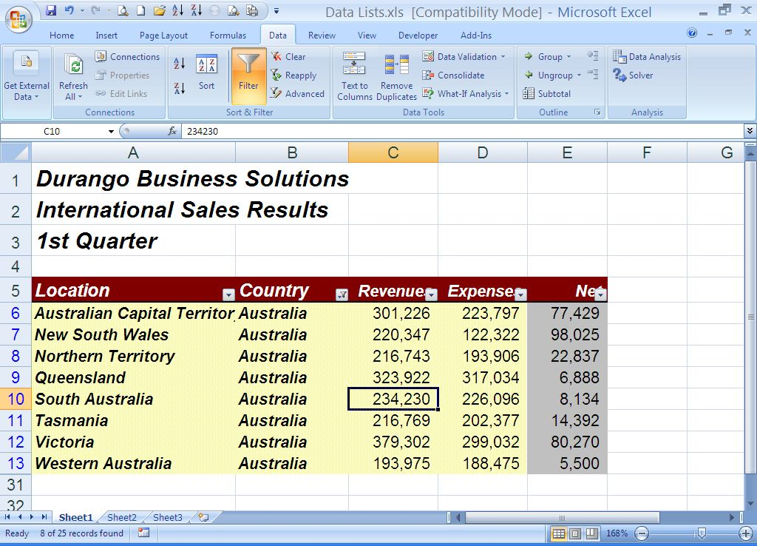
- After applying the initial filter, you can also filter the results as necessary.
- To redisplay all rows in the list, click on the arrow next to the column label you used to filter the data and click on All. Excel displays all rows in the list. If you used more than one column to filter, click on All for each column. Excel displays blue arrows for filtered columns.

Working with Filtered Data
Once you filter a list, you can work only with the data that Excel displays. You can:
- use the AutoSum button to calculate the sums of all visible cells.
- use the Chart button to create charts based on all visible cells.
- use the Copy and Paste commands to duplicate visible cells.
- use the Print button to print only the visible cells.
- use the Sort Ascending or Sort Descending button to sort the visible cells.
- format the visible cells.
- Changes you make to the filtered data remain intact when you redisplay the entire list. For example, if you sort visible cells, they remain sorted when you display the entire list.
- Although you can create a chart based on filtered data, the chart is interactive and changes if you change the filter that is applied to the data. If you want the chart to remain static, you should copy and paste the filtered data to a new worksheet and then base the chart on the copied data.

Removing AutoFilter
You can remove the AutoFilter feature from your list when you no longer want to filter your data.
To remove the AutoFilter feature from your list, click on the Data tab and locate Outline group, and click on Filter to clear it. Excel removes the arrow next to each column label in the list.
- If your list was filtered when you removed AutoFilter, Excel automatically redisplays all records in the list.

Using AutoFilter with Top 10
You can filter the highest or lowest values in a list using AutoFilter with Top 10. Although the name suggests you can filter the top ten values, you can actually filter any number of top or bottom values you want.
If you want the top ten values to be in ascending or descending order, first sort by the column in which you want to filter the top ten.
To use AutoFilter with Top 10, use the following steps:

Click on any cell in the list.

If you are not already in AutoFilter mode, click on the Data tab and locate Outline group, and click on Filter. Click on the arrow of the column for which you want to filter the highest or lowest values.
- If the list that Excel displays contains a large number of options, you may need to scroll through the list in order to see the options at the top of the list.

Click on Number filters and then on Top 10.
Excel displays the Top 10 AutoFilter dialog box:
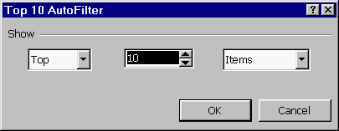

In the left list, do one of the following:
- Click on Top to filter the highest values.
- Click on Bottom to filter the lowest values.

In the middle box, enter the number of either the top or bottom values you want to filter.

In the right list, do one of the following:
- Click on Items if you are filtering values.
- Click on Percent if you are filtering percentages.

Click on OK.
Excel filters the list.

Creating a Custom AutoFilter
You can create a custom AutoFilter that allows you to specify one or two comparison criteria for a column. Comparison criteria allow you to select records that fall within a specified range (for example, all records that have values greater than 200700 (>200700) in the Revenues column). You can use the six comparison operators (greater than, less than, etc.) to display records that meet the criteria. You can also specify two comparison criteria to display all records that fall between two values (for example, records that have values greater than 200700 (>200700) and less than 300000 (<300000) in the Revenues column).

Filtering with a Single Comparison Criterion
To create a custom AutoFilter with one comparison criterion, use the following steps:

If you are not already in AutoFilter mode, switch to AutoFilter mode.

Click on the arrow in the column you want to filter and click on Text filters (or Number Filters) and then on Custom Filter.
Excel displays the Custom Filter dialog box:
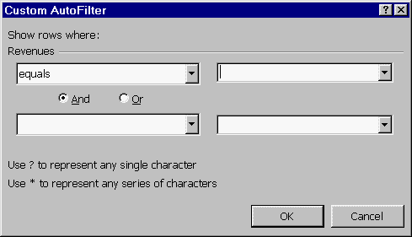

Click on the arrow immediately beneath the column label under Show rows where and select the comparison operator you want to use.

Do one of the following:
- In the list to the right of the comparison operator list, type the value you want to use in the comparison.
- Click on the arrow and select the value you want to use in the comparison from the list.

Click on OK.
Excel filters the list based on the comparison criterion you specified.

Filtering with Two Comparison Criteria
You have two options for specifying two comparison criteria:
- You can use the AND option to combine two comparison criteria to narrow the search. Records must meet both criteria to be selected.
- You can use the OR option to specify two different comparison criteria to expand the search. Records meeting either criterion are selected.
To create a custom AutoFilter with two comparison criteria, use the following steps:

If you are not already in AutoFilter mode, switch to AutoFilter mode.

Click on the arrow in the column you want to filter and click on Number Filter (or Text filter) and then on Custom.
Excel displays the Custom AutoFilter dialog box.

Click on the arrow immediately beneath the column label under Show rows where and select the comparison operator you want to use.

Do one of the following:
- In the list to the right of the comparison operator list, type the value you want to use in the comparison.
- Click on the arrow and select the value you want to use in the comparison from the list.

Do one of the following:
- Click on And if you want both comparison criteria to apply.
- Click on Or if you want to apply separate comparison criteria.

Click on the second arrow beneath the column label and select a second comparison operator.

Do one of the following:
- In the list to the right of the comparison operator list, type the value you want to use in the comparison.
- Click on the arrow and select the value you want to use in the comparison from the list.

Click on OK.
Excel filters the list based on the comparison criteria you specified.

Key Points to Remember
- Excel’s AutoFilter feature allows you to view a subset of the data in a list by displaying only those records that meet the criteria you establish. To use AutoFilter to filter a list, click on the Data tab and locate Outline group, and click on Filter. Click on the arrow for the column you want to filter and select the value for which you want to filter.
- With the filtered data, you can use the following features: the AutoSum button, the Chart Wizard button, the Copy and Paste commands, the Print button, and the Sort Ascending and Sort Descending buttons.
- To remove the AutoFilter, click on the Data tab and locate Outline group, and click on Filter to clear it.
- You can filter the highest or lowest values in a list using AutoFilter with Top 10 by clicking on Top 10 from the AutoFilter list for the appropriate column.
- You can create a custom AutoFilter that allows you to specify one or two comparison criteria for a column. Comparison criteria allow you to select records that fall within a specified range.
- You can create a custom AutoFilter by clicking on Custom from the AutoFilter list for the appropriate column.
- You can also create a custom AutoFilter with two criteria. You can either narrow the search by requiring both criteria to be met or you can expand the search by requiring only one criterion to be met.

Lesson:

Working with the Advanced Filter
When you want to apply a more complex filter to your data, you can use the Advanced Filter feature. The Advanced Filter feature allows you to query your database and display only the information that meets the criteria you specify. In addition, Advanced Filter allows you to set AND/OR comparison criteria for more than one column and to extract the data that meets the criteria to a new range.
There are two steps to using the Advanced Filter. You must:
- set up a criteria range on your worksheet.
- execute the Advanced Filter command.

Setting Up the Criteria Range
When you set up a criteria range, you specify the conditions by which you want to filter the list. You will then use this range when you execute the Advanced Filter command.
To set up a criteria range, use the following steps:

Move to a blank section of the worksheet or to another sheet.

Type the column heading for each column for which you want to specify criteria.
- The column headings should match those in the data list.

In the row(s) immediately beneath the column headings, type the criteria you want to use to filter the list.
- You can include the column headings more than once if you want to specify a range of values or include multiple criteria. For example, you can filter your database to show a range of values between 18000 and 30000 in the column labeled Totals by entering the label twice in the criteria range, typing >18000 in the cell beneath the first label, and <30000 in the cell beneath the second label.

Examples of Criteria Ranges
The following are examples of the types of criteria ranges you can use to filter your list:

Displaying Records that Meet All Criteria
The following shows a criteria range that displays only those records that meet all criteria specified. If you want the range to meet all the criteria, type the conditions in the same row. The criteria range below displays records in which Country equals Australia and Net is greater than 50000 (>50000):
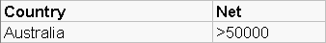

Displaying Records that Meet Different Criteria
The following shows a criteria range that displays those records that meet at least one of the criteria specified. In the example below, because the criteria are in separate rows, Excel finds either records where Country equals United States or Net is greater than 100000:
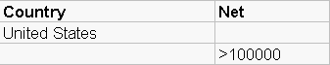

Displaying Records that Fall Within a Range of Values
The following shows a criteria range that displays records with values that fall between two specified values. The criteria range below displays records in which Net is greater than 100000 and Net is less than 200700:
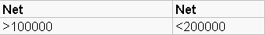

Combining AND/OR Relationships
The following shows a criteria range that displays records that meet separate sets of criteria. The criteria range below displays records where Country equals Canada AND Net is greater than 50000 or where Country equals Mexico AND Net is greater than 250000:
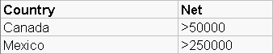
- If you want to specify multiple criteria for the same field and use an OR relationship, you can either enter the field name twice and place the field values on different rows or you can enter the field name once and place the field values one beneath the other.
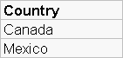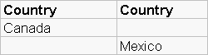

Filtering Data with the Advanced Filter
Once you have set up your criteria range, you can execute the Advanced Filter command.
To execute the Advanced Filter command, use the following steps:

Click on any cell in the list.

Click on the Data tab and locate Outline group, and click on Advanced. Excel displays the Advanced Filter dialog box:
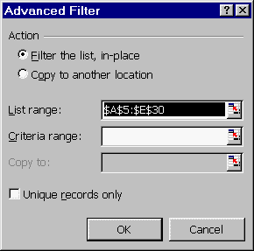
Hide Dialog Box

The following table describes the options available in the Advanced Filter dialog box:
Option | Description
Action | provides two actions: Filter the list, in-place, which hides the rows in the list that do not meet the criteria you specified, or Copy to another location, which places a copy of the records that meet the criteria you specified in another location. This is also referred to as extracting data.
List range | displays the range containing the list.
Criteria range | allows you to specify the range that contains the criteria.
Copy to | allows you to specify the range to which you want to copy the records that meet the criteria. The range you specify must be on the same sheet as the data list. This option is only available if you select Copy to another location under Action. You can use the Hide Dialog Box button to select the range.
Unique records only | excludes any duplicate records in the records that meet the criteria.

Click on the Hide Dialog Box button for the Criteria range box.
Excel collapses the dialog box so that you can easily select the criteria range.

Select the cells in the criteria range and press the Enter key.
Excel enters the criteria range and returns to the dialog box.

Select or change any of the other options.

Click on OK.
Excel filters the list based on the criteria you specified.

Displaying All Data
After you have a filtered list in place with the Advanced Filter command, you can redisplay all records in the list using the Clear command.
To display all records, click on the Data tab and locate Sort & Filter group, and click on Clear.
Excel displays all the records in the list.

Key Points to Remember
- There are two steps to using the Advanced Filter: set up a criteria range on your worksheet, and execute the Advanced Filter command.
- To set up a criteria range, type the column headings that correspond to the columns you want to filter in a blank section of the worksheet. In the row(s) immediately beneath the column headings, type the criteria you want to use to filter the list.
- You can create several types of criteria ranges when you filter data. You can display records that meet all criteria (AND), display records that meet one of several criteria (OR), display records that fall within a range of values, and combine AND/OR relationships.
- To filter data with the Advanced Filter command, Click on the Data tab and locate Outline group, and click on Advanced. Specify the list in the List range box and specify the criteria range in the Criteria range box.
- To display all records in the filtered list, Click on the Data tab and locate Outline group, and click on Clear.
Lesson:

Performing Web Queries
Excel’s Web query feature allows you to import data from a Web page into a worksheet. The Web query and the Web page are linked, so as the contents of the Web page change, you can update the Web query in Excel. For example, you may want to display stock quotes from the Internet or budget information from your company’s intranet in an Excel Web query. You can also perform calculations on the data in the Web query. You can import the Web query data into an existing worksheet or into a new worksheet.
- To perform a Web query, you must have a Web browser and Internet access.
To perform a Web query, use the following steps:

Select the cell that will be the upper-left corner of the range for the query results.

Click on the Data tab, point to Get External Data, and click on From Web.
Excel displays the New Web Query dialog box:
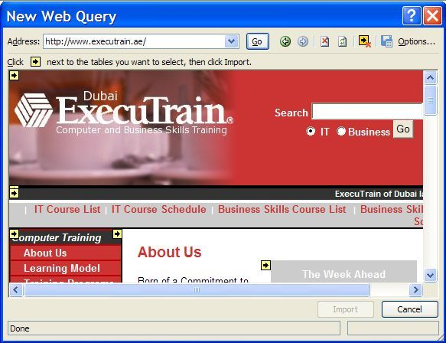

Type the URL of the Web site from which you want to import information in the first box.
- You can also click on Browse Web to launch your default Web browser so that you can locate the Web site. Once you have located the site, copy the URL, switch back to Excel, and paste the URL into the box.

Select from the following options to specify how much formatting you want the imported Web page to retain:
Option | Description
None | removes all formatting from the Web page.
Rich text formatting only | retains the basic Web page formatting, but not more advanced formatting, such as hyperlinks or merged cells.
Full HTML formatting | retains all Web page formatting, including advanced formatting.
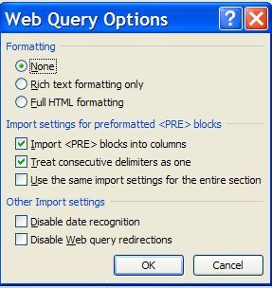

- If you want to save the query so that you can easily run it again later, click on Save Query. Excel displays the Save Query dialog box. Enter a name for the query or accept the default name Excel provides and click on Save. Excel returns to the New Web Query dialog box.

Click on OK.
Excel displays the Returning External Data to Microsoft Excel dialog box:
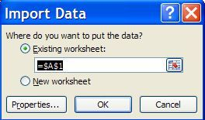

Do one of the following:
- If you want to import the results of the Web query into an existing worksheet, click on Existing worksheet.
- If you want to import the results of the Web query into a new worksheet, click on New worksheet.

Click on OK.
Excel displays a message while it retrieves the data.
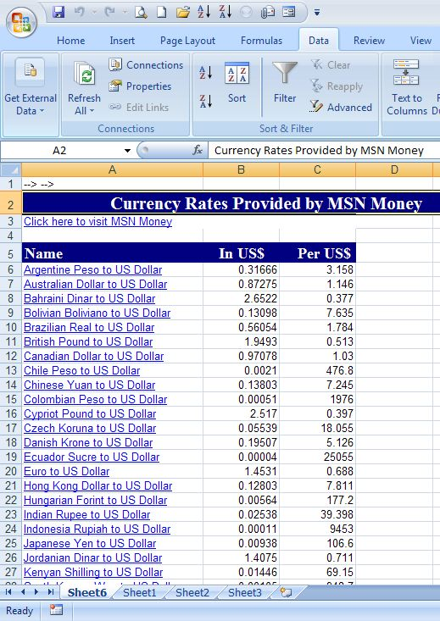
Excel displays the Web query in the selected worksheet along with the Connections and Properties on the Data tab and pointing to Connections group.

- You may have to adjust the column widths in the Web query.
- To refresh the data in the Web query, click on a cell in the query and click on the Refresh All button.

Running a Saved Web Query
Excel allows you to save Web queries and run them whenever you want. Excel also provides you with several predefined Web queries that are more complex than the ones you can create yourself. One of the predefined queries allows you to access a stock quote for a particular stock by providing the stock symbol.
To run a saved Web query, use the following steps:

If you want to place the query results in the current worksheet, select the cell in the upper-left corner of the range for the query results.
- The cursor cannot be positioned within an existing Web query.

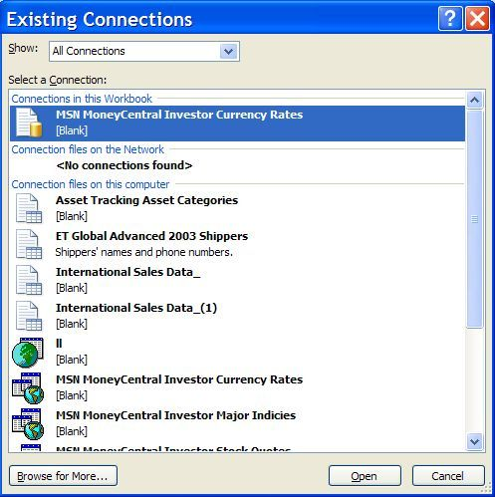
Point to Data tab and locate Get External Data , select “Exiting Connections”
Excel displays the Run Query dialog box:

Double-click on the query you want to run.
- The Browse for more option provides you access to additional Web sites from which you can create Web queries.
Excel displays the Returning External Data to Microsoft Excel dialog box:

Do one of the following:
- If you want to import the results of the Web query into an existing worksheet, click on Existing worksheet.
- If you want to import the results of the Web query into a new worksheet, click on New worksheet.

Click on OK.
Excel displays the Enter Parameter Value dialog box:
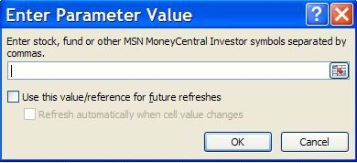

Type the stock symbol.
- You can enter multiple stock symbols by separating them with commas.

Click on OK.
- It is important to know the symbol for each stock involved in the Web query. If you do not know the symbol, you will not be able to execute the quote.
Excel displays a message while it retrieves the data and then displays the Web query in the worksheet.

Key Points to Remember
- Excel’s Web query feature allows you to import data from a Web page into a worksheet.
- Once you retrieve the information into a worksheet, you can work with the information using Excel commands and refresh the information as necessary.
- To create a Web query, you must have a Web browser and access to the Internet.
- To create a Web query, click on the Data menu, point to Get External Data.
- You must know the URL of the Web page you want to import.
- You can also run one of Excel’s predefined Web queries to access a variety of information.
- To run a saved query, click on the Data menu, point to Get External Data, and click on Existing Connections.

