September 2, 2010
PRESS RELEASE

SALMAN KHURSHID, MINISTER OF STATE (INDEPENDENT CHARGE) FOR CORPORATE AFFAIRS AND MINORITY AFFAIRS INAUGURATES 38TH NATIONAL CONVENTION OF COMPANY SECRETARIES
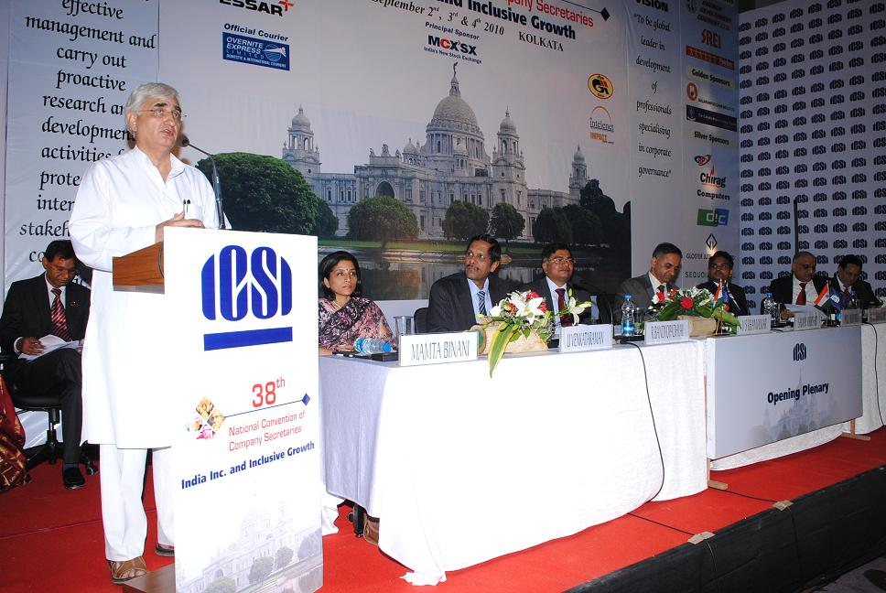

Corporate Social Responsibility is to be taken from “Company’s Vision” to “Country’s Vision” said Salman Khurshid while inaugurating the 38th National Convention of Company Secretaries here today, emphasizing the role of Company Secretaries in corporate sector.

Referring that corporates are the cutting edge to economic growth, he spoke about the importance of corporate democracy, industrial democracy, stakeholder dialogue with the board, etc. He referred to Company Secretaries as centre point in not only advising and guiding the Boards of companies but also cautioning them against any mis-governance. He said the injury to the company is an injury to the entire system and quoted the examples of Satyam Scam and Bhopal Gas Tragedy. The attitude and culture towards inclusive growth has to be inculcated and nurtured in all corporates, emphasized Minister.

The Minister welcomed the recommendations of Parliamentary Standing Committee on Companies Bill which covers various aspects including Secretarial Audit, rotation of auditors, role of independent directors, etc.

While concluding the Minister said CSR is no longer charity or philanthropy. It should be imbibed in the corporate culture that leads to responsible business. He emphasized the role of Company Secretaries in the companies.

R Bandyopadhyay, Secretary, Ministry of Corporate Affairs while delivering his address at the ICSI Convention stated Ministry of Corporate Affairs has got special attachment towards Company Secretary profession. The upliftment of “Aam Admi” is crucial for economic growth and the entire Ministry is working towards this direction, he stated. He spoke about India Corporate Week, 2009 covering two themes namely, Corporate Governance and Corporate Social Responsibility, and informed that Ministry held 124 programmes during India Corporate Week.

Referring to the strength of Indian economy, Mr. Bandyopadhyay said the economic recession of 2008 had not made major impact on Indian economy and the country was able to still achieve 6.5% GDP growth rate. Probably, in one or two years India may achieve 10% GDP growth rate also. But the challenge is the development of 500 million people in the country who do not have access to basic needs. In this context he emphasized that CSR should be inbuilt in the culture of the company. Equality of growth process and equitable dispersal of resources is crucial for inclusive growth, reiterated Mr. Bandyopadhyay, and emphasized that the professionals being the eyes and ears of the Ministry, should ensure compliance of law in true letter and spirit.

H M Bangur, Managing Director, Shree Cement Ltd. in his key note address said that the fundamental philosophy of the business is to serve the society. He said Indian corporate sector with its present focus on inclusive growth is continually broadening the scope of its activities with corporate social responsibility, in order to address the long term needs of the society.

U Venkataraman, Executive Director, MCX-SX Ltd. in his special address said that 3G’ is the buzz word covering three aspects namely, inclusive growth, corporate governance, creation of new generation investors. He spoke at length about the investor awareness programmes of Ministry of Corporate Affairs, SME Exchange, etc.

Vinayak S Khanvalkar, President, the ICSI said that Business Leaders are advised by professionals like Company Secretaries on various business issues such as Corporate Strategy, governance, disclosures, policy decisions etc. As the governance and sustainability initiatives are baseline of inclusive growth, the role of Company Secretary in this respect have been substantially raised. He spoke about various ICSI Initiatives for members, students, etc.

Anil Murarka, Vice President, The ICSI and Chairman, Convention Organising Sub Committee in his welcome address said that the development of agriculture, labour technologies and development of rural population are crucial for inclusive growth of the nation.

S Kumar, Principal Director, the ICSI proposed a vote of thanks.

Earlier, Mamata Binani, Chairman, EIRC of the ICSI introduced the dignitaries on the dais.

SUTANU SINHA
DIRECTOR

