NON APPLICABILITY OF CARO 2003 TO PRIVATE COMPANIES

Private Limited companies, conditions for non-applicability (ALL TO BE SATISFIED):
1. Paid up capital and reserves not more than Rs. 50 Lacks and
2. Which doesn’t have loan outstanding exceeding Rs. 25 from any bank or Financial Institution (other than NBFC s) and
3. Having turnover of Rs. 5 Cr or less
At any point of time during the financial year

RTP OF AUDIT NOV 2011
VERY IMPORTANT DOUBT

Question

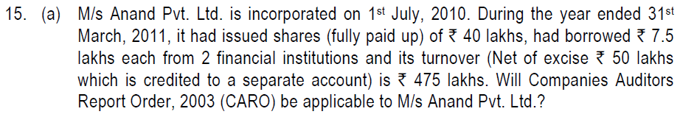

Solution

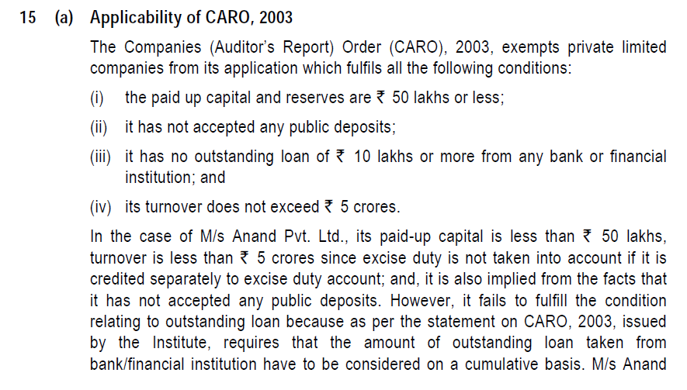

WAITING FOR YOUR REPLIES

